Brett Shelley
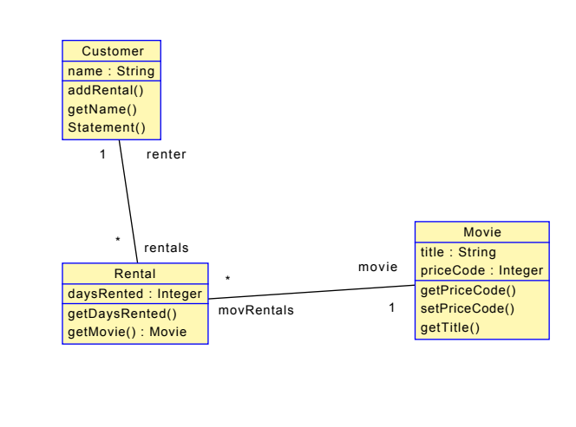
Alex Irish
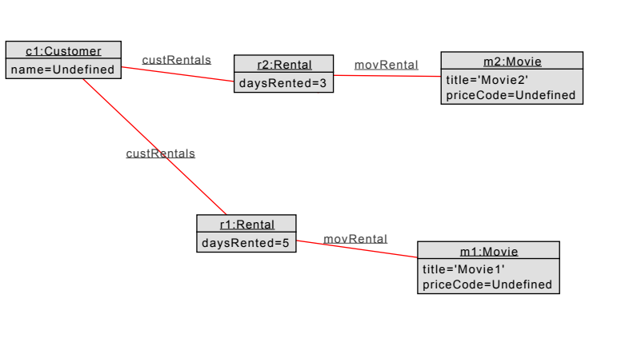

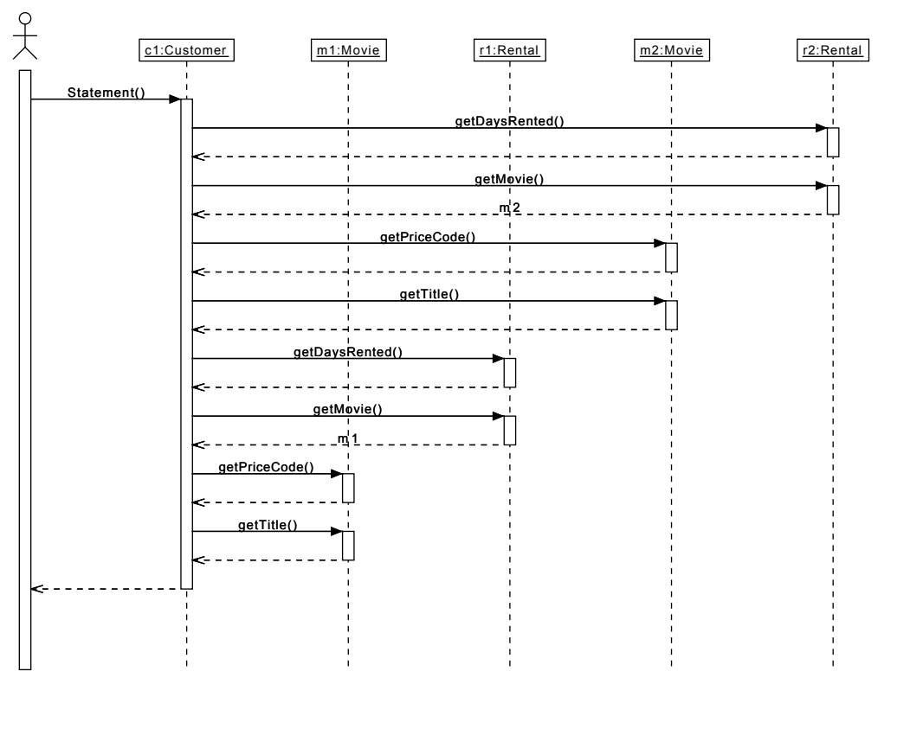

model MovieRental

enum PriceCode {regular, family, newRelease}

class Customer
attributes
name:String
operations
addRental()
getName()
Statement()
begin
declare m:Movie;
for ren in self.rentals do
ren.getDaysRented();
m := ren.getMovie();
m.getPriceCode();
m.getTitle();
end
end
end

class Rental
attributes
daysRented:Integer
operations
getDaysRented()
begin
end
getMovie() : Movie
begin
result := self.movie
end
end

class Movie
attributes
title:String
priceCode:Integer
operations
getPriceCode()
begin
end
setPriceCode()
getTitle()
begin
end
end

association custRentals between
Customer[1] role renter
Rental[0..*] role rentals
end

association movRental between
Rental[0..*] role movRentals
Movie[1] role movie
end

!create c1:Customer
!create m1:Movie
!create r1:Rental
!set m1.priceCode := PriceCode::regular
!set m1.title := 'Movie1'
!set r1.daysRented := 5
!insert (c1,r1) into custRentals
!insert (r1,m1) into movRental

!create m2:Movie
!create r2:Rental
!set m2.priceCode := PriceCode::newRelease
!set m2.title := 'Movie2'
!set r2.daysRented := 3
!insert (c1,r2) into custRentals
!insert (r2,m2) into movRental

!c1.Statement()

