Brett Shelley
Alex Irish
ESOF 422
HW2

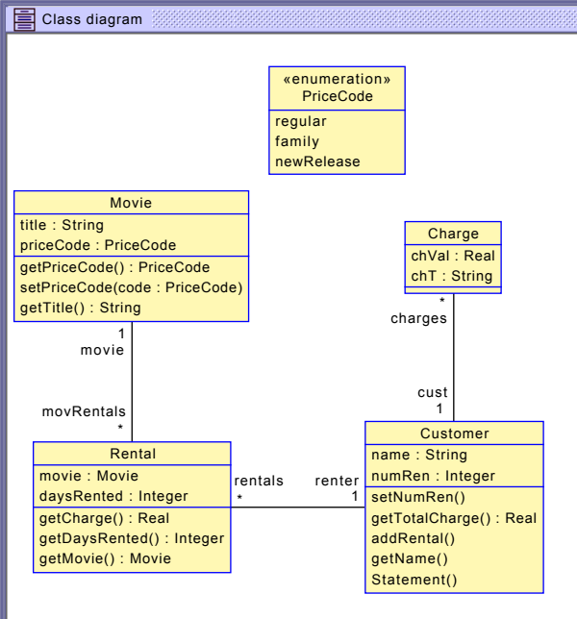

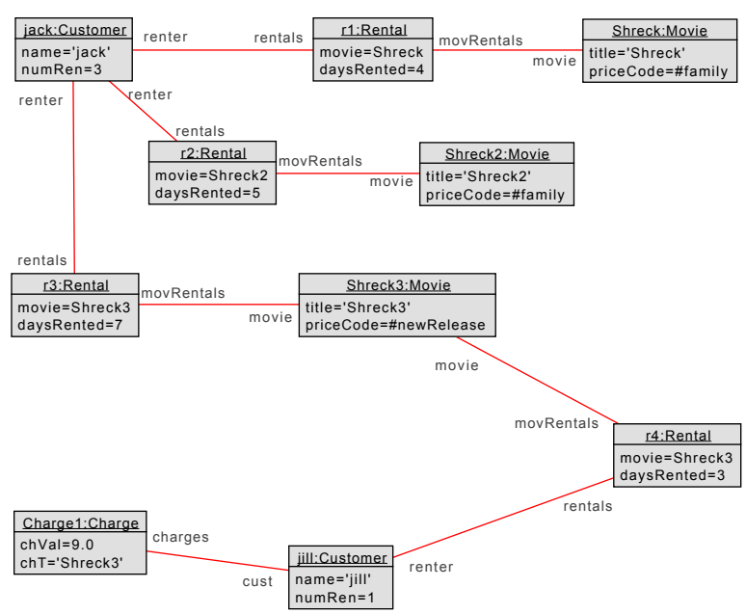

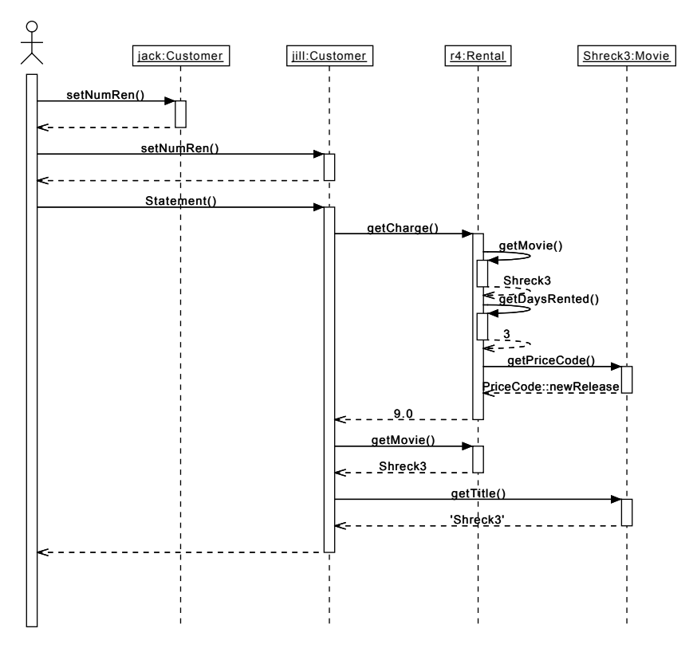

Iterator Pattern: An iterator class is used to look through the elements of of a collection by looking at each element sequentially by looking at an element followed by the element designated by the next pointer in the current element.
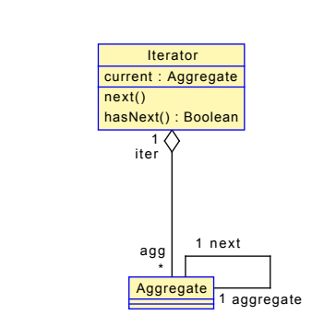

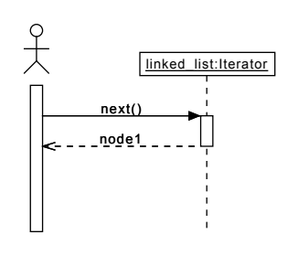

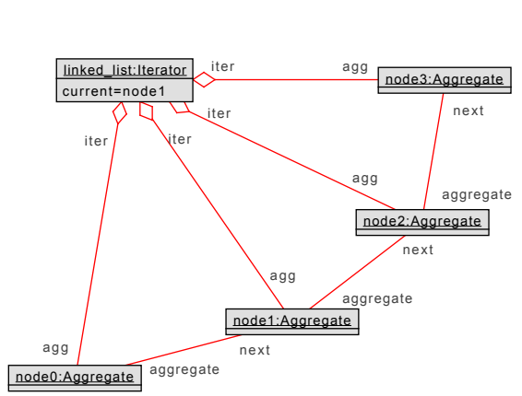
Iterator.use

-- USE model for an Iterator --

model Iterator

-- classes
class Aggregate
attributes
operations
end

class Iterator
attributes
current:Aggregate
operations
next():Aggregate
begin
self.current := self.current.next;
result := self.current;
end

hasNext():Boolean
begin
result := self.current.next->notEmpty;
end
end

-- associations

aggregation creates between
Iterator [1] role iter
Aggregate [0..*] role agg
end

association next between
Aggregate [1]
Aggregate [1] role next
end

-- constraints
constraints
context Iterator::next():Aggregate
pre nextPre: current.next->notEmpty

Iterator.x

-- Object models commands for Iterator

-- create objects
!create linked_list:Iterator
!create node0:Aggregate
!create node1:Aggregate
!create node2:Aggregate
!create node3:Aggregate

-- create associations
!insert (linked_list,node0) into creates
!insert (linked_list,node1) into creates
!insert (linked_list,node2) into creates
!insert (linked_list,node3) into creates
!insert (node0,node1) into next
!insert (node1,node2) into next
!insert (node2,node3) into next

-- assign varibles
!set linked_list.current := node0

-- call next
! linked_list.next()

