
Cavite States University – Cavite City Campus
Department of Information Technology

STUDY BUDDY

Asuncion, Irish Aliyah F.
Janda, Sean Angelo M.
Santulan, Jal Joven P.
Lontoc, Max Alfred S.
Santiago, Rain Justine C.
Buhain, Ash Jecel C.

Submitted To:
Mr. Armin Aragoncillo

Submission Date:
November 18,2025

System Design for Study Buddy
Designing a Study Buddy involves creating a solution for studying, resources sharing and also to connect peers for improving academic performance. Study Buddy is not only to provide resources and to find a tutor for the IT/CS students but also to improve the users experience in a sense of cooperative learning. In this article, we will explore the fundamental aspects of system design for Study Buddy, covering essential features, architecture considerations, and best practices to ensure a scalable and user – friendly solution.


Requirements for Study Buddy Design
- Functional Requirements
  - User Registration: Users must be able to register with their details based on the roles access.
  - Upload/download reviewers: Students/tutor can upload material/review
  - Chatrooms (group or private): They can choice the chatrooms they want. If they choose group they will go to study groups and if private, it will only between student and tutor.
  - Tutor searching and reviewer: Student can choose who will he/she be tutor and can search for reviewer specific reviewer.
  - Study group creation and joining: User can create a chatroom for specific subjects and can join other chatrooms.
- Non – Functional Requirements
  - Mobile/friendly responsive design: Can adapt to different screen size of the devices.
  - Secure data handling: Users data is safe and only the admin will handle access control.
  - Simple UI: Clean, simple and easy to users to use and navigate.
  - Accessible reviewer search: Users can search what reviewer they can based on the category of the subject.

Use Case Diagram for Study Buddy Design
Actors in our System
- Student Tutor: responsible for teaching their fellow student with their chosen specialized subject. They can also add students, accept users, and add reviewers.
- IT/CS Students: those who can add tutors, chat a tutor, and add reviewers.
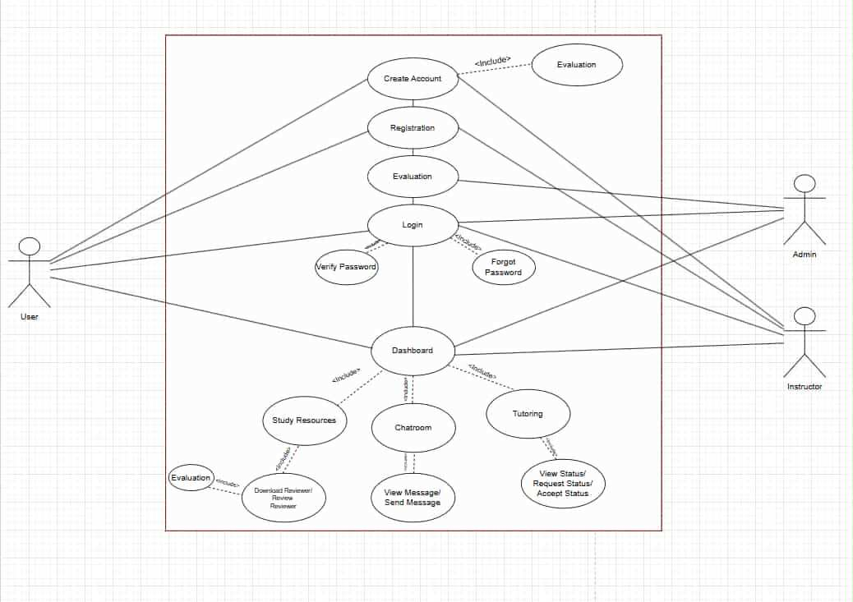
- Admin: responsible for cancelling/accepting uploading resources, monitor the messages, manage the account of every user.

Capacity Estimation for Study Buddy Design
Capacity estimation for Study Buddy involves handling expected IT/CS students and data resources efficiently. The goal is to make our web application run and perform smoothly so that users can upload resources anytime, and can handle adding/accepting users at the very same time.
- Concurrent Users: 50 to 100
- This is based on the assumption that 50 up to 100 users might be using the system simultaneously for uploading resources, adding, and accepting users, etc.
- Data Storage
  - Resources Data Storage
    - Number of Resources: 500 resources
    - Size per Book: 5mb
    - File Type: PDF
    - Total Storage for Resources: 500 resources x 5 MB = 2, 500 MB = 2.5GB
  - Members Data Storage
    - Number of Members: 50 to 100 users
    - Size per Member: 1 MB
    - Total Storage for Members: 100 users x 1 mb = 100 MB = 0.1 GB
  - Total Storage for Study Buddy
    - Resources: 2.5 GB
    - Members: 0.1 GB
    - Total: 2.6 GB

High – Level Design for Study Buddy Design
- User Interface (UI) Layer
  - Web Application: Interface for admin to manage users, resources and chatrooms. Built using VB.NET, HTML, CSS, JavaScript.
  - Mobile Application: Mobile – friendly Interface for accessing Study Buddy. Built using frameworks in Visual Studio.
- Application Layer
  - Handle incoming requests, process them, and send responses back to the UI layer. Implemented using a framework in Visual Studio.
  - Implement the core functionalities such as user management, resources management and chatroom management.
- Data Layer
  - Database Management System (DBMS): Stores all the data related to users, tutors, resources, and chatrooms.
  - Data Access Layer: Manages database interactions. These implements CRUD operations using phpMyAdmin in xampp.

Database Design for Study Buddy Design:
This is our ER diagram, which consists how the users, account, resources, chatroom, tutor, and profile interact.
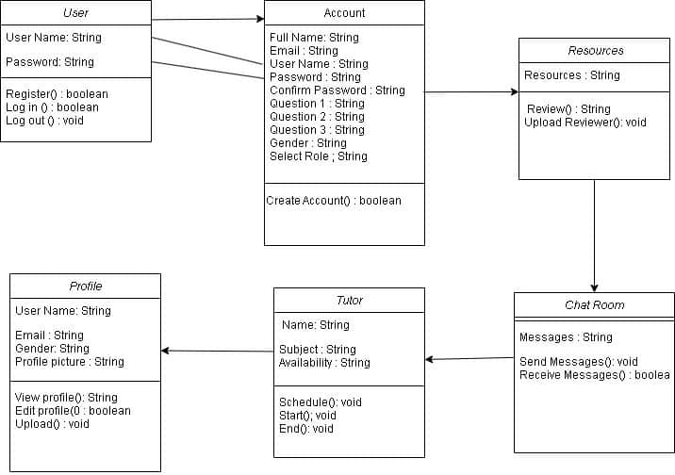

- Table for resources:
CREATE TABLE RESOURCES(
Id INT(11),
FileName VARCHAR(250),
Subject VARCHAR(250),
UploadedBY VARCHAR(250),
FilePath VARCHAR(250),
Upload_date DATETIME,
Is_approved TINYINT(1),
Uploaded_by VARCHAR(100),
category VARCHAR(100),
PRIMARY KEY( id)
);

- Table for friend request
CREATE TABLE FOR FRIENDREQUEST
RequestID INT(250),
FromUserID INT INT(250),
ToUserID INT(250),
Status VARCHAR(250)
);
- Table for User
CREATE TABLE OFR USER
UserID INT(250),
FirstName VARCHAR(250),
LastName VARCHAR(250),
Password TEXT,

Role VARCHAR(250),
Status VARCHAR(250),
PRIMARY KEY(UserID)
);
- Table for Chatrooms
CREATE TABLE FOR CHATROOMS
MessageID INT(250),
SenderID INT(250),
RoomID INT(250),
Content VARCHAR(250),
TimeStamp Date
);

