Chapter 3
RESULTS AND DISCUSSION
Performance Analysis
This part of the study focuses on the results of the survey we conducted for "COBRA: COMPREHENSIVE ONLINE BEGINNER RESOURCE FOR PYTHON APPLICATION." The main goal was to find out if the system actually works well for its intended users, the beginner learners with little to no programming experience. We measured the system’s quality using the ISO 9126 standard to see if it meets the necessary requirements.
Experimental
To evaluate the system, we used a descriptive research method with a survey questionnaire. We distributed these surveys to random learners who tested the system.
We used a 5-Point Likert Scale to quantify their answers. Basically, we asked them how much they agreed with specific statements about the system's quality. To interpret the data, we calculated the Weighted Mean using the standard formula.

The scoring guide we used is:
Scale | Range of Score Value | Verbal Interpretation
5 | 4.51 - 5.00 | Strongly Agree
4 | 3.51 - 4.50 | Agree
3 | 2.51 - 3.50 | Moderately Agree
2 | 1.51 - 2.50 | Slightly Agree
1 | 1.00 - 1.50 | Disagree

Results and Analysis

Here are the results of the survey conducted for the research. The data is derived from the 21 respondents’ ratings during the testing of the system.

Table 1
Computed Weighted Mean of COBRA: Comprehensive Online Beginner Resource for Python Application Based on the ISO 9126 Functionality Metric
Perceived by the Beginner Learners.
N = 21
Sub-Characteristics | SA  (5) | A  (4) | MA  (3) | SLA  (2) | D  (1) | TWP | WM | VA
Suitability  Lessons, videos and games fit the needs of a Python beginner. | 16  (80) | 2  (8) | 3  (9) | 0  (0) | 0  (0) | 21  (97) | 4.62 | SA
Accurateness  No wrong results in quiz, exercise and game checking | 12  (60) | 6  (24) | 2  (6) | 1  (2) | 0  (0) | 21 | 4.38 | A
Security  Progress records stay private to the account owner. | 12  (60) | 5  (20) | 3  (9) | 1  (2) | 0  (0) | 21 | 4.33 | A
Total Average Weighted Mean |  |  |  |  |  |  | 4.44 | A

Legend:

4.51 - 5.00 Strongly Agree
3.51 - 4.50 Agree
2.51 - 3.50 Moderately Agree
1.51 - 2.50 Slightly Agree
1.00 - 1.50 Disagree

TWP Total Weighted Point
WM Weighted Mean
VI Verbal Interpretation

Table 1 presents the assessment of the learners regarding the system's Functionality. The overall weighted mean obtained is 4.44, which is interpreted as "Agree." This indicates that the respondents found the system's features complete and correct for learning Python. The attribute Suitability received the highest mean of 4.62, interpreted as "Strongly Agree," suggesting that the lessons, video tutorials and game-based activities were appropriate for beginners. Accuracy received a mean of 4.38 (Agree), showing that the exams, coding exercises and games were checked correctly, while Security received 4.33 (Agree), indicating that the learners felt their progress records were protected.

Table 2
Computed Weighted Mean of COBRA: Comprehensive Online Beginner Resource for Python Application Based on the ISO 9126 Reliability Metric
Perceived by the Beginner Learners.
N = 21
Sub-Characteristics | SA  (5) | A  (4) | MA  (3) | SLA  (2) | D  (1) | TWP | WM | VA
Fault Tolerance  No crash or freeze on wrong code, fast navigation, or switching between lesson, video and coding task. | 14  (68) | 4  (16) | 2  (5) | 2  (4) | 0  (0) | 21  (92) | 4.38 | A
Recoverability  Quiz or coding progress restored after disconnection or browser crash; consistent evaluation outputs. | 12  (60) | 6  (24) | 2  (6) | 1  (2) | 0  (0) | 21  (92) | 4.38 | A
Total Average Weighted Mean |  |  |  |  |  |  | 4.38 | A

Legend:

4.51 - 5.00 Strongly Agree
3.51 - 4.50 Agree
2.51 - 3.50 Moderately Agree
1.51 - 2.50 Slightly Agree
1.00 - 1.50 Disagree

TWP Total Weighted Point
WM Weighted Mean
VI Verbal Interpretation

Table 2 shows the Reliability assessment with a composite mean of 4.38 (Agree). The attributes Fault Tolerance and Recoverability both received a mean of 4.38 (Agree), which suggests that the system stays stable during normal use and can restore the learners' progress after an interruption. However, the statement on stability when submitting incorrect code or navigating quickly received the lowest rating of 4.19 (Agree), which is still within the positive range but indicates that some users may have encountered minor freezes or delays that are typical in a newly developed system.

Table 3
Computed Weighted Mean of COBRA: Comprehensive Online Beginner Resource for Python Application Based on the ISO 9126 Usability Metric
Perceived by the Beginner Learners.
N = 21
Sub-Characteristics | SA  (5) | A  (4) | MA  (3) | SLA  (2) | D  (1) | TWP | WM | VA
Understandability  Directions, videos, coding steps and error messages are clear. | 13  (65) | 4  (17) | 3  (9) | 1  (2) | 0  (0) | 21  (93) | 4.40 | A
Learnability  Features, navigation and the coding workspace are learned without confusion. | 13  (67) | 4  (17) | 3  (8) | 1  (1) | 0  (0) | 21  (93) | 4.44 | A
Operability  Smooth switching and easy-to-use controls and buttons. | 14  (70) | 4  (16) | 3  (8) | 1  (1) | 0  (0) | 21  (95) | 4.50 | A
Total Average Weighted Mean |  |  |  |  |  |  | 4.45 | A

Legend:

4.51 - 5.00 Strongly Agree
3.51 - 4.50 Agree
2.51 - 3.50 Moderately Agree
1.51 - 2.50 Slightly Agree
1.00 - 1.50 Disagree

TWP Total Weighted Point
WM Weighted Mean
VI Verbal Interpretation

As shown in Table 3, the Usability of the system received a composite mean of 4.45, interpreted as "Agree." Operability received the highest score in this category with a mean of 4.50 (Agree). This implies that the layout is intuitive, allowing learners to easily switch between video tutorials, game activities and the coding workspace without needing complex training. Learnability received a mean of 4.44 (Agree), indicating that the platform's features can be learned easily, while Understandability received 4.40 (Agree), suggesting that the instructions and error messages are clear but can still be improved.

Table 4
Computed Weighted Mean of COBRA: Comprehensive Online Beginner Resource for Python Application Based on the ISO 9126 Efficiency Metric
Perceived by the Beginner Learners.
N = 21
Sub-Characteristics | SA  (5) | A  (4) | MA  (3) | SLA  (2) | D  (1) | TWP | WM | VA
Time Behavior  Videos and games load without long buffering; code and results checked immediately. | 12  (62) | 6  (25) | 2  (5) | 1  (1) | 0  (0) | 21  (93) | 4.44 | A
Resource Utilization  Runs smoothly in standard browsers with video and game content | 14  (70) | 4  (16) | 3  (8) | 1  (1) | 0  (0) | 21  (95) | 4.50 | A
Total Average Weighted Mean |  |  |  |  |  |  | 4.47 | A

Legend:

4.51 - 5.00 Strongly Agree
3.51 - 4.50 Agree
2.51 - 3.50 Moderately Agree
1.51 - 2.50 Slightly Agree
1.00 - 1.50 Disagree

TWP Total Weighted Point
WM Weighted Mean
VI Verbal Interpretation

Finally, The Efficiency of the system, as seen in Table 4, received a composite mean of 4.47 (Agree). Resource Utilization scored 4.50 (Agree) and Time Behavior scored 4.44 (Agree). This suggests that the platform loads lessons, videos and results at an acceptable speed and does not consume excessive memory on the learners' devices, which is important for students using ordinary computers and browsers.

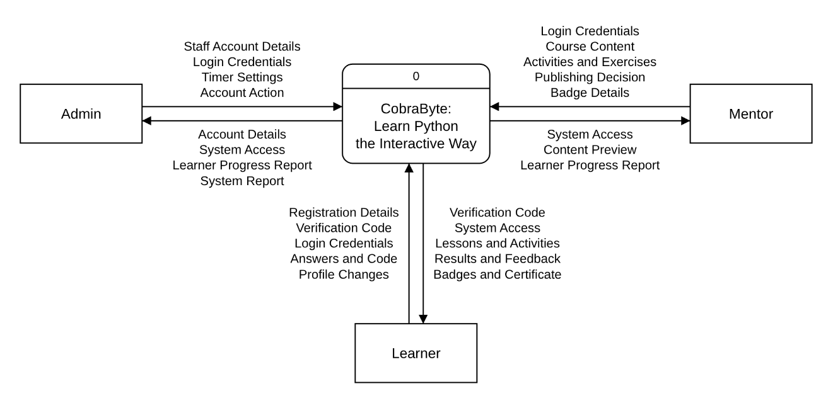
SYSTEM ARCHITECTURE

Figure #
Context Diagram of CobraByte
This Context Diagram shows COBRA as a single process (0) and the data it exchanges with its three external entities: the Admin, the Mentor and the Learner.
The Learner sends "Registration Details", the "Verification Code", "Login Credentials", "Answers and Code" and "Profile Changes" into the system. In return, the system provides the Learner with the "Verification Code", "System Access", "Lessons and Activities", "Results and Feedback", and their "Badges and Certificate".
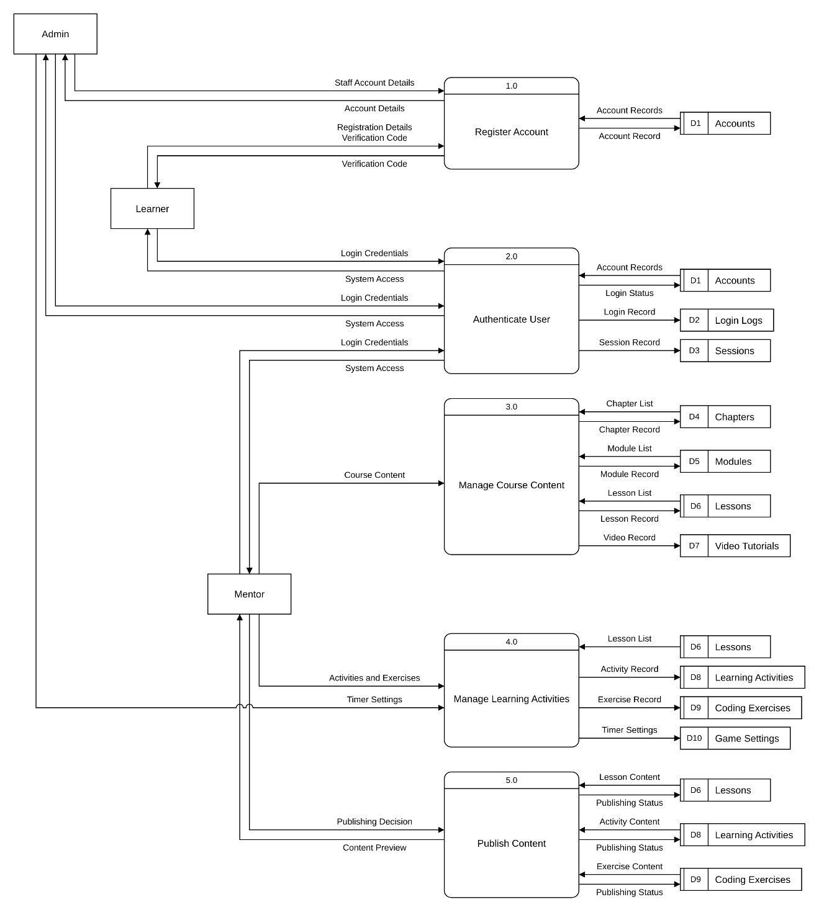
The Mentor sends "Login Credentials", "Course Content", "Activities and Exercises", the "Publishing Decision" and "Badge Details", and receives "System Access", a "Content Preview" and the "Learner Progress Report". The Admin sends "Staff Account Details", "Login Credentials", "Timer Settings" and an "Account Action", and receives the "Account Details", "System Access", the "Learner Progress Report" and the "System Report".

Figure #
Data Flow Diagram Level 0 (Part 1 of 3: 1.0 to 5.0)
This Level 0 Data Flow Diagram breaks CobraByte into its nine major processes. Because the diagram is large, it is shown in three parts; this part covers processes 1.0 to 5.0. A data store used by more than one process is drawn next to each of them and is marked with a second line in its ID strip.
Register Account (1.0) checks the Learner's "Registration Details" against the "Account Records" in Accounts (D1), sends a "Verification Code", and saves the "Account Record". The Admin uses the same process to create staff accounts with the "Staff Account Details" and receives the "Account Details". Authenticate User (2.0) checks the "Login Credentials" of every user against Accounts (D1), saves the "Login Status", a "Login Record" in Login Logs (D2) and a "Session Record" in Sessions (D3), and returns "System Access".
The Mentor builds the course through Manage Course Content (3.0), which saves the chapter, module, lesson and video records in Chapters (D4), Modules (D5), Lessons (D6) and Video Tutorials (D7). Manage Learning Activities (4.0) saves the Mentor's "Activities and Exercises" in Learning Activities (D8) and Coding Exercises (D9), and the Admin's "Timer Settings" in Game Settings (D10). Publish Content (5.0) reads the lesson, activity and exercise content, gives the Mentor a "Content Preview", and saves the "Publishing Status" of each item according to the Mentor's "Publishing Decision".

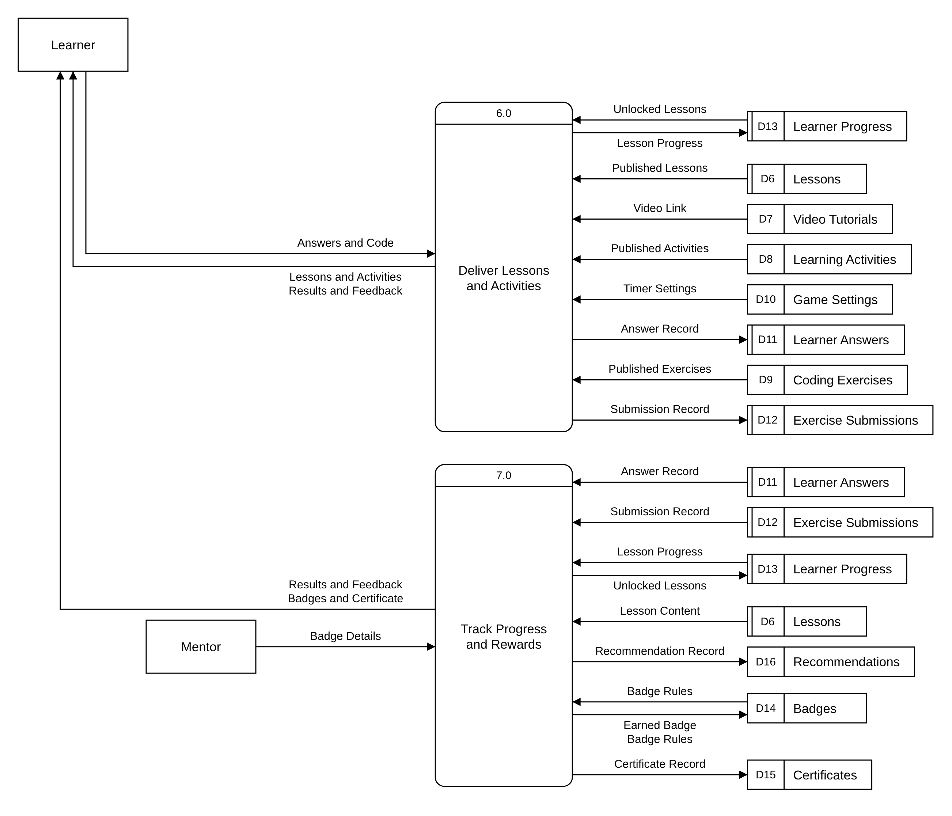
Figure #
Data Flow Diagram Level 0 (Part 2 of 3: 6.0 to 7.0)
This part of the Level 0 Data Flow Diagram covers processes 6.0 and 7.0. Deliver Lessons and Activities (6.0) reads the "Unlocked Lessons" from Learner Progress (D13) and the published lessons, videos, activities and exercises, together with the "Timer Settings" from Game Settings (D10), and gives the Learner the "Lessons and Activities". The Learner's "Answers and Code" are checked and returned as "Results and Feedback", while the "Answer Record", "Submission Record" and "Lesson Progress" are saved in Learner Answers (D11), Exercise Submissions (D12) and Learner Progress (D13).
Track Progress and Rewards (7.0) reads the "Answer Record", "Submission Record" and "Lesson Progress" to save the "Unlocked Lessons", and compares missed items with the "Lesson Content" to save a "Recommendation Record" in Recommendations (D16). It checks the "Badge Rules" in Badges (D14), saves each "Earned Badge" and "Certificate Record" in Certificates (D15), and shows the Learner their "Results and Feedback" and "Badges and Certificate". The Mentor's "Badge Details" are saved as "Badge Rules".
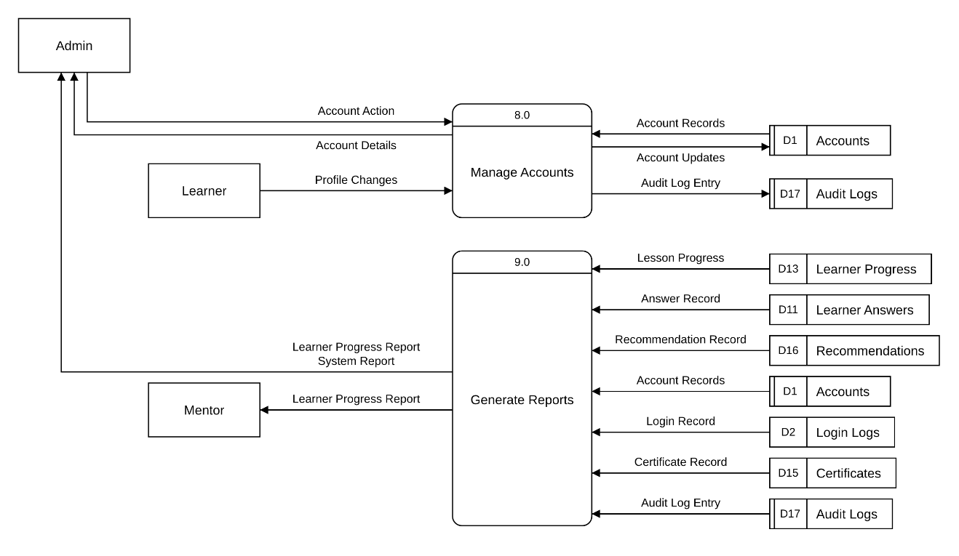

Figure #
Data Flow Diagram Level 0 (Part 3 of 3: 8.0 to 9.0)
This part of the Level 0 Data Flow Diagram covers processes 8.0 and 9.0. Manage Accounts (8.0) applies the Admin's "Account Action" to the "Account Records" in Accounts (D1), returns the "Account Details", saves the "Account Updates", and writes an "Audit Log Entry" in Audit Logs (D17). It also saves the Learner's "Profile Changes".
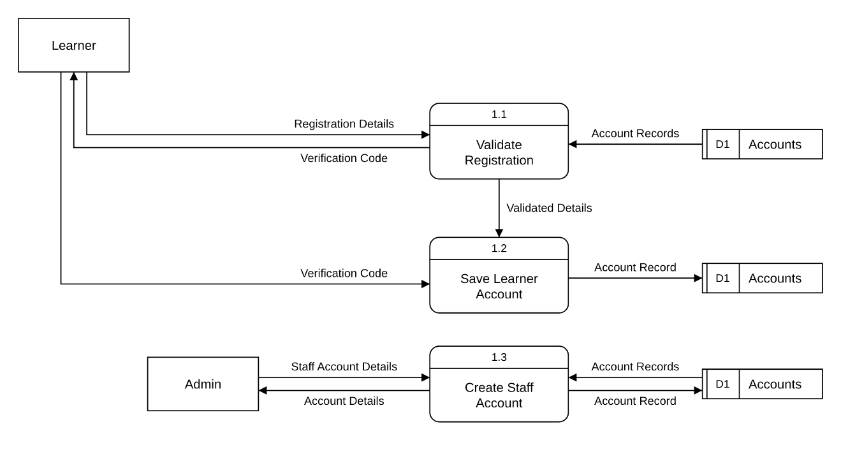
Generate Reports (9.0) reads the "Lesson Progress", "Answer Record" and "Recommendation Record" to produce the "Learner Progress Report" for the Mentor and the Admin. It also reads the "Account Records", "Login Record", "Certificate Record" and "Audit Log Entry" to produce the "System Report" for the Admin.

Figure #
Data Flow Diagram Level 1 - 1.0 Register Account
This Level 1 Data Flow Diagram breaks down Register Account (1.0). The process begins with Validate Registration (1.1), where the Learner submits their "Registration Details". These are checked against the "Account Records" in Accounts (D1) so that no email or username is used twice, and a "Verification Code" is sent to the Learner.
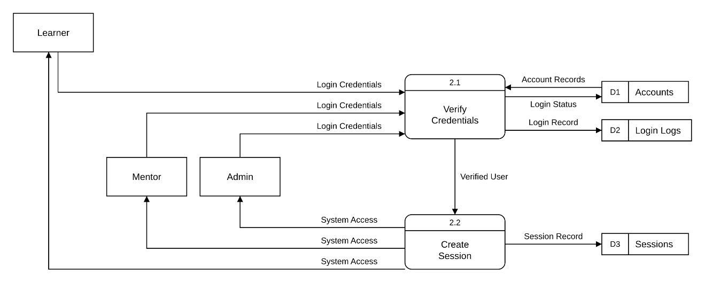
The "Validated Details" pass to Save Learner Account (1.2). Once the Learner enters the "Verification Code", the new "Account Record" is saved in Accounts (D1). Admin and Mentor accounts are created by the Admin through Create Staff Account (1.3), which checks the "Staff Account Details" against the "Account Records", saves the "Account Record", and returns the "Account Details".
Figure #
Data Flow Diagram Level 1 - 2.0 Authenticate User
This Level 1 Data Flow Diagram breaks down Authenticate User (2.0), which works the same way for the Learner, the Mentor and the Admin. In Verify Credentials (2.1), the user's "Login Credentials" are checked against the "Account Records" in Accounts (D1). The process saves the "Login Status", such as failed attempts and lockouts, and records each attempt as a "Login Record" in Login Logs (D2).
When the credentials are correct, the "Verified User" passes to Create Session (2.2), which saves a "Session Record" in Sessions (D3) and grants "System Access" to the user, opening the dashboard for their role.

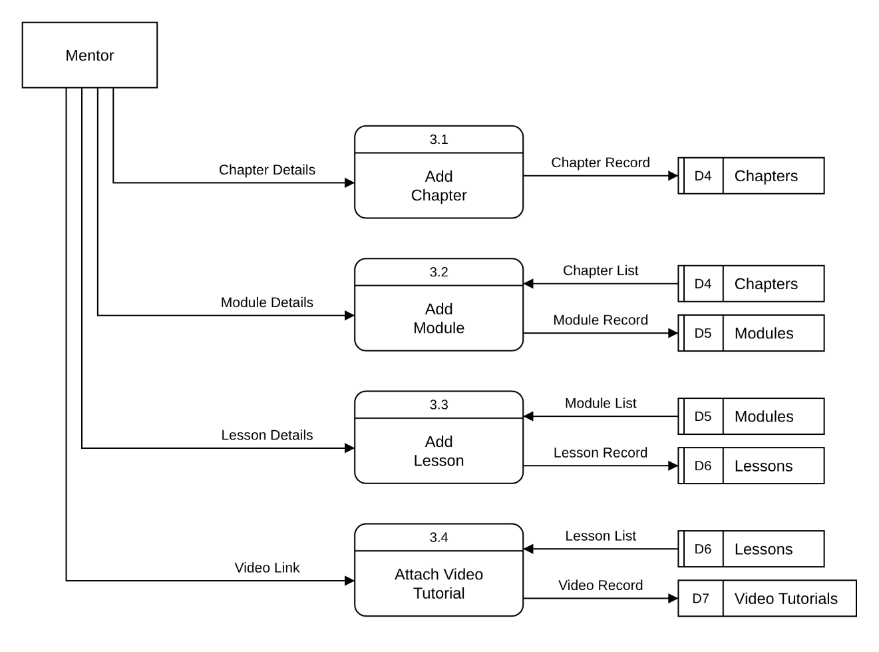
Figure #
Data Flow Diagram Level 1 - 3.0 Manage Course Content
This Level 1 Data Flow Diagram breaks down Manage Course Content (3.0), where the Mentor builds the structure of the course. Add Chapter (3.1) saves the "Chapter Details" as a "Chapter Record" in Chapters (D4). Add Module (3.2) uses the "Chapter List" to place the "Module Details" under a chapter and saves the "Module Record" in Modules (D5).
Add Lesson (3.3) uses the "Module List" to place the "Lesson Details" under a module and saves the "Lesson Record" in Lessons (D6). Finally, Attach Video Tutorial (3.4) links the Mentor's "Video Link" to a lesson from the "Lesson List" and saves the "Video Record" in Video Tutorials (D7).

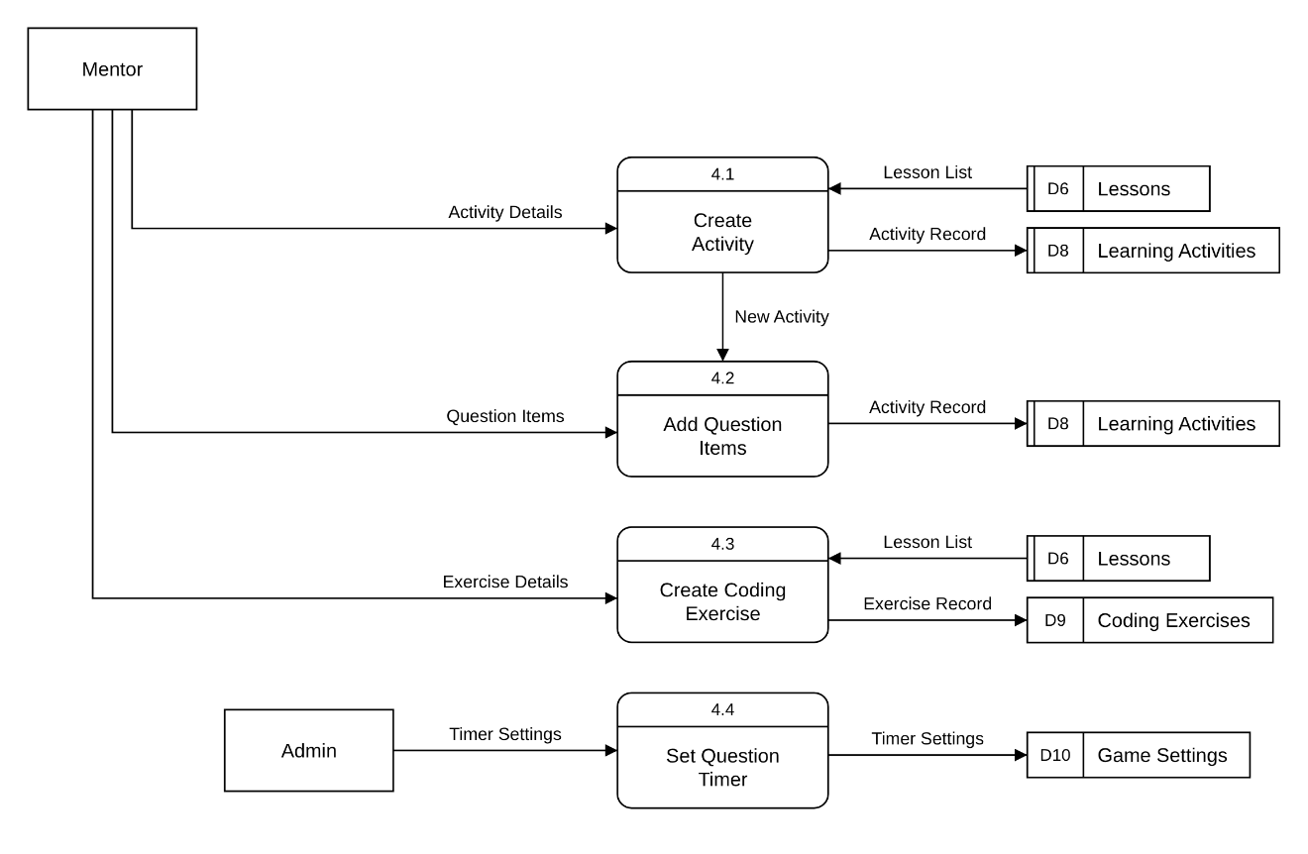
Figure #
Data Flow Diagram Level 1 - 4.0 Manage Learning Activities
This Level 1 Data Flow Diagram breaks down Manage Learning Activities (4.0). In Create Activity (4.1), the Mentor enters the "Activity Details" for a lesson chosen from the "Lesson List" in Lessons (D6), and the "Activity Record" is saved in Learning Activities (D8). The "New Activity" passes to Add Question Items (4.2), where the Mentor adds the "Question Items" for Multiple Choice, Fill in the Blanks or Flashcards, saved with the "Activity Record".
Create Coding Exercise (4.3) saves the Mentor's "Exercise Details" for a lesson as an "Exercise Record" in Coding Exercises (D9). In Set Question Timer (4.4), the Admin enters the "Timer Settings", the time allowed for each question, which are saved in Game Settings (D10).

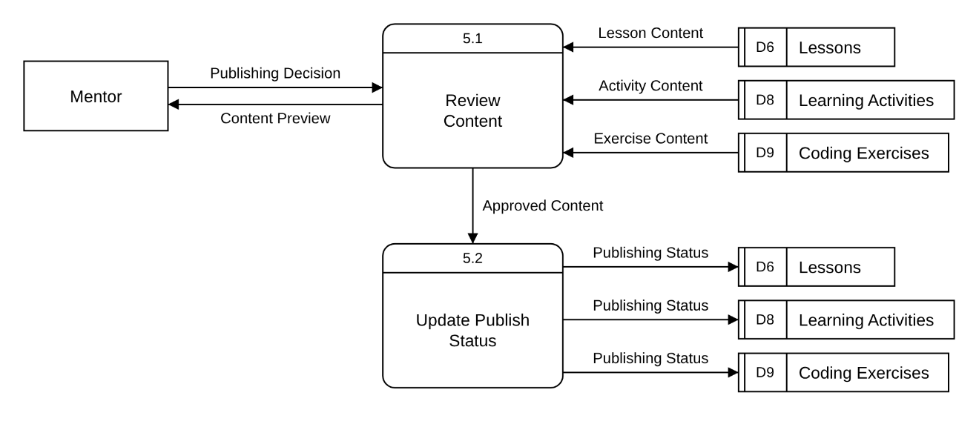
Figure #
Data Flow Diagram Level 1 - 5.0 Publish Content
This Level 1 Data Flow Diagram breaks down Publish Content (5.0). In Review Content (5.1), the system reads the "Lesson Content", "Activity Content" and "Exercise Content" from Lessons (D6), Learning Activities (D8) and Coding Exercises (D9), and shows the Mentor a "Content Preview" of how learners will see it.
Based on the Mentor's "Publishing Decision", the "Approved Content" passes to Update Publish Status (5.2), which saves the "Publishing Status" of each item in its data store. Only published content is shown to learners.
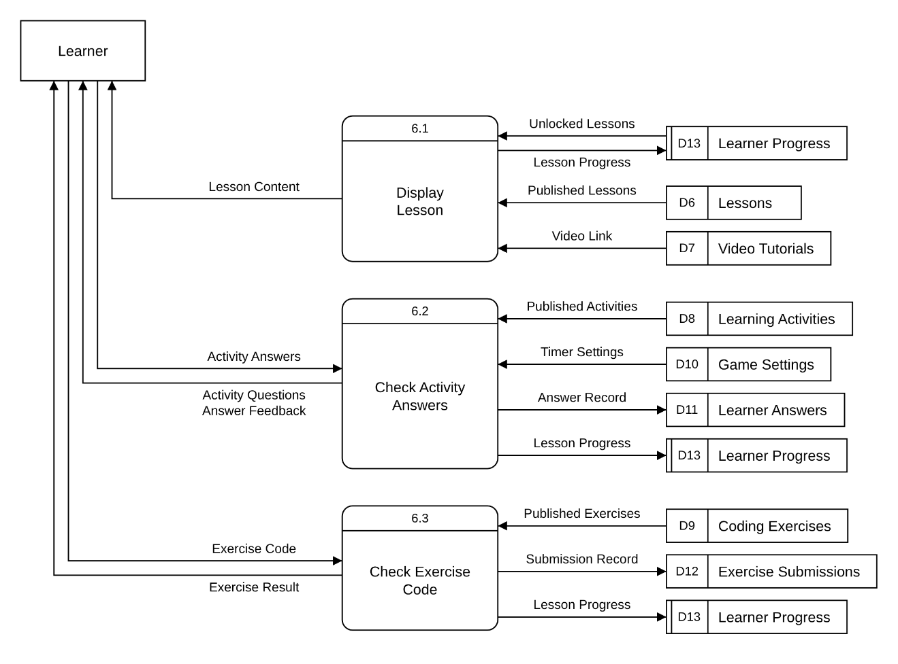
Figure #
Data Flow Diagram Level 1 - 6.0 Deliver Lessons and Activities
This Level 1 Data Flow Diagram breaks down Deliver Lessons and Activities (6.0). Display Lesson (6.1) reads the Learner's "Unlocked Lessons" from Learner Progress (D13), the "Published Lessons" from Lessons (D6) and the "Video Link" from Video Tutorials (D7), shows the Learner the "Lesson Content", and saves the "Lesson Progress".
Check Activity Answers (6.2) reads the "Published Activities" from Learning Activities (D8) and the "Timer Settings" from Game Settings (D10), and shows the Learner the "Activity Questions". The Learner's "Activity Answers" are checked and returned as "Answer Feedback", and the "Answer Record" and "Lesson Progress" are saved in Learner Answers (D11) and Learner Progress (D13).
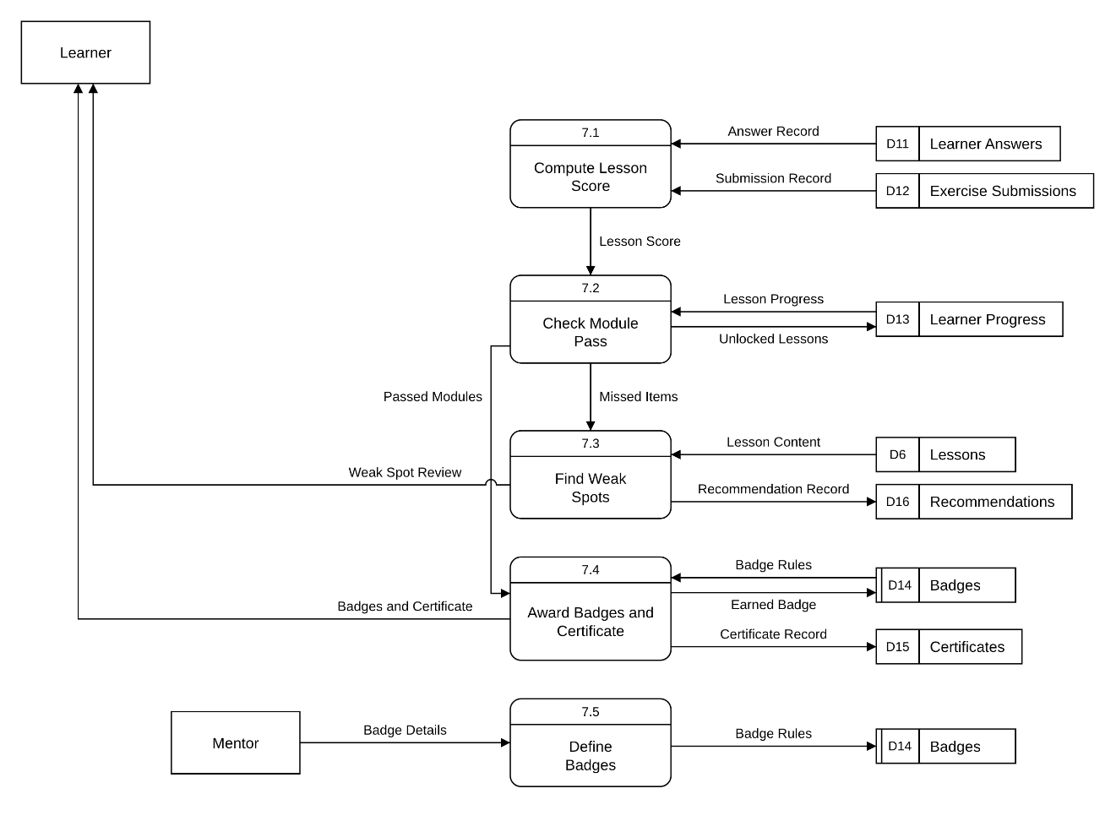
Check Exercise Code (6.3) checks the Learner's "Exercise Code" against the "Published Exercises" in Coding Exercises (D9), returns the "Exercise Result", and saves the "Submission Record" in Exercise Submissions (D12) and the "Lesson Progress".
Figure #
Data Flow Diagram Level 1 - 7.0 Track Progress and Rewards
This Level 1 Data Flow Diagram breaks down Track Progress and Rewards (7.0). Compute Lesson Score (7.1) reads the "Answer Record" from Learner Answers (D11) and the "Submission Record" from Exercise Submissions (D12), and passes the "Lesson Score" to Check Module Pass (7.2). Using the "Lesson Progress" from Learner Progress (D13), a module passes when all its lessons are completed with an average of at least 80%, and the next "Unlocked Lessons" are saved.
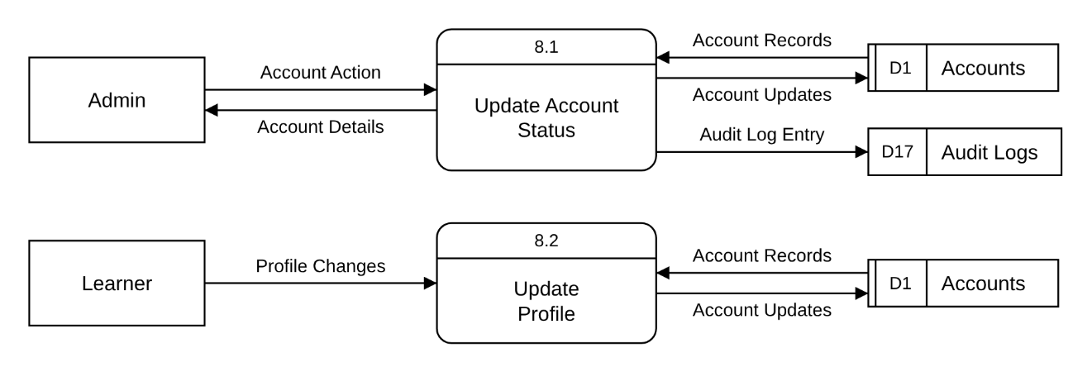
The "Missed Items" pass to Find Weak Spots (7.3), which matches them with the "Lesson Content" in Lessons (D6), saves a "Recommendation Record" in Recommendations (D16), and gives the Learner a "Weak Spot Review". The "Passed Modules" pass to Award Badges and Certificate (7.4), which compares them with the "Badge Rules" in Badges (D14), saves each "Earned Badge" and the "Certificate Record" in Certificates (D15), and shows the Learner their "Badges and Certificate". The Mentor creates badges through Define Badges (7.5), which saves the "Badge Details" as "Badge Rules".
Figure #
Data Flow Diagram Level 1 - 8.0 Manage Accounts
This Level 1 Data Flow Diagram breaks down Manage Accounts (8.0). In Update Account Status (8.1), the Admin sends an "Account Action", such as archiving, restoring or unlocking an account. The process reads the "Account Records" from Accounts (D1), returns the "Account Details", saves the "Account Updates", and writes an "Audit Log Entry" in Audit Logs (D17).
In Update Profile (8.2), the Learner's "Profile Changes" are checked against the "Account Records" and saved as "Account Updates" in Accounts (D1).
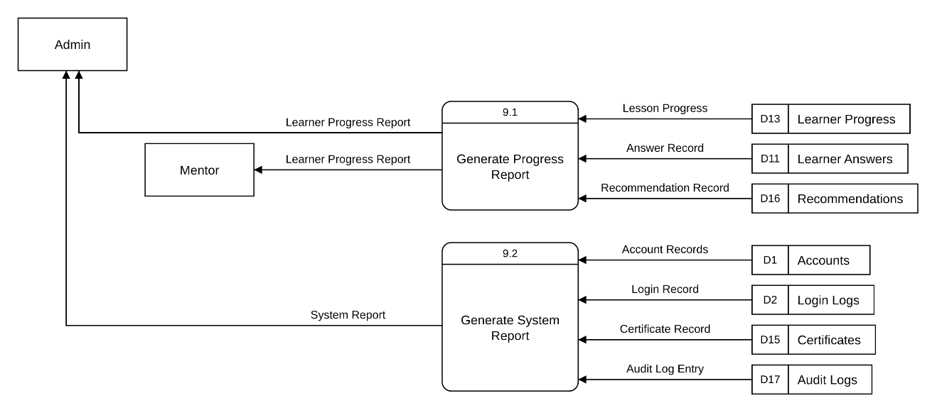
Figure #
Data Flow Diagram Level 1 - 9.0 Generate Reports
This Level 1 Data Flow Diagram breaks down Generate Reports (9.0). Generate Progress Report (9.1) reads the "Lesson Progress" from Learner Progress (D13), the "Answer Record" from Learner Answers (D11) and the "Recommendation Record" from Recommendations (D16), and produces the "Learner Progress Report" for the Mentor and the Admin.
Generate System Report (9.2) reads the "Account Records" from Accounts (D1), the "Login Record" from Login Logs (D2), the "Certificate Record" from Certificates (D15) and the "Audit Log Entry" from Audit Logs (D17), and produces the "System Report" for the Admin.

Database Design

CHAPTER 4
SUMMARY OF FINDINGS, CONCLUSIONS, AND RECOMMENDATIONS
The primary objective of this study was to develop and evaluate COBRA: Comprehensive Online Beginner Resource for Python Application. The system’s performance was evaluated by Beginner Learners using the ISO 9126 software
quality standards.
Summary of Findings
Table #
Overall Computed Weighted Mean of COBRA: Comprehensive Online Beginner Resource for Python Application Based on the ISO 9126
Perceived by Beginner Learners
ISO 9126 | Average | Verbal Interpretation
Functionality | 4.44 | Agree
Usability | 4.38 | Agree
Reliability | 4.45 | Agree
Efficiency | 4.47 | Agree
Total Rating | 4.44 | Agree
N = 21

Conclusions

Recommendations

