About the company
About the company:
- Founded in 2013
- Fashionable health trackers designed and engineered for women
- Collecting data on activity, sleep, stress, and reproductive health
- Empowering women with knowledge about their own health and habits.

Products
About the products:
- Bellabeat app:
- Provides users with health data related to their activity, sleep, stress, menstrual cycle, and mindfulness habits.
- Help users better understand their current habits and make healthy decisions.
- The app connects to their line of smart wellness products

- Leaf:
- Bellabeat’s classic wellness tracker can be worn as a bracelet, necklace or clip.
- The Leaf tracker connects to the Bellabeat app to track activity, sleep and stress

- Time:
- This wellness watch combines the timeless look of a classic timepiece with smart technology to track user activity, sleep and stress.
- The Time watch connects to the Bellabeat app to provide you with insights into your daily wellness

- Spring:
- Water bottle that track daily water intake using smart technology to ensure that you are appropriately hydrated throughout the day.
- The Spring water bottle connects to the Bellabeat app to track your hydration level

- Bellabeat membership:
- Subscription-based membership program for users.
- Gives users 24/7 access to fully personalized guidance on nutrition, activity, sleep, health and beauty and mindfulness based on their lifestyle and goals.

Objectives
Scenario:
Sršen knows that an analysis of Bellabeat’s available consumer data would reveal more opportunities for growth. She has asked the marketing analytics team to focus on a Bellabeat product and analyze smart device usage data in order to gain insight into how people are already using their smart devices. Then, using this information, she would like high-level recommendations for how these trends can inform Bellabeat marketing strategy.

You have been asked to focus on one of Bellabeat’s products and analyze smart device data to gain insight into how consumers are using their smart devices. The insights you discover will then help guide marketing strategy for the company. You will present your analysis to the Bellabeat executive team along with you high-level recommendations for Bellabeat’s marketing strategy

Products:
- Bellabeat app
- Leaf
- Time
- Spring
- Bellabeat membership

Platforms of advertising:
- Traditional media: radio, out-of-home billboards, television
- Google Search, Facebook and Instagram pages, and consistently engages consumers on Twitter.
- Runs video ads on Youtube and displays ads on the Google Display Network to support campaigns around the key marketing dates

Case Study Roadmap
Case Study Roadmap:
The co-founder and Chief Creative Officer asks to analyze smart device usage data in order to gain insight into how consumers use non-Bellabeat smart devices. She wants you to select one Bellabeat product to apply these insights to in your presentation.

Guiding Questions:
- What are some trends in smart device usage?
- How could these trends apply to Bellabeat customers?
- How could these trends help influence Bellabeat marketing strategy?

Report with the following deliverables:
- A clear summary of business task
- A description of all data sources used
- Documentation of any cleaning or manipulation of data
- A summary of your analysis
- Supporting visualizations and key findings
- Your top high-level content recommendations based on your analysis

Timeline: One week
- Ask: 1 day
- Prepare: 1 day
- Process: 1.5 days
- Analyze : 1.5 days
- Share: 1 day
- Act: 1 day

Products:
- Bellabeat app:
- Provides users with health data related to their activity, sleep, stress, menstrual cycle, and mindfulness habits.
- Help users better understand their current habits and make healthy decisions.
- The app connects to their line of smart wellness products

ASK
ASK
The co-founder and Chief Creative Officer asks to analyze smart device usage data in order to gain insight into how consumers use non-Bellabeat smart devices. She then wants you to select one Bellabeat product to apply these insights to in your presentation.

Deliverable: A clear statement of the business task

Business Task Statement:
The objective is to analyze smart device usage data to derive insights into consumer behavior with other smart devices (e.g., fitness trackers, smart home devices, wearables, etc.). These insights will help identify trends, preferences, and usage patterns that can inform strategic decisions regarding marketing strategies for our smartwatch app.
The findings will be presented to stakeholders with actionable recommendations for optimizing our app to better align with consumer expectations and improve overall engagement.

Stakeholders:
- Urška Sršen: Bellabeat’s cofounder and Chief Creative Officer
- Background in Artistry
- Sando Mur: Mathematician and Bellabeat’s cofounder; key member of the Bellabeat executive team
- Executive Team

PRODUCT : Time
- This wellness watch combines the timeless look of a classic timepiece with smart technology to track user activity, sleep and stress.
- The Time watch connects to the Bellabeat app to provide you with insights into your daily wellness

Guiding Questions:
- What is the problem you are trying to solve?
- Discover trends/patterns in non-Bellabeat smart devices usage.
- Apply these findings into promoting Bellabeat’s APP

- What are some trends in smart device usage?
- Fitness trends (workout routine), a workout exercise?
- An eating method?
- PCOS tracking
- A sleeping schedule method?
- Cleansing/detoxing trend?
- Strava App trend on tiktok?
- Marathon, 10K steps, etc.

- How could these trends apply to Bellabeat customers (women focusing on improving/maintaining their health)? How would they interest Bellabeat consumers/customers? Relatable?
- Trends that could focus on empowering women’ health
- Trends that help improving women’s lifestyle/ life quality

- How could these trends help influence Bellabeat marketing strategy?
- Implementation of new features?

PREPARE
Dataset: FitBit Fitness Tracker Data
Source: Public - Kaggle
Link: https://www.kaggle.com/datasets/arashnic/fitbit
Meta Data:
- Date: 04/12/2016 - 05/12/2016
- From: Consented thirty eligible Fitbit users
- Contains: minute-level output for physical activity, heart rate, sleep monitoring and steps

This dataset was generated by respondents to a distributed survey via Amazon Mechanical Turk between 04/12/2016 - 05/12/2016. The dataset was made available through Möbius and licensed under CC0: Public Domain.

Guiding Questions:
- Where is your data stored?
- Google Cloud BigQuery and Google Sheets

- How is the data organized? Is it in long or wide format?
- The data is organized in a long format with each ID is stored in multiple rows

- Are there issues with bias or credibility in this data? Does your data ROCCC?
- After removing any duplicates, there are 33 users instead of 30 users like stated in the meta data.
- This data was collected in 2016 which is not reliable by the time this analysis is done.
- The data might pose some bias since it is a small sample size that does not represent the whole entire picture/population.
- There is an absence of demographic information such as gender, age, location which makes it harder to determine if this dataset is a true representation of the population. Recommendations after analysis might be impacted and not the most useful/optimized since Bellabeat target customers are women.
- How are you addressing licensing, privacy, security and accessibility?
- License: CC0: Public Domain
- Acknowledgment:
Furberg, Robert; Brinton, Julia; Keating, Michael ; Ortiz, Alexa
https://zenodo.org/records/53894#.YMoUpnVKiP9

PROCESS
I will be using the following 9 datasets for my analysis:
- dailyActivity_merged
- dailyCalories_merged
- dailyIntensities_merged
- dailySteps_merged
- hourlyCalories_merged
- hourlyIntensities_merged
- hourlySteps_merged
- sleepDay_merged
- weightLogInfo_merged
Importing data:
# Importing data
activity <- read.csv("raw_csv_data_format/dailyActivity_merged.csv")
View(activity)

calories <- read.csv("raw_csv_data_format/hourlyCalories_merged.csv")
View(calories)

intensities <- read.csv("raw_csv_data_format/hourlyIntensities_merged.csv")
View(intensities)

steps <- read.csv("raw_csv_data_format/hourlySteps_merged.csv")
View(steps)

sleepDay <- read.csv("raw_csv_data_format/sleepDay_merged.csv")
View(sleepDay)

weightLog <- read.csv("raw_csv_data_format/weightLogInfo_merged.csv")
View(weightLog)
Cleaning Process Excel:
- Google Sheets
- Removing duplicates and trimming whitespace
- Filter out any null values
- File hourlyCalories_merged:
Split the column ActivityHour into two columns: ActivityDate and ActitivyHour
- ActivityDate contains date format: m/dd/yyyy
- ActivityHour contains 24H format: hh:mm:ss

- File hourlyIntensities_merged:
Split the column ActivityHour into two columns: ActivityDate and ActitivyHour
Using split(substitute())
- ActivityDate contains date format: m/dd/yyyy
- ActivityHour contains 24H format: hh:mm:ss

- File hourlySteps_merged:
Split the column ActivityHour into two columns: ActivityDate and ActitivyHour
Using split(substitute())
- ActivityDate contains date format: m/dd/yyyy
- ActivityHour contains 24H format: hh:mm:ss

- File sleepDay_merged:
3 duplicate rows found and removed
Split the column ActivityHour into two columns: ActivityDate and ActitivyHour
Using split(substitute())
- ActivityDate contains date format: m/dd/yyyy
- ActivityHour contains 24H format: hh:mm:ss

- File weightLogInfo_merged:
Split the column ActivityHour into two columns: ActivityDate and ActitivyHour
Using split(substitute())
- ActivityDate contains date format: m/dd/yyyy
- ActivityHour contains 24H format: hh:mm:ss

- RStudio
Merge files that share the same information
Double checking formatting before starting the analysis process

Cleaning process with only RStudio:

- Upload the raw csv data into RStudio
I noticed that the dailyActivity_merged file also contains data that is in dailyCalories_merged, dailyIntensities_merged, and dailySteps_merged. Therefore these 3 files will be dropped from the analysis process.

Remaining Datasets:
- activity <- dailyActivity_merged
- calories <- hourlyCalories_merged
- intensities <- hourlyIntensities_merged
- steps <- hourlySteps_merged
- sleepDay <- sleepDay_merged
- weightLogInfo <- weightLogInfo_merged

- Remove Duplicates
# Remove Duplicated using duplicated()
activity <- activity[!duplicated(activity), ]
calories <- calories[!duplicated(calories), ]
intensities <- intensities[!duplicated(intensities), ]
steps <- steps[!duplicated(steps), ]
weightLog <- weightLog[!duplicated(weightLog), ]
sleepDay <- sleepDay[!duplicated(sleepDay), ]
-> File sleepDay_merged contains 3 duplicate rows -> Removed

- Check for unique ID
n_distinct(activity$Id)
n_distinct(calories$Id)
n_distinct(intensities$Id)
n_distinct(steps$Id)
n_distinct(sleepDay$Id)
n_distinct(weightLog$Id)
The dataset contains 33 users instead of 30 users like stated in the description.
sleepDay_merged has 24 users and weightLogInfo_merged only has 8 reported users.

Data from weightLogInfo_merged will be dropped from investigation since 8 participations are not sufficient for an accurate analysis. Further study will not have a significant impact and might also create bias among data.

After dropping weightLogInfo, remaining datasets are:
- daily
- calories
- intensities
- steps
- sleepDay

- Formatting
- Fix datetime formatting of sleepDay_merged - DONE
- Merge sleepDay_merged into dailyActivity_merged - DONE

- Splitting ActivityHour in hourlyCalories, hourlyInt, hourlySteps into 2 columns:
- date: m/dd/yyyy
- hour: 24h format

After merging sleepDay_merged into dailyActivity_merged, remaining datasets are:
- daily
- calories
- intensities
- steps

ANALYZE
DATASETS:
- daily
- calories
- intensities
- steps

Observations:
- Both average steps and average intensities have pretty much the same distributions throughout the hours
- Most steps recorded are during 8AM to 3PM and 5PM to 7PM timeframe
- Most intensities hours are from 8AM to 3PM and 5PM to 7PM time frame
- Calories burned above 80 cal/hour are spread from 5AM to 10PM
- The highest are above 120 cal/hour during 5PM to 7PM
- Positive correlation between steps taken and calories burned
- Positive correlation between total time in bed and total minutes asleep

- Negative correlation between total minutes asleep and sedentary minutes
# sedentary minutes vs minutes as sleep -> Negative correlation
ggplot(data=daily, mapping = aes(x=TotalMinutesAsleep, y=SedentaryMinutes)) + geom_point() + geom_smooth()
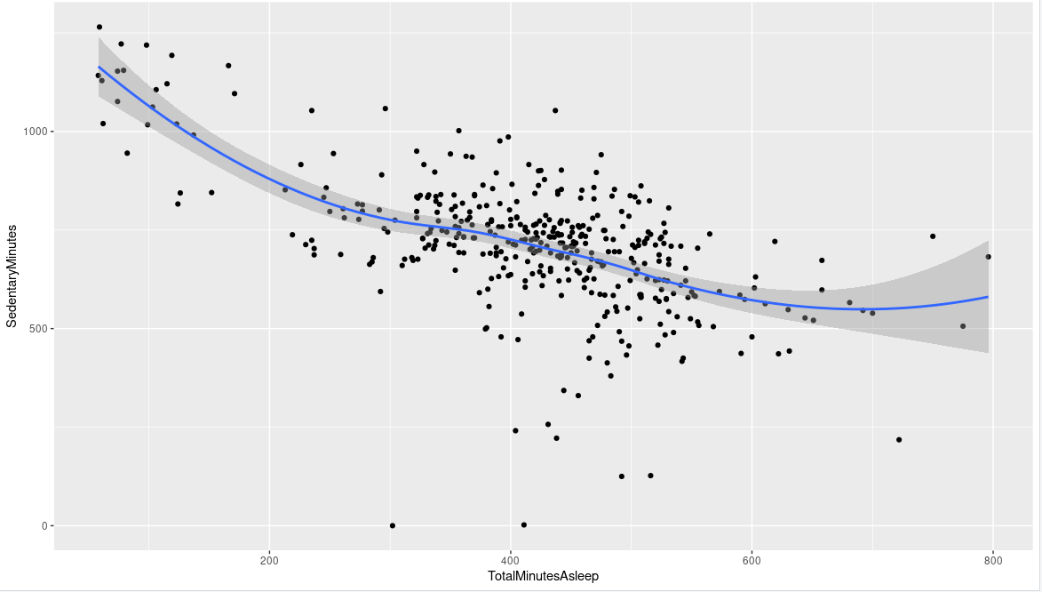
People who are less active through the day (high sedentary minutes) have harder time during sleep (bad quality sleep, around 3-4 hours of sleep per night)
People who are more active tend to have better quality sleep (8 hours of sleep)
-> Less daily activity leads to hard time asleep at night
-> Office jobs impact sleep quality
-> People who are not active a lot during daytime tends to not get enough sleep (maybe in a desk job where you need to be focus for a long period of time with minimum movements)
-> Add new features that remind users to take a break (once users that a break/doing some light activities -> keeping the streak/growing a pet/feeding the pet)
-> Can give some recommendation on how to have a better sleep (i.e reduce sedentary minutes)
-> Can recommend some light 5-10 minutes exercise to help getting better sleep

activity %>% select(TotalSteps,
TotalDistance,
SedentaryMinutes,
VeryActiveMinutes,
FairlyActiveMinutes,
LightActiveDistance) %>% summary()
TotalSteps TotalDistance SedentaryMinutes VeryActiveM FairlyActiveM LightlyActiveM
Min. : 0 Min. : 0.000 Min. : 0.0 Min. : 0.00 Min. : 0.00 Min. : 0.0
Mean : 7638 Mean : 5.490 Mean : 991.2 Mean : 21.16 Mean : 13.56 Mean :192.8
Max. :36019 Max. :28.030 Max. :1440.0 Max. :210.00 Max. :143.00 Max. :518.0

TotalSteps TotalDistance SedentaryM VeryActiveM FairlyActiveM LightlyActiveM
Min. : 0 Min. : 0.000 Min. : 0.0 Min. : 0.00 Min. : 0.00 Min. : 0.0
Median : 7406 Median : 5.245 Median :1057.5 Median : 4.00 Median : 6.00 Median :199.0
Mean : 7638 Mean : 5.490 Mean : 991.2 Mean : 21.16 Mean : 13.56 Mean :192.8
Max. :36019 Max. :28.030 Max. :1440.0 Max. :210.00 Max. :143.00 Max. :518.0

Average steps per day is a bit below recommended for having lower risk of dying of any cause.
“Compared with people who took 4,000 steps a day, those who took 8,000 steps a day at the start of the study had a 50% lower risk of dying from any cause during follow-up. People who took 12,000 steps a day had a 65% lower risk of dying than those who took only 4,000.”
National Institutes of Health
Average sedentary minutes is pretty high, approx 16 hours a day. Considering users have an 8 hour sleep, that means they are barely moving the whole day
Based on the ActivityMinutes, we can see that majority participants are in LightlyActive group, they might mostly working in office at a desk job
# sleep summary -> Averagely around 7hrs of sleep per night
sleepDay %>% select(TotalSleepRecords, TotalMinutesAsleep, TotalTimeInBed) %>% summary()

TotalSleepRecords TotalMinutesAsleep TotalTimeInBed
Min. :1.00 Min. : 58.0 Min. : 61.0
Median :1.00 Median :432.5 Median :463.0
Mean :1.12 Mean :419.2 Mean :458.5
Max. :3.00 Max. :796.0 Max. :961.0

PLOTTING
# What's the relationship between steps taken in a day and sedentary minutes? Positive correlation
# How could this help inform the customer segments that we can market to?
Our participants are majority working at a desk job with little movements required
-> Corporate/office jobs
# E.g. position this more as a way to get started in walking more?
# Or to measure steps that you're already taking?
ggplot(data=activity, aes(x=TotalSteps, y=SedentaryMinutes)) + geom_point() + geom_smooth()
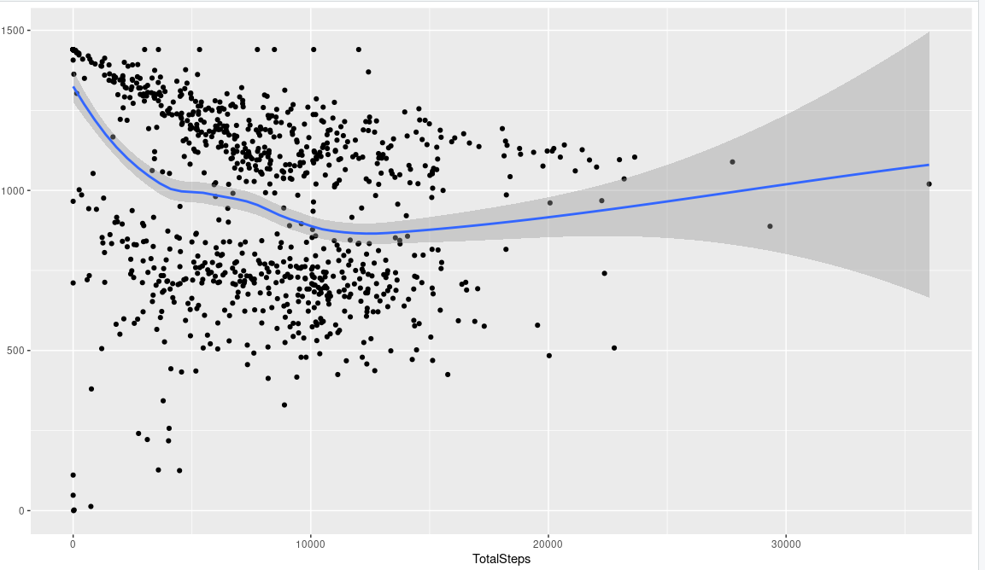
# What's the relationship between minutes asleep and time in bed? Positive correlation
# You might expect it to be almost completely linear - are there any unexpected trends?
Majority participants have 6 to 9 (360-640 minutes) hours of sleep per night
ggplot(data=daily, aes(x=TotalMinutesAsleep, y=TotalTimeInBed)) + geom_point() + geom_smooth()
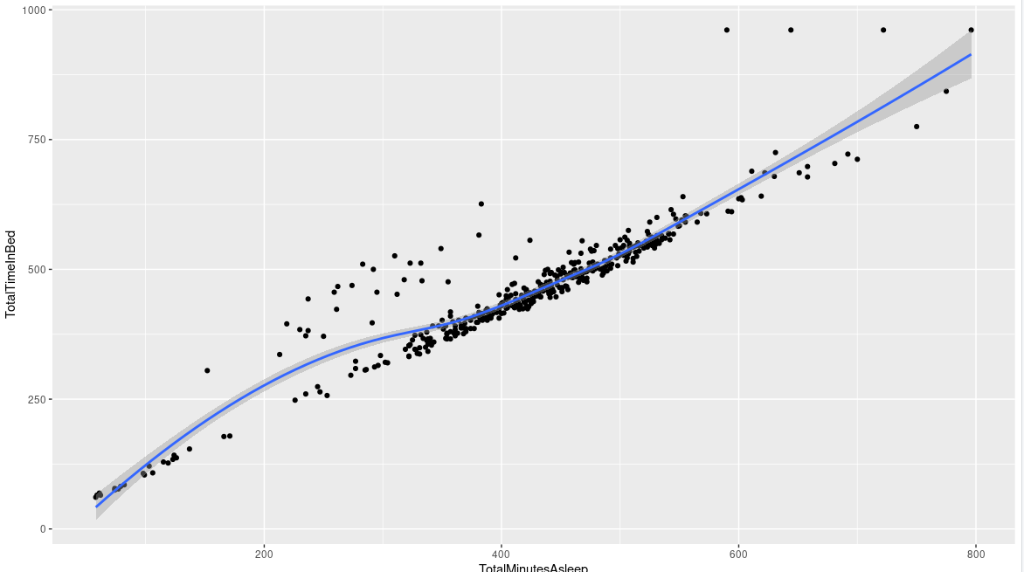
# Do participants who sleep more also take more steps or fewer steps per day? Negative correlation
ggplot(data=daily, aes(x=TotalMinutesAsleep, y=TotalSteps)) + geom_point() + geom_smooth()
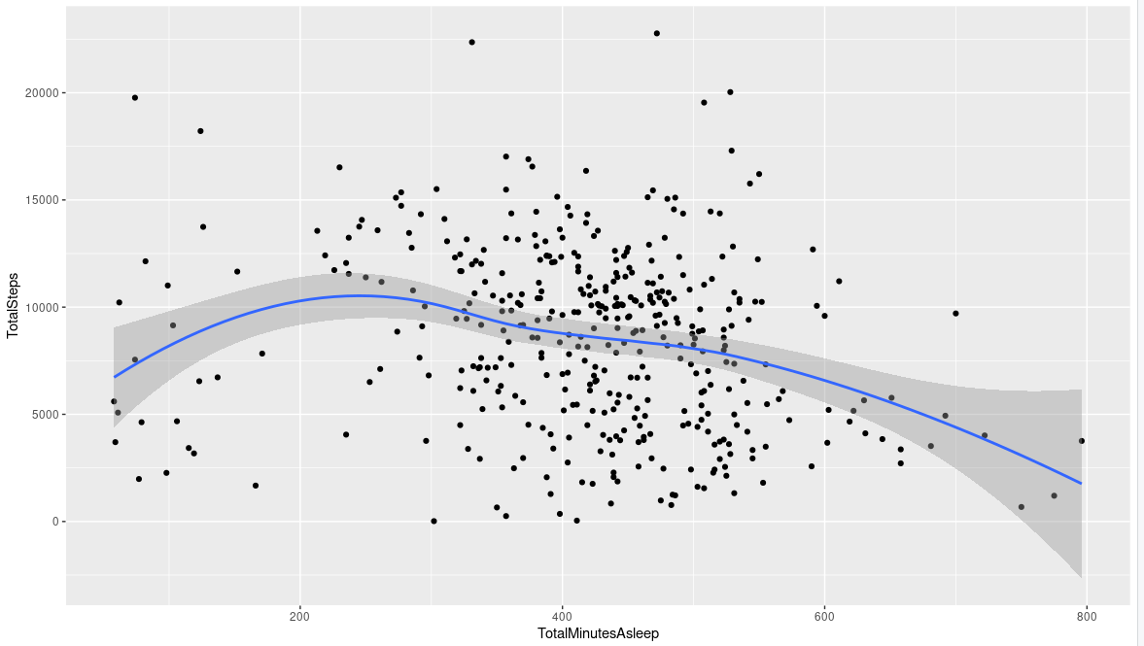
# Do people who burn more calories tend to get more sleep?
ggplot(data=daily, aes(x=TotalMinutesAsleep, y=Calories)) + geom_point() + geom_smooth()
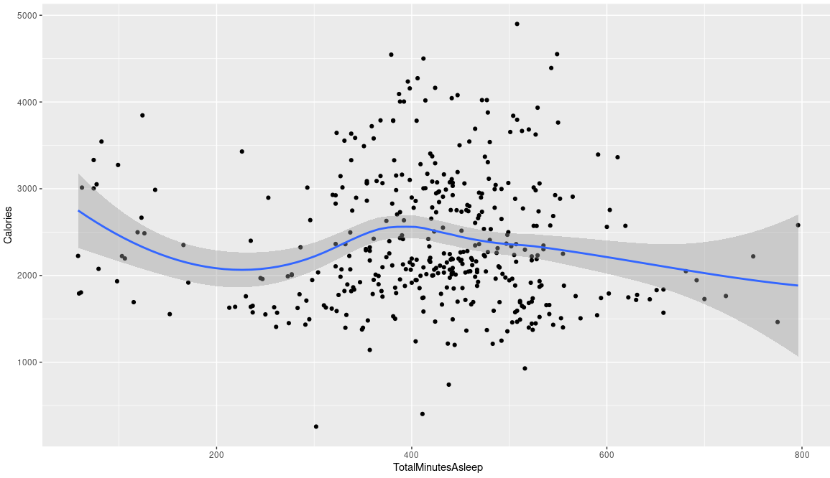

Trends:
- Users activities are most prominently around 5PM to 7PM (after work)
- Steps and intensities hours are high during first half of a regular 9-5 work day (users are mostly working in office/desk job)

Do people who burn more calories tend to get more sleep? Not really, it’s a straight line

RECOMMENDATION
RECOMMENDATION: for marketing strategy team

- Promote more on Tiktok
- Advertising more on Tiktok where most trends usually occur.
- Add Tiktok Shop for every video that showcases the products
- Runs ads on Tiktok
- Engage with influencers (gym, athlete, women health expert)

*** This is products enhancement -> might not be related to the business task ****
** Can promote by posting videos on social platforms about using these recipes**

- Includes healthy recipes
- Meal Prep Recipes
- Detox, debloated drinks ( smoothies, Juices)
- Ginger shots etc.

- Customized exercises based on users activity, sleep, stress, menstrual cycle, and mindfulness habits.

Market to corporate office customer segment

Packages
Install Packages:

install.packages(“tidyverse”) # for import, clean and plot
install.packages(“janitor”) # clean

Presentations

Key Points
Key Points:
- Business Task: Identifying trends in smart device usage and make high level recommendation for the marketing strategy team
- Dataset: https://www.kaggle.com/datasets/arashnic/fitbit
- Recommended by the CCO
- Shared by Möbius on Kaggle and licensed under CC0: Public Domain.
- Meta data: Eligible 30 Fitbit users consented to share their data in the Amazon Mechanical Turk survey.
- Period: 04/12/2016 - 05/12/2016
- Contains: minute-level output for physical activity, heart rate, sleep monitoring, steps, and heart rate
- ROCCC: Reliable, Original, Comprehensive, Current and Cited
- Not reliable: dataset is biased since demographic information (gender, age, occupation, region, etc.) unknown. Impossible to determine if this dataset is a true presentation of a whole. Analysis finds that there are 33 users instead of 30 users like stated in the meta data. Number of users among all the tables are not the same.
- Not original: dataset is shared on Kaggle but sourced from Zenodo; a general-purpose research repository where any research output can be shared by its users, i.e a third party (obtained info from users)
- Not comprehensive: the dataset does not have significant value for this analysis because of the absence in demographic information. Bellabeat is a women wellness company whose sole target is women.
- Not current: The data was collected 9 years ago (pre-covid) period hence it does not relevant to these days. The trends and patterns observed does not have enough value to make informative recommendations or decisions.
- Is cited: The data is cited on Kaggle
- Observations and Findings:

- Recommendations:
- Little meditations, stretch before going to be to improve sleep quality (recommend some stretching videos or meditation music)
- Add stress level features and its impact to our health. How daily habits can improve mental health
- Sleep quality features: see how long user sleeps and how good the sleep is with sleep breakdown
- Gain insights you need about user activity and health so they can see how it’s impacting their overall well-being
- Active heart rate (especially for stressful environment): track heart rate 24/7 to see how your body reacts to daily routine and decisions. Send alert if heart rate is higher or lower than normal (abnormal rate). Recommend some breathing videos/sound to calm users.

-> People who are not active a lot during daytime tends to not get enough sleep (maybe in a desk job where you need to be focus for a long period of time with minimum movements)
-> Add new features that remind users to take a break (once users that a break/doing some light activities -> keeping the streak/growing a pet/feeding the pet)
-> Can give some recommendation on how to have a better sleep (i.e reduce sedentary minutes)
-> Can recommend some light 5-10 minutes exercise to help getting better sleep

- Promote more on Tiktok
- Advertising more on Tiktok where most trends usually occur.
- Add Tiktok Shop for every video that showcases the products
- Runs ads on Tiktok
- Engage with influencers (gym, athlete, women health expert)

*** This is products enhancement -> might not be related to the business task ****
** Can promote by posting videos on social platforms about using these recipes**

- Includes healthy recipes
- Meal Prep Recipes
- Detox, debloated drinks ( smoothies, Juices)
- Ginger shots etc.

- Customized exercises based on users activity, sleep, stress, menstrual cycle, and mindfulness habits.

Market to corporate office customer segment
FOCUS ON:
- Sleep
- Activity (sedentary minutes, total steps,

color
Signature color: #FE8F77

Limitations and Biased
Limitations and Biased:

- Sleep data might be biased since only 12 out of 24 users have records of more than 20 sleep nights. Since we merged sleep and activity together and drop the null values, only 12 out of 24 users have more than 20 record inputs
- This dataset is really small and biased since the number of records among users are not the same

Groups
Groups classification:
Sedentary: More than 8 hours of sedentary per day
https://health-infobase.canada.ca/datalab/pass-blog.html

