**GATED RECURRENT UNIT:**

|  |  |  |  |  |  |  |  |  |  |  |  |  |  |
| --- | --- | --- | --- | --- | --- | --- | --- | --- | --- | --- | --- | --- | --- |
|  | **Units** | **Look Back** | **Learning** | **Drop-out** | **Opti** | **Loss** | **Batch size** | **Patience** | **Epoch** | **Stop** | **MAE** | **RMSE** | **Train**  **Vali loss** |
|  | 1 | 30 |  | 0.2 | Adam | MSE | 16 | 10 | 100 |  | 1.6412 | 1.7711 |  |
|  | 1 | 48 |  | 0.2 | Adam | MSE | 16 | 10 | 100 | 63 | 0.7013 | 1.1176 | 2.2800e04  1.256e04 |
|  | 1 | 48 |  | 0.2 | Adam | MSE | 16 | 5 | 100 |  | 3.5646 | 3.6119 | 3.386e04  2.701e04 |
|  | 1 | 48 |  | 0.2 | Adam | MSE | 16 | 12 |  | 100 | 1.2584 | 1.4304 | 2.199e04 1.128e04 |
|  | 1 | 48 |  | 0.2 | Adam | MSE | 16 | 10 | 100 | 60 | 150.6249 | 216.7622 | 10.9876  6.1569 |
| **1** | New data | 48 |  | 0.2 | Adam | MSE | 16 | 10 | 100 | 66 | 1.0349 | 1.3535 | 2.246e04 1.285e04 |
| **2** | New data | 24 |  | 0.2 | Adam | MSE | 16 | 10 | 100 | 46 | 1.7580 | 1.8770 | 2.352e04  1.353e04 |
| **3** | New data | 48 | 0.0001 | 0.2 | Adam | MSE | 16 | 10 | 100 | 52 | 2.5794 | 2.9961 | 0.0103  0.0147 |
| **4** | New data | 48 | 0.0001 | 0.2 | Adam | MSE | 16 | 7 | 100 | 19 | 1.2702 | 1.5968 | 0.0137  0.0187 |
| **5** | New data | 48 | 0.01 | 0.2 | Adam | MSE | 16 | 7 | 100 | 35 | 1.4409 | 1.7368 | 0.0117  0.0137 |
|  |  |  |  |  |  |  |  |  |  |  |  |  |  |

**LONG SHORT-TERM MEMORY**

|  |  |  |  |  |  |  |  |  |  |  |  |  |  |
| --- | --- | --- | --- | --- | --- | --- | --- | --- | --- | --- | --- | --- | --- |
|  | **Units** | **Look Back** | **Learning** | **Drop-out** | **Opti** | **Loss** | **Batch size** | **Patience** | **Epoch** | **Stop** | **MAE** | **MSE** | **Train Vali loss** |
| **1** | New data | 48 |  | 0.2 | Adam | MSE | 16 | 10 | 100 | 18 | 1.7109 | 1.8793 | 2.569e04 2.173e04 |
| **2** | New data | 24 |  | 0.2 | Adam | MSE | 16 | 10 | 100 | 46 | 1.2175 | 1.3828 | 2.251e04 1.194e04 |
| **3** | New data | 48 | 0.0001 | 0.2 | Adam | MSE | 16 | 10 | 100 | 19 | 3.6921 | 3.7830 | 0.0122 0.0182 |
| **4** | New data | 48 | 0.0001 | 0.2 | Adam | MSE | 16 | 7 | 100 | 14 | 5.5323 | 5.6720 | 0.0125 0.0198 |
| **5** | New data | 48 | 0.01 | 0.2 | Adam | MSE | 16 | 7 | 100 | 13 | 0.7993 | 1.1206 | 0.0135 0.0171 |
|  |  |  |  |  |  |  |  |  |  |  |  |  |  |
|  |  |  |  |  |  |  |  |  |  |  |  |  |  |

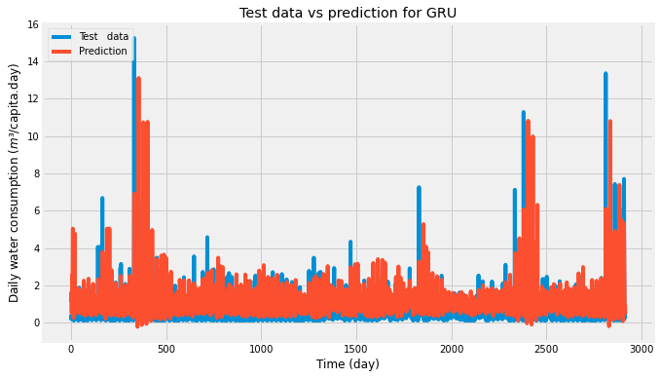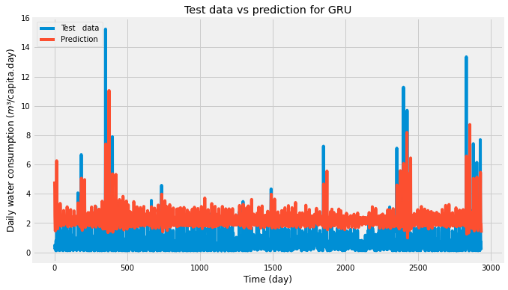

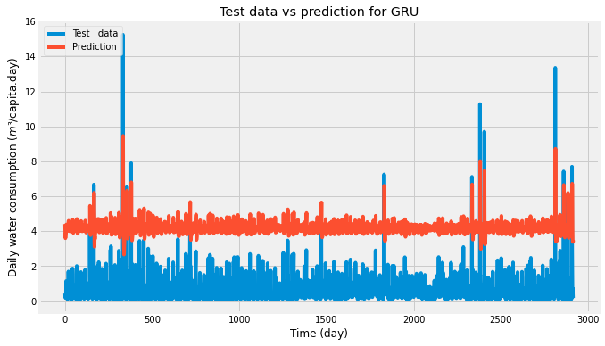

Figure 1EPOCH 5

Do you need to keep the tuning the same when adding more variables

Need GRU and LSTM to be the same

When stop..?

Lookback / lags

Different models – feature engineering

Overall complexity – important !

Nr models

Hyperparameter

Evaluation

Run newdata 3

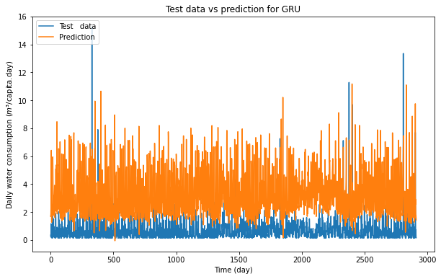

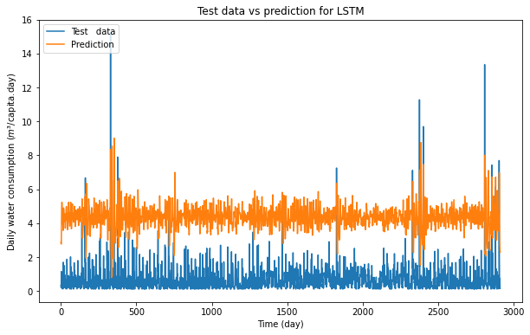

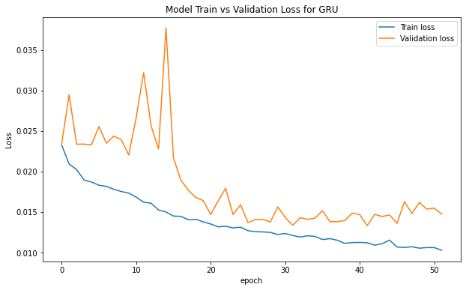

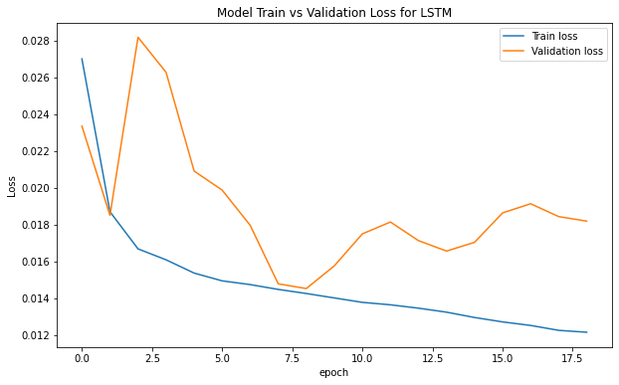

Run 4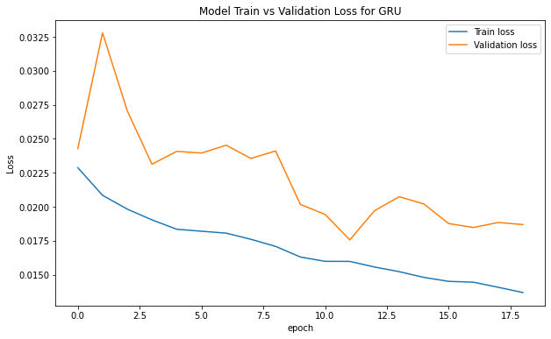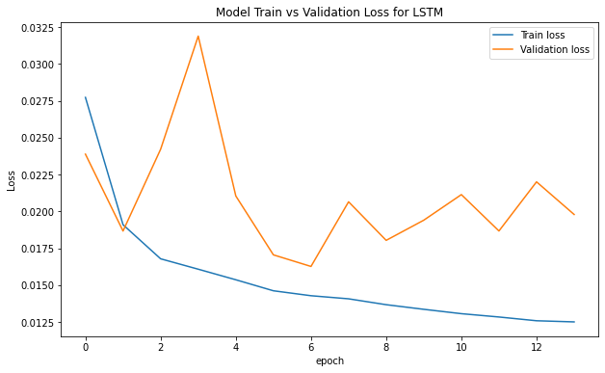

Run5

