Part 1

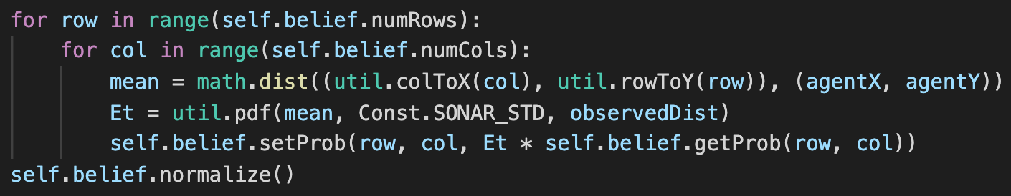

Goal : page4image52199632page4image52202544

1. Firstly calculate Et by pdf of Gaussian distribution using util.pdf(mean, std, observedDist), where mean = distance ( (X_tile,Y_tile) , (agentX, agentY) ).
2. Secondly multiply self.belief.getProb() = page4image52199632 with Et.
3. Finally do normalization on the probabilities.

Part 2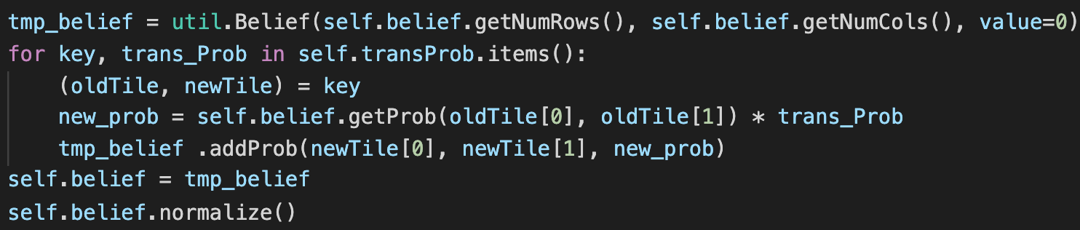

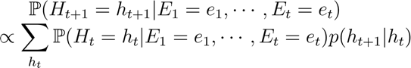Goal :

1. To avoid using one updated grid to update another one, initialize a new belief by

tmp_belief = util.Belief().

1. Then, for (key, value) = (oldTile, newTile), transProb) in self.tansProb{ }, update the current probability with transition probability such that

new_prob = self.belief.getProb(oldTile[0], oldTile[1]) * trans_Prob.

1. Finally, do normalization on the probabilities.

Part 3-1 observe()

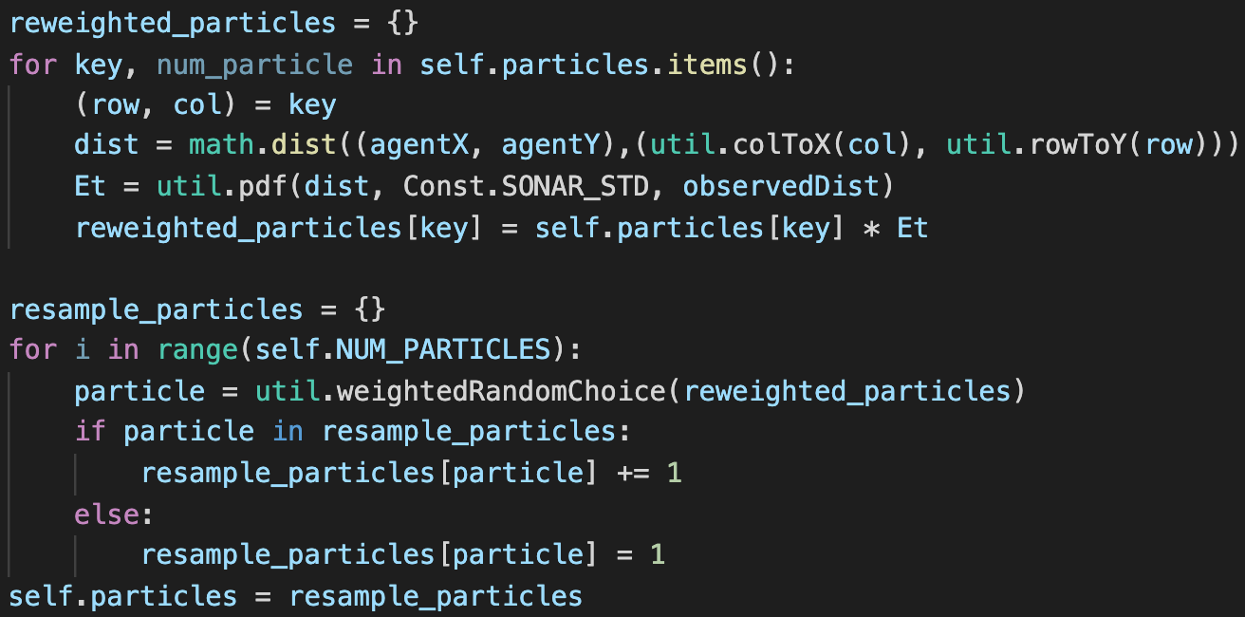

1. In the Reweight Part, firstly calculate the emission probability Et as part 1 ; then create a dictionary reweighted_particle{ } to store the particles weighted by Et.
2. (1) In the Resample Part, iterate |self.NUM_PARTICLES| times to create resample

particles chosen by weightedRandomChoice(reweighted_particle).

(2) Next, store those particles in dictionary resample_particles{ } with

conditional statement “particle in resample_particles : …” to avoid key errors.

(3) Lastly self.particles = resample_particles

Part 3-2 elapseTime()

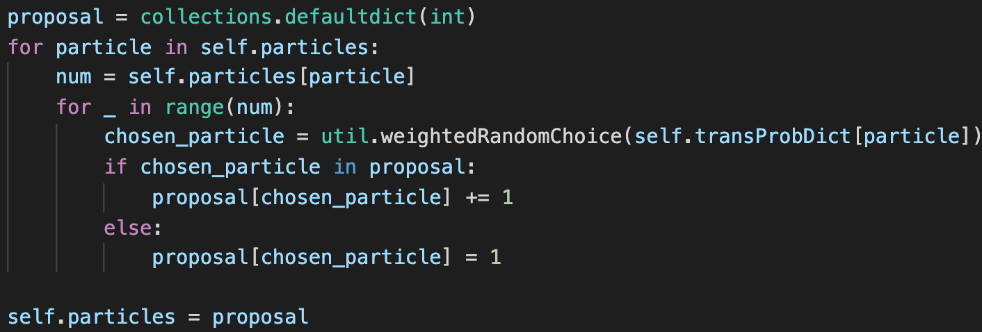

1. For each particle (locations) in self.particles, there are “num” number of particles.
2. Secondly call chosen_particle = util.weightedRandomChoice() once for each particle in order to resample on the basis of transProbDict[particle].
3. Thirdly record the number of particles at each chosen_particle (location) in proposal{ }, and set self.particles = proposal

Problem

Q : In part 3-2, if I declare a dictionary like “proposal = { } “, Key error will be invoked

even though conditional statement “if key in dictionary : …” is in the presence.

A : I still don’t know why the conditional statement works well on Part 3-1 but fail

on Part 3-2, yet it can be solved by using defaultdict to declare a dictionary.