**EDITING BY PAGE INSTRUCTION**

1. COPY AND PASTE THE WHOLE FOLDER ON YOUR WORKSTATION

2. DOUBLE CLICK THE WORD: " Copyright © 2021 Iristech Finance - Design by: Iristech Creative Solutions " ON THE FOOTER



DOUBLE CLICK THE WORD

3. ENTER THE PASSWORD: IRISTECH

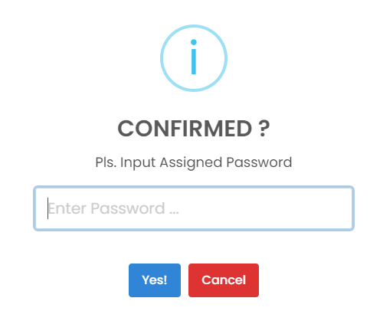

4. START EDITING BY CLICKING TO EVERY WORDS ON THE PAGE

Sample:



CLICK THE WORD MODIFY

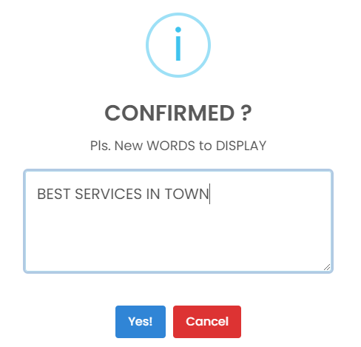

OUTPUT / RESULT

ENTER THE WORD/S MODIFY

5. IF YOU DONE: JUST CLICK THE BUTTON:"DONE EDITING" ON THE FOOTER



OUTPUT / RESULT

6. RIGHT CLICK THE PAGE OR CTRL S TO SAVE THE PAGE

SUGGESTION: SAVE IT ON THE SAME LOCATION

