survey on psmu&obi
2026-04-30
library(readxl)
survey_data <- read_excel("PSMU_OBI_cleaned.xlsx")
## New names:
## • `` -> `...26`
## • `` -> `...28`
gender_col <- "2. Which of the following best describes your gender? /以下哪项最符合您的性别？"
gender_table <- table(survey_data[[gender_col]])
gender_percent <- round(prop.table(gender_table) * 100, 2)
gender_table
##
## Female /女 Male /男 Other /其他
## 28 5 1
gender_percent
##
## Female /女 Male /男 Other /其他
## 82.35 14.71 2.94
age_col <- "1. What is your age? /您的年龄是？"
age_table <- table(survey_data[[age_col]])
age_percent <- round(prop.table(age_table) * 100, 2)
age_table
##
## 18–24 years /18-24岁 25–29 years /25-29岁
## 29 5
age_percent
##
## 18–24 years /18-24岁 25–29 years /25-29岁
## 85.29 14.71
library(dplyr)
##
## Attaching package: 'dplyr'
## The following objects are masked from 'package:stats':
##
## filter, lag
## The following objects are masked from 'package:base':
##
## intersect, setdiff, setequal, union
survey_data %>%
summarise(
smu_mean = mean(smu_total, na.rm = TRUE),
smu_sd = sd(smu_total, na.rm = TRUE),
obi_mean = mean(obi_total, na.rm = TRUE),
obi_sd = sd(obi_total, na.rm = TRUE)
)
## # A tibble: 1 × 4
## smu_mean smu_sd obi_mean obi_sd
## <dbl> <dbl> <dbl> <dbl>
## 1 16.8 4.71 23.1 7.71
cor_result <- cor.test(survey_data$smu_total, survey_data$obi_total, method = "spearman")
## Warning in cor.test.default(survey_data$smu_total, survey_data$obi_total, :
## Cannot compute exact p-value with ties
cor_result
##
## Spearman's rank correlation rho
##
## data: survey_data$smu_total and survey_data$obi_total
## S = 2285, p-value = 3.073e-05
## alternative hypothesis: true rho is not equal to 0
## sample estimates:
## rho
## 0.6508783
cor_result <- cor.test(survey_data$smu_total, survey_data$obi_total, method = "pearson")
cor_result
##
## Pearson's product-moment correlation
##
## data: survey_data$smu_total and survey_data$obi_total
## t = 4.8213, df = 32, p-value = 3.338e-05
## alternative hypothesis: true correlation is not equal to 0
## 95 percent confidence interval:
## 0.3977423 0.8093024
## sample estimates:
## cor
## 0.6486613
# Load package
library(ggplot2)
# Draw scatter plot
ggplot(survey_data, aes(x = smu_total, y = obi_total)) +
geom_point(color = "skyblue", size = 2, alpha = 0.6) +
geom_smooth(method = "lm", color = "darkblue", se = TRUE) +
labs(title = "Correlation between Addictive Social Media Use \nand Impulsive Buying",
x = "Problematic Social Media Use (SMU)",
y = "Online Buying Impulsiveness (OBI)") +
theme_minimal()
## `geom_smooth()` using formula = 'y ~ x'
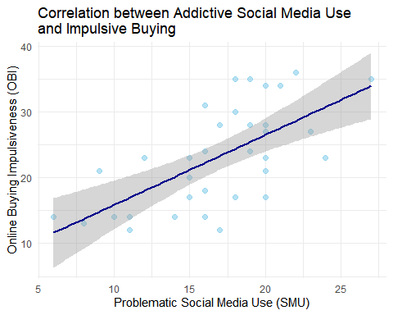
# Load package
library(ggplot2)
# 1. Gender Bar Chart
gender_data <- as.data.frame(table(survey_data[[gender_col]]))
colnames(gender_data) <- c("Gender", "Count")
ggplot(gender_data, aes(x = Gender, y = Count, fill = Gender)) +
geom_bar(stat = "identity", width = 0.6, color = "white") +
theme_minimal() +
labs(title = "Gender Distribution", x = "Gender", y = "Count") +
theme(legend.position = "none") +
geom_text(aes(label = Count), vjust = 0) +
ylim(0, 35)
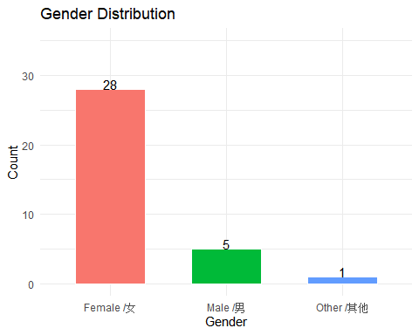
# 2. Age Bar Chart
age_data <- as.data.frame(table(survey_data[[age_col]]))
colnames(age_data) <- c("Age", "Count")
ggplot(age_data, aes(x = Age, y = Count, fill = Age)) +
geom_bar(stat = "identity", width = 0.6, color = "white") +
theme_minimal() +
labs(title = "Age Distribution", x = "Age Group", y = "Count") +
theme(legend.position = "none") +
geom_text(aes(label = Count), vjust = 0) +
ylim(0, 35)
