

|  |  |  |  |  |  |
| --- | --- | --- | --- | --- | --- |
| Programme | : | **BTech – ECE and ECM** | Semester | : | **Win 2022** |
| Course | : | **Essentials of Data Analytics Lab** | Code | : | **CSE3506** |
| Faculty | : | **Gobinath N** | Slot | : | **L51 + L52** |

**Ex.10_Random Forest**

**Aim:** : To solve the given dataset glass.csv using random forest.

**PROGRAM:**

rm(list=ls()) install.packages("stats") install.packages("dplyr") install.packages("randomForest")

library(stats) library(dplyr) library(randomForest) mydata <- read.csv("glass.csv")

View(mydata) str(mydata) set.seed(120)

index = sample(2,nrow(mydata),replace=TRUE,prob=c(0.75,0.25))

training <- subset(mydata, index == 1) testing <- subset(mydata, index == 2) RFM = randomForest(Type~.,data=training) species_pred = predict(RFM,testing) testing$species_pred = species_pred

View(testing)

CFM = table(testing$species,testing$species_pred)

Classification_Accuracy = sum(diag(CFM))/sum(CFM) Classification_Accuracy

**OUTPUT:**

**Given Data:**

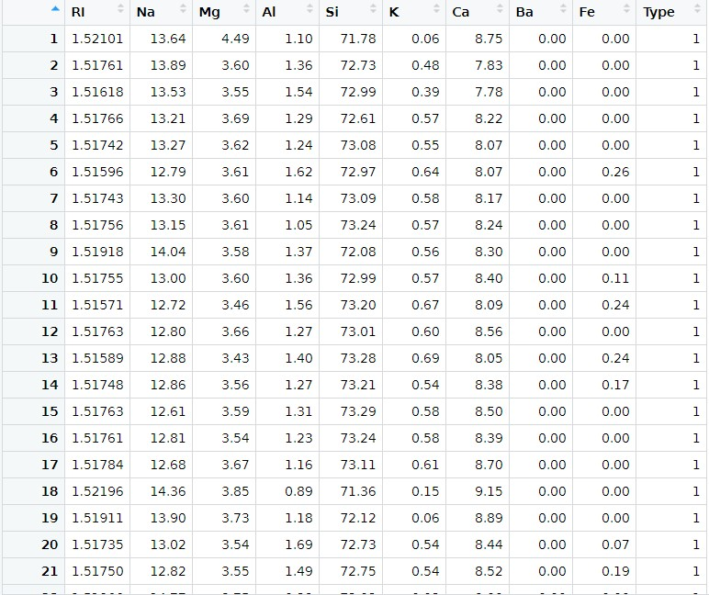

**Training Data:**

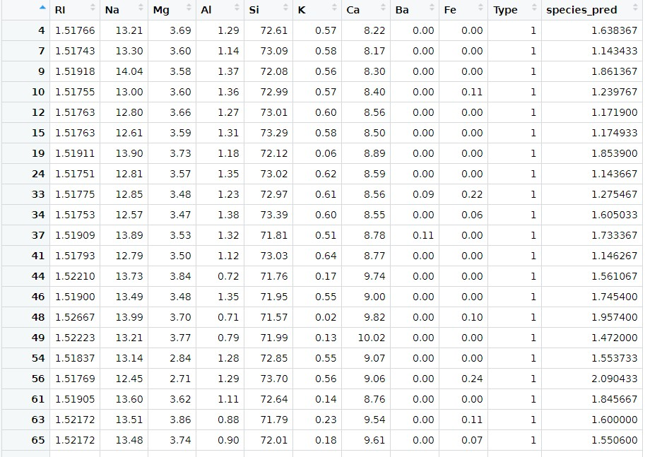

**Accuracy of the model:**

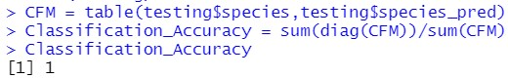

**Result:**

Hence the accuracy of the data is calculated as 1 so the data is balanced.