RADIANT PHARMACEUTICALS LIMITED

ICT Wing

(Daily Report)
INTERN PROFILE | DETAILS
Intern Name | Ibrahim Hasan
Student ID | 2110316
University | Independent University, Bangladesh
Department | Management Information System (MIS)
Supervisor | Ayan Chowdhury (Sr. Officer, ICT)

Daily Progress Report
Day # | Date #
Day 14 | 10-Jun-2026

Task Assigned:
Practice Django Website, Layout Fixes & Pivot Reports Integration.
• Navigation & Responsive Layout: Restructure the vertical sidebar navigation using native Tabler/Bootstrap grid systems to fix layout sizing mismatches on mobile screens.
• Dashboard Alignment: Re-integrate the Transmission comparison chart next to the Model Distribution chart and display regional sales distribution tables.
• O(1) Indexed VIN Search: Implement simulated B-Tree index indicators and alerts on the inventory database page.
• Excel Pivot Analytics & CSV Export: Create 4 custom pivot reports with Flatpickr dark-mode calendar ranges and native CSV file export capabilities.
Learning Outcome: (Add detailed learnings and screenshots here):
• Codebase Housekeeping & Asset Pruning: Learned to analyze project assets, resulting in the cleanup of 13 directories and 224 redundant static files.
• Native Grid Layout & Mobile UI: Mastered Tabler's responsive navigation wrapper classes to resolve multi-viewport grid alignment problems without custom overrides.
• Date-Range Input Integration: Configured the Flatpickr calendar library with customized dark mode styling and custom inline SVG icons.
• Indexing Search Optimization: Simulated low-level B-Tree database query behavior and communicated performance changes to the user using UI alert badges.

Work Completed:
• Responsive Navigation Layout: Integrated native Tabler classes in base and sidebar templates, resolving all mini-screen and mobile display issues.
• Dashboard Symmetrical Charts: Aligned the Transmission comparison donut chart alongside the Model Distribution pie chart, and added a Top States markets table.
• B-Tree Simulated Search: Implemented instant VIN search feedback using simulation alerts displaying simulated B-Tree search times.
• Analytics Page & Pivot Reports: Created 4 pivot reports matching excel sheets with Flatpickr dark-mode calendars and body category filters.
• CSV Export & Developer Footers: Integrated native CSV export endpoints for all pivot reports.
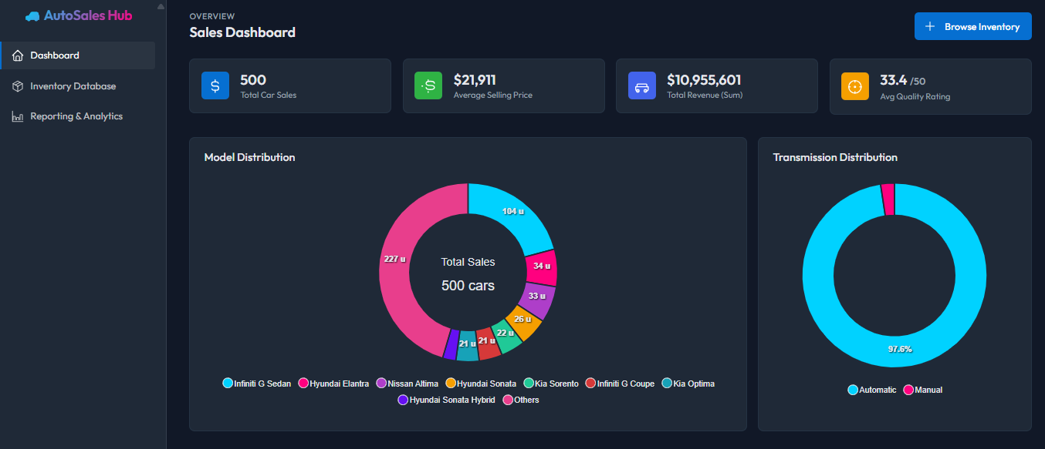
Figure 1: Desktop Dashboard View showing overall performance KPIs, symmetrical charts, and sales trends.
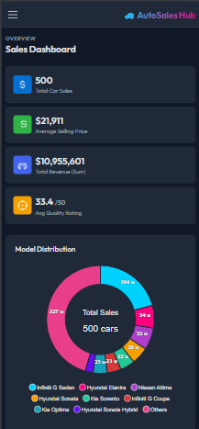
Figure 2: Mobile Responsive Sidebar Navigation and stacked dashboard layout on a mobile screen.
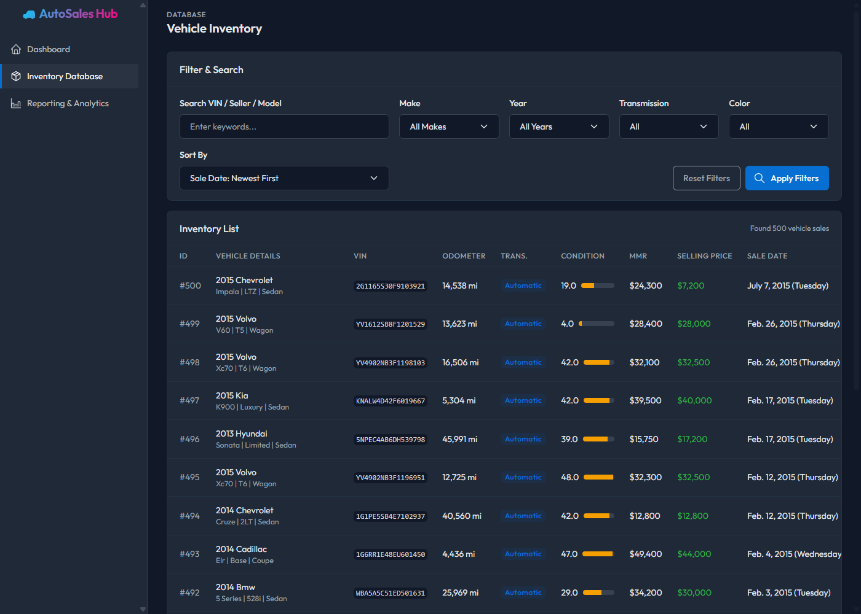
Figure 3: Interactive Inventory Data Table showing B-Tree simulated indexed search badges.
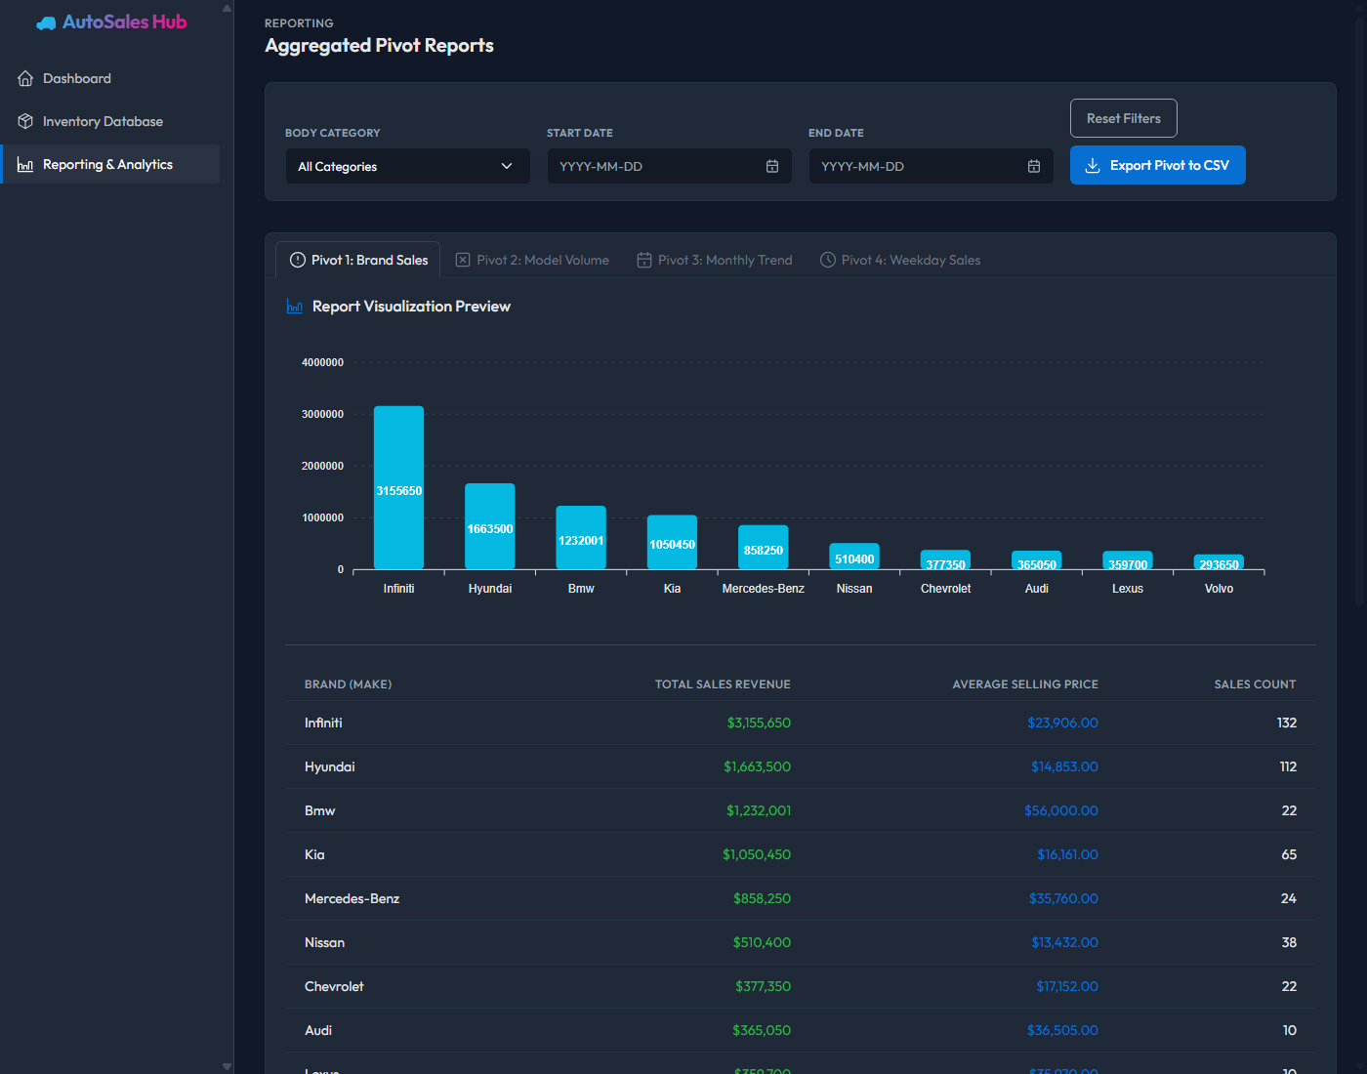
Figure 4: Analytics Page showing Pivot Reports, category filters, Flatpickr date ranges, and CSV export.

Problems Faced:
• Inline Styling Inconsistencies: Custom CSS height and flex overrides clashed with Tabler's grid rules, leading to distorted elements during viewport resizing.
• Default Browser Date Inputs: HTML5 date inputs displayed browser-specific icons and light-colored calendars that conflicted with the site's dark theme.
Solution Attempted:
• Native Tabler CSS Classes: Replaced custom styling with Tabler's native grid columns and alignment utilities for seamless responsive transitions.
• Flatpickr Dark Mode Integration: Configured the Flatpickr library with material dark theme options and injected custom SVG calendar icons into standard input elements.

