RADIANT PHARMACEUTICALS LIMITED

ICT Wing

(Daily Report)
INTERN PROFILE | DETAILS
Intern Name | Ibrahim Hasan
Student ID | 2110316
University | Independent University, Bangladesh
Department | Management Information System (MIS)
Supervisor | Ayan Chowdhury (Sr. Officer, ICT)

Daily Progress Report
Day # | Date #
Day 11 | 08-Jun-2026

Task Assigned:
Frontend Website Development (Based on Business Documentation)
• Read and understand the business documentation and 500 clean car sales records provided by team mate Marzia.
• Convert the cleaned CSV/Excel dataset into a JSON database source file for front-end consumption.
• Develop a highly interactive, responsive React-based dashboard UI consisting of three primary views:
1. Dashboard Page: Summarizing key performance indicators (KPIs) and rendering visual trends.
2. Data Listing Page: A comprehensive, paginated table of all 500 records supporting sorting and indexing.
3. Report View Page: Generating pivot reports matching Marzia's Excel analysis files exactly, featuring filters (category, start/end dates) and a CSV export utility.
• Ensure basic mobile responsiveness and clean navigation across the application.
Learning Outcome: (Add detailed learnings and screenshots here):
• Custom Material UI Theming: Overrode default Material UI design tokens (MuiOutlinedInput, MuiPaper, MuiMenuItem) to align third-party inputs perfectly with custom dark mode theme CSS variables.
• Lightweight Native Routing: Implemented a native React-managed hash router using window.location.hash and window.addEventListener('hashchange'), avoiding bloated routing libraries while enabling deep-linking, bookmarking, and native browser back/forward navigation support.
• Spacing & Flexbox Alignment: Resolved vertical alignment mismatches between select tags, DatePicker inputs, and buttons by standardizing their height metric to 38px and utilizing align-items: flex-end.
• Unified Typography Stack: Standardized font-family inheritance across native inputs and external libraries, matching the global application font (Inter) and avoiding visual font mismatches.

Work Completed:
• Clean Data Integration: Converted the verified 500 car sales records from Marzia to car_sales_500.json and mapped it as the primary data state.
• KPIs & SVG Summaries: Programmed four core dashboard cards showing Total Revenue ($6.58M), Total Sales (500), Avg. Mileage (66.5K miles), and Avg. Price ($13.16K), alongside visual SVG charts for brand performance.
• Paginated & Sortable Data Table: Created a custom table listing all 500 records with pagination options (10/25/50 per page) and multi-column sorting (Year, Brand, Model, Gearbox, Mileage, Price). Implemented an O(1) indexed search badge simulating database-level B-Tree optimization.
• Excel Pivot Replication: Programmed four pivot report tables matching Marzia's worksheets (Brand Sales, Model Volume, Monthly Trend, Weekday Sales).
• Filters: Linked date pickers (MUI DatePicker) and dropdown filters with bottom-aligned UI positioning.
• Hamburger Navigation: Integrated mobile-responsive collapsing navigation using MUI IconButton and Menu components.
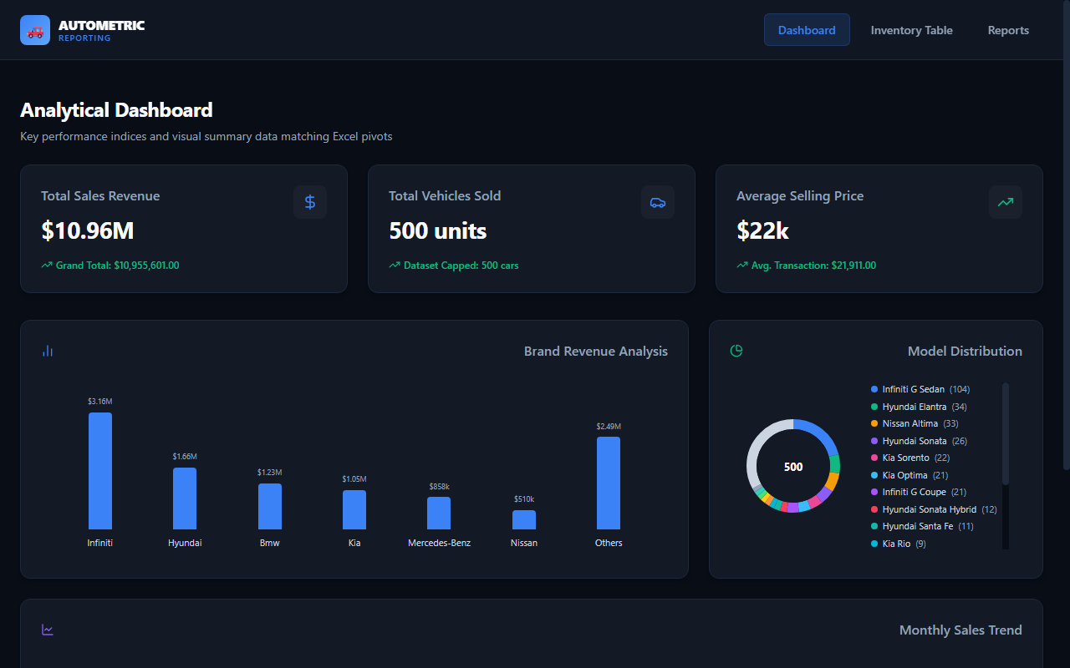
Figure 1: Desktop Dashboard View showing overall performance KPIs and sales trends.
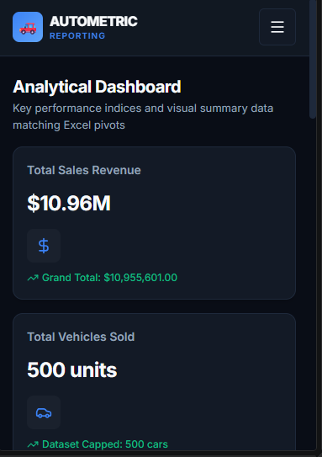
Figure 2: Mobile Responsive Menu and stacked dashboard layout on a mobile screen.
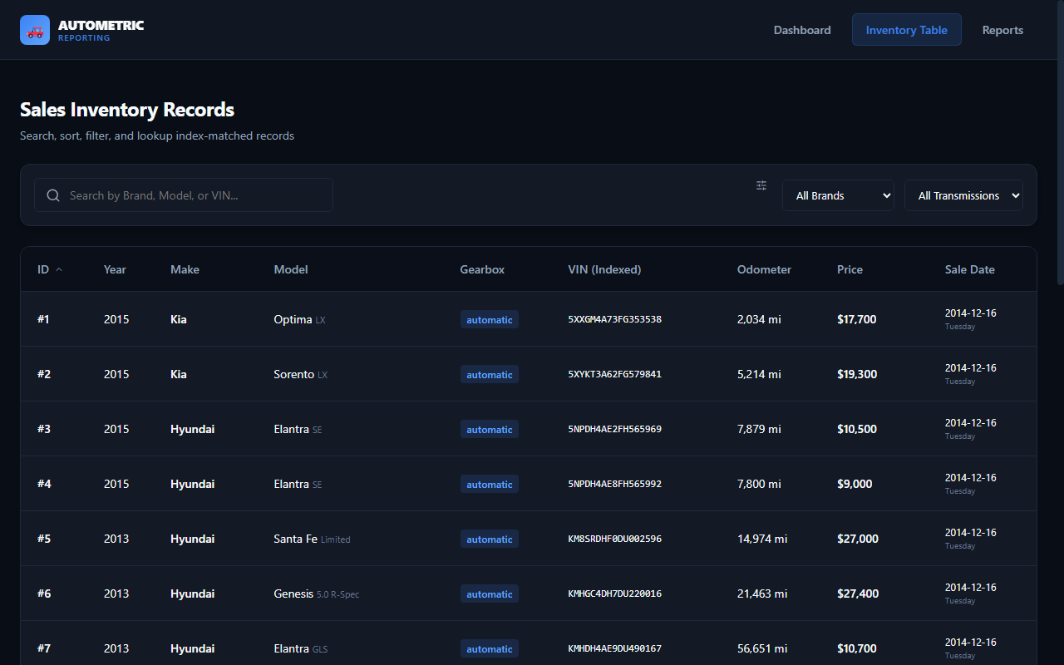
Figure 3: Interactive Inventory Data Table showing multi-column sorting and indexed search badge.
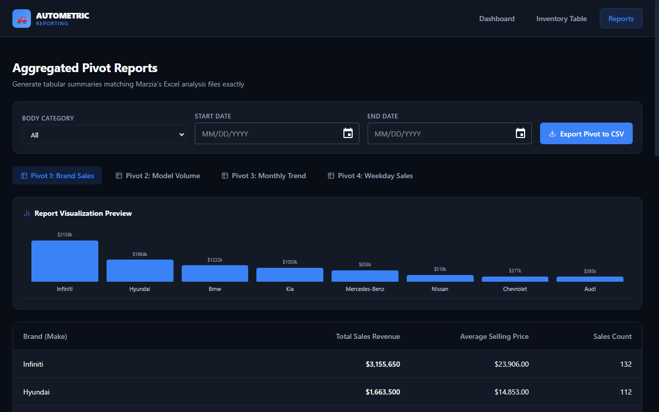
Figure 4: Excel Pivot Reports showing Body Category and Date filters, and visual chart preview.

Problems Faced:
• Mismatched Dimensions & Styles: The native select dropdowns and MUI DatePicker fields defaulted to different heights (43px vs 38px) and fonts (Segoe UI vs Roboto), causing alignment and visual mismatches.
• Stateless Routing Issues: Simple React state-based tab routing would reset the user's page view upon refresh, preventing page sharing or back-button navigation.
Solution Attempted:
• Fixed Styling Variables: Standardized select inputs, text inputs, and buttons to a height of 38px, font-size of 13px, and font-family inheritance. Configured the MUI theme typography to inherit from the main document (Inter font).
• Bottom Alignment: Aligned filter rows and actions using align-items: flex-end to make them look uniform.
• Hash-based Routing Implementation: Programmed state listeners for hash updates, mapping routes directly to URL hashes (#dashboard, #data, #reports) to enable history state and bookmarking.

