GO Code Design and Implementation

Design:
Design of the console:
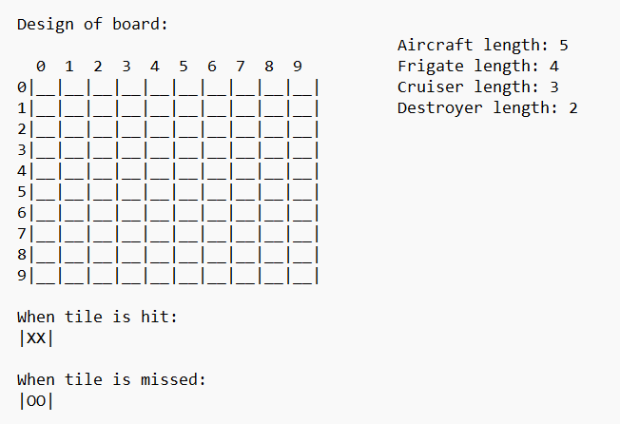

Implementation:
Steps for programming:
- Create a display of the board.
- Generate random coordinates for ship placement.
- Generate ship tiles based on the random coordinates.
- Check if any of the used tiles are duplicated.
- Check if the player guess has hit a ship.
- Generate each boat.
- Saves user input as guesses.
- Checks win conditions.

Functional Pseudocode:
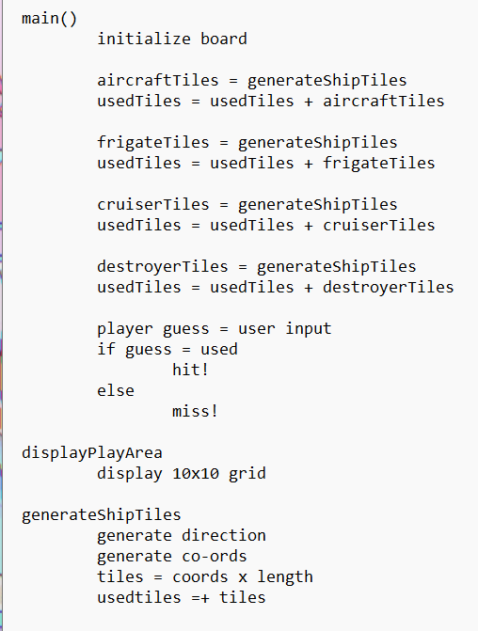

First Iteration of code:
package main

import (
"fmt"
"math/rand"
)

func displayPlayArea(T [][]string) {
fmt.Println(" 0 1 2 3 4 5 6 7 8 9")
for i := 0; i < len(T); i++ {
for j := 0; j < len(T[i]); j++ {
fmt.Printf("%s ", T[i][j])
}
fmt.Println()
}
}

func generateShipTiles(upOrDown int, shipSize int, usedTiles [][]int) [][]int {
var shipTiles [][]int

for {
if upOrDown == 0 {
shipPositionX := rand.Intn(10 - shipSize + 1)
shipPositionY := rand.Intn(10)

shipTiles = [][]int{
{shipPositionX, shipPositionY},
{shipPositionX + 1, shipPositionY},
{shipPositionX + 2, shipPositionY},
{shipPositionX + 3, shipPositionY},
}
} else {
shipPositionX := rand.Intn(10)
shipPositionY := rand.Intn(10 - shipSize + 1)

shipTiles = [][]int{
{shipPositionX, shipPositionY},
{shipPositionX, shipPositionY + 1},
{shipPositionX, shipPositionY + 2},
{shipPositionX, shipPositionY + 3},
}
}

if !containsAny(usedTiles, shipTiles) {
break
}
}

return shipTiles
}

func containsAny(usedTiles [][]int, shipTiles [][]int) bool {
for _, tile := range shipTiles {
if contains(usedTiles, tile) {
return true
}
}
return false
}

func contains(usedTiles [][]int, tile []int) bool {
for _, t := range usedTiles {
if t[0] == tile[0] && t[1] == tile[1] {
return true
}
}
return false
}

func main() {

// Play area initialization
T := make([][]string, 10)
for i := range T {
T[i] = make([]string, 10)
for j := range T[i] {
T[i][j] = "|__"
}
T[i][9] = "|__|\n"
}

// Aircraft Carrier Generation
upOrDown := rand.Intn(2)

usedTiles := make([][]int, 0)

aircraftTiles := generateShipTiles(upOrDown, 5, usedTiles)
usedTiles = append(usedTiles, aircraftTiles...)

// Frigate Generation
frigateTiles := generateShipTiles(upOrDown, 4, usedTiles)
usedTiles = append(usedTiles, frigateTiles...)

// Cruiser Generation
cruiserTiles := generateShipTiles(upOrDown, 3, usedTiles)
usedTiles = append(usedTiles, cruiserTiles...)

// Destroyer Generation
destroyerTiles := generateShipTiles(upOrDown, 2, usedTiles)
usedTiles = append(usedTiles, destroyerTiles...)

// Destroyer2 Generation
destroyer2Tiles := generateShipTiles(upOrDown, 2, usedTiles)
usedTiles = append(usedTiles, destroyer2Tiles...)

hits := 0

displayPlayArea(T)

for hits <= 16 {
var xGuess, yGuess int
fmt.Print("Enter row coordinate: ")
fmt.Scan(&xGuess)
fmt.Print("Enter column coordinate: ")
fmt.Scan(&yGuess)

guessed := [][]int{{xGuess, yGuess}}

if containsAny(usedTiles, guessed) {
fmt.Println("Hit!")
hits++
if yGuess == 9 {
T[xGuess][yGuess] = "|XX|\n"
} else {
T[xGuess][yGuess] = "|XX"
}
} else {
fmt.Println("Miss!")
if yGuess == 9 {
T[xGuess][yGuess] = "|00|\n"
} else {
T[xGuess][yGuess] = "|00"
}
}

displayPlayArea(T)
}

fmt.Println("You hit every ship!")
}

Issues with iteration 1:
- No validation
- No introduction
- No difficulty

Iteration 2:

package main

import (
"fmt"
"math/rand"
)

func displayPlayArea(T [][]string) {
fmt.Println(" 0 1 2 3 4 5 6 7 8 9")
for i := 0; i < len(T); i++ {
for j := 0; j < len(T[i]); j++ {
fmt.Printf("%s ", T[i][j])
}
fmt.Println()
}
}

func generateShipTiles(upOrDown int, shipSize int, usedTiles [][]int) [][]int {
var shipTiles [][]int

for {
if upOrDown == 0 {
shipPositionX := rand.Intn(10 - shipSize + 1)
shipPositionY := rand.Intn(10)

shipTiles = [][]int{
{shipPositionX, shipPositionY},
{shipPositionX + 1, shipPositionY},
{shipPositionX + 2, shipPositionY},
{shipPositionX + 3, shipPositionY},
}
} else {
shipPositionX := rand.Intn(10)
shipPositionY := rand.Intn(10 - shipSize + 1)

shipTiles = [][]int{
{shipPositionX, shipPositionY},
{shipPositionX, shipPositionY + 1},
{shipPositionX, shipPositionY + 2},
{shipPositionX, shipPositionY + 3},
}
}

if !containsAny(usedTiles, shipTiles) {
break
}
}

return shipTiles
}

func containsAny(usedTiles [][]int, shipTiles [][]int) bool {
for _, tile := range shipTiles {
if contains(usedTiles, tile) {
return true
}
}
return false
}

func contains(usedTiles [][]int, tile []int) bool {
for _, t := range usedTiles {
if t[0] == tile[0] && t[1] == tile[1] {
return true
}
}
return false
}

func main() {

// Play area initialization
T := make([][]string, 10)
for i := range T {
T[i] = make([]string, 10)
for j := range T[i] {
T[i][j] = "|__"
}
T[i][9] = "|__|\n"
}

// Aircraft Carrier Generation
upOrDown := rand.Intn(2)

usedTiles := make([][]int, 0)

aircraftTiles := generateShipTiles(upOrDown, 5, usedTiles)
usedTiles = append(usedTiles, aircraftTiles...)

// Frigate Generation
frigateTiles := generateShipTiles(upOrDown, 4, usedTiles)
usedTiles = append(usedTiles, frigateTiles...)

// Cruiser Generation
cruiserTiles := generateShipTiles(upOrDown, 3, usedTiles)
usedTiles = append(usedTiles, cruiserTiles...)

// Destroyer Generation
destroyerTiles := generateShipTiles(upOrDown, 2, usedTiles)
usedTiles = append(usedTiles, destroyerTiles...)

// Destroyer2 Generation
destroyer2Tiles := generateShipTiles(upOrDown, 2, usedTiles)
usedTiles = append(usedTiles, destroyer2Tiles...)

hits := 0

fmt.Print("Welcome to Battleships!, the game where you try to sink the enemy's ships. You must find and destroy 5 different boats on a 10x10 grid: an Aircraft Carrier which is 5 spaces long, a Frigate which is 4 spaces long, a Cruiser which is 3 spaces long and 2 Destroyers which are 2 spaces long. Developed by 21307114.\nPlease select a difficulty:\n1. Casual\n2. Advanced\n3. Impossible\n")

displayPlayArea(T)

for hits <= 16 {
var xGuess, yGuess int

for {
fmt.Print("Enter row coordinate (0-9): ")
if _, err := fmt.Scan(&xGuess); err != nil || xGuess < 0 || xGuess > 9 {
fmt.Println("Please enter a valid row coordinate between 0 and 9.")
continue
}

fmt.Print("Enter column coordinate (0-9): ")
if _, err := fmt.Scan(&yGuess); err != nil || yGuess < 0 || yGuess > 9 {
fmt.Println("Please enter a valid column coordinate between 0 and 9.")
continue
}

// Break out of the loop if valid coordinates are entered
break
}

guessed := [][]int{{xGuess, yGuess}}

if containsAny(usedTiles, guessed) {
fmt.Println("Hit!")
hits++
if yGuess == 9 {
T[xGuess][yGuess] = "|XX|\n"
} else {
T[xGuess][yGuess] = "|XX"
}
} else {
fmt.Println("Miss!")
if yGuess == 9 {
T[xGuess][yGuess] = "|00|\n"
} else {
T[xGuess][yGuess] = "|00"
}
}

displayPlayArea(T)
}

fmt.Println("You hit every ship!")
}

- Validation added to user input
- Introduction added
- Difficulty levels added

