FULL STACK DEVELOPER INTERNSHIP
INTERNSHIP REPORT
Ledger
SaaS Subscription Management Platform with Stripe & Docker
Codec Technologies Pvt. Ltd.
Role: Full Stack Developer Intern
Duration: 06/08/2026 – 06/09/2026
Mode: Pan India, Hybrid
Submitted by
Alok Yadav
B.Tech – Computer Science & Engineering
Session 2024–28
Roll No.: 2410030867 Section: 3CSE19

Certificate
Insert the original internship certificate issued by Codec Technologies Pvt. Ltd. on this page before final submission.
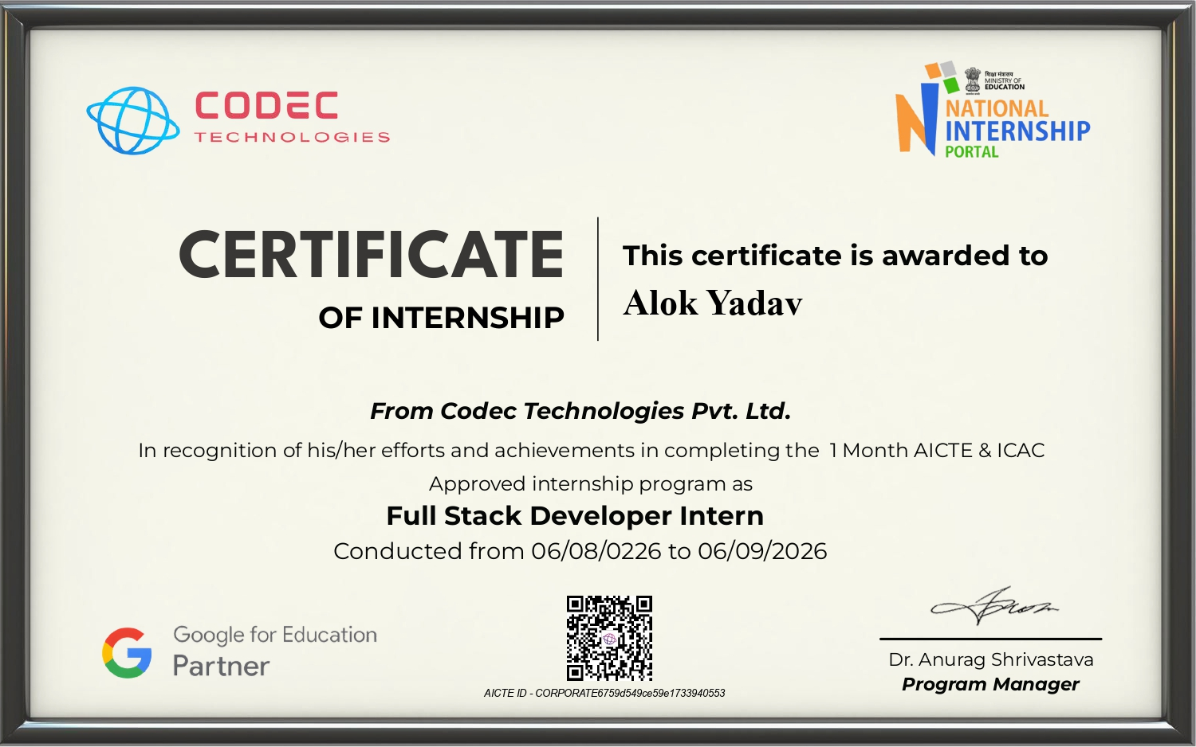

Declaration
I hereby declare that this internship report titled “Ledger – SaaS Subscription Management Platform with Stripe & Docker” is a record of the practical work carried out during my Full Stack Developer Internship at Codec Technologies Pvt. Ltd. from 06/05/2026 to 06/06/2026.
The report presents the technologies, application architecture, subscription and billing workflow, containerization approach, testing activities, challenges, and learning outcomes associated with the completed project.
Date: 25/07/26
Alok Yadav

Acknowledgement
I would like to express my sincere gratitude to Codec Technologies Pvt. Ltd. for providing me with the opportunity to undertake a Full Stack Developer Internship and gain practical exposure to cloud deployment and automation.
I am thankful to the mentors and faculty members who supported the learning process and helped me understand practical concepts related to full-stack application development, PostgreSQL database design, Stripe integration, JWT authentication, Docker containerization, and troubleshooting.
Finally, I would like to thank everyone who contributed directly or indirectly to the successful completion of this internship project.

Table of Contents
Chapter | Title
1 | Introduction
2 | Company & Internship Overview
3 | Project Overview
4 | Technology Stack
5 | System Architecture
6 | Implementation
7 | Containerization & Deployment
8 | Application Configuration
9 | Testing & Validation
10 | Challenges & Solutions
11 | Learning Outcomes
12 | Conclusion
13 | Future Scope
14 | References

List of Figures
Figure | Description
5.1 | Ledger Application Architecture
5.2 | Docker Compose Service Architecture
6.1 | Ledger Authentication and Interface
6.2 | Ledger REST API Backend
6.3 | PostgreSQL Database Schema
7.1 | Docker Compose Service Architecture
7.2 | Dockerfiles and Compose Configuration
8.1 | Application Configuration and Environment
9.1 | Application Validation Evidence

1. Introduction

1.1 Background
Modern SaaS applications combine a web interface, backend APIs, persistent data storage, authentication, subscription management, and external payment services. During the internship, these concepts were applied through the development of Ledger, a full-stack subscription and billing management platform.

1.2 Internship Overview
The internship was completed as a Cloud Computing Intern at Codec Technologies Pvt. Ltd. from 06/05/2026 to 06/06/2026. The internship focused on cloud computing training and practical project work.

1.3 Objectives
- Understand practical cloud computing concepts.
- Deploy a multi-tier web application using AWS.
- Gain hands-on experience with EC2, S3, RDS and IAM.
- Implement CI/CD using GitHub Actions.
- Develop cloud deployment and troubleshooting skills.

1.4 Scope
The practical scope covered frontend and backend development, PostgreSQL database design, JWT-based authentication, role-based access control, Stripe subscription and billing integration, usage analytics, Docker-based local deployment, and application troubleshooting for the Ledger platform.

2. Company & Internship Overview

2.1 Company
Codec Technologies Pvt. Ltd. provided the internship environment for practical learning and project-oriented implementation. The internship combined technical training with the development of a complete SaaS subscription management application.

2.2 Internship Details
Parameter | Details
Organization | Codec Technologies Pvt. Ltd.
Role | Cloud Computing Intern
Duration | 06/05/2026 – 06/06/2026
Mode | Pan India, Hybrid
Focus | Cloud Computing Training & Practical Project Work

2.3 Nature of Work
The internship work involved understanding full-stack application architecture and applying it to a practical SaaS platform. The completed work included developing separate frontend and backend services, connecting the backend to PostgreSQL, integrating Stripe for billing, implementing authentication and role guards, and containerizing the services with Docker Compose.

3. Project Overview

3.1 Project Title
Ledger – SaaS Subscription Management Platform with Stripe & Docker

3.2 Project Description
Ledger is a full-stack SaaS subscription management platform that separates the frontend, backend and database into independent services. It provides account authentication, subscription plans, Stripe Checkout, billing portal access, invoice synchronization, usage analytics, and role-based administration.

3.3 Project Objectives
- Create a functional SaaS platform with separate presentation, application, and data layers.
- Build a responsive dashboard using Next.js, TypeScript, and Tailwind CSS.
- Develop REST APIs using Node.js and Express.js for authentication, plans, subscriptions, billing, usage, and administration.
- Store users, plans, subscriptions, invoices, usage records, and audit logs in PostgreSQL.
- Integrate Stripe Checkout, Billing Portal, subscription changes, cancellations, and webhook-based billing synchronization.

3.4 Application Layers
Layer | Technology | Deployment
Presentation | Next.js + TypeScript | Docker container
Application | Node.js + Express.js | Docker container
Data | PostgreSQL | Docker Compose

4. Technology Stack

4.1 Frontend
Next.js 14 with the App Router and TypeScript were used to build the Ledger interface. Tailwind CSS provides the styling system, while Recharts is used for usage analytics visualization.

4.2 Backend
Node.js and Express.js were used to implement the backend REST API. The backend uses modular controllers, routes, middleware, services, and SQL data-access models, with JWT authentication and role-based route protection.

4.3 Database
PostgreSQL is used as the application database. The schema contains users, plans, subscriptions, invoices, usage records, and audit logs, with UUID identifiers, constraints, indexes, and timestamps.

4.4 Cloud & DevOps
Category | Technologies / Services
Frontend | Next.js 14, TypeScript, Tailwind CSS, Recharts
Backend | Node.js, Express.js
Database | PostgreSQL 16
Payments | Stripe Checkout, Billing Portal, Webhooks
Authentication | JWT, bcrypt
Containerization | Docker, Docker Compose
Source Control | Git / GitHub

4.5 Development Environment
The application is configured for containerized local development through Docker Compose, with PostgreSQL, backend, and frontend services communicating over the Compose network.

5. System Architecture

5.1 Multi-Tier Architecture
The system follows a layered full-stack structure. The presentation layer provides the Next.js interface, the application layer handles Express REST APIs and business logic, and the data layer provides persistent PostgreSQL storage. Stripe acts as an external payment and billing service.
Layer | Component | Purpose
Presentation | Next.js + Tailwind | User interface, dashboard, plans, billing and admin views
Application | Node.js + Express | REST API, business logic, authentication and role guards
Data | PostgreSQL | Persistent users, plans, subscriptions, invoices, usage and audit data
Figure 5.1: Multi-Tier System Architecture

5.2 AWS Deployment Architecture
The Next.js frontend, Express backend, and PostgreSQL database are defined as separate Docker Compose services. The backend communicates with PostgreSQL for application data and with Stripe for checkout, billing portal, subscription changes, and webhook events.
Component | Resource | Role
Frontend | Next.js Docker service | Web interface on port 3000
Backend | Express Docker service | REST API on port 4000
Database | PostgreSQL Docker service | Persistent application data
Payments | Stripe | Checkout, subscriptions, billing portal and webhooks
Figure 5.2: AWS Deployment Architecture

6. Implementation

6.1 Frontend Implementation
The Ledger frontend was developed using Next.js 14, TypeScript, Tailwind CSS, and reusable React components. The application includes authentication, dashboard, plans, billing, and admin views.
Figure 6.1: Ledger Authentication and Application Interface — insert the corresponding project screenshot.

6.2 Backend Implementation
The backend was implemented using Node.js and Express.js. It exposes REST endpoints for authentication, plans, subscriptions, billing, usage analytics, and administration. Helmet, CORS, Morgan, centralized error handling, and environment-based configuration are included.
Figure 6.2: Ledger REST API Backend — insert the corresponding project screenshot.

6.3 Database Implementation
The application uses PostgreSQL through the pg connection pool. The database schema defines users and roles, subscription plans, subscriptions, invoices, usage records, and audit logs, with indexes for subscription and usage queries.
Figure 6.3: PostgreSQL Database Schema — insert the corresponding project screenshot.

6.4 Authentication & Authorization
Authentication and access control are handled at the application level. Passwords are hashed with bcrypt, sessions use stateless JWTs, and API routes use requireAuth and requireRole middleware to enforce user, billing_admin, and admin permissions.

7. Containerization & Deployment

7.1 Containerization Overview
Docker and Docker Compose are used to containerize the frontend and backend and to provide a reproducible local development environment. The Compose configuration also provisions PostgreSQL and connects the application services.
Stage | Frontend Path | Backend Path
Source | Git repository | Git repository
Build | Dockerfile → Next.js build | Dockerfile → npm install
Orchestration | Docker Compose | Docker Compose
Result | Running frontend service | Running API service
Figure 7.1: CI/CD Pipeline

7.2 Frontend Container
The frontend Dockerfile installs dependencies, copies the Next.js application, runs the production build, exposes port 3000, and starts the Next.js server.

7.3 Backend Container
The backend Dockerfile installs production dependencies, copies the Express application, exposes port 4000, and starts the Node.js server. Docker Compose supplies the PostgreSQL connection and service dependencies.

7.4 Service Orchestration
The container configuration and application startup flow were reviewed to verify that the frontend, backend, and PostgreSQL services are defined consistently and communicate through the configured environment variables.
Figure 7.2: Dockerfiles and Compose Configuration — insert the corresponding project screenshot.

8. Application Configuration

8.1 Frontend Configuration
The frontend is configured as a Dockerized Next.js service. The production Dockerfile performs dependency installation and a Next.js build before starting the application on port 3000.

8.2 Backend Configuration
The Node.js/Express backend is configured as a separate Docker service on port 4000. Environment variables provide the database connection, JWT secret, Stripe keys, webhook secret, and client URL.

8.3 Database Configuration
PostgreSQL 16 is provisioned by Docker Compose with a persistent pgdata volume. The backend connects using DATABASE_URL and includes a migration command for applying schema.sql.

8.4 CORS Configuration
Because the frontend and backend are separate services, CORS is configured with CLIENT_URL and credentials support so that authenticated API requests can be accepted from the configured client origin.

8.5 Stripe Webhook Configuration
Stripe webhooks require the raw request body for signature verification. The webhook route is therefore mounted before the global JSON parser, and Stripe events are synchronized with local subscription and invoice records.
Figure 8.1: Docker Compose Configuration — insert the corresponding project screenshot.

9. Testing & Validation
Validation Area | Verification Performed | Status
Authentication | Registration, login and JWT session flow reviewed | Verified
Frontend ↔ Backend | API client communication and authorization headers checked | Verified
Database | PostgreSQL schema, connection pool and migration reviewed | Verified
Subscriptions | Checkout, plan change and cancellation flow reviewed | Verified
Billing | Billing portal and invoice synchronization flow reviewed | Verified
Containerization | Dockerfiles and Compose service configuration reviewed | Verified

9.1 Application Evidence
The application can be validated through its major user-facing flows, including sign in and account creation, dashboard usage analytics, plan selection, subscription management, billing portal access, and the role-based admin interface.
Figure 9.1: Application Validation Evidence — insert the relevant Ledger application screenshots.

10. Challenges & Solutions
Challenge | Solution / Resolution
Separate frontend and backend | Configured NEXT_PUBLIC_API_URL and CORS with CLIENT_URL.
Protected API routes | Used JWT authentication and requireRole authorization.
Stripe webhook parsing | Mounted raw-body webhook routes before express.json().
Billing synchronization | Stripe webhook handlers update local subscription and invoice data.
Reproducible setup | Docker Compose defines frontend, backend, PostgreSQL, and persistent storage.

11. Learning Outcomes

11.1 SaaS Architecture
Understood separation of frontend, backend, database, and payment responsibilities.

11.2 Technology Stack
Worked with Next.js, Express.js, PostgreSQL, Stripe, JWT, Tailwind CSS, and Docker.

11.3 Containerization
Learned to package services with Dockerfiles and Docker Compose.

11.4 Security & Authorization
Applied JWT sessions, bcrypt password hashing, and role-based authorization.

11.5 Troubleshooting
Practiced troubleshooting authentication, APIs, database, Stripe webhooks, CORS, and containers.

11.6 Production Readiness
Understood maintainable service boundaries and production considerations.

12. Conclusion
The internship provided practical exposure to SaaS development through Ledger, combining Next.js, Express.js, PostgreSQL, Stripe, authentication, analytics, and Docker Compose.
The implementation demonstrates Next.js, Express.js, PostgreSQL, Stripe, JWT, bcrypt, and Docker Compose as one subscription-management system.
The internship strengthened troubleshooting across CORS, JWT, PostgreSQL, Stripe webhooks, environment variables, and service communication.

13. Future Scope
The following improvements are future enhancements and were not part of the completed implementation.
- Email verification and password reset.
- Rate limiting and stronger API security.
- Queued asynchronous Stripe webhook processing.
- Production PostgreSQL, HTTPS, monitoring, and backups.
- Detailed usage metering and billing analytics.
- Expanded audit logging and security monitoring.

14. References
- Next.js documentation and App Router reference.
- Node.js and Express.js documentation.
- PostgreSQL documentation.
- Stripe documentation for Checkout, Billing Portal and Webhooks.
- Docker and Docker Compose documentation.

