**Image Compression Using Backpropagation Method**

Mohammad Mirzanejad

**Deep learning network with a hierarchical structure**

In the network architecture, each layer only receives input from the previous layer and sends it to the next layer. All layers are fully connected. The input layer consists of text features and each node in the output layer contains a category label.

**Text feature extraction**

This method uses word count, TF-IDF, N-grams to extract text features. N-grams are a sequence of N words. For example, the following text consists of the following N-gram:

In this text we introduced this technique

Feature count (1): { ( In, 1), (this, 2), (text, 1), (we, 1), (introduced, 1), (technique, 1) }

Feature count (2): { ( In, 1) , (this, 2), (text, 1), (we, 1), (introduced, 1), (technique, 1), (In this, 1), (This text, 1), (text we, 1),... }

Feature count is determined by the maximum of N-gram, that is, Feature count (2) includes both 1-gram and 2-gram. The resulting feature space:

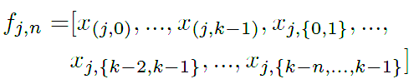2- You have also completed the gram count (2) online. It should be done

where $f$ is the feature space of document $j$ for an N-gramof size n where $x$ is specified by a word or the number of N-grams counted.

The figure shows the sub-architecture of the neural network. The left grid shows the model at the parent level and the right side shows the child level. ${ψ }_{i}$ is defined by $y$ as input documents at the parent level. The figure on the left shows the network structure for the first level (parent level) of the category. The second level classification (child level) in the hierarchical structure consists of deep networks that are trained for the output related to a specific domain in the first level. The second level in the structure of this network is connected to the output of the first level. For example, if the output of the first level, the label is computer science then the network at the next level (figure on the right side ) ${ψ }_{i}$ is trained only for documents related to computer science. In fact, the first level network is trained with all documents and each network at the next level is trained only for documents related to a specific domain.

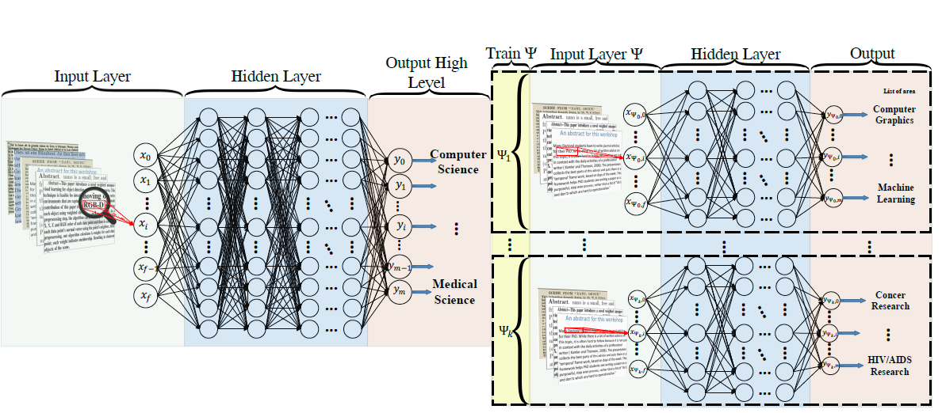

For training, the network uses the standard backpropagation algorithm , sigmoid, and ReLU activation functions. The output layer uses softmax which are listed below respectively.

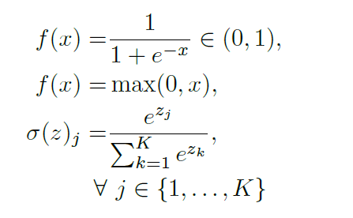

A set of inputs including pairs of document samples and their corresponding categories is given, and the network must perform learning by using hidden layers of the inputs and the target space The network is trained with 8 hidden layers, 1024 nodes in each layer, and a learning rate of 0.001.

Experiment with a learning rate of 0.2

|  |  |  |
| --- | --- | --- |
| The error rate for the test set | The error rate for the training set | Neurons |
| 11.3% | 6.3% | 100 |
| 10.9% | 5.6% | 150 |
| 10.1% | 4.8% | 200 |

1. **Number of neurons=** 200

**MSE for Train Data**

**MSE for Validation Data:**

1. **The number of neurons in the hidden layer is 100 for the first hidden layer and 100 for the second hidden layer.** According to the comparison with the case of 200 hidden neurons, the error on the training data was about 7.3% and on the test data, the error was reported as 14.7% which shows an increase in the error rate.
2. **For 200 neurons in the hidden layer:** In the experiments performed for leaening rate of 0.5 and with different numbers of hidden neurons, the algorithm mostly did not converge, but by halving the value of the learning rate after a few epochs better answers were obtained.

|  |  |  |
| --- | --- | --- |
| Accuracy for the test set | Accuracy of the training set | Learning rate |
| 86.6% | 90.3% | 0.5 |
| 89.9% | 95.2% | 0.1 |
| 94.7% | 97.8% | 0.002 |

The number of training rounds was between 4 and 5 rounds.

|  |  |
| --- | --- |
| Average PSNR | Neurons |
| 51.71 | 9 |
| 60.62 | 16 |
| 63.91 | 36 |

MSE plot for 9 neurons:

MSE plot for 16 neurons

MSE plot for 36 neurons

**Compressed Images:**

Number of hidden neurons : 9

 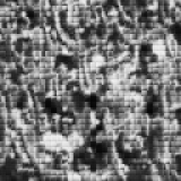 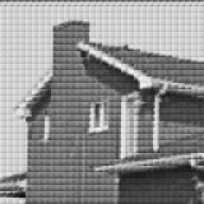  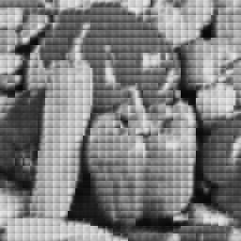

The number of hidden neurons is 16

 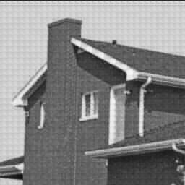 

The number of hidden neurons is 36

 