Starviewer is an application for the visualisation and navigation of medical images using the DICOM protocol. It supports different modalities: X-ray, CT, magnetic resonance, mammography, radio fluoroscopy, ultrasound and others. It can communicate with any PACS, or obtain images from external files.

# How to find a study in the pacs

To look for a study in the PACS, go to menu **File>PACS**, or press CONTROL+P keys. The following window appears:

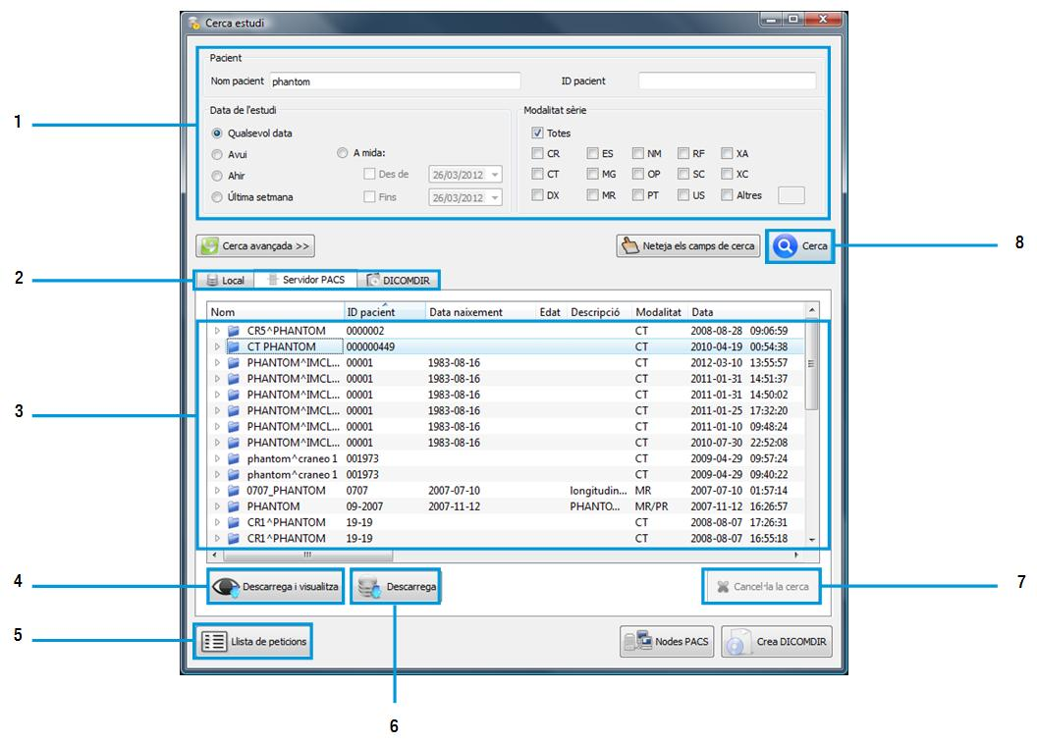

Check that **PACS Server** tab is selected (2).

Enter search parameters (patient name, study date…) (1).

Click **Search** button (or press RETURN key) (8).

Select one or several studies from the list (3).

Click **Retrieve & View** so that the study is retrieved and opened automatically (4).

If the study has to be retrieved and not viewed, click **Retrieve** (6).

To cancel the query while it is being executed, click **Cancel query** (7).

To check the status of the retrievals, click **Operation List** (5).

# Choose series of the study

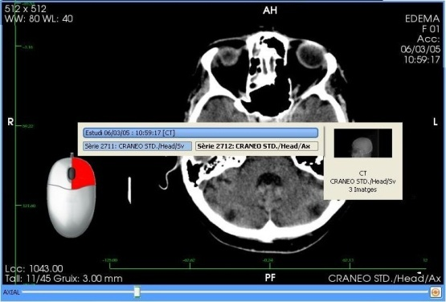

1. Right-click in a window

2. Select a series of the list

# aplicacioWLContrast and brightness (Window Level)

1. Hold right button of the mouse in a window

2. Move mouse from top to bottom and/or from right to left

# Tools

|  |  |  |  |  |
| --- | --- | --- | --- | --- |
| Slicing | **Scroll.** Change image of the series image by moving the mouse. | botoesquerrebotoMigMoure | grid.png | **Viewers’ layout.** Choose the number of windows or a hanging protocol. |
| C:\Users\Roger\Documents\trueta\starviewer\src\main\images\magnify.png | **Zoom.** Zoom in by moving the mouse up and down. | botoesquerre |  | **Related studies.** Search for studies that may be related to the patient. |
|  | **Move.** Change image’s position following the direction of the mouse. |  |  | **Reconstructions.** Switch to axial, sagittal or coronal view. |
|  | **Window change.** Change contrast and brightness of the image. |  |  | **Horizontal/Vertical Flip.** Flip image horizontally or vertically. |
| C:\Users\Ester\Documents\starviewerRevertTools\starviewer\src\main\images\ellipticalROITool.png | **Elliptical ROI.** Draw an elliptical shaped ROI to compute the area and the average of the voxels’ values. | botoesquerre |  | **Clockwise/Counter-clockwise rotation.** Rotate the image 90º in the indicated direction. |
| magicroitool.png | **Magical ROI.** Create a ROI semiautomatically. | botoesquerre |  | **Restore a viewer.** Restore the viewer to its initial state. |
|  | **Polyline ROI.** Draw a ROI manually to compute the area and the average of the voxels’ values. | botoesquerre |  | **Invert VOI LUT.** Invert the colours of the image. |
| circleTool.png | **Circle.** Create a circular region to find the centre. | botoesquerre |  | **Screenshot.** Export an image or all images to an external file. |
|  | **Distance.** Set two points to compute the distance between them. | botoesquerre |  | **Export a series.** Export a series to DICOM and optionally send it to a PACS. |
|  | **Angle.** Set three points and compute the angle they form. | botoesquerre | play.png | **Play.** Show images one after another. |
|  | **Open Angle.** Compute the angle between two lines. | botoesquerre |  | **Patient information.** Show/hide viewer’s textual information. |
| eraserViewer.png | **Erase/All of current viewer.** Erase all chosen annotations or all of the viewer. | botoesquerre |  | **DICOM information.** Dump specific information of the image contained in the DICOM. |
|  | **Reference Lines.** Show the location of the current image in the other windows. |  | linked.png | **Automatic synchronisation.** Automatically synchronise (if possible) all viewers to the same position. |
|  | **3D Cursor.** Locate in all images the point selected with the mouse. |  | linkAll.pngunlinkAll.png | **Manual synchronisation.** Synchronise viewers according to current image. |
|  | **Voxel Information.** Show information of the voxel placed under the cursor. |  |  | **Propagate.** Propagate active viewer’s visualisation properties and apply them on the viewers that meet some common criteria. |