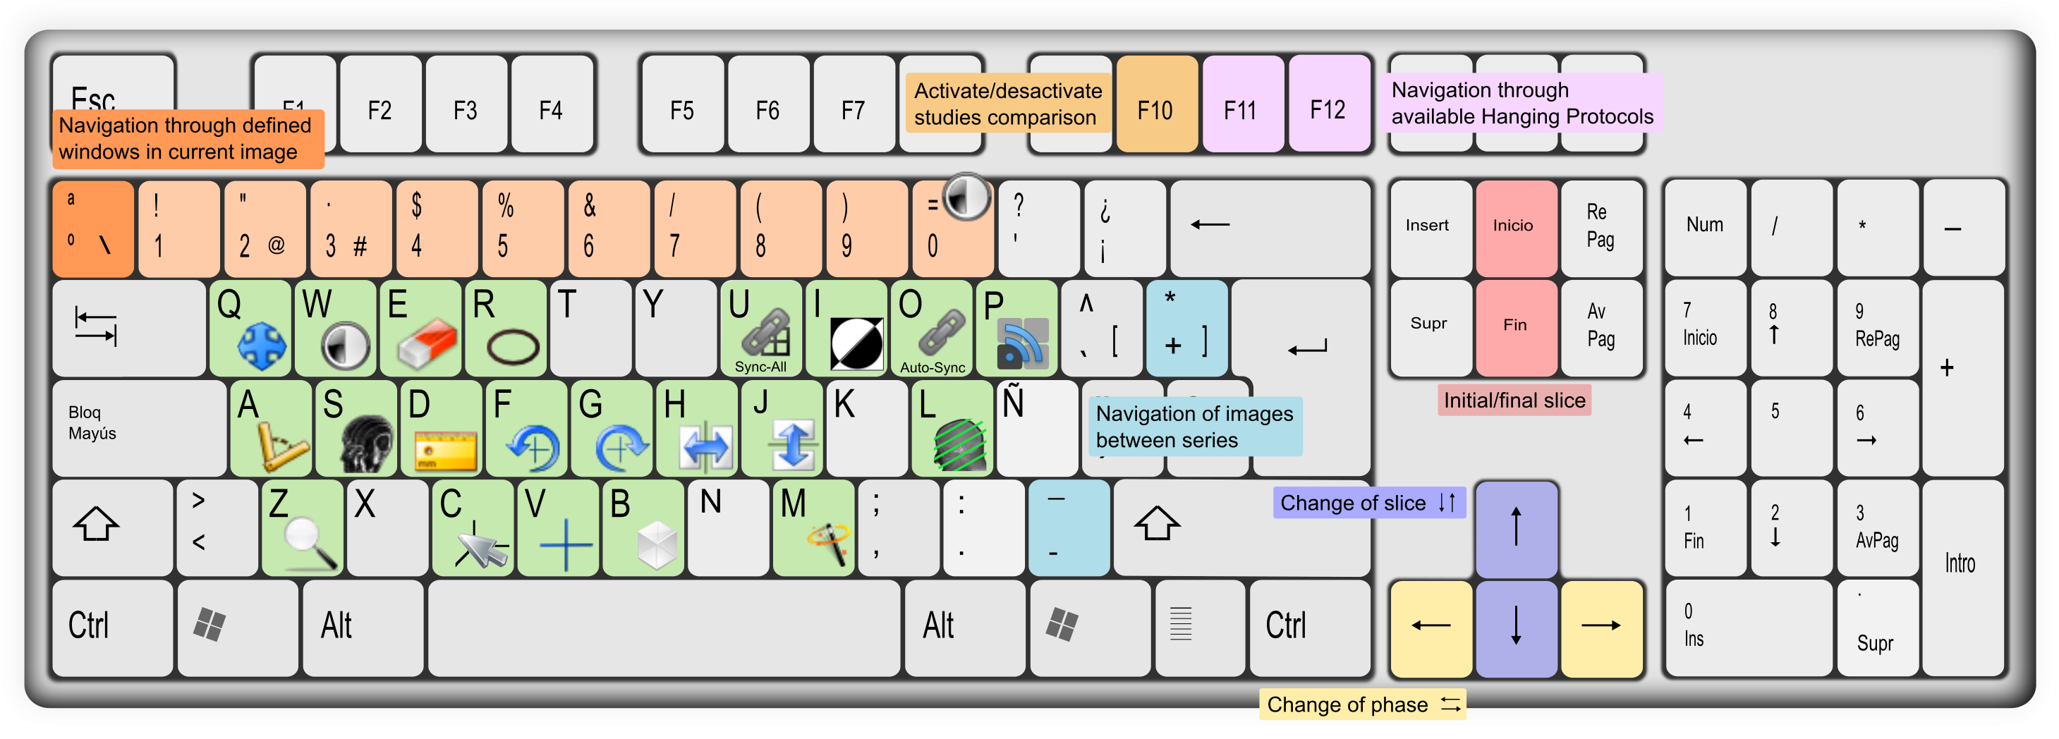

|  |  |  |  |  |  |  |  |  |
| --- | --- | --- | --- | --- | --- | --- | --- | --- |
| C:\Documents and Settings\Roger\starviewer\src\main\images\axial.png | Axial view | Ctrl + 1 | C:\Documents and Settings\Roger\starviewer\src\main\images\new.png | New window | Ctrl + N | nonClosedAngle.png | Open angle | ⇧ + A |
| C:\Documents and Settings\Roger\starviewer\src\main\images\sagital.png | Sagittal view | Ctrl + 2 | C:\Documents and Settings\Roger\starviewer\src\main\images\open.png | Open files | Ctrl + O | C:\Documents and Settings\Roger\starviewer\src\main\images\polyline.png | Polygonal region | ⇧ + R |
| C:\Documents and Settings\Roger\starviewer\src\main\images\coronal.png | Coronal view | Ctrl + 3 | C:\Documents and Settings\Roger\starviewer\src\main\images\openDICOMDIR.png | Open DICOMDIR | Ctrl + D | eraserViewer.png | Erase all annotations | Ctrl + E |
| C:\Documents and Settings\Roger\starviewer\src\main\images\photo.png | Current image screenshot | Ctrl + S | C:\Documents and Settings\Roger\starviewer\src\main\images\database.png | Explore local studies | Ctrl + L | restore.png | Restore | Ctrl + R |
| Whole series screenshot | Ctrl + A | C:\Documents and Settings\Roger\starviewer\src\main\images\pacsQuery.png | Search in the PACS | Ctrl + P | fullscreen.png | Maximise to several screens | Ctrl +⇧+ M |
| C:\Users\Roger\Documents\trueta\starviewer\src\main\images\unlinkAll.png | Unlink all viewers | ⇧ + U | C:\Users\Roger\Documents\trueta\starviewer\src\main\images\magnify.png | Magnify | ⇧ + Z |  | Move window to another screen | Ctrl +⇧+ |
|  | External applications | ⇧ + F1 ... F12 |  |  |  |  |  |  |