HY342 – PARALLEL COMPUTING

Irodotos Apostolou csd4437

How my algorithm works: I store the graph in Adjacency List that every node in the graph store in the same position a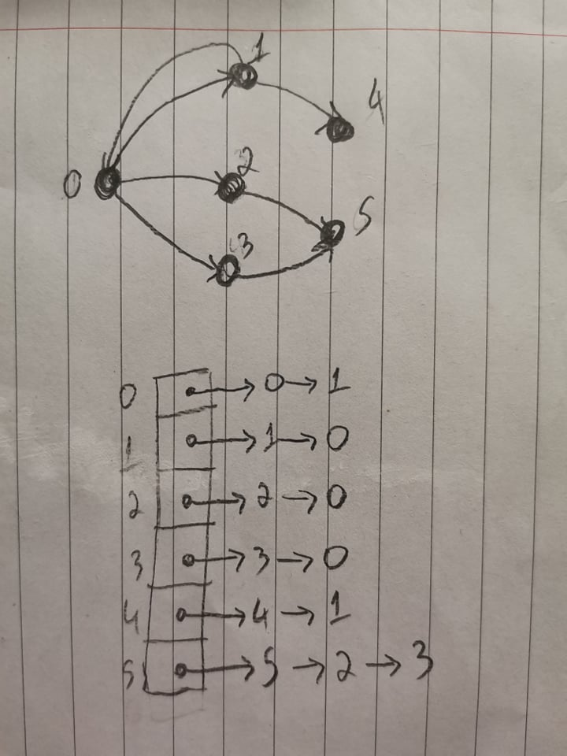s the node id and it have a list with all the incoming nodes. For example

Every time I run the pagerank I check my list with neighbors and I divide neighbors value with neighbors outgoing edges and I add it in my value.

How I get speedup with threads: I split the table in the number of threads so I give less job in each thread an run parallel

