

**Experiment No.:3**

| **TITLE:** Building and configuring simple topology using Network tool - CISCO PACKET TRACER. |
| --- |

**______________________________________________________________________________**

**AIM:** To build and configure simple network topology using CISCO Packet Tracer.

Packet Tracer is a network simulation program that allows students to experiment with network behaviour and ask “what if” questions. Packet Tracer provides simulation, visualization, and authoring, assessment, and collaboration capabilities and facilitates the teaching and learning of complex technology concepts.

**______________________________________________________________________________**

**Expected Outcome of Experiment:**

**CO:** Explain the fundamentals of the data communication networks, reference models, topologies, physical media, devices, simulators and identify their use in day to day networks.

**_____________________________________________________________________________**

**Books/ Journals/ Websites referred:**

1. <http://www.google.com>
2. A. S. Tanenbaum, “Computer Networks”, Pearson Education, Fourth Edition
3. B. A. Forouzan, “Data Communications and Networking”, TMH, Fourth Edition
4. [CISCO PACKET TRACER 8.0.1 and Higher version (free download)](https://mega.co.nz/#!q4p0wS7Z!J9jkMwXzZSO4zP1kZX632VFYyxNzwPUhvx8f8Ejyen0%20(53.3%20MB))

**Pre-Lab/ Prior Concepts:** Simple Network flow

**______________________________________________________________________________**

**New Concepts to be learned**: Purpose of this lab is to become familiar with building topologies in Packet Tracer. ______________________________________________________________________________

**Stepwise-Procedure:**

Creating a simple LAN network using packet tracer:

Step 1: Select two PCs (PC0 and PC1) from the end devices and one fast ethernet switch (2950/24 ports)

Step 2: Connect PCs and switch via copper cable from the panel. Connection can be verified by appearance of all green dots on the links.

Step 3: For PCs to communicate click on PC0.

* Dialog box for PC0 appears
* Click on desktop applications by packet tracer.
* Go to IP configuration.
* Enter IP address to identify host i.e. PC0 (for example: 192.168.1.1)
* Subnet mask-by default already set one can change it as per his/her specification.

Step 4: Repeat step 3 for PC1

Step 5: Ping both the PCs and check their working status.

Step 6: Simple PDU (Protocol Data Unit) to simulate network traffic by sending ICMP PDU to assess the network traffic. View simulation in simulation mode

**IMPLEMENTATION:** (printout of simulation code)

**Network Topologies:**

1. **Topology with a HUB**

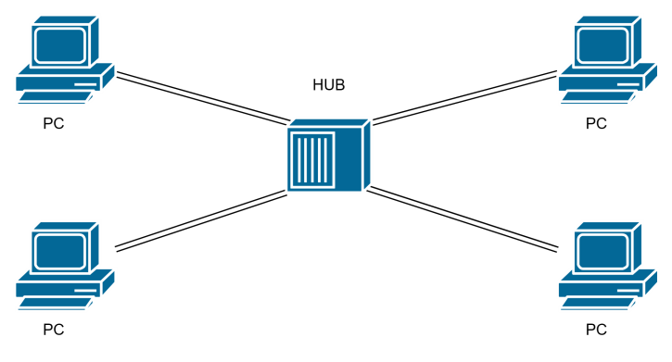

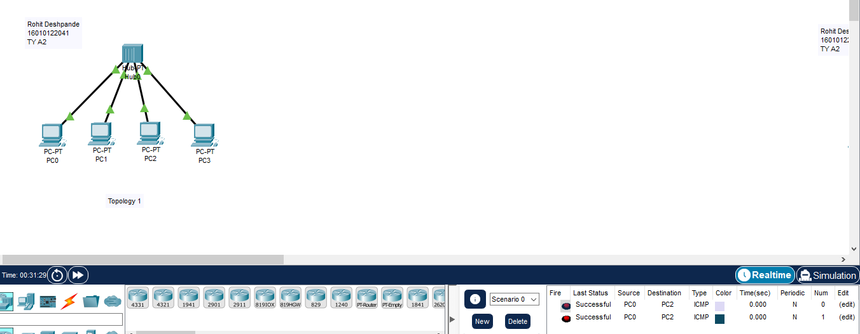

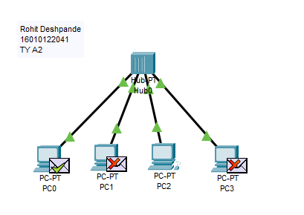

**2. Topology with a Switch**

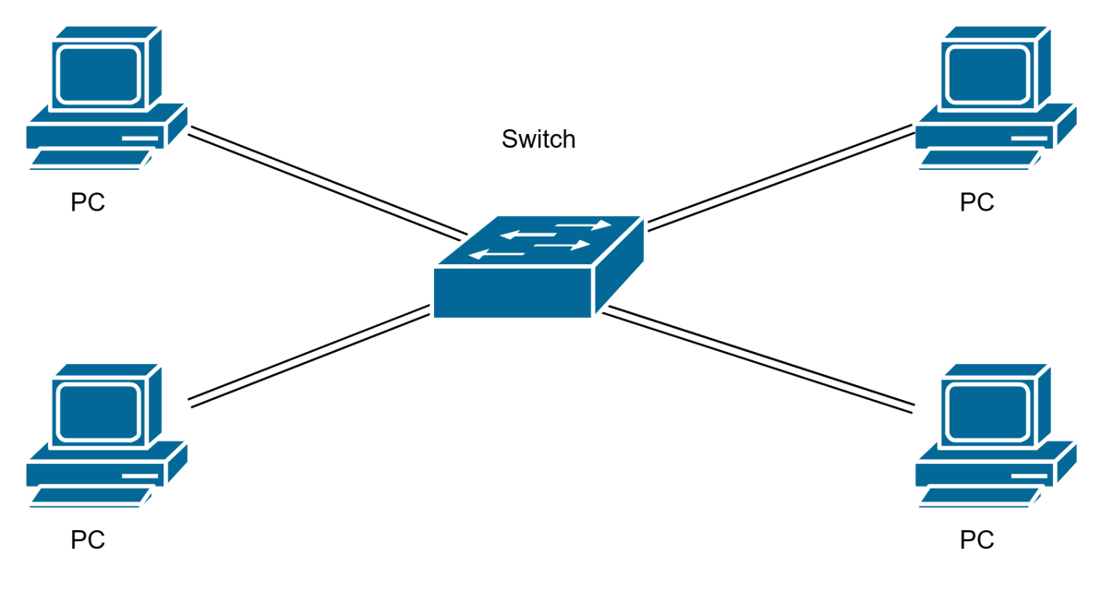

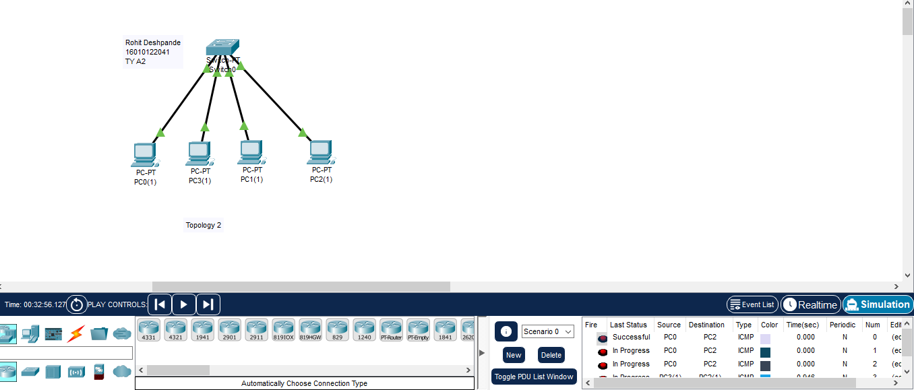

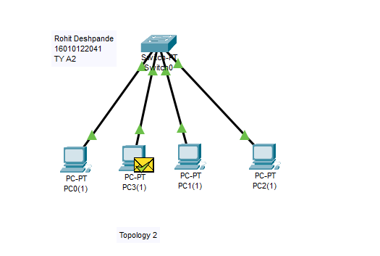

**3. Topology with two switches**

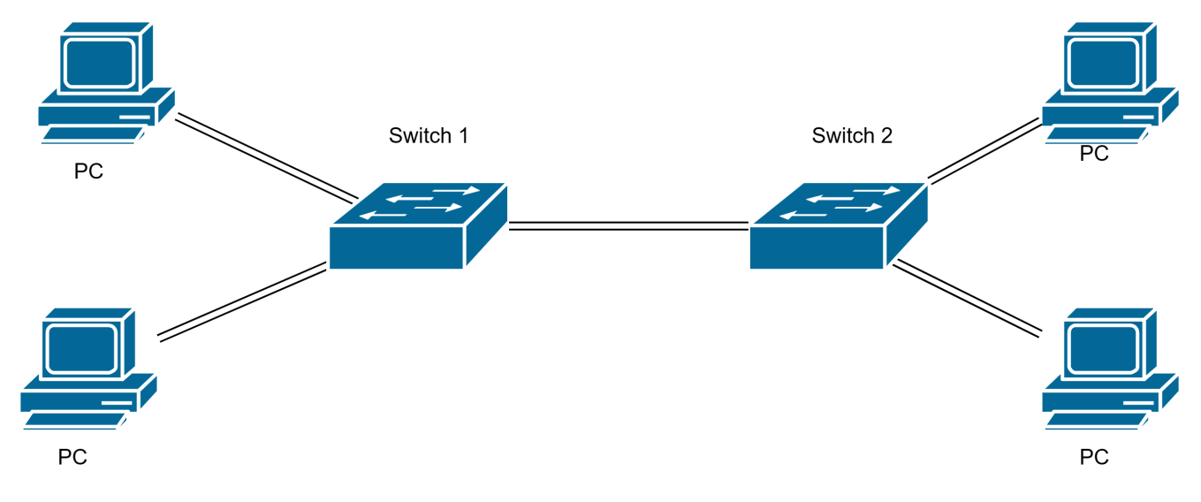

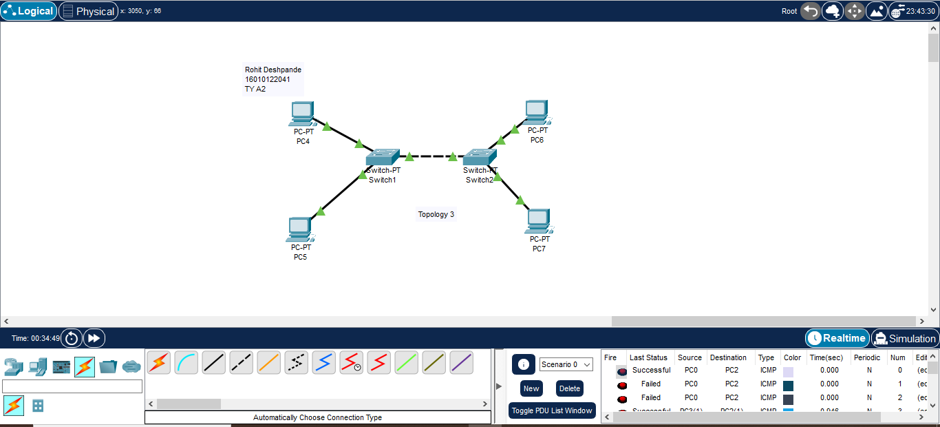

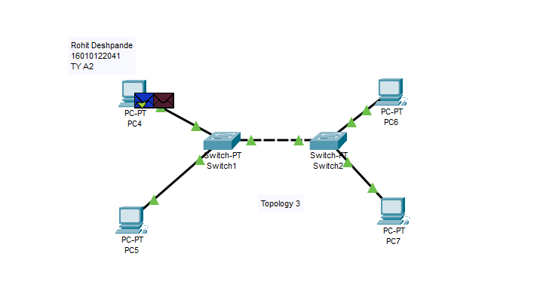

1. **Topology with 3 switches in a loop (Concept of STP)**

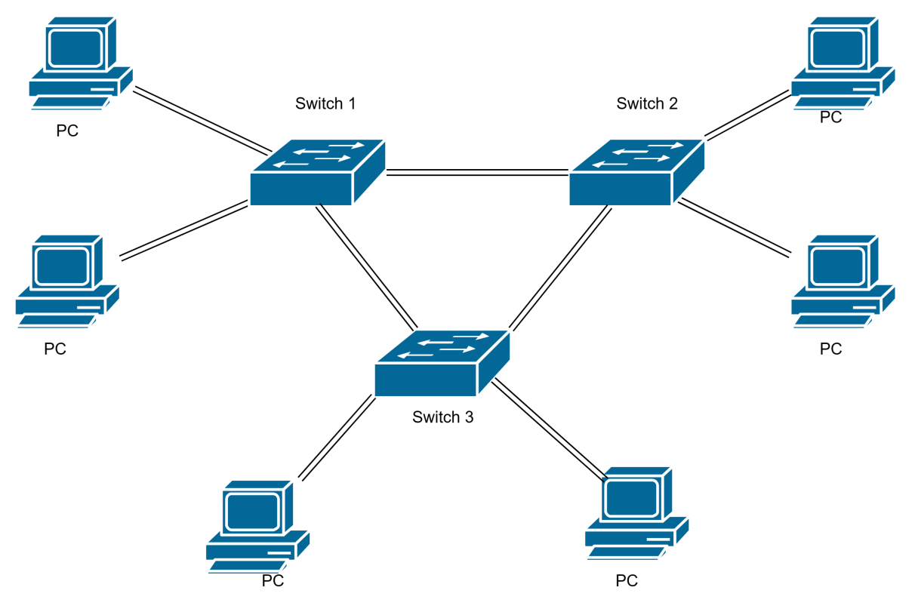

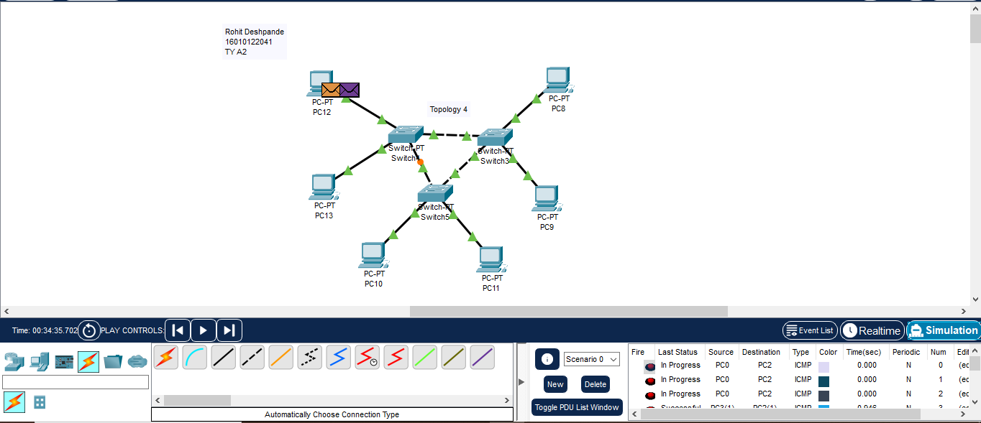

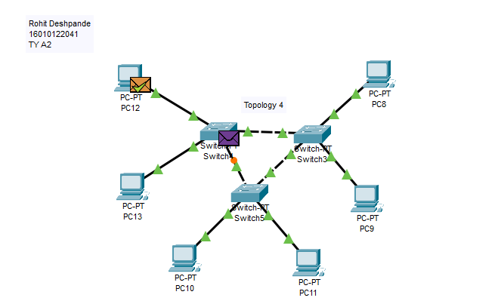

**CONCLUSION:** We understood different network topologies and they were configured successfully using CISCO Packet Tracker.

**Post Lab Questions**

1. **List features of CISCO packet tracer.**

Features Cisco Packet Tracer includes:

• Makes teaching easier by providing a free, multiuser environment for instructors to easily teach complex technical concepts.

• Makes learning easier by providing a realistic network simulation and visualization environment.

• Provides authoring of learning activities, tasks, labs, and complex assessments.

• Supports lectures, group and individual labs, homework, assessments, case studies, games, and competitions.

• Supplements real equipment and enables extended learning opportunities beyond physical classroom limitations.

• Simulates continuous real-time updates of underlying network logic and activities.

• Empowers students to explore concepts, conduct experiments, and test their understanding.

• Promotes social learning through a network-capable (peer-to-peer) application with opportunities for multiuser competition, remote instructor-student interactions, social networking, and gaming.

1. **Explain difference between working of a Hub and a Switch in a given topology.**

• A hub is a networking device that connects multiple PCs to a single network, where as a switch connects multiple devices on a single computer network.

• A hub operates on the OSI physical layer, where as a switch operates on the OSI data link layer

**Date: _____________ Signature of faculty in-charge**