

**Experiment No.:9**

| **TITLE: Study and configure DHCP & DNS protocol using Cisco Packet tracer** |
| --- |

**AIM:** To study and configure **DHCP/DNS** protocol using Cisco Packet tracer

**______________________________________________________________________**

**Expected Outcome of Experiment:**

**CO:**

**______________________________________________________________________**

**Books/ Journals/ Websites referred:**

1. A. S. Tanenbaum, “Computer Networks”, Pearson Education, Fourth Edition
2. B. A. Forouzan, “Data Communications and Networking”, TMH, Fourth Edition

______________________________________________________________________

**Pre Lab/ Prior Concepts:**

IPv4 Addressing, Subnetting, Link State Protocol, Router configuration Commands

**______________________________________________________________________**

**New Concepts to be learned: DHCP/DNS** Protocol and its configuration.

**______________________________________________________________________**

**THEORY:**

### DHCP (Dynamic Host Configuration Protocol)

DHCP (Dynamic Host Configuration Protocol) is a network management protocol used to automatically assign IP addresses and other network configurations (like subnet mask, default gateway, and DNS server) to devices on a network. It eliminates the need for manually configuring IP settings on each device, streamlining network management, especially in larger networks.

#### How DHCP Works:

1. **DHCP Discovery**: When a device (DHCP client) connects to a network, it sends out a broadcast message (DHCPDISCOVER) to discover available DHCP servers.
2. **DHCP Offer**: The DHCP server responds to the client with a DHCPOFFER message, proposing an IP address and other network configuration details.
3. **DHCP Request**: The client replies to the server with a DHCPREQUEST message, indicating acceptance of the offered IP configuration.
4. **DHCP Acknowledgment**: The server sends a DHCPACK message to confirm the lease of the IP address and finalize the configuration.

The assigned IP address is "leased" for a certain period, after which the client must renew it. DHCP simplifies network administration by dynamically managing IP addresses, preventing conflicts, and ensuring efficient IP address allocation.

#### Advantages:

* **Automatic Configuration**: Eliminates the need for manual IP configuration.
* **Centralized Management**: Network administrators can manage and modify IP settings from a central DHCP server.
* **Efficient IP Utilization**: Dynamic assignment prevents the wastage of IP addresses, ensuring optimal use of available resources.

### DNS (Domain Name System)

DNS (Domain Name System) is the backbone of the internet's naming system, translating human-readable domain names (like [www.example.com](http://www.example.com)) into IP addresses (like 192.0.2.1) that computers use to identify each other on the network. DNS plays a crucial role in web browsing, email, and other services by resolving domain names into machine-readable formats.

#### How DNS Works:

1. **DNS Query**: When a user enters a domain name in their browser, the DNS resolver (usually provided by the ISP) checks its cache for the IP address. If the information is not cached, the resolver queries a DNS server.
2. **Recursive Query**: The resolver may perform a recursive query to multiple DNS servers, starting from the **root** servers, then moving to **TLD (Top-Level Domain)** servers (e.g., .com, .org), and finally to the **authoritative name server** that holds the IP address for the specific domain.
3. **DNS Response**: Once the authoritative name server is reached, it responds with the corresponding IP address, which the resolver sends back to the client. The client can then connect to the server using the IP address.

#### Types of DNS Records:

* **A Record**: Maps a domain to an IPv4 address.
* **AAAA Record**: Maps a domain to an IPv6 address.
* **MX Record**: Specifies the mail server responsible for receiving emails for the domain.
* **CNAME Record**: Points one domain name to another (alias).
* **NS Record**: Identifies the name servers responsible for the domain.

#### Advantages:

* **Easy Navigation**: Allows users to navigate the web using domain names instead of remembering numerical IP addresses.
* **Scalability**: DNS is highly scalable, handling billions of queries per day.
* **Decentralized Architecture**: The hierarchical nature of DNS ensures resilience and efficient handling of domain queries.

Both DHCP and DNS are essential components in managing and navigating modern computer networks, enabling seamless communication between devices and internet services.

**IMPLEMENTATION:**

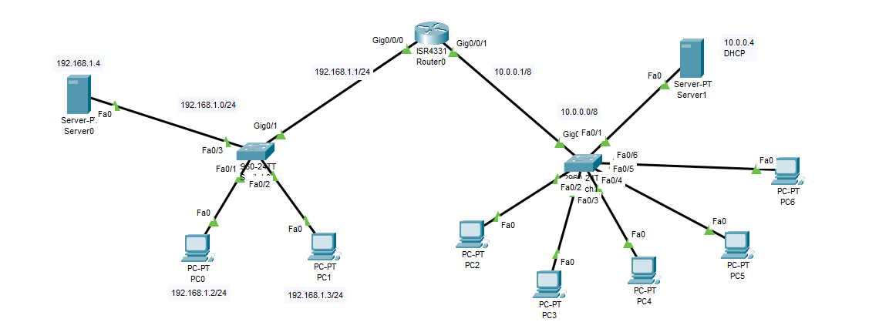

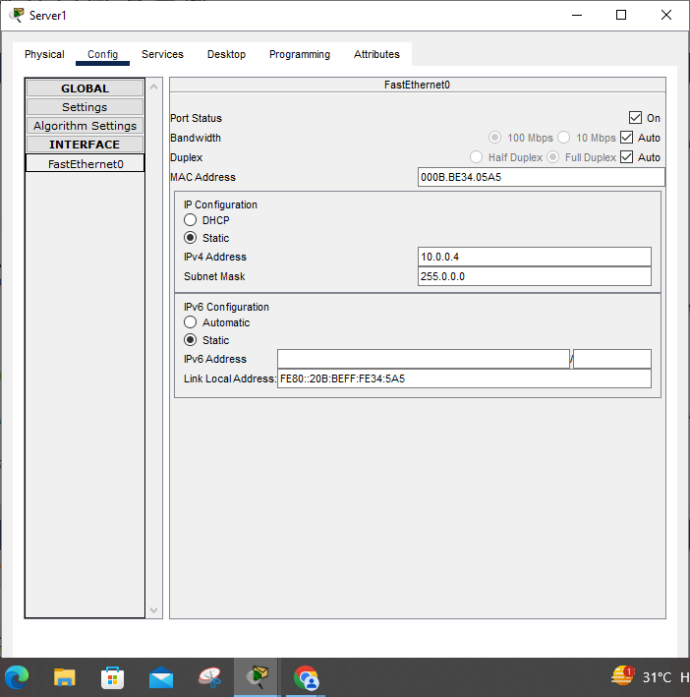

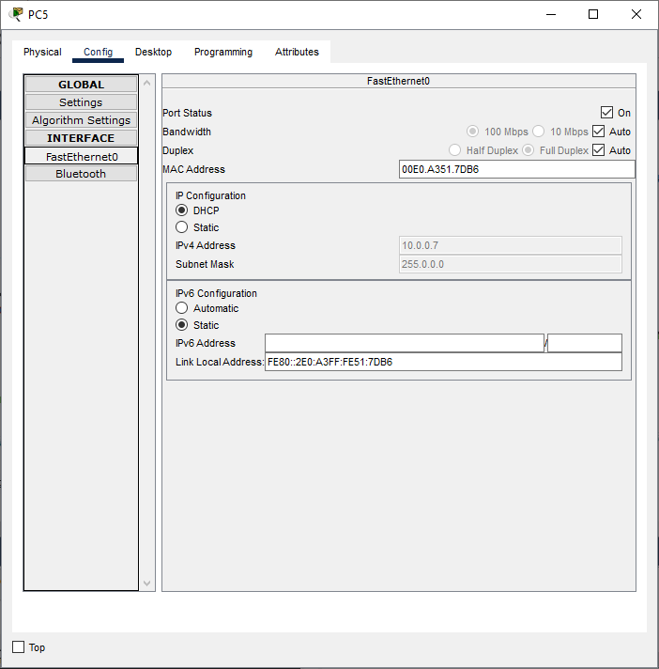

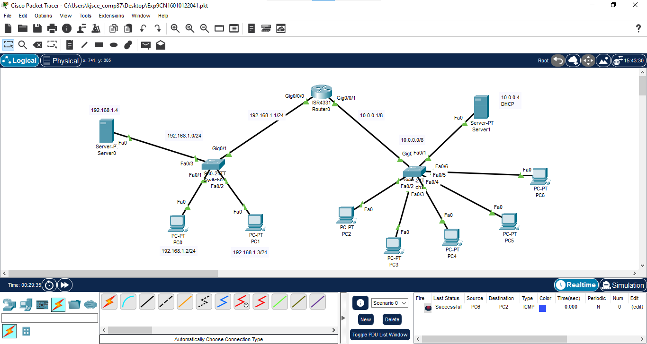

**CONCLUSION:** Successfully implemented DHCP and DNS network.

**Date: ___________ Signature of faculty in-charge**