**Software Engineering**

**Experiment 8**

**Name:** Rohit Sattendra Deshpande

**Batch:** TY COMPS A2

**Roll No.:** 16010122041

_____________________________________________________________________________________

**Study of Project Management Tools:**

**Jira: A Comprehensive Tool for Agile Project Management**

**Introduction**

Jira, developed by Atlassian, is one of the leading project management and issue-tracking tools in the tech industry, widely adopted by agile development teams. Originally created as a bug and issue tracker, Jira has evolved into a fully-featured project management platform with a strong focus on agile methodologies. Known for its robust and customizable features, Jira provides teams with tools for sprint planning, issue tracking, backlog management, and project reporting. It supports various agile frameworks, including Scrum, Kanban, and hybrid approaches, making it highly versatile for development and non-development projects alike.

**Key Features of Jira**

1. **Sprint Planning:** Jira is designed to streamline sprint planning, allowing teams to create and manage sprints effortlessly. With customizable Scrum boards, teams can organize their backlog, estimate task complexity, and set sprint goals. Jira also provides burndown charts, which track the team’s progress throughout a sprint, helping them stay on track with their objectives.
2. **Issue and Task Tracking:** At its core, Jira excels in issue and task tracking. Issues can be assigned to team members, tagged with priority levels, and categorized by type (bug, task, story, epic, etc.). Each issue includes space for descriptions, attachments, comments, and status updates, creating a single source of truth for all task-related information. This functionality helps teams monitor each issue's lifecycle and ensures efficient task management.
3. **Backlog Prioritization:** Jira’s backlog functionality is essential for agile teams, enabling them to prioritize tasks based on project needs. Product owners and managers can easily reorder tasks, assign priorities, and plan future sprints. Using drag-and-drop capabilities, teams can organize the backlog visually, which aids in planning and prioritization.
4. **Agile Framework Support:** Jira natively supports both Scrum and Kanban methodologies, making it highly adaptable to various agile frameworks. Teams practicing Scrum can use sprint boards, backlogs, and detailed reporting to manage their sprints, while Kanban teams benefit from a streamlined workflow visualization on Kanban boards. Custom workflows allow Jira to adapt to hybrid or custom agile approaches that might blend Scrum and Kanban elements.
5. **Reporting and Analytics:** Jira includes powerful reporting and analytics tools, providing insights into team performance and project progress. Built-in reports, such as velocity charts, burndown and burnup charts, sprint reports, and cumulative flow diagrams, allow teams to analyze productivity, identify bottlenecks, and improve processes. These reports are crucial for agile teams to review retrospectives and implement continuous improvement.
6. **Customization and Integration:** One of Jira’s standout features is its high level of customization. Teams can create custom issue types, statuses, workflows, and fields, adapting Jira to meet specific project requirements. Additionally, Jira integrates seamlessly with other tools in the Atlassian suite, such as Confluence, Bitbucket, and Trello, and supports integrations with hundreds of third-party applications, making it a versatile choice for organizations of all sizes.
7. **Automation:** Jira offers automation rules that allow teams to streamline repetitive tasks, improve efficiency, and reduce manual work. For example, teams can set rules to automatically assign issues, update statuses, or trigger notifications based on specific conditions. Automation is highly customizable and helps reduce administrative overhead, allowing teams to focus on high-priority work.

**Benefits of Using Jira for Agile Teams**

1. **Enhanced Collaboration:** Jira centralizes information and facilitates communication between team members, product owners, and stakeholders, fostering a collaborative environment.
2. **Visibility and Transparency:** With boards, reports, and customizable workflows, teams and stakeholders have full visibility into project progress, task status, and team productivity.
3. **Scalability:** Jira scales well from small to large teams and is used in various industries, from startups to enterprise-level organizations.
4. **Continuous Improvement:** Built-in reporting and retrospective tools encourage agile teams to continually improve by learning from past sprints and implementing new strategies.

**Drawbacks of Jira**

While Jira offers many benefits, it also has some limitations. Some users find Jira’s interface complex and initially challenging to navigate. Customizing Jira can also be time-intensive, particularly for teams unfamiliar with its robust feature set. Additionally, Jira's pricing can be a consideration for small teams or startups with limited budgets.

**Conclusion**

Jira has become a premier choice for agile teams due to its comprehensive feature set, flexibility, and scalability. Whether used for sprint planning, issue tracking, or agile reporting, Jira provides tools that enable teams to work more efficiently and collaboratively. While it may have a learning curve, the investment in time to understand and customize Jira often yields high returns in team productivity and project success. As agile practices continue to evolve, Jira’s adaptability ensures it remains relevant in an increasingly competitive project management software landscape. 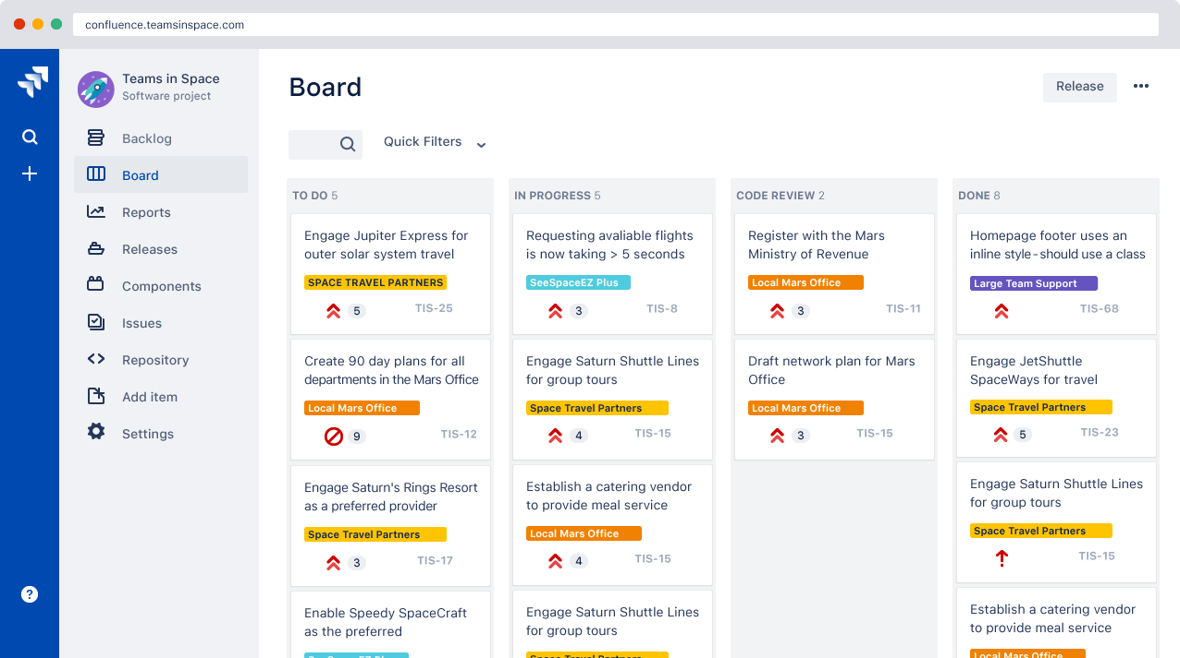

**A dashboard view in Jira**

**Trello: A Flexible Tool for Visual Project Management**

**Introduction**

Trello, developed by Atlassian, is a popular project management tool known for its simple yet powerful card-based Kanban system. Trello’s visual approach to task management, which organizes projects into boards, lists, and cards, makes it highly effective for tracking tasks across various stages. Originally created for personal task organization, Trello has expanded into a versatile platform widely used by agile teams, small businesses, and even large organizations. Trello’s flexibility and ease of use make it an excellent choice for agile project management, creative collaboration, and productivity tracking.

**Key Features of Trello**

1. **Kanban-Based Board Structure:** Trello is built around a Kanban-style interface, where each project is visualized as a board. Within each board, teams can create lists representing stages of the workflow, such as “To Do,” “In Progress,” and “Done.” Cards are used to represent individual tasks and can be moved from one list to another, providing a clear visual indication of progress.
2. **Cards and Task Details:** Cards are the core element of Trello’s task management system. Each card represents a task or item and can be enriched with various details such as descriptions, due dates, checklists, attachments, and comments. Team members can be assigned to cards, creating accountability and ensuring that everyone knows their responsibilities. Cards can also be labeled with color-coded tags, helping teams organize tasks by category or priority.
3. **Team Collaboration:** Trello supports team collaboration through commenting, tagging, and notifications. Team members can leave comments on cards, tag others to bring their attention to specific tasks, and receive notifications about updates. This allows for real-time communication, making Trello ideal for distributed teams. The built-in activity log also provides a history of actions taken on each card, giving team members insight into recent changes.
4. **Butler Automation:** Trello includes an automation feature called Butler, which allows users to automate repetitive tasks and create custom workflows. With Butler, teams can set up rules, buttons, and commands to automatically move cards, assign team members, or send notifications based on triggers, such as due dates or card movements. This helps teams reduce administrative work and streamline task management.
5. **Power-Ups and Integrations:** Trello’s Power-Ups (integrations) enhance its functionality by allowing users to add features like calendar views, reporting, time tracking, and custom fields. Power-Ups also enable seamless integration with other tools, such as Slack, Google Drive, and Jira, making it easier to connect Trello with existing workflows. Trello offers a wide range of Power-Ups, from communication tools to advanced analytics, giving teams flexibility in customizing the platform to meet their needs.
6. **Flexible Project Management:** While Trello is commonly associated with Kanban, it is flexible enough to support various project management styles. Teams can customize boards to fit their workflow, creating unique lists and labels tailored to the specific project. For agile teams, Trello can be used to manage sprints, product backlogs, and task prioritization.
7. **Mobile and Desktop Accessibility:** Trello’s web-based platform is accessible on desktop and mobile devices, allowing teams to manage projects on the go. The mobile app offers a streamlined experience with nearly all the features available on the desktop, making it easy for team members to stay updated and engaged, regardless of their location.

**Benefits of Using Trello**

1. **Ease of Use:** Trello’s intuitive design and drag-and-drop functionality make it accessible for users of all experience levels, reducing the learning curve.
2. **Visual Organization:** Trello’s card-based system allows teams to visualize tasks and workflows, which is especially helpful for agile teams managing iterative processes.
3. **Collaboration and Transparency:** Trello’s collaboration features, including comments, tags, and activity logs, provide transparency and facilitate teamwork.
4. **Flexibility and Customization:** Trello is highly adaptable to different project types and scales, from personal task tracking to team-level project management.

**Limitations of Trello**

While Trello is highly flexible, it has some limitations, particularly for larger teams or complex projects. Trello’s visual approach can become cluttered when handling high volumes of cards, making it challenging to manage large backlogs. Additionally, Trello lacks built-in reporting and analytics features, which may require teams to use Power-Ups or third-party tools for detailed metrics and tracking. For organizations seeking highly structured project management with detailed timelines, dependencies, or Gantt charts, Trello may require additional integrations to fulfill these needs.

**Conclusion**

Trello is an accessible and flexible tool for project management, ideal for agile teams, creative projects, and personal organization. Its simplicity, combined with powerful collaboration features and customizable boards, make it a favorite for visual task management. While it may lack some advanced functionalities found in more complex project management tools, Trello’s ease of use, automation options, and range of integrations provide a compelling solution for teams looking to manage projects and track progress visually. Its continued evolution and integrations with other Atlassian products ensure that Trello remains a relevant and valuable tool for modern, agile project management. 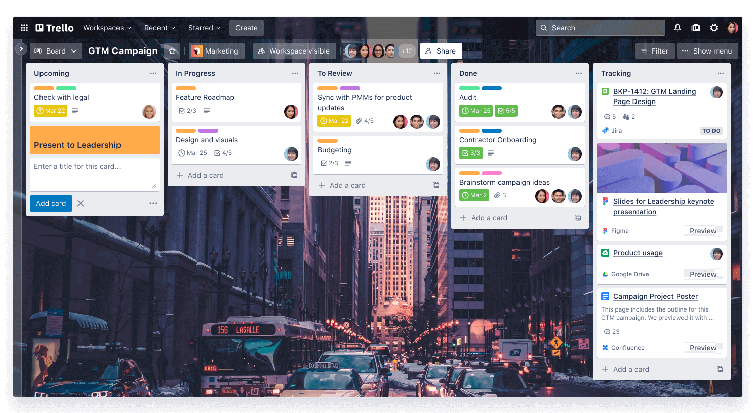

**A workspace overview in Trello**