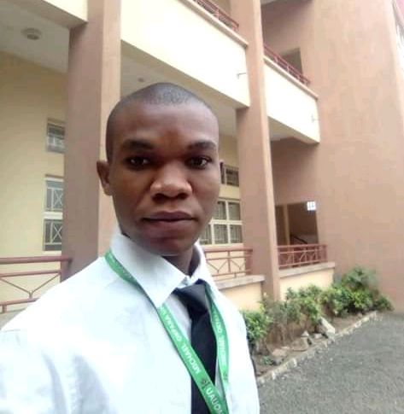

****NTOMCHUKWU IROKA CHISOM****

**PERSONAL INFO**

* **First Name:** Ntomchukwu
* **Surname:** Iroka
* **Middle Name:** Chisom
* **Nationality:** Nigerian
* **State:** Imo State
* **Local Government:** Orsu
* **Address:** Opposite Christ Anglican Church, Ubahaeze-deke Awo-Idemili in Orsu L.G.A Imo state.
* **Date of Birth:** 01/August/1996
* **Gender:** Male
* **Main Email:** irokatochukwu@gmail.com
* **Other Email:** irokant09@gmail.com
* **Mobile Number:** +2349014864168
* **NATIONAL ID Card:** see it on https://iroka09.github.io/my_credentials/national_id_card.jpg

**Education**

* **Degree:** Bachelor of Engineering in Electrical and Electronics Engineering
* **University:** Michael Okpara University of Agriculture Umudike (MOUAU)
* **Graduation Year:** 2019/2020
* **Statement Of Result:** See it on https://iroka09.github.io/my_credentials/statement_of_result.jpg
* **NSE Student Member:** https://iroka09.github.io/my_credentials/nse_student_member_cert.jpg

**Skills**

**Full Stack Web Development:**

* **Markup Languages:** HTML
* **Style Sheet Languages:** CSS, Sass
* **Front-End Technologies:** JavaScript, TypeScript, ReactJS, NextJS, Redux, Bootstrap, Material-UI, TailwindCSS and Responsive design that suits all screens.
* **Back-End Technologies:** NodeJS, Typescript, ExpressJS, MongoDB/MongooseJS, NextJS, Next-Auth, Socket.io

**Other Technologies:** Jest (testing library), Webpack, Babel, JavaScript (Web Development), Python (Data Analysis).

* **Portfolio:** https://iroka09.github.io
* **Certificate1**: https://iroka09.github.io/my_credentials/ict_solution_cert.jpg
* **Certificate2**: https://iroka09.github.io/my_credentials/ict_competent_cert.jpg
* **Certificate3**: https://iroka09.github.io/my_credentials/cartel_ict_cert.jpg

**Summary:** My proficiency in web development technologies ensures innovative problem-solving and a comprehensive understanding of both hardware and software aspects. My versatility is poised to enhance project outcomes and contribute to the technological advancement of the organization.

**Computer operation**

* Microsoft Excel
* Microsoft Word
* Graphics Design using CorelDraw

**Summary:** My broad skill set extends to electrical engineering, software programming, and graphic design, ensuring a comprehensive approach to projects. My proficiency in Git commands and SQL further enhances collaboration and data management.

**Electrical & Electronics:**

House wiring.

Ability to repair home electrical appliances.

Ability to repair some electronics devices.