**UI Design**

I have chosen to redesign (depicted to the left) the app WilkinDone. Unfortunately this is an iOS only application but I have given the Android app design guide. From top to bottom, I have chosen to remove the bar from the top of the app which had the sole purpose of switching views between table/calendar modes. I kept the filter/search bar to search through tasks based on user requirements. With the removal of the top toggle bar, the application has more screen real estate to dedicate to tasks. Currently, the application displays tasks in the groups The Past, Earlier, Later Today, Tomorrow, This Week, This Month, and The Future. I think this is too complicated and should just be Past, Now (not present because both past and present start with "P" which could become visually confusing), and Future. On the bottom navbar, I have chosen to include a "Toggle View" button which will allow users to view tasks in a table or calendar view. To create a new task (this screen only) there will be a large circular button in the middle of this navbar. To the right of this, the settings button to access app settings.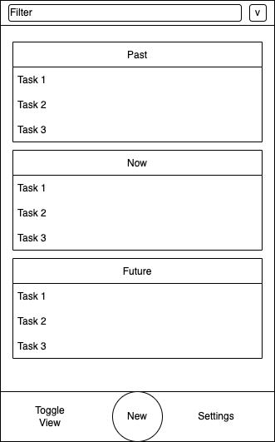

The only real performance issue I have had with regards to the UI of the app is a spinner after unlocking my screen. The application does not seem to be caching/saving state correctly when the user's device is locked. If the application is open when the screen is unlocked, the background becomes dark and inaccessible while the spinner spins. The same behavior occurs when switching focus back to WilkinDone after it has been minimized. This probably has to do with the local storage of the application and we can probably cache some data in memory to speed this up slightly.