Q1. Why is "matrixtask" using most of the CPU utilization?
A: Because this “for (simulationdelay = 0; simulationdelay<1000000000; simulationdelay++) ; “ would take a lot of time(Execution time is very long).

Q2. Why must the priority of "communicationtask" increase in order for it to work properly
A: The task of communicationtask could preemptive the task of matrixtask when it exists blocked state.

Q3. What happens to the completion time of "matrixtask" when the priority of "communicationtask" is increased?
A: The task of matrixtask would be preemptived by the task of communicationtask.n

Q4. How many seconds is the period of "matrixtask"? (Hint: look at vApplicationTickHook() to measure it)
A: About 900~1000ms.

Simulation result:

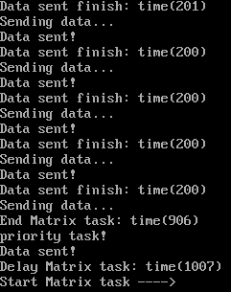
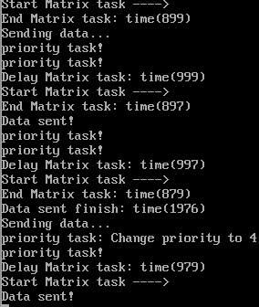
Start Matrix
End Matrix
Matrix
Communication
Priority Set
t
Sending data ...
Priority check
Priority check
Start Matrix
End Matrix
Data sent!
Priority check
Priority check
Start Matrix
End Matrix
Sending data ...
Change priority to 4
Priority check
Data sent!
Matrix function
Sending data ...
Matrix function
Data sent!
Matrix function
Sending data ...
Matrix function
Data sent!
Matrix function
Start Matrix
Sending data ...
...

