Theory assignment

1. T1(15, 1, 14) T2(20, 2, 26) T3(22, 3)
Requirement 1: f >= 3
Requirement 2: f = {22, 20, 15, 12, 11, 10, 6, 5, 4, 3, 2, 1}
Requirement 3: 2f - gcd(pi, f) <= Di
f | T1(15, 1, 14) T2(20, 2, 26) T3(22, 3)
22  20  15  12  11  10  6 | 44 - 1 <= 14 (X)  40 - 5 <= 14 (X)  30 - 15 <= 14 (X)  24 - 3 <= 14 (X)  22 - 1 <= 14 (X)  20 - 5 <= 14 (X)  12 - 3 <= 14 (OK) 12 - 2 <= 26 (OK) 12 - 2 <= 22 (OK)
Frame size: 6
2. T1(4, 1) T2(5, 2, 7) T3(20, 5)
Requirement 1: f >= 5
Requirement 2: f = {1, 2, 4, 5, 10, 20}
Requirement 3: 2f - gcd(pi, f) <= Di
f | T1(4, 1) T2(5, 2, 7) T3(20, 5)
20  10  5  4 | 40 - 4 <= 4 (X)  20 - 2 <= 4 (X)  10 - 1 <= 4 (X)  8 - 4 <= 4 (OK) 8 - 1 <= 7 (OK) 8 - 4 <= 20 (OK)
Frame size: 4, Job from T3 split into 2 parts. One part is time of 4, another is time of 1.
3. T1(5, 0.1) T2(7, 1) T3(12, 6) T4(45, 9)
Requirement 1: f >= 9
Requirement 2: f = {1, 2, 3, 4, 5, 6, 7, 9, 10, 12, 14, 15, 18, 20, 21, 28, 30, 35, 42, 45}
Requirement 3: 2f - gcd(pi, f) <= Di
f | T1(5, 0.1) T2(7, 1) T3(12, 6) T4(45, 9)
45  42  35  30  28  21  20  18  15  14  12  10  9  7  6  5  4  3 | 90 - 5 <= 5 (X)  84 - 1 <= 5 (X)  70 - 5 <= 5 (X)  60 - 5 <= 5 (X)  56 - 1 <= 5 (X)  42 - 1 <= 5 (X)  40 - 5 <= 5 (X)  35 - 1 <= 5 (X)  30 - 5 <= 5 (X)  28 - 1 <= 5 (X)  24 - 1 <= 5 (X)  20 - 5 <= 5 (X)  18 - 1 <= 5 (X)  14 - 1 <= 5 (X)  12 - 1 <= 5 (X)  10 - 5 <= 5 (OK) 10 - 1 <= 7 (X)  8 - 1 <= 5 (X)  6 - 1 <= 5 (OK) 6 - 1<= 7 (OK) 6 – 3 <= 12 (OK) 6 - 3 <= 45 (OK)
Frame size: 3.
Job from T3 splits into 2 parts, each part is 3. Job from T4 splits into 3 parts, each is the same.
Simulation assignment
1. T1(2, 0.5), T2(3, 1.2), T3(6, 0.5)and the RM scheduler into the SimSo simulator
- What is the utilization factor of the system and what is the value for Urm(3)
Ans: U = 0.5 / 2 + 1.2 /3 + 0.5 /6 = 0.7333
Urm(3) = 3(2^1/3 – 1) = 0.779
U <= Urm → system is guaranteed feasible.
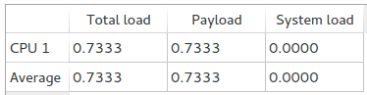

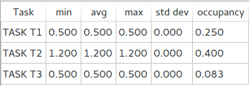

- What is the minimum/maximum/average response time of all tasks?
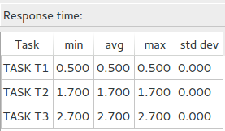

- Is any task missing the deadline? Which task? Where?
Ans: The system is feasible, there isn't any task missing deadline.
- If a deadline is missed, could it be avoided by changing the scheduler?
Ans: The system is feasible.
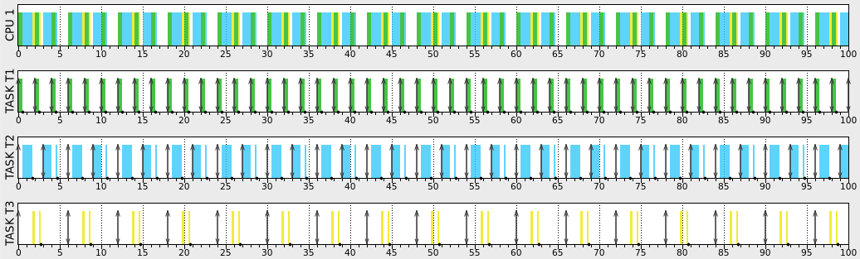
2. T1(2, 0.5, 1.9) T2(5, 2) T3(1, 0.1, 0.5) T4(10, 5, 20)and the EDF scheduler into the SimSo simulator
- What is the utilization factor of the system and what is the value for Urm(4)
Ans: Urm(4) = 4(2^1/4 – 1) = 0.7568
U = 0.5/2 + 2/5 + 0.1 + 5/10 = 1.25
U > 1, the system is guaranteed not feasible.
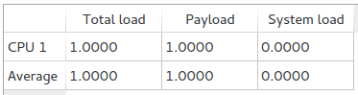

- What is the minimum/maximum/average response time of all tasks?
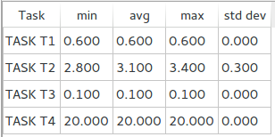

- Is any task missing the deadline? Which task? Where?
Ans: T4 is missing the deadline at time 30, 40, 50, 60, 70, 80, 90, 100.
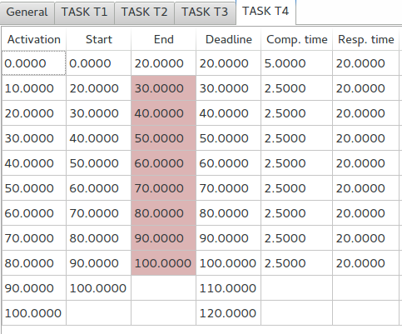

- If a deadline is missed, could it be avoided by changing the scheduler?
Ans: Because U > 1, it couldn't be avoided by changing the scheduler.

