Simulation assignment
- Consider the tasks T1(3, 0.5), T2(4, 1.5, 3), T3(7, 1.0, 5) and the EDF scheduler. A sporadic job arrives at t=50 having the execution time of 10 and a relative deadline of 30. Create the sporadic task in SimSo by selecting: ”generate task set” and then list of act. Dates to the release time
- What is the minimum/maximum/average response time of all tasks?
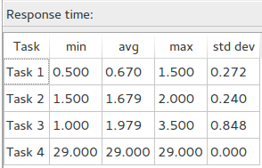

- Is any task missing the deadline? Which task? Where?
=>All tasks meet deadline.
- Is the sporadic job meeting its deadline?
=>Yes
- What is the response time for the sporadic job?
=>29
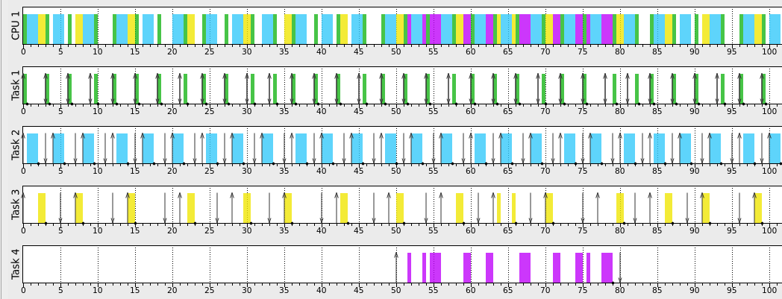

- Consider the tasks T1(3, 0.5), T2(4, 1.5, 3), T3(7, 1.0, 5) and the RM scheduler. A sporadic job arrives at t=50 having the execution time of 10 and a relative deadline of 30. Create the sporadic task in SimSo by selecting: ”generate task set” and then list of act. Dates to the release time
- What is the minimum/maximum/average response time of all tasks?
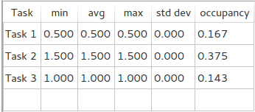

- Is any task missing the deadline? Which task? Where?
=>Task 4 is missing the deadline at time 80.
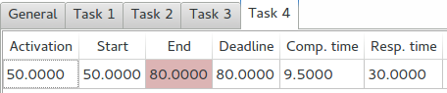

- Is the sporadic job meeting its deadline?
=>No, it is missing deadline.
- What is the response time for the sporadic job?
=>30, but the job is rejected.
- Which scheduler is better is better in this example; EDF or RM?
=>EDF, because all tasks aren't missing deadline by using this scheduler.
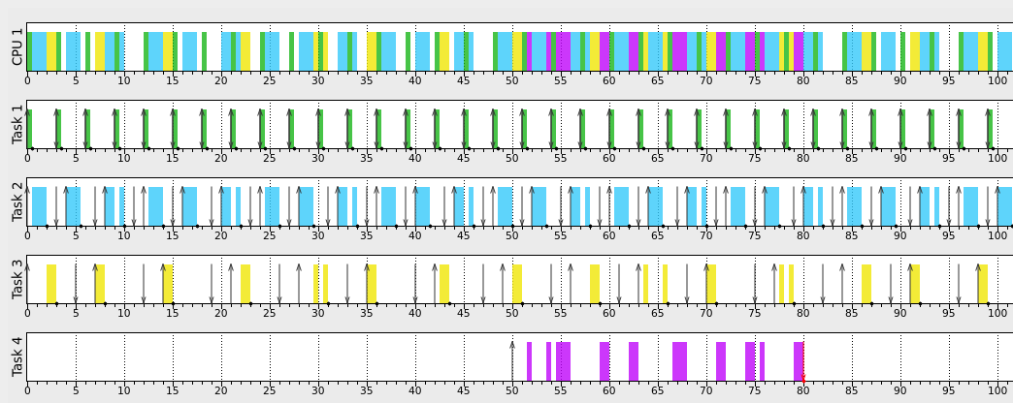

※note: Because I simulate it wit stm32 qemu tool, the performance of execution maybe slower.
- Is the system fast enough to handle all aperiodic tasks? Why?
=>No, aperiodic tasks would be interrupt by matrix task.
- If not, solve this problem without alter the functionality of any task
=>You can promote aperiodic task priority.
- What is the response time of the aperiodic task?
=>If you set priority value to 4, its response time is about 10 seconds.
- Provide a screenshot of the running system
