Simulation assignment
- CT1(2,1) T2(2.5,0.1) T3(3,1) T4(4,1) T5(4.5,0.1) T6(5,1) T7(6,1) T8(7,1) T9(8,1) T10(8.5,0.1) T11(9,1)
ID | P,e | ui
T1  T2  T3  T4  T5  T6  T7  T8  T9  T10  T11 | (2, 1)  (2.5, 0.1)  (3, 1)  (4, 1)  (4.5, 0.1)  (5, 1)  (6, 1)  (7, 1)  (8, 1)  (8.5, 0.1)  (9, 1) | 0.5  0.04  0.333  0.25  0.0222  0.2  0.167  0.142  0.125  0.01176  0.111

P1: T1 T2 T5 T7 T10
P2: T3 T4 T8
P3: T6 T9 T11
Urm(2) = 2(2^1/2 – 1) = 0.8284
Urm(3) = 3(2^1/3 – 1) = 0.7797
Urm(4) = 4(2^1/4 – 1) = 0.7568
Urm(5) = 5(2^1/5 – 1) = 0.7435
Urm(6) = 6(2^1/6 – 1) = 0.7347

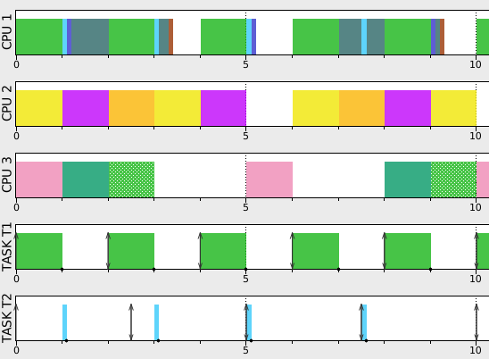

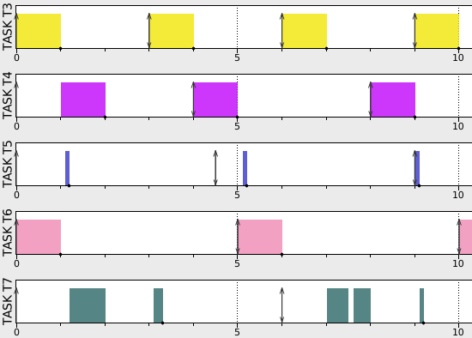

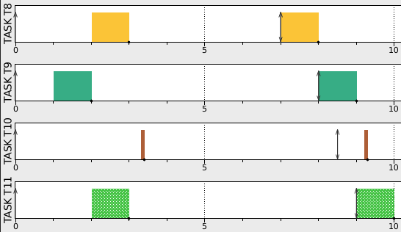

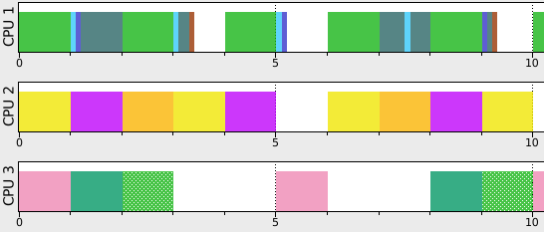

"""
Partitionned EDF using PartitionedScheduler.
"""
from simso.core.Scheduler import SchedulerInfo
from simso.utils import PartitionedScheduler
from simso.schedulers import scheduler
import math

@scheduler("simso.schedulers.P_RM")
class P_RM(PartitionedScheduler):
def init(self):
PartitionedScheduler.init(
self, SchedulerInfo("simso.schedulers.RM_mono"))

def packer(self):
# First Fit
cpus = [[cpu, 0] for cpu in self.processors]
cpu_list = {}
cpu_list[0] = 0
cpu_list[1] = 0
cpu_list[2] = 0
for task in self.task_list:
m = cpus[0][1]
j = 0
print task.period
# Find the processor with the lowest load.
for i, c in enumerate(cpus):
util = c[1] + float(task.wcet) / task.period
task_num = cpu_list[i] + 1
urm = task_num*(math.pow(2, 1.0/task_num) - 1)
#print i, util, task_num, urm
if util < urm:
#print task.period
self.affect_task_to_processor(task, cpus[i][0])
cpus[i][1] += float(task.wcet) / task.period
cpu_list[i] += 1
break
else:
continue
#if c[1] < m:
#m = c[1]
#j = i

# Affect it to the task.
#self.affect_task_to_processor(task, cpus[j][0])

# Update utilization.
#cpus[j][1] += float(task.wcet) / task.period
return True

Programming assignment

