

CSE370 : Database Systems
Project Report
Project Title : Foundora – A Platform Connecting Startups with Investors

Group No : _3_, CSE370 Lab Section : _20_, Fall 2025
ID | Name | Contribution
23201562 | MD.RATUL HASAN SARKAR | Frontend full development
23201555 | Fuad Mohammed Jawad | Backend development
23201460 | MD Mashrafi Mahmud Rafi | Backend development

Table of Contents

Section  No | Content | Page No
1 | Introduction | 3
2 | Project Features | 3
3 | ER/EER Diagram | 4
4 | Schema Diagram | 5
5 | Normalization | 6
6 | Frontend Development | 7
7 | Backend Development | 8-9
8 | Source Code Repository | 10
9 | Conclusion | 10
10 | References | 10

Introduction

Foundora is a digital platform designed to bridge the gap between startups and investors in one secure, easy-to-use ecosystem. It enables users to sign up and manage personalized dashboards where startups can showcase their ideas and funding needs, while investors can discover, evaluate, and connect with promising ventures. With detailed profiles, smart search and filters, real-time messaging, meeting scheduling, funding tracking, and instant notifications, Foundora simplifies the entire investment connection process—making collaboration faster, transparent, and more efficient for both sides.

Project Features

ID,  Name | Features [3 per member]
23201562,  MD.RATUL HASAN SARKAR | Ft 1 | User Dashboard
23201562,  MD.RATUL HASAN SARKAR | Ft 2 | Startup & Investor Profiles
23201562,  MD.RATUL HASAN SARKAR | Ft 3 | Notifications & Alerts
23201555,  Fuad Mohammed Jawad | Ft 1 | User Sign Up & Sign In, Dashboard, Profile
23201555,  Fuad Mohammed Jawad | Ft 2 | Messaging System
23201555,  Fuad Mohammed Jawad | Ft 3 | Search & Filter
23201460,  MD Mashrafi Mahmud Rafi | Ft 1 | Funding Tracker
23201460,  MD Mashrafi Mahmud Rafi | Ft 2 | Schedule for a meeting
23201460,  MD Mashrafi Mahmud Rafi | Ft 3 | Notifications & Alerts

ER/EER Diagram

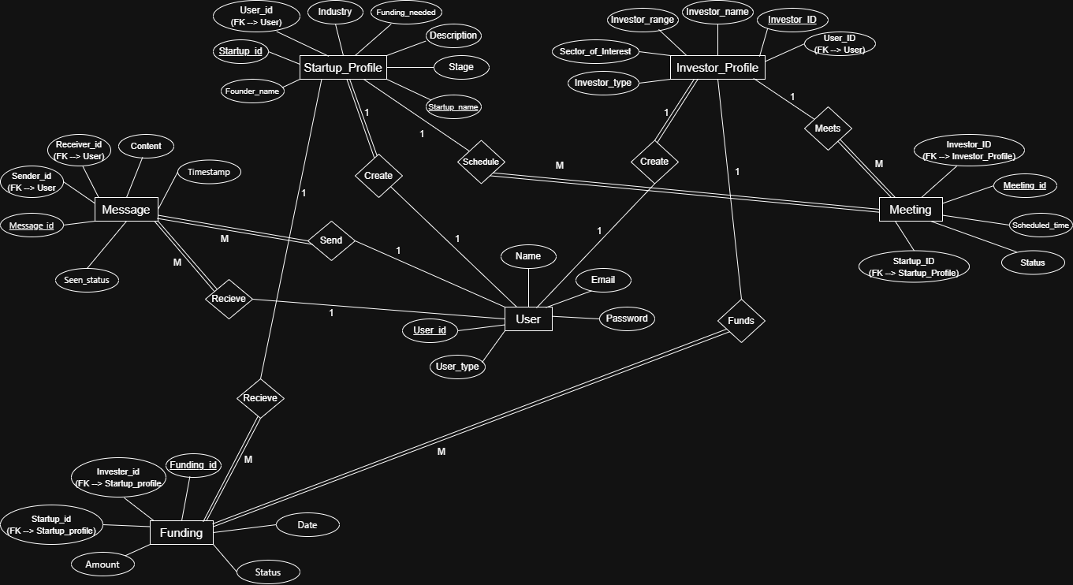

Schema Diagram

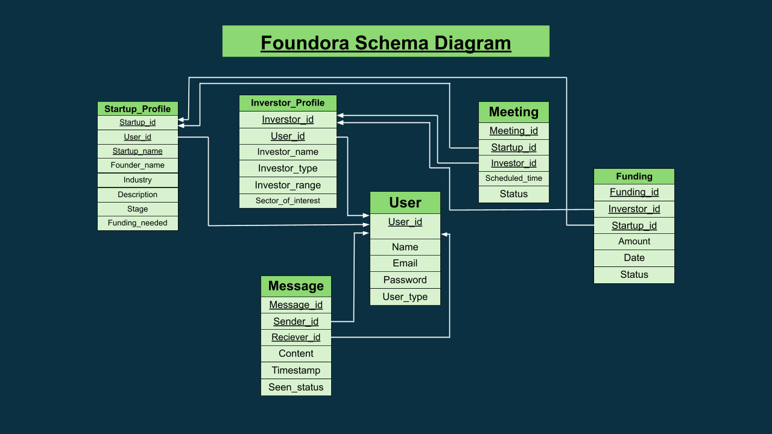

Normalization

- Explain if your converted Schema is in 1NF or not. If not, decompose it to 1NF.
- Explain if your converted Schema is in 2NF or not. If not, decompose it to 2NF. Can there be any partial functional dependencies in your relational schema?
- Explain if your converted Schema is in 3NF or not. If not, decompose it to 3NF. Can there be any transitive dependencies in your relational schema?

First Normal Form (1NF):
The converted schema satisfies 1NF as all relations contain a primary key and all attributes hold atomic, indivisible values. There are no repeating groups or multi-valued attributes. Therefore, no decomposition is required.

Second Normal Form (2NF):
The schema is in 2NF because each relation uses a single-attribute primary key. As a result, partial functional dependencies cannot exist. Hence, no decomposition is necessary.

Third Normal Form (3NF):
The schema also satisfies 3NF since all non-key attributes depend only on the primary key and not on other non-key attributes. There are no transitive dependencies present. Therefore, no further decomposition is required.

Conclusion:
The converted relational schema is fully normalized and conforms to 1NF, 2NF, and 3NF.
Frontend Development

Briefly discuss about Frontend Development and add relevant Screenshots (if required) by mentioning Individual Contributions

Contribution of ID : 23201562, Name : MD.RATUL HASAN SARKAR

I was responsible for developing the entire frontend of the Foundora platform. The frontend was designed with a strong focus on usability, performance, and modern UI aesthetics to ensure a smooth experience for both startups and investors.

Tools & Technologies Used
- HTML for structuring all web pages
- JavaScript (JS) for interactivity and dynamic behavior
- Tailwind CSS for utility-first styling, reducing CSS complexity and keeping the codebase lightweight
- shadCN UI library to build visually appealing, consistent, and reusable UI components

Scope of Work
- Designed and implemented 10 fully responsive frontend pages
- Developed key interfaces such as:
  - User authentication pages (Sign Up / Sign In)
  - User dashboards for investors and startups
  - Profile pages
  - Messaging interface
  - Funding tracker UI
  - Meeting scheduling pages
- Ensured clean layout, responsive design, and smooth user flow across devices

Development Approach
The project began with frontend-first development, allowing the team to clearly visualize the system’s workflow and user interactions before backend integration. This approach helped validate UI/UX decisions early and ensured the platform met user expectations.
Overall, my contribution established a solid, scalable, and visually polished frontend foundation for the Foundora platform.

Backend Development

Briefly discuss about Backend Development and add relevant Screenshots (if required) by mentioning Individual Contributions

Contribution of ID : 23201460, Name : MD Mashrafi Mahmud Rafi

This system is designed to manage meetings, funding activities, and notifications for two different user roles: startups and investors. Each PHP file handles a specific responsibility, such as retrieving data, creating new records, updating statuses, and returning structured JSON responses to the frontend. Proper role-based access control is applied so that startups and investors can only perform actions relevant to their permissions. The system also emphasizes secure database interactions by validating inputs and safely executing SQL queries. Together, these components ensure smooth communication, accurate data handling, and real-time updates within the platform.

Meetings.php fetches meeting data based on whether the user is a startup or an investor, safely executes SQL queries, and returns the results as JSON. Create_meeting.php allows only startup users to create a meeting by validating input data and inserting a new record into the database. Update_meeting_status.php updates the meeting status (scheduled, cancelled, or completed) using different logic depending on the user type.

Funding.php retrieves funding information for startups or investors and sends the formatted data to the frontend. Create_funding.php allows investors to create new funding records after validating the required inputs. Update_funding.php updates funding status using separate SQL logic for startups and investors.

Get_notification.php collects notifications from messages and funding activities, formats them based on user type, sorts them by time, and returns them as JSON. Update_notification.php marks notifications as updated in the database and returns a success response.

Contribution of ID : 23201555, Name : Fuad Mohammed Jawad

The backend of the system was developed using PHP and MySQL to manage user login, data handling, and communication between the frontend and the database. User login and registration are handled by auth.php, which checks user credentials and starts user sessions. Access to protected pages is controlled using auth_check.php, ensuring that only logged-in users can use the system, while logout.php safely logs users out.

The database connection is managed in database.php, which provides a single reusable connection for all backend files. User details needed for the dashboard are prepared in dashboard.php and shared with the frontend. Live dashboard information such as unread messages and upcoming meetings is provided through dashboard_data.php using JSON responses.

Messaging features are handled by messages_api.php, which allows users to view conversations, send messages, read message threads, and mark messages as seen.

The search feature is implemented using search.php and search_data.php, enabling users to find relevant startup or investor profiles based on their role and interact with them.

Profile management is handled by update_profile.php, which allows users to update their profile details securely and view_profile.php, which displays public profile information of other users. Additionally, me.php provides basic information about the currently logged-in user for frontend use. Overall, these backend components work together to provide secure access, role-based features, and smooth interaction between startups and investors.

Source Code Repository

Google Drive Link: FOUNDORA

Conclusion

The Foundora project successfully delivers a robust platform that connects startups and investors through a secure and well-structured system. The application integrates essential features such as user authentication, profile management, messaging, meeting scheduling, funding tracking, notifications, and search functionality, enabling smooth and effective communication between users.
From a technical standpoint, the backend was developed using PHP, ensuring reliable server-side processing, data handling, and integration with the normalized relational database (up to Third Normal Form – 3NF). The frontend was built using modern web technologies, resulting in a responsive and visually appealing user interface. The frontend-first development approach helped validate system workflows early and ensured consistency between the user experience and backend logic.

References

- W3Schools. (2024). HTML, CSS, JavaScript & PHP Tutorials.
https://www.w3schools.com — Used for frontend and backend development concepts.

- Tailwind Labs. (2024). Tailwind CSS Documentation.
https://tailwindcss.com/docs — Reference for utility-first CSS framework used in frontend design.

- PHP Documentation. (2024). PHP Manual.
https://www.php.net/docs.php — Used for backend development and server-side scripting.

- shadCN UI. (2024). shadCN UI Documentation.
https://ui.shadcn.com — Used for modern UI components and frontend styling.

