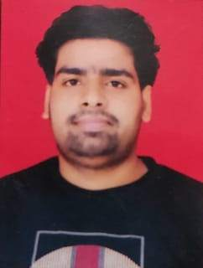

**EDUCATION**

Bachelors in Computer Science Engineering | Chandigarh University, Gharuan

*Session: 2019-2023 | Score: 6.97 CGPA*

Intermediate (CBSE) |SGN International School, Delhi

*Session: 2018-2019 | Percentage: 51%*

Matriculation (CBSE) | SGN International School, Delhi

*Session: 2016-2017 | Percentage: 70%*

**TRAINING & PROJECTS**

Summer Training (06-2021  -   08-2021)

 Internshala , Gurgaon, India

This training has helped me to learn and implement the concepts of Data Structure And Algorithms . The training included online video content along with quiz, assignments, and module tests to check my progress. The training program has helped me to walk through all the DSA concepts and implement those concepts. This has increased my theoretical as well as practical knowledge by creating various projects ike a desktop Notification and PhoneBook Application using Doubly Linked List.

**ACADEMIC ACHIEVEMENTS**

Qualified Science Olympiad

**CERTIFICATIONS & AWARDS**

Programming for Everybody (getting started with Python)

<https://coursera.org/share/38d54c7f8dfb9d304efba5dd3967b487>

C for Everyone: Programming Fundamentals

<https://www.coursera.org/account/accomplishments/verify/8X8GGFL38THC>

Data Structure And Algorithms

Certificate no. : 8A22A453-59EC-62C8-0386-DEA829ACE783

**Ronak Choubey**

Address:: Jaspal colony Giaspura Ludhiana Punjab ,141016

E-mail:19BCS2583@cuchd.in

Phone: +91 9999999999

LinkedIn:

**PROFESSIONAL SUMMARY**

A well-organized, creative and goal-oriented graduate possessing excellent communication, problem-solving and leadership skills with a flair to explore suitable avenues in Computer Science Engineering while developing advanced projects with efficiency and quality.

**TECHNICAL COMPETENCIES**

C++ |Data Structure and Algorithim | PYTHON |C

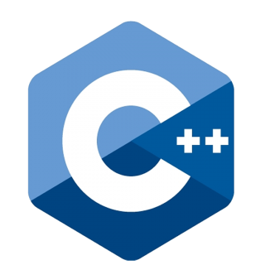 

**INTERPERSONAL SKILLS**

Communication skill l Problem Solving**|** Teamwork**|** Decision Making

**INTERESTS & HOBBIES**

Writing **|** Blogging **|**Exploring new technologies **|** Travelling **|** Reading **|** Gardening

**LANGUAGES KNOWN**

English **|** Hindi **|**

**PERSONAL DETAILS**

Mother’s Name: Geeta Choubey

Father’ Name: Arvind Choubey

D.O.B.:

Languages Known: