The objective in this phase was to develop a model which could use the observed values of temperature and humidities and use them in conjunction with the means and variances of the observations from each sensor, at different times obtained from the training data, to produce predictions of the outputs of those sensors for which the reading cannot be attained.

The technique utilized in the code takes into account the hidden correlations between the temperature and humidity sensors to produce more accurate results. It shall be best explained by an example-

Suppose we are using windowed active inference with a budget of 5. Therefore, at t = 0.5 (first time instant) we choose sensors h0, h1, h2, h3 & h4 for getting the actual humidity readings and sensors t5, t6, t7, t8 & t9 for getting the actual temperature readings. It was observed by analyzing the training data that the ratio between the humidity means and the temperature means for each sensor over the 3 days fluctuated around 2.0.

Therefore, this ratio was subsequently computed from the training data and was used to predict outputs of humidity sensors h5, h6, h7, h8 & h9 from temperature sensors t5, t6, t7, t8 & t9 and predict outputs of temperature sensors t0, t1, t2, t3 & t4 from the humidity sensors h0, h1, h2, h3 & h4.

This way, instead of taking readings of h0, h1, h2, h3, h4 and t0, t1, t2, t3, t4 and using the means computed from the training data as output predictions for other sensors, we are able to predict with more accuracy for a greater number of sensors as we are utilizing the correlations between the humidity and the temperature readings.

In the max-variance inference approach, the same technique is utilized by tracking the humidity & temperature sensors (having maximum variances) for which the readings are obtained.

The relations between the Mean Absolute Errors and the different budgets pertaining to reach active inference for temperature and humidity sensor predictions are as follows –

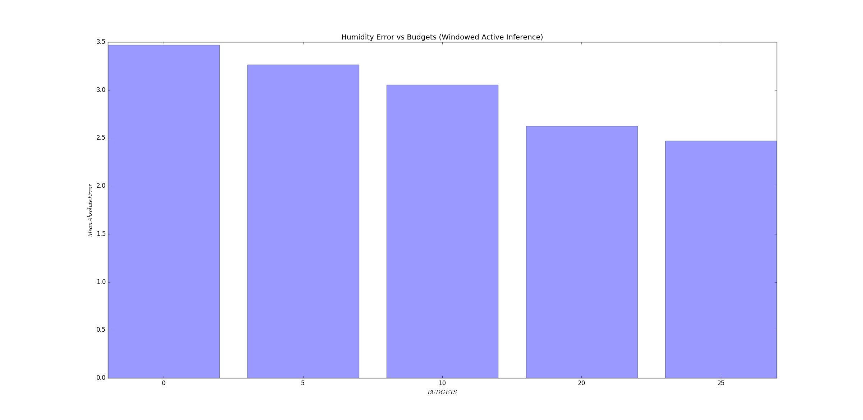

As is clearly evident, the error for the humidity sensor predictions decrease with the increase in budget. This behavior is expected and is natural as the outputs of more number of sensors are known with 100% accuracy when budget increases.

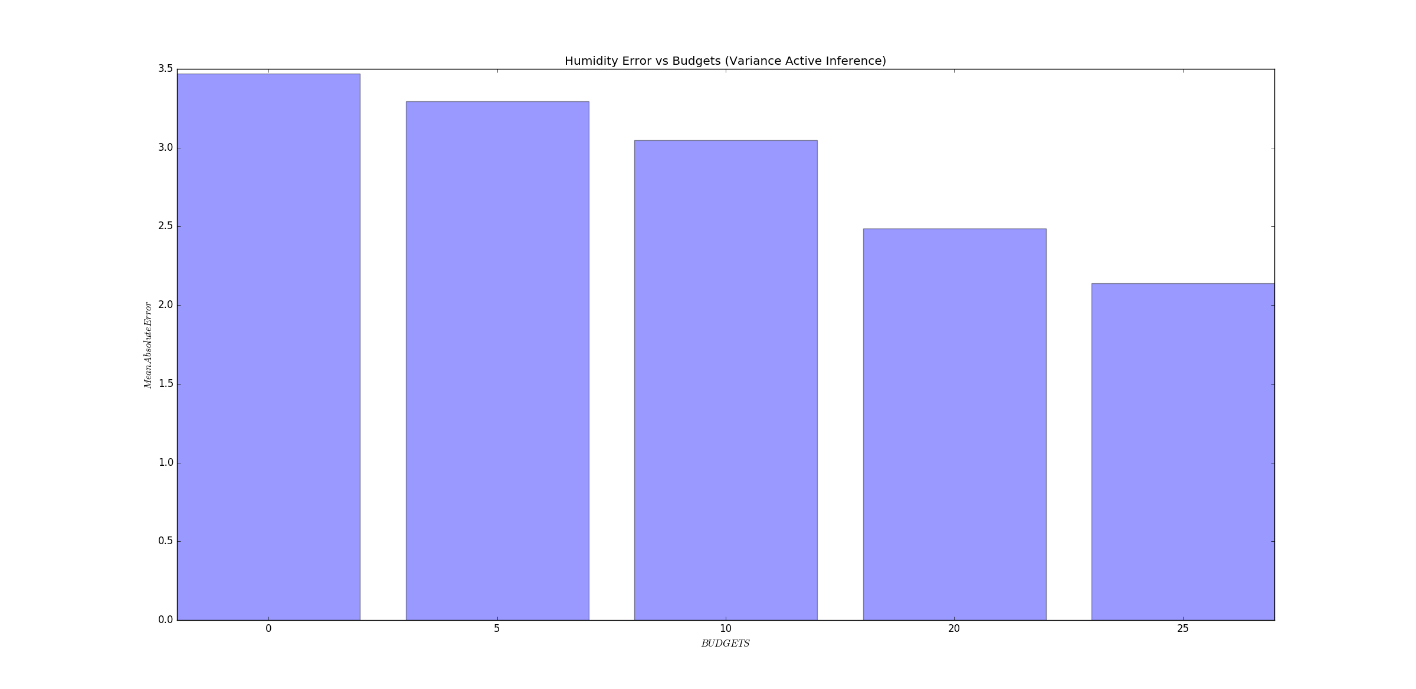

A similar behavior is noticed in the case when the humidity sensor outputs are predicted using the max-variance active inference. However, it can be seen that the errors in this case are somewhat lesser than the windowed inference case.

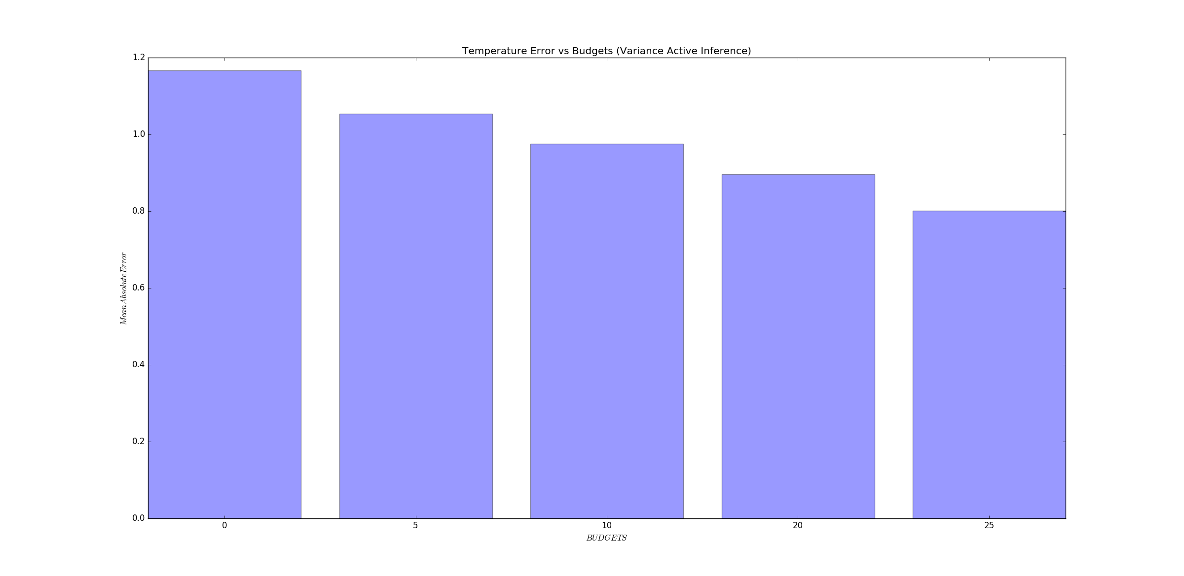

The same trend is observed in the case of temperature sensor output prediction using max-variance active inference.

However, the case is different when the temperature sensor outputs are predicted using windowed active inference –

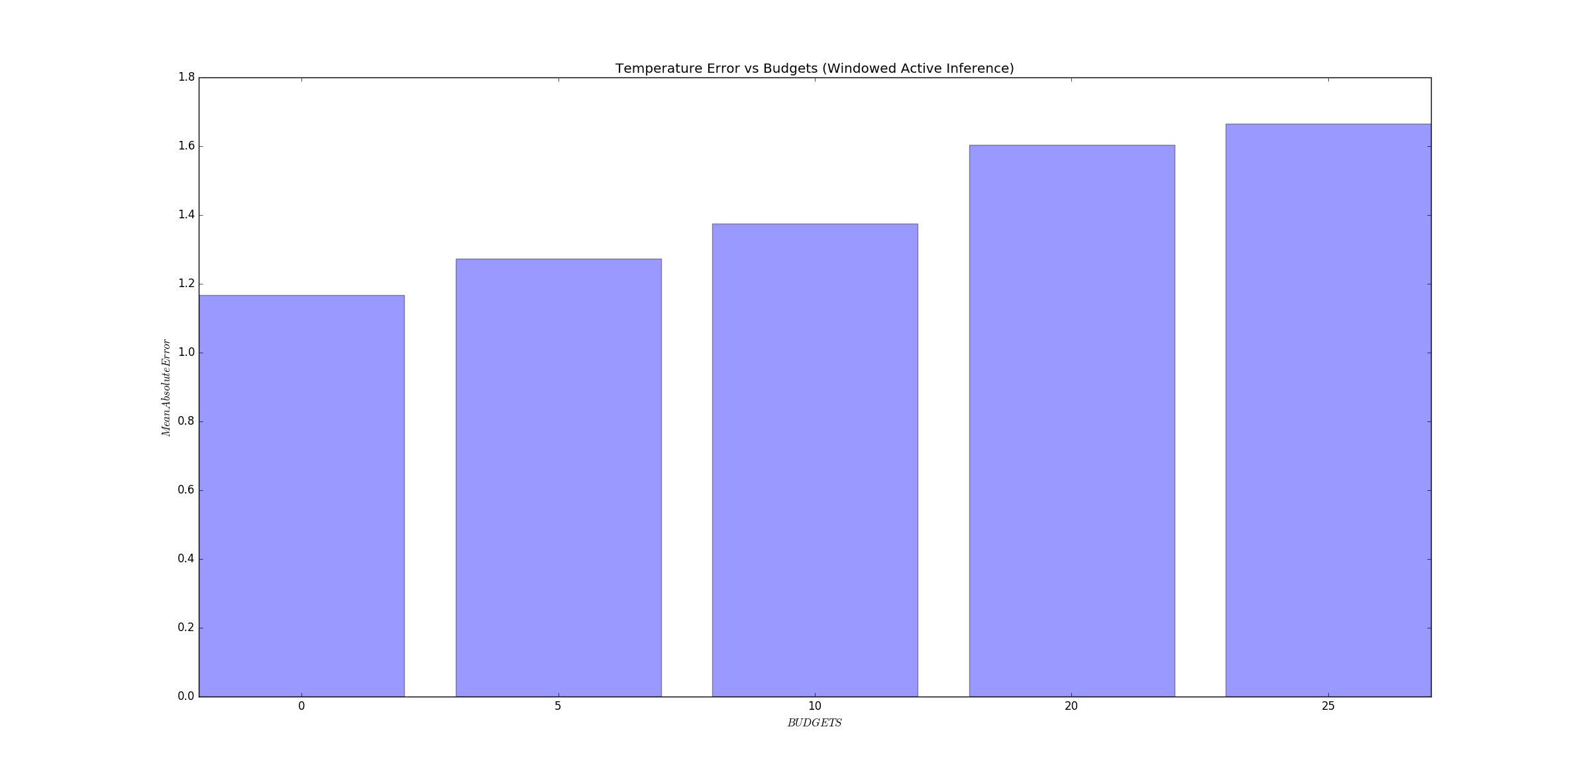

The exact cause of this behavior is unknown. However, an approximate explanation could be that this trend is just noise because the scale of the mean absolute error (Y-axis) is too small. Upon looking closely, it can be seen that the error rises from around 1.2 to around 1.6 which implies a change of 0.2. Now an error change of 0.2 seems pretty insignificant as compared to a budget change of 25. Hence, it is assumed to be data noise.