The objective in this phase was to develop a model which could use the observed values of temperature and humidities and use them in conjunction with the means and variances of the observations from each sensor, at different times obtained from the training data, to produce predictions of the outputs of those sensors for which the reading cannot be attained.

In the code, multiple approaches were employed namely –

1. Windowed Active Inference with hour constant model parameters.
2. Windowed Active Inference with day constant model parameters.
3. Variance based Active Inference with hour constant model parameters.
4. Variance based Active Inference with day constant model parameters.

In the hour constant parameter model, the model parameters are kept constant at the 0.5 hour level and in the day constant model, the parameters are kept constant at the day level.

It was found through the experiments that the performance of the day constant model with variance based active inference was the worst and yielded and extremely high error which changed very little with increasing budget.

The performance of the day constant model with window based active inference initially starts with a terrible performance, but gradually improves by several orders of magnitude with every increase in budget.

All in all, the best performance (in terms of least mean squared errors) is yielded by the window based inference model from phase 1.

The relations between the Mean Absolute Errors and the different models for every budget is as follows-

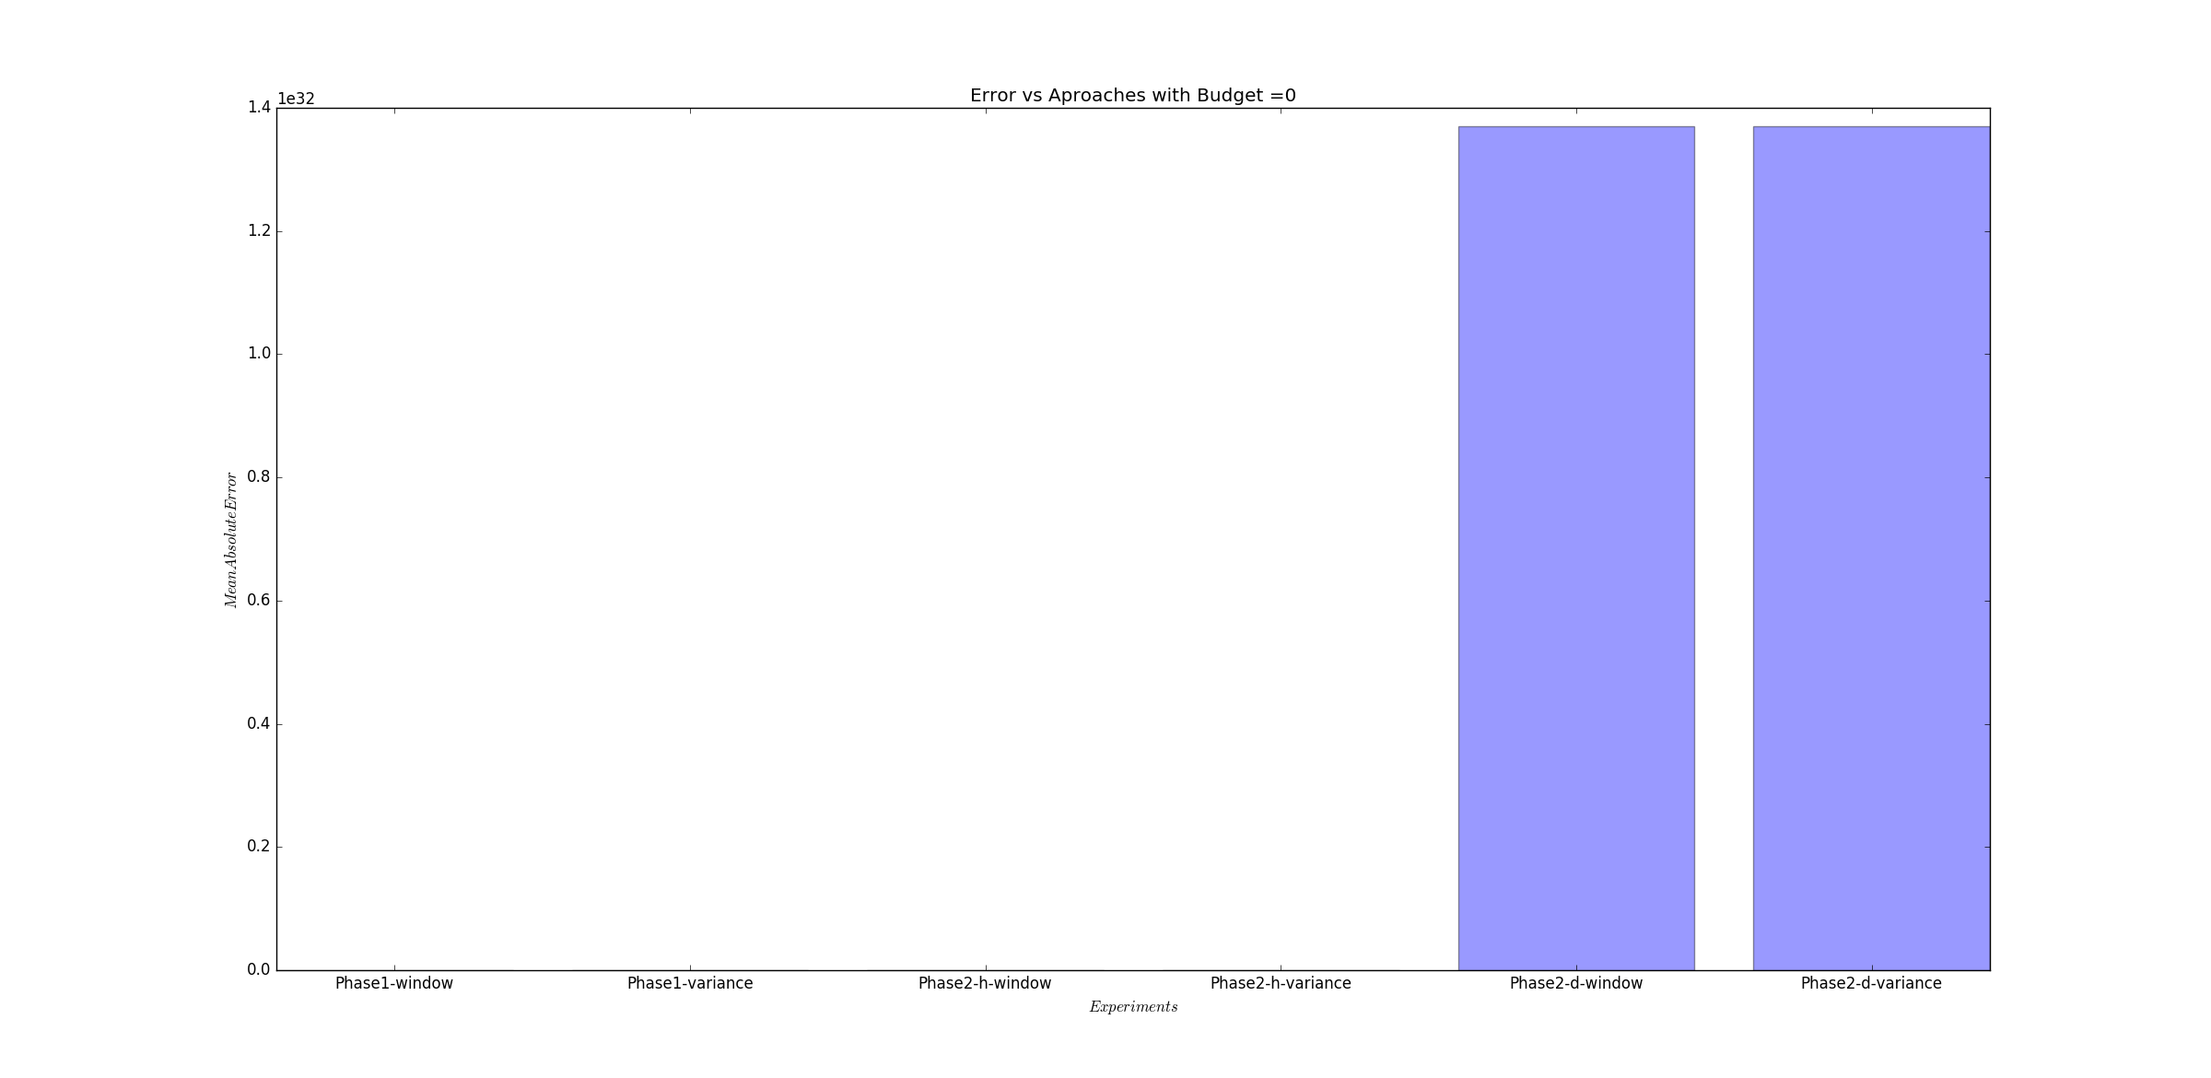

As is clearly evident, the errors from the day-level variance-inference models are so great that they mask the errors of the other approaches which are as follows-

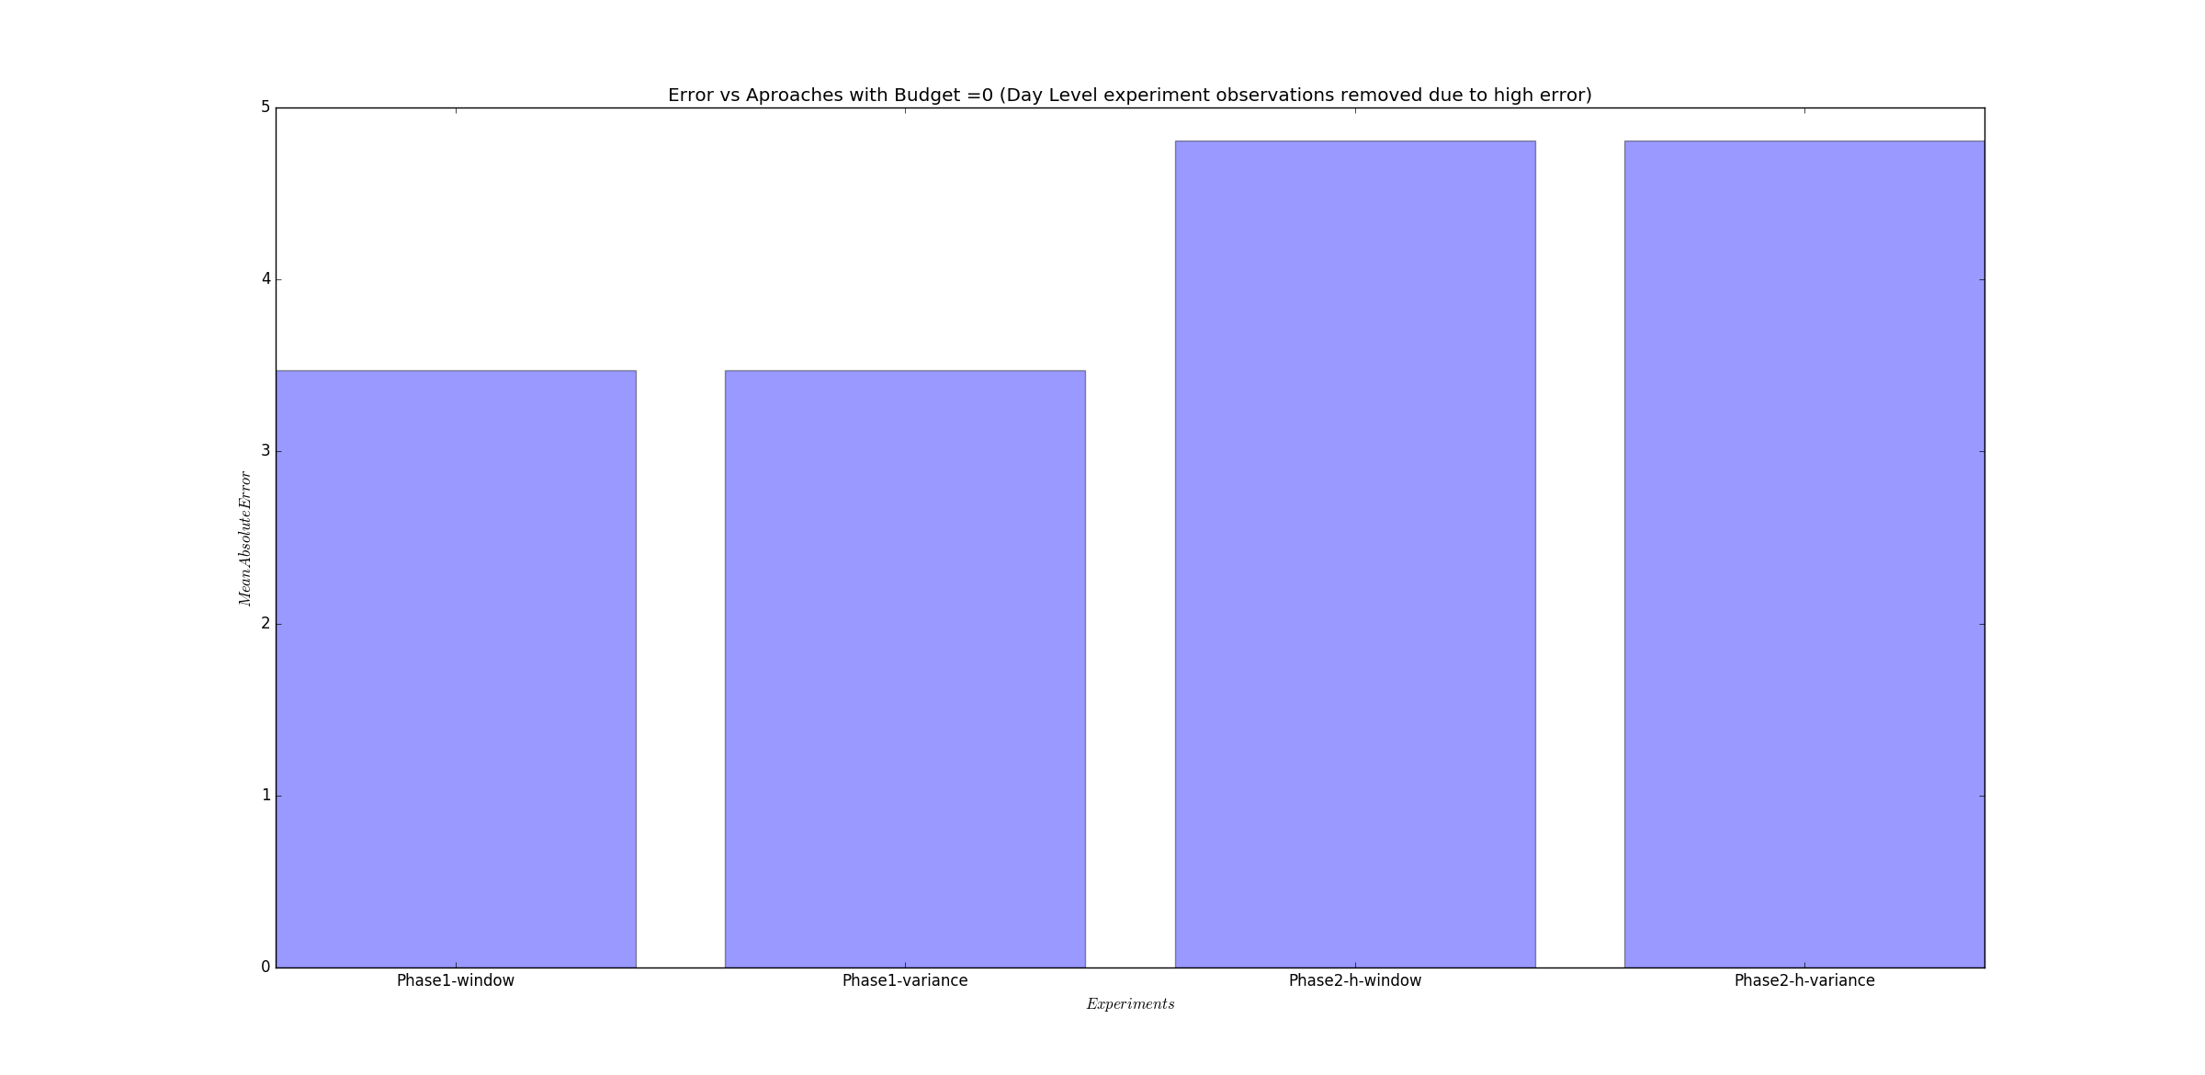

For budget=5, a similar behavior is observed but however, now only the phase2 day-level variance-inference model has a high error and the error of the phase2 day-level windowed-inference model has a much lesser error that its also barely visible-

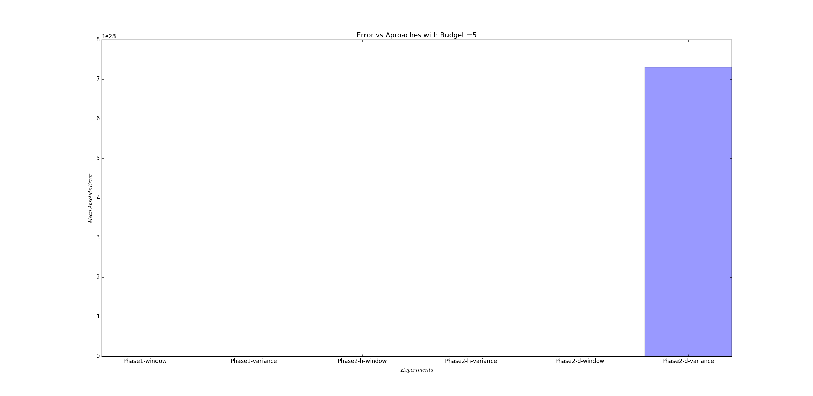

However, the error of the phase2 day-level windowed-inference model is still a lot greater than the other ones. The following graph illustrates the error of the 1st 4 models from the left-

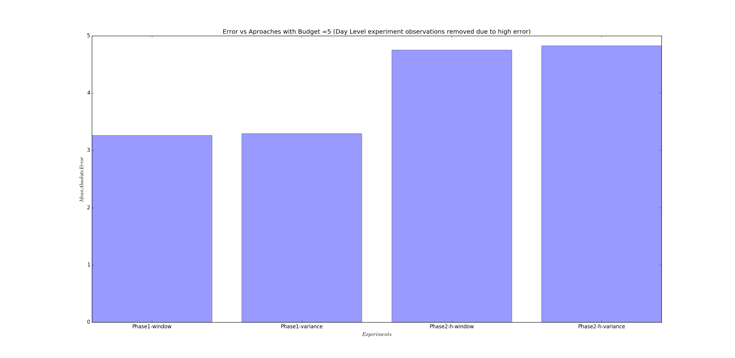

The following results were obtained for budget = 10

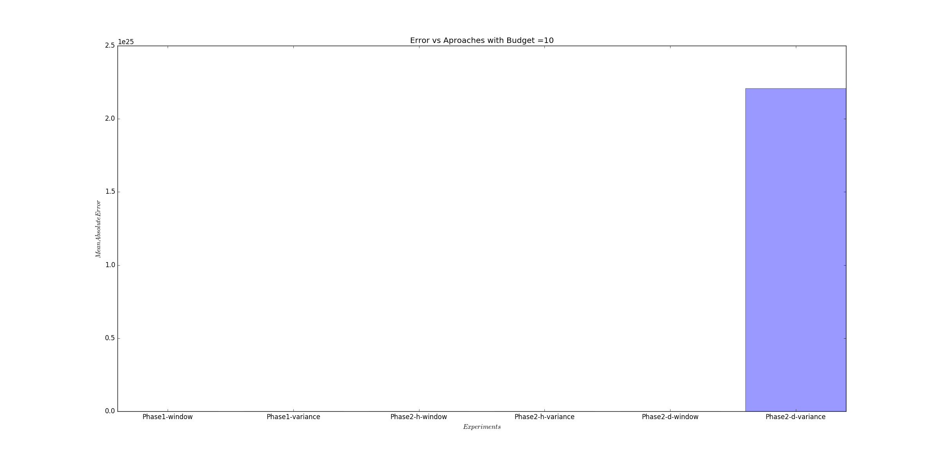

As we can see, the error of Phase2-d-variance model is slowly reducing. However, it is much more than the others which are –

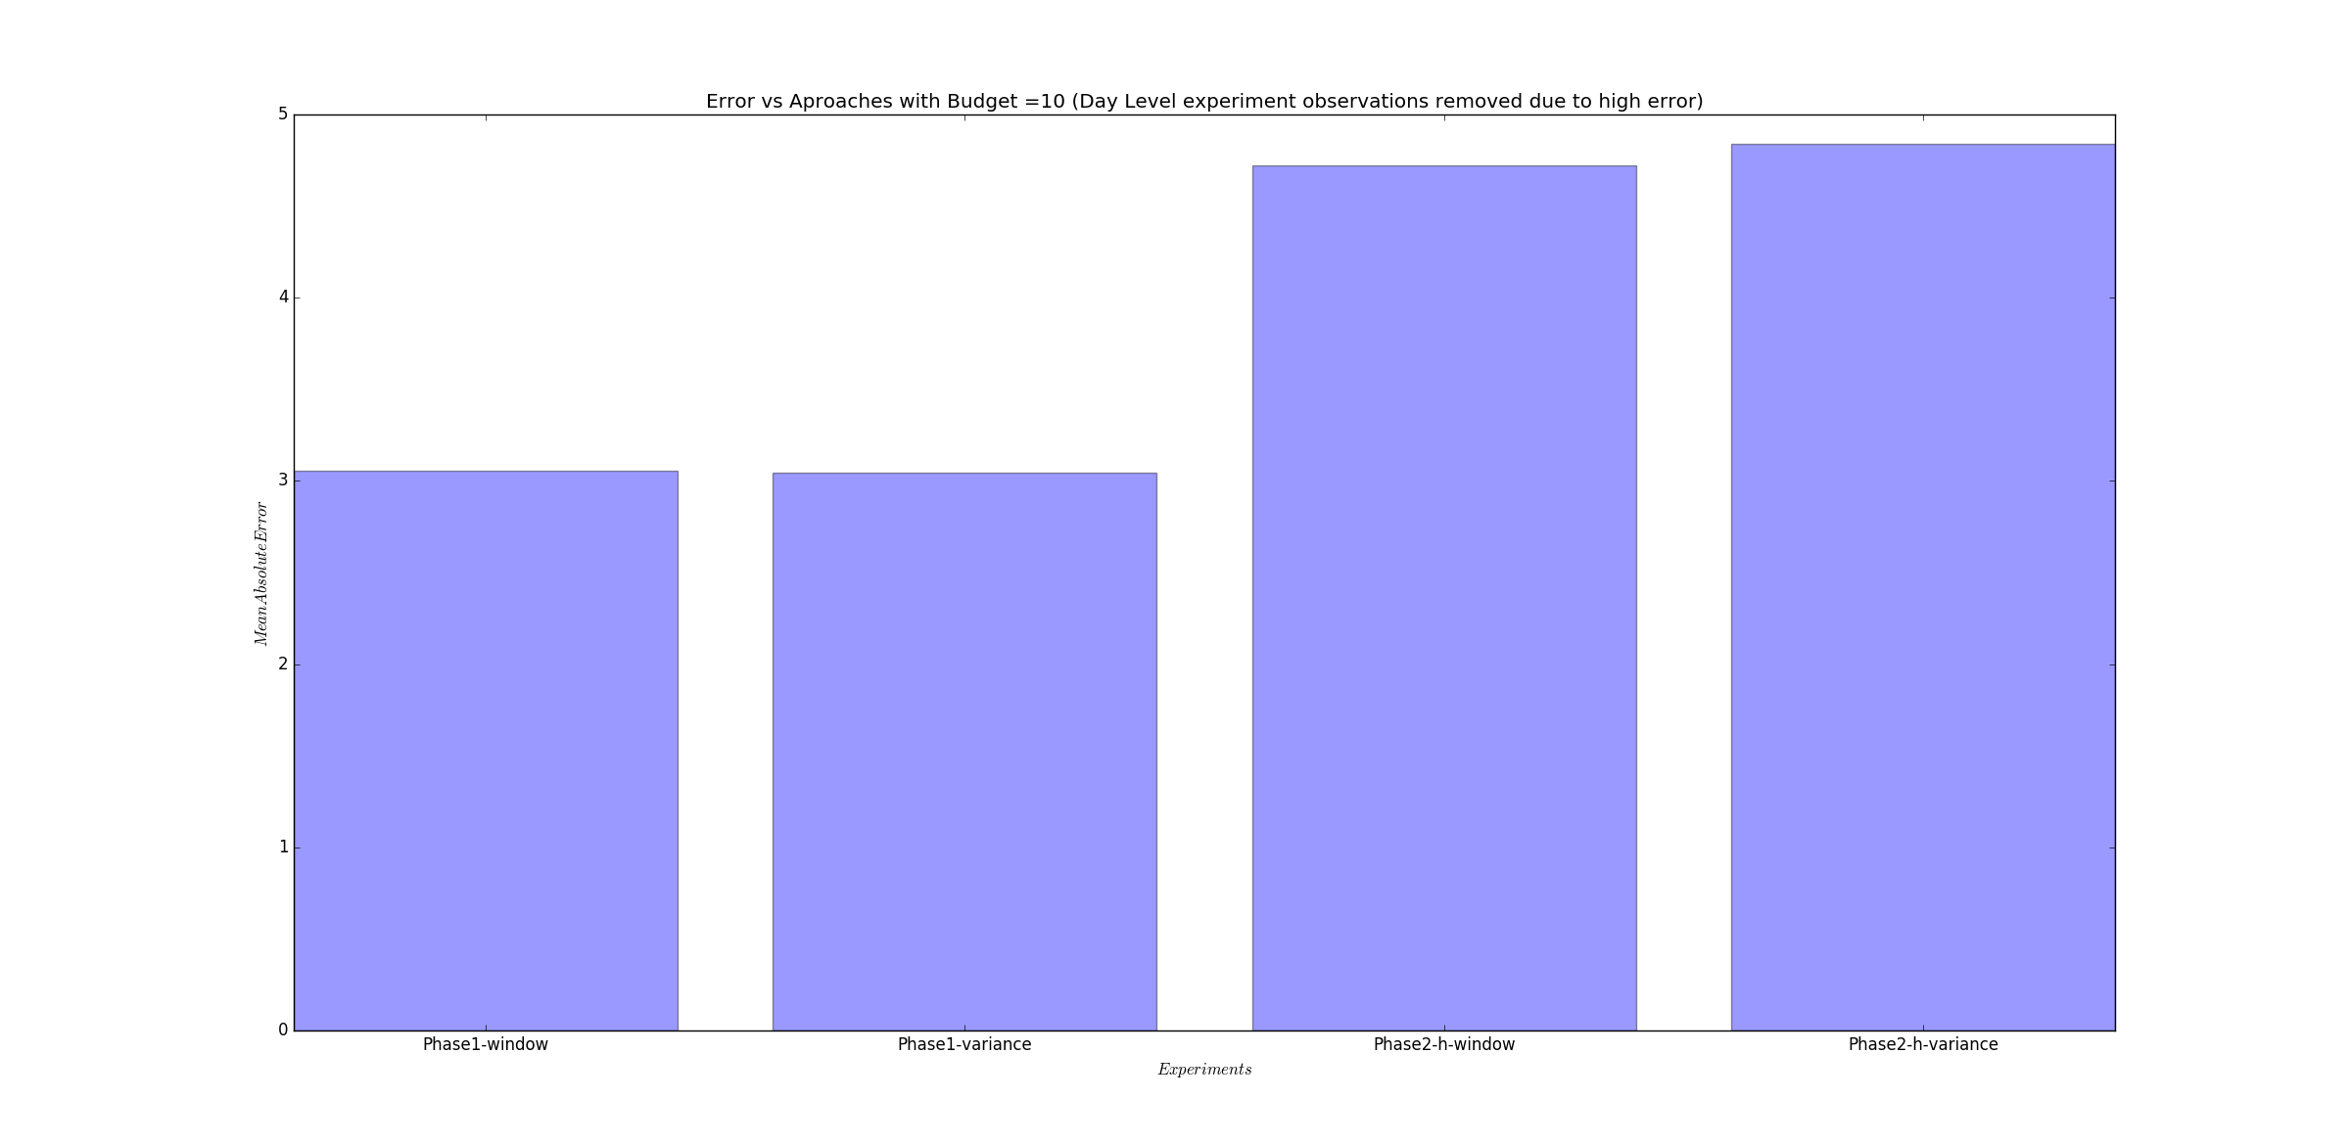

The error of Phase2-d-variance further reduces a little with budget=20-

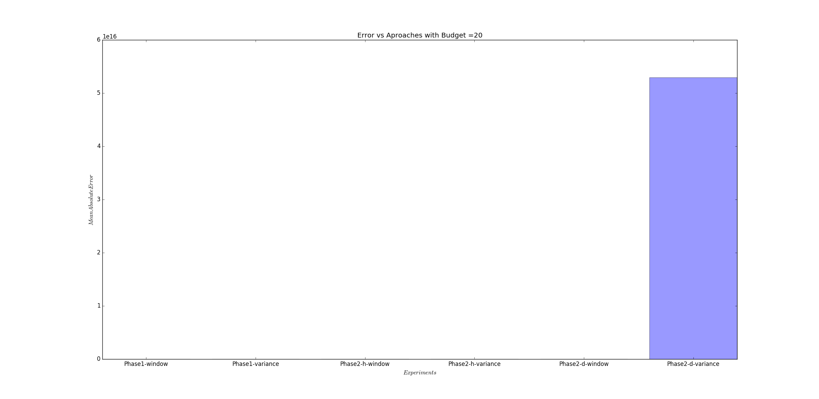

The errors of the other models are as follows-

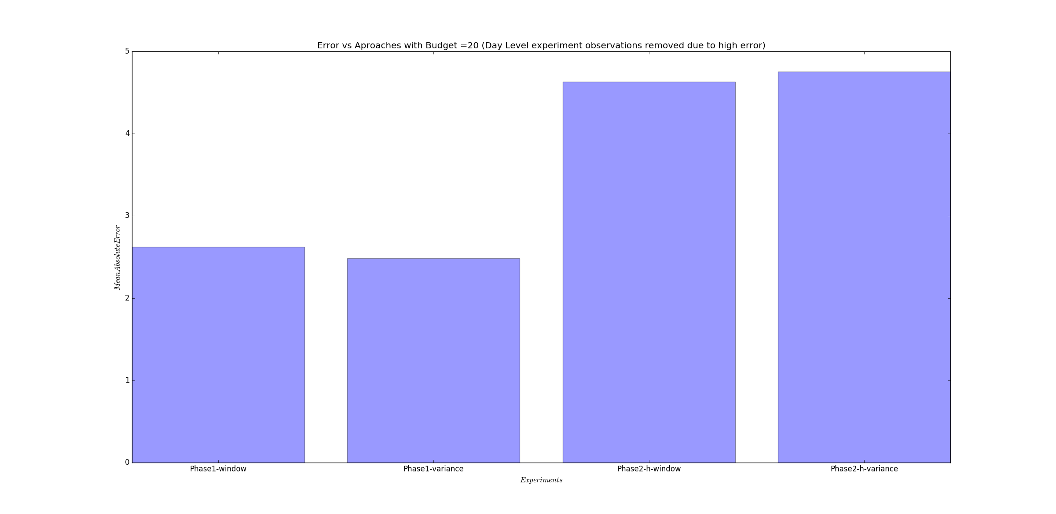

Things get a bit more interesting at budget=25. The overall bar graph is as follows-

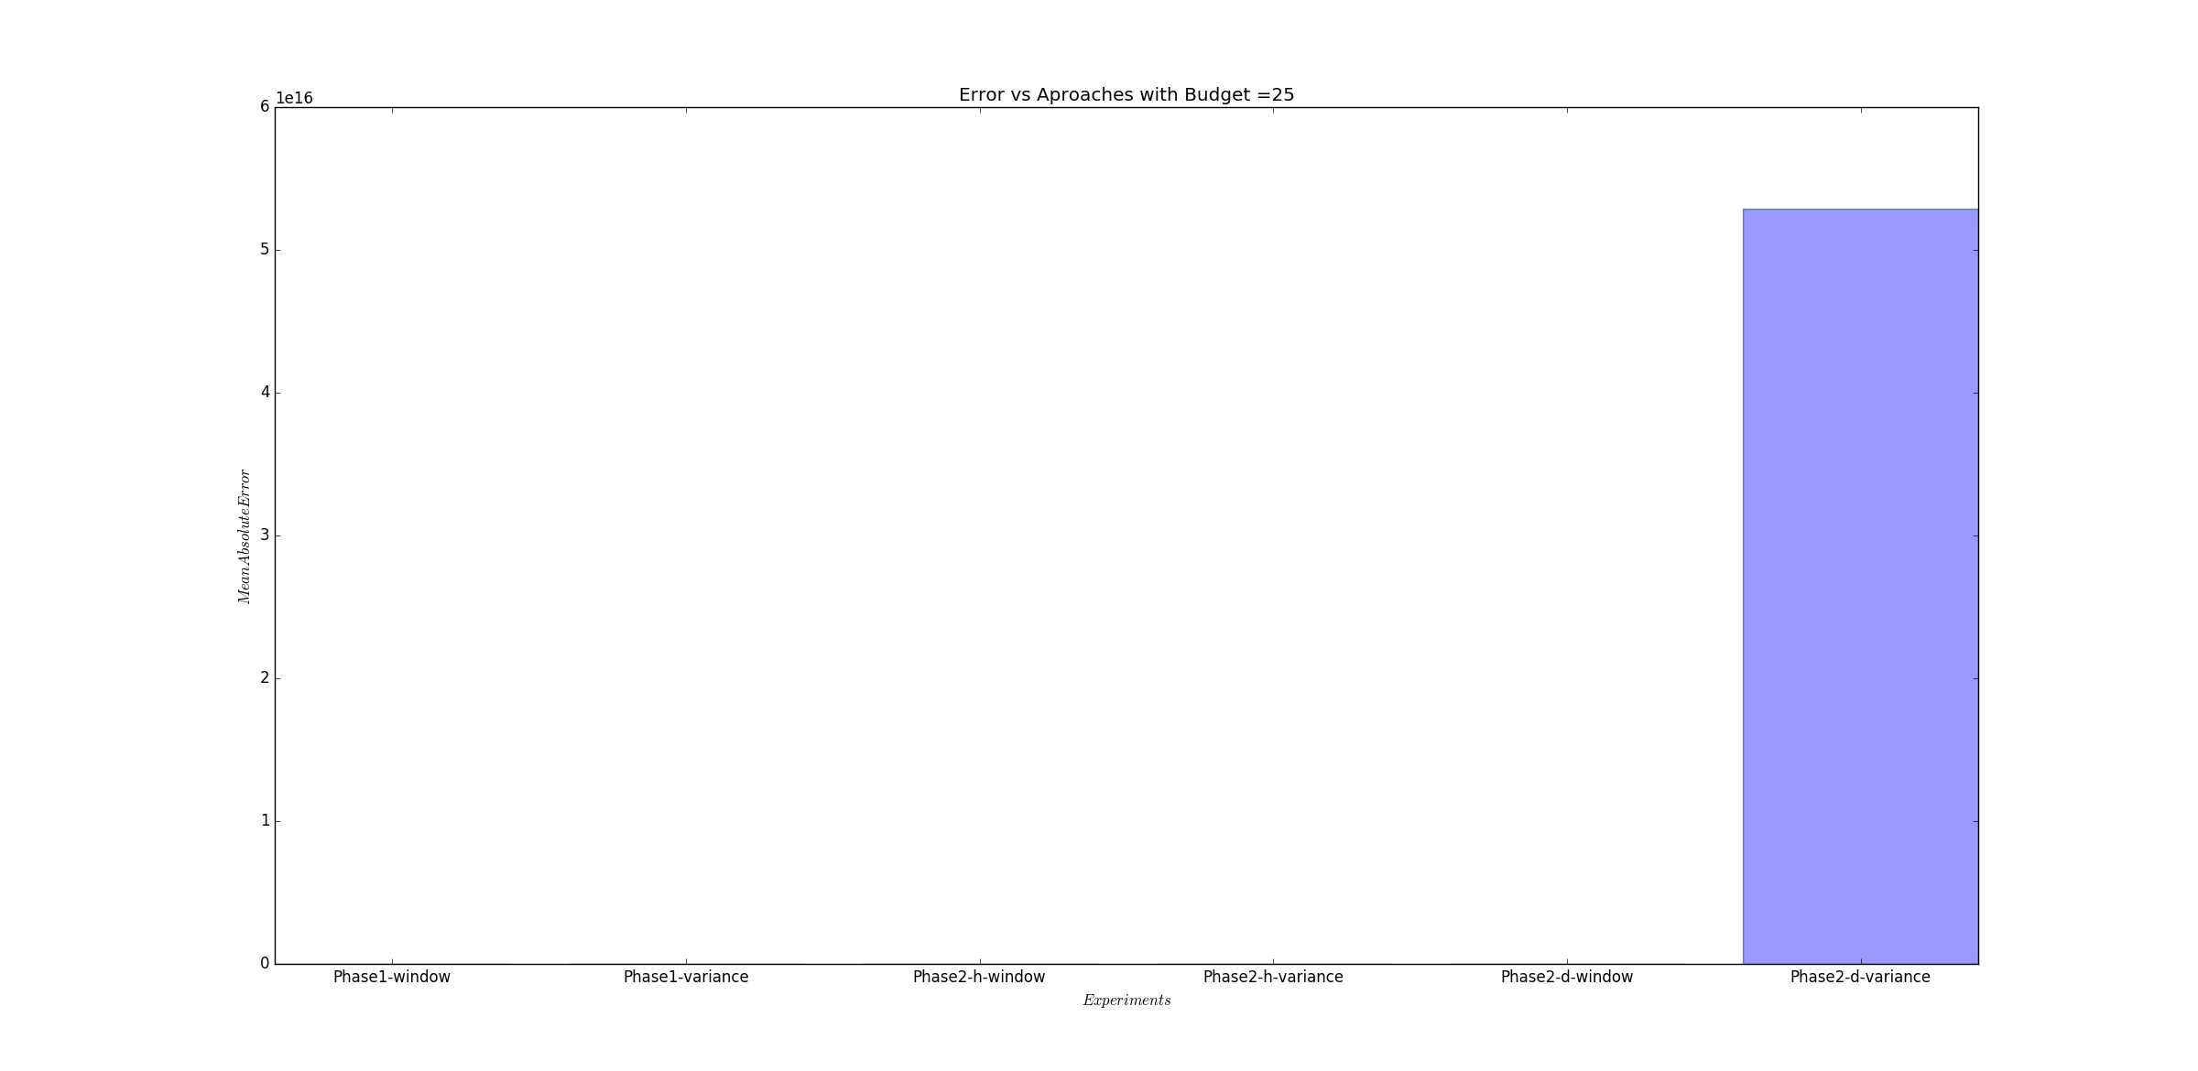

There is not much to observe in the graph above. However, the error of the Phase2-d-window has now reduced to a level where it can me matched with the other models. The bar graph is as follows-

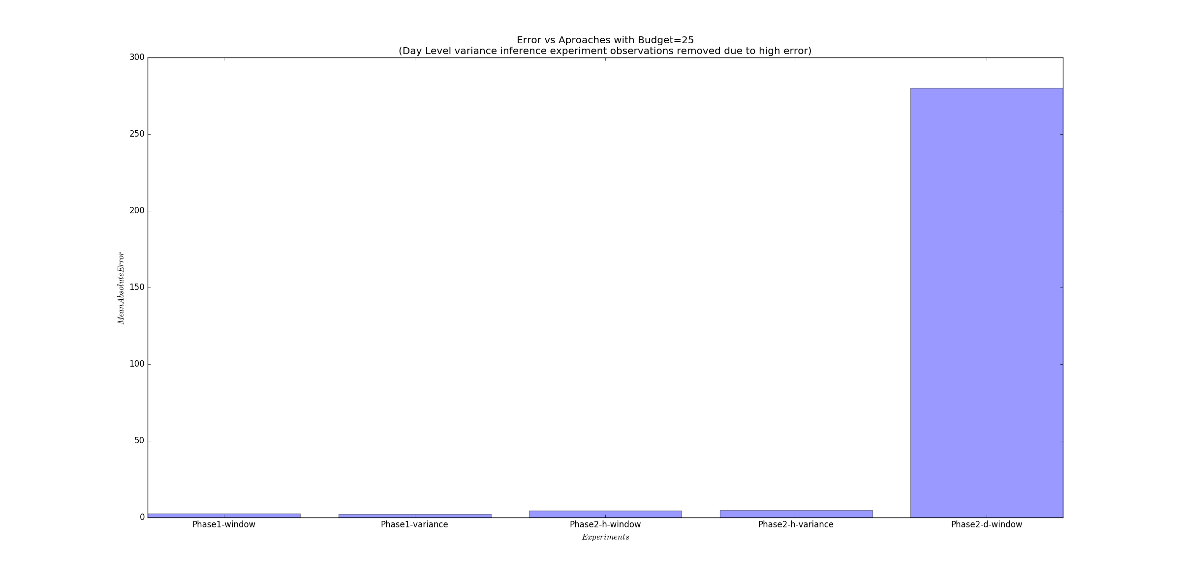

For further clarification, the errors of the 1st 4 models from the left are as follows-

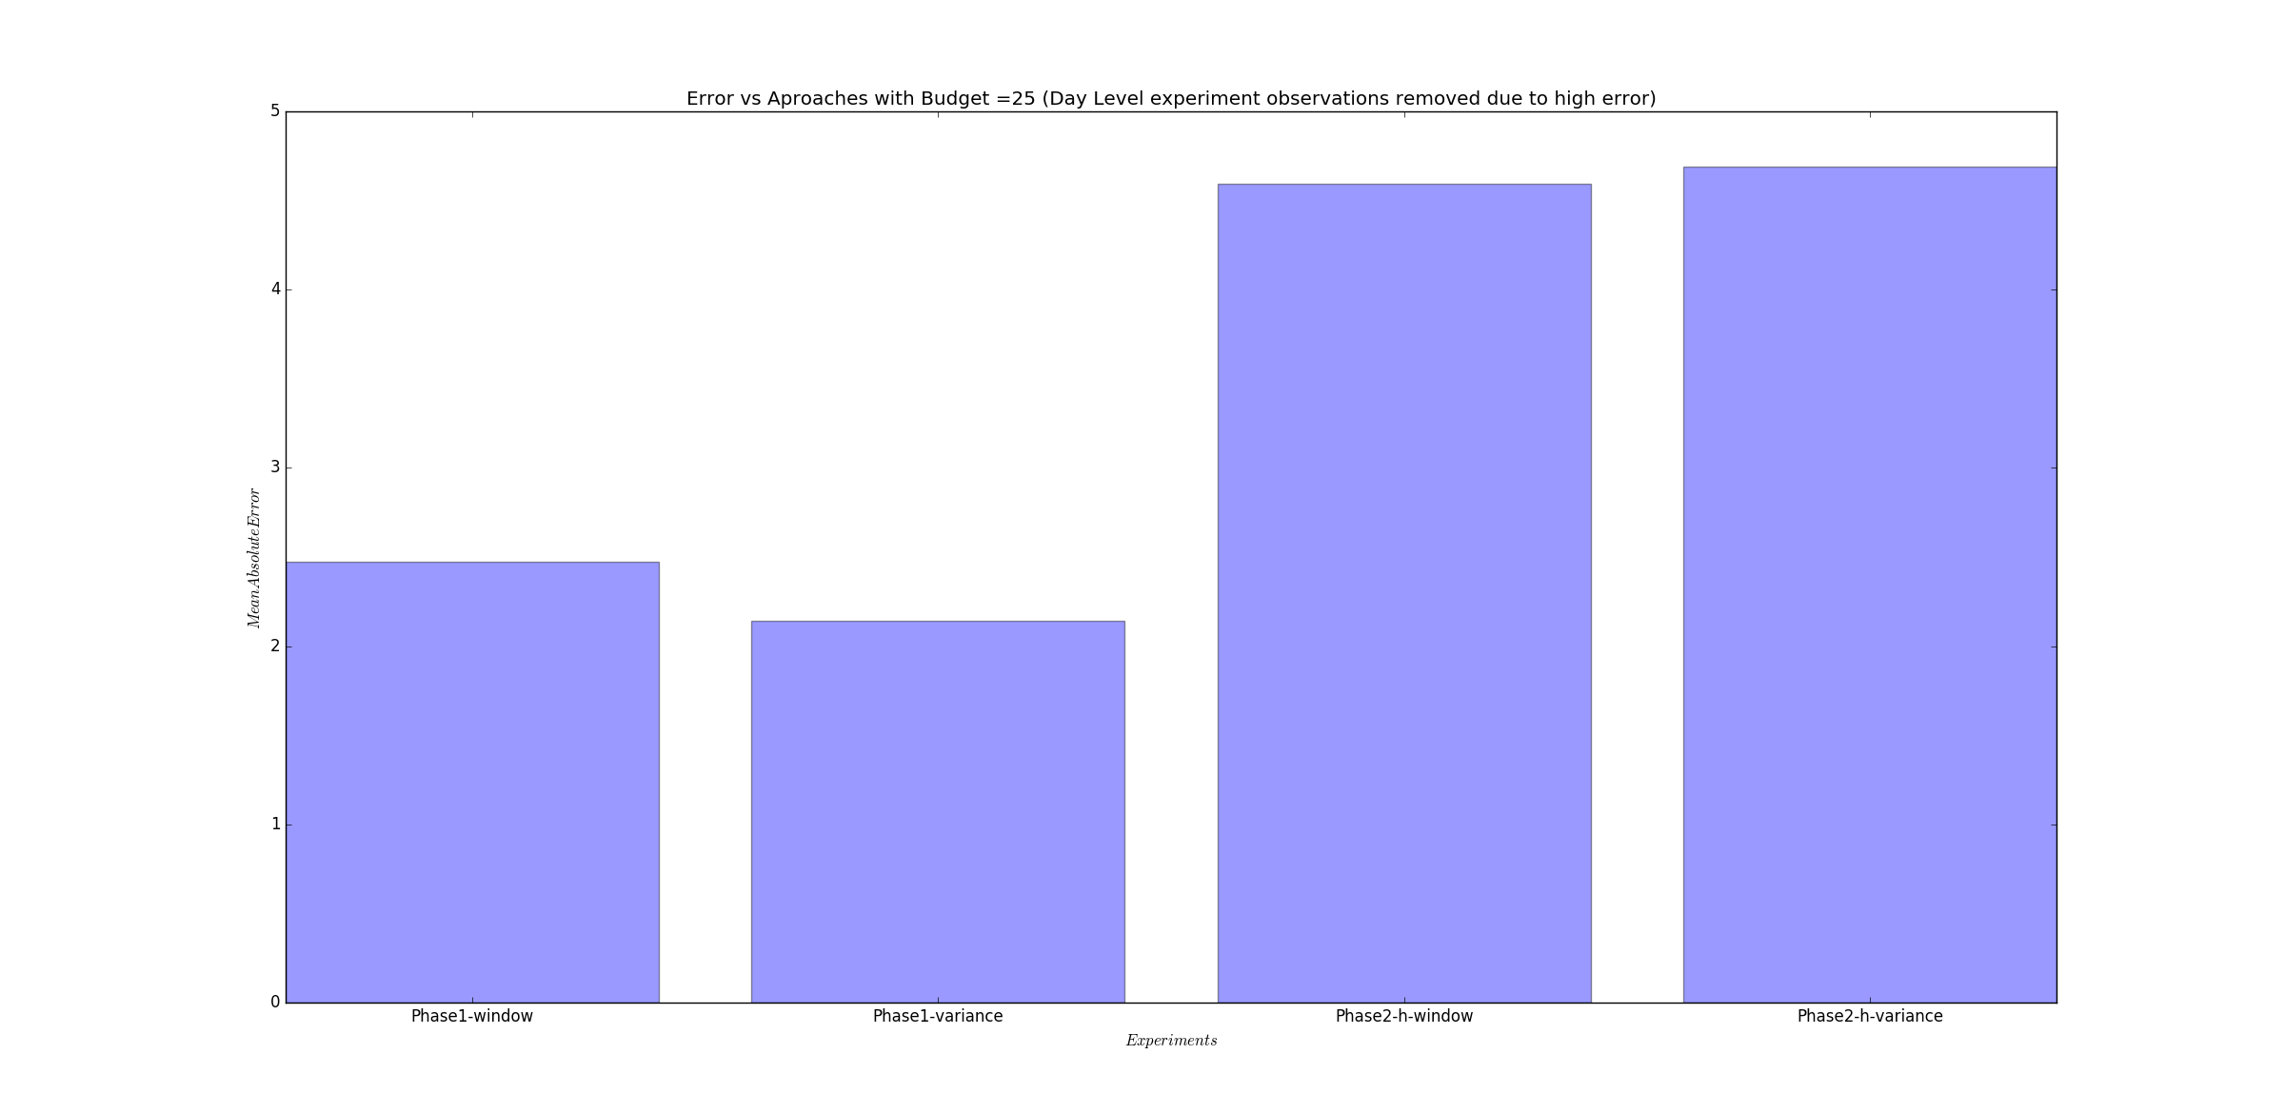

From the bar plots presented above, it can be easily inferred that the phase1 models outperform all the phase2 models.