The objective in this phase was to develop a model which could use the observed values of temperature and humidities and use them in conjunction with the means and variances of the observations from each sensor, at different times obtained from the training data, to produce predictions of the outputs of those sensors for which the reading cannot be attained.

In the code, multiple approaches were employed namely –

1. Windowed Active Inference with hour constant model parameters.
2. Variance based Active Inference with hour constant model parameters.

In the hour constant parameter model, the model parameters are kept constant at the 0.5 hour level.

It was found through the experiments that the performance of the model on the humidity dataset in phase 2 was worse than that of the temperature dataset.

The performance of the day constant model with window based active inference in phase 2 initially starts with a terrible performance, but gradually improves by several orders of magnitude with every increase in budget.

All in all, the best performance (in terms of least mean squared errors) is yielded by the inference models from phase 3.

The relations between the Mean Absolute Errors and the different models for every budget is as follows-

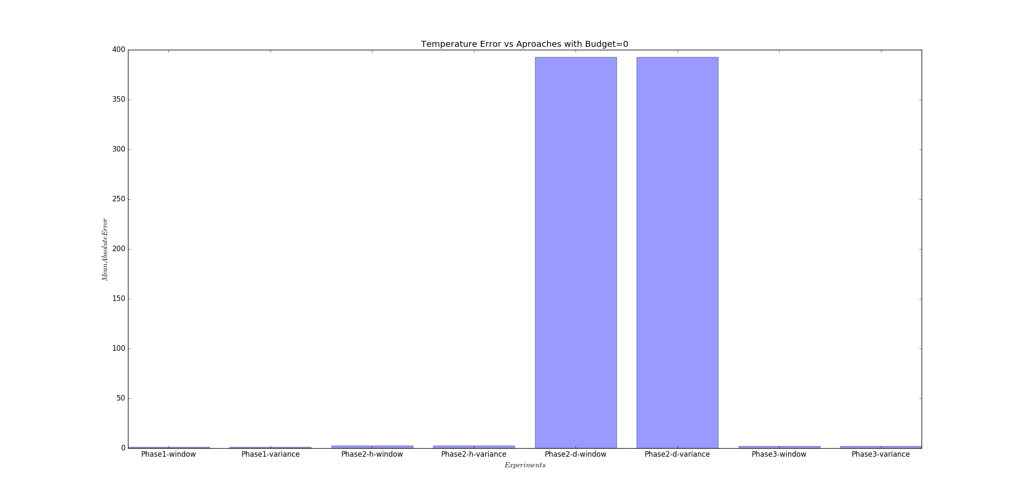

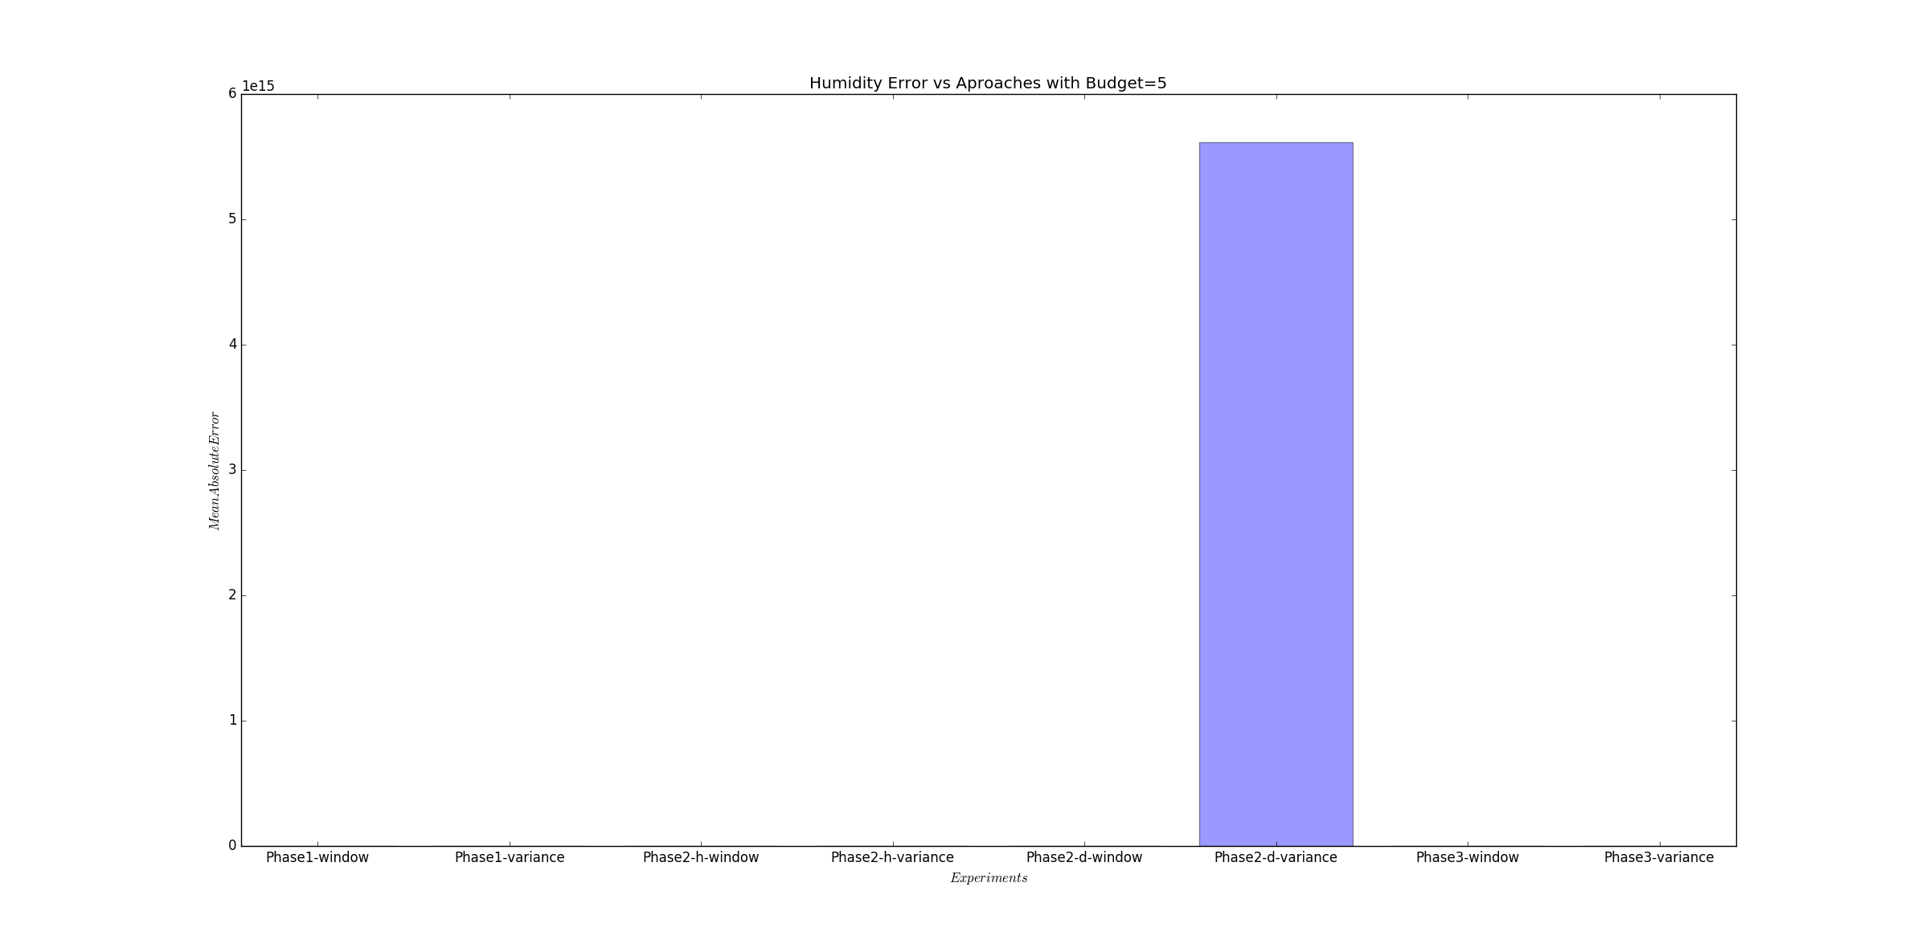

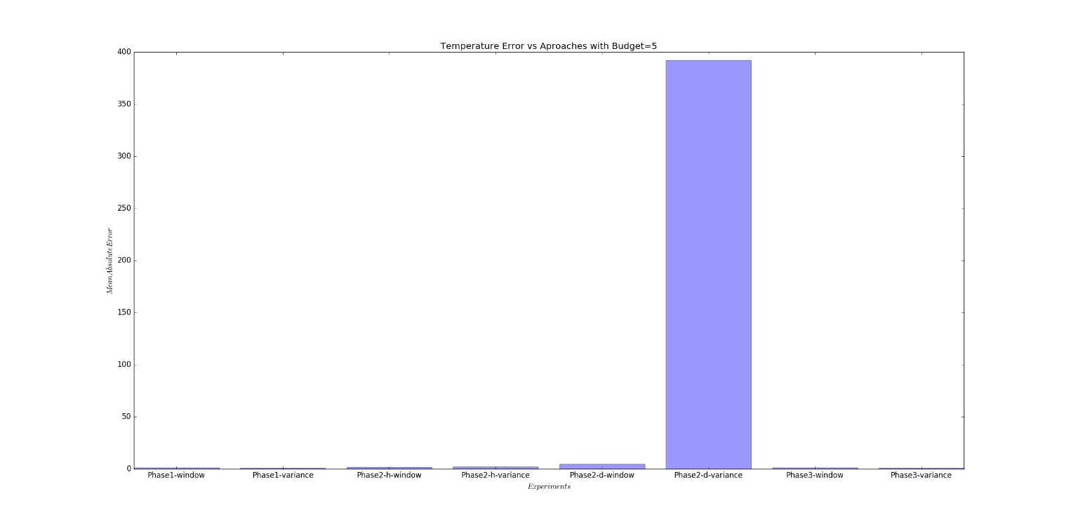

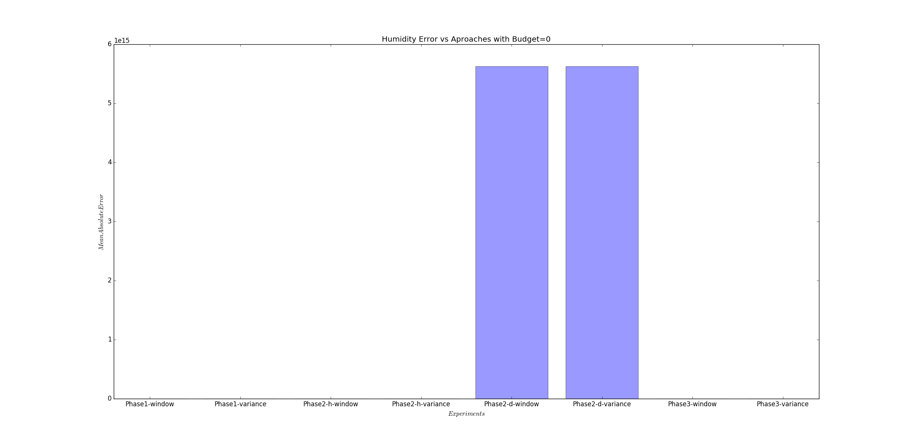

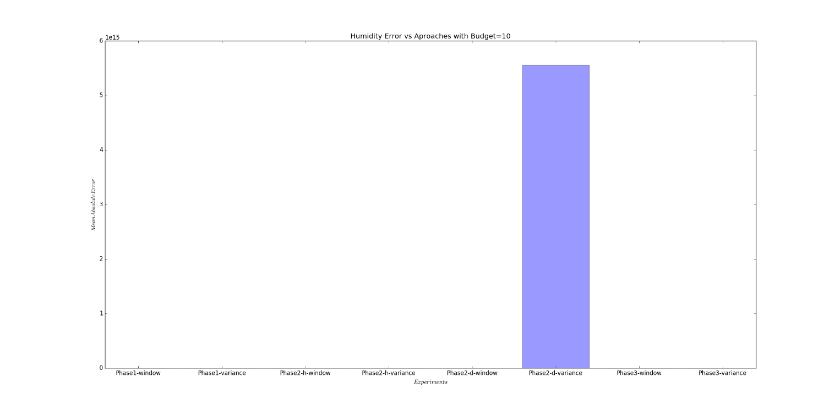

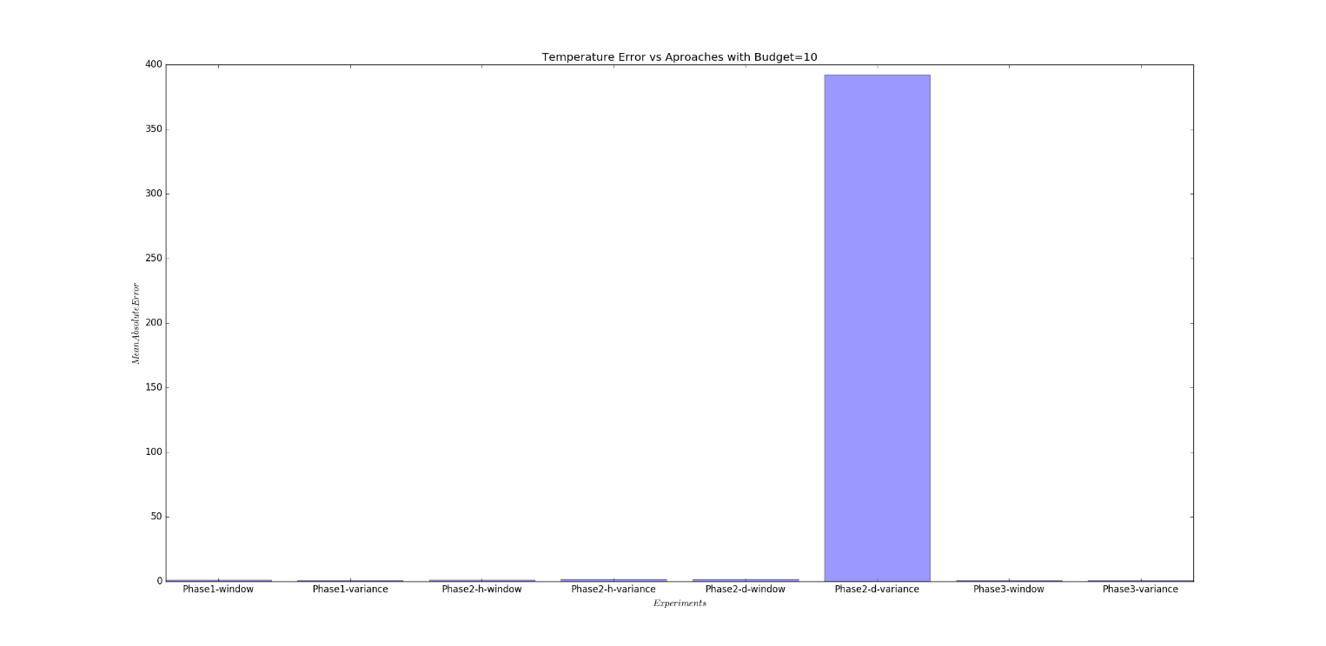

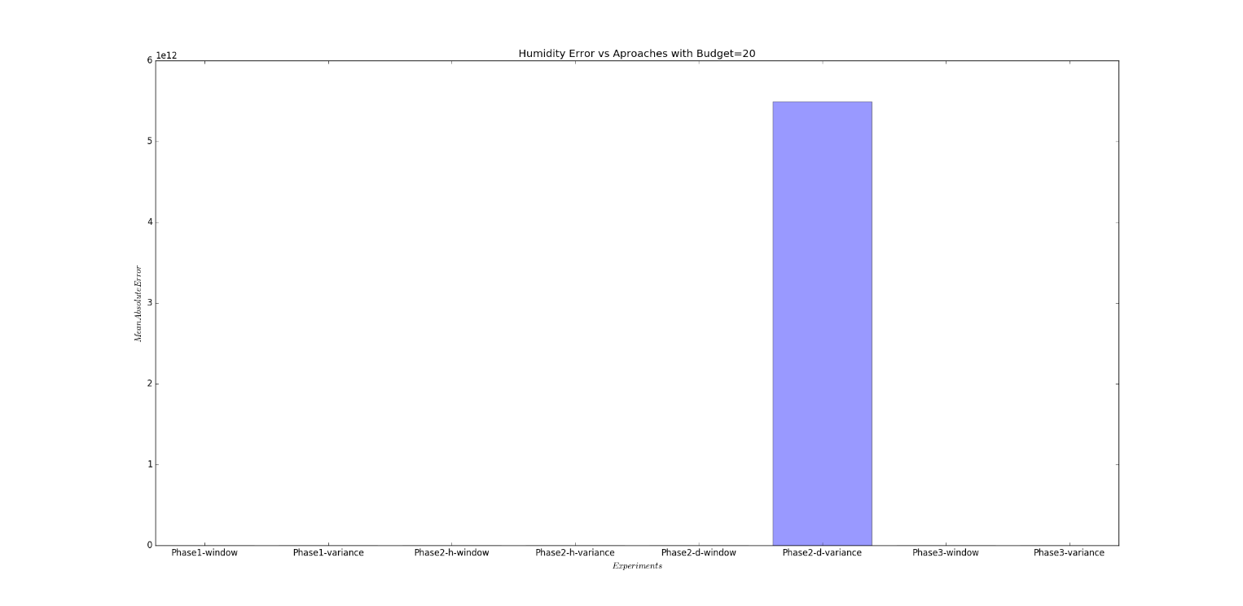

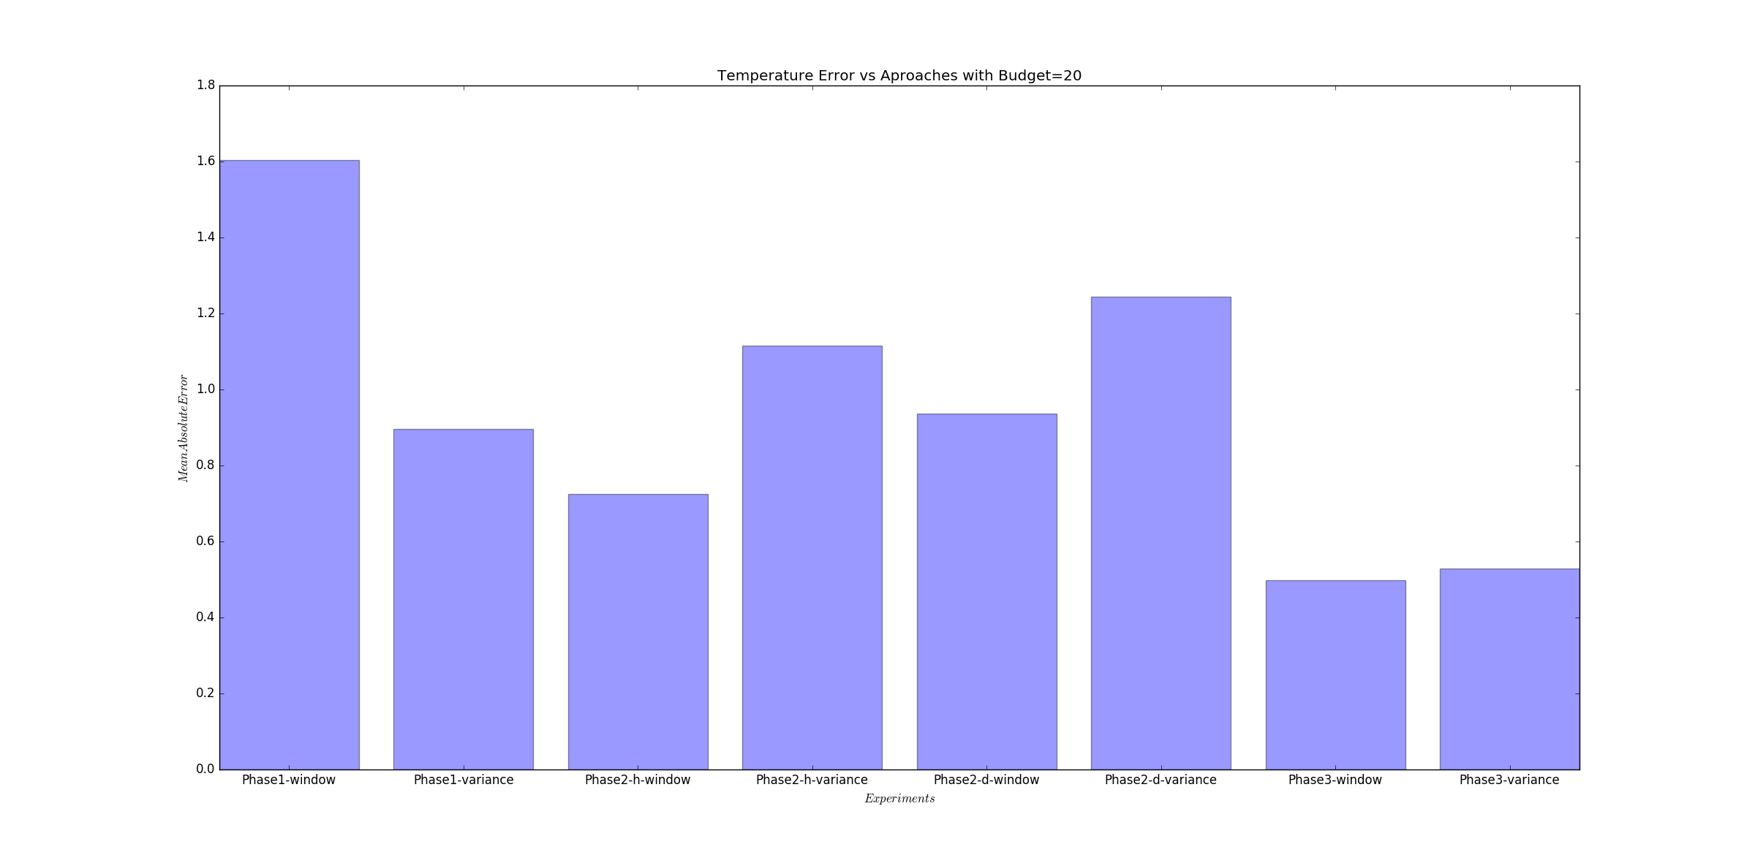

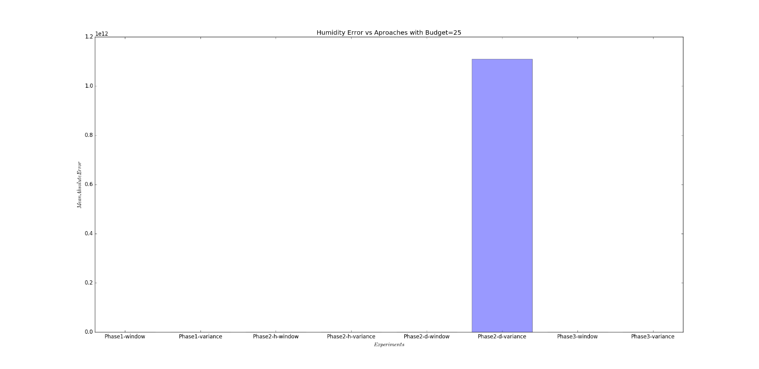

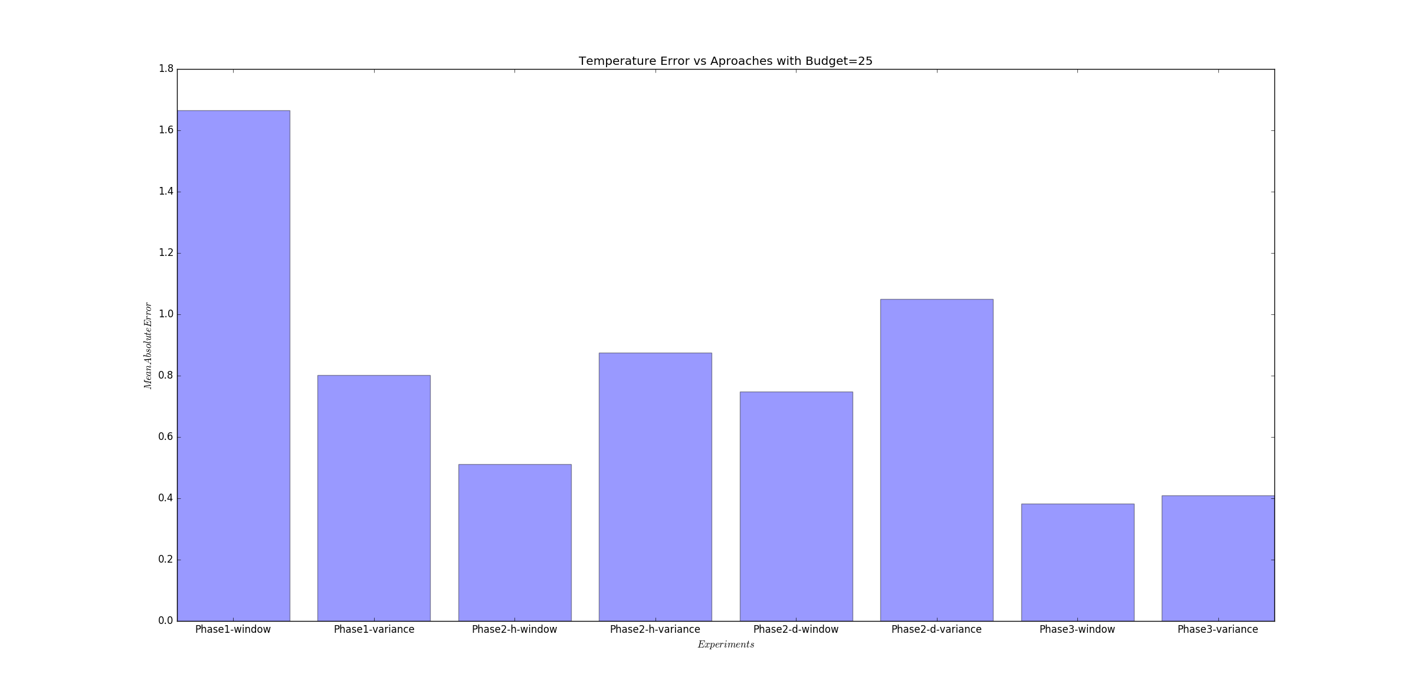

As is evident from the plots above, we can see that the performance of the inference models improves with increasing budget and in subsequent phases suggesting that the models so devised have improved with each iteration. Plots corresponding to each budget and each dataset have been presented here.