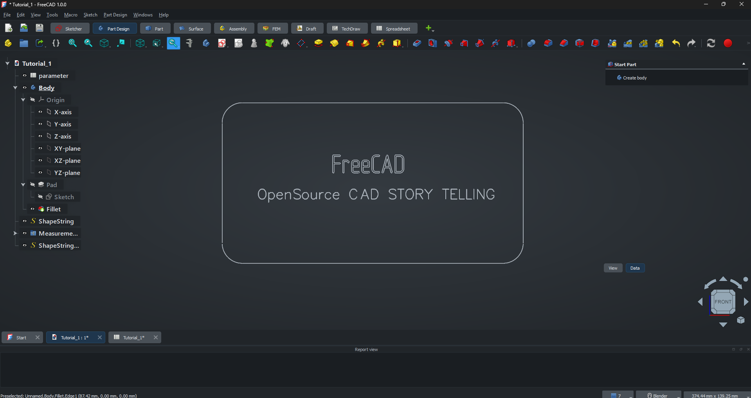
Table of Contents
1. Chapter: Getting Ready 3
1. Meet the Computer (1 hr) 3
2. Installing FreeCAD (1 hr) 3
3. Exploring the FreeCAD Screen (1 hr) 3
4. Moving Around in 3D (1 hr) 3
2. Chapter: First Shapes 3
1. Creating Simple Objects (2 hr) 3
2. Moving Objects (2 hr) 4
3. Colours and Appearance (2 hr) 4
4. Mini Project: Build a Toy Block Set (2 hr) 4
3. Chapter: Drawing Shapes (Sketcher) 4
1. What is a Sketch (2 hr) 4
2. Drawing Basic Shapes (3 hr) 4
3. Editing Shapes (3 hr) 4
4. Mini Project: Draw a House (2 hr) 5
4. Chapter: From 2D to 3D 5
1. Making Shapes Pop Out (Extrude / Pad) (3 hr) 5
2. Cutting Shapes (Pocket) (3 hr) 5
3. Combining Shapes (3 hr) 5
4. Mini Project: Make a Toy Brick (like LEGO) (3 hr) 5
5. Chapter: Fun Object Projects (12 Hours) 5
1. Build a Toy Car (3 hr) 5
2. Build a Rocket (3 hr) 5
3. Build a Cup (3 hr) 5
4. Build a Simple Robot (3 hr) 5
6. Chapter: Creativity Time (8 Hours) 5
1. Make Your Own Toy (2 hr) 5
2. Build a Simple Animal (2 hr) 5
3. Build a Castle (2 hr) 5
4. Color and Decorate Your Models (2 hr) 5
7. Chapter: Saving and Sharing (4 Hours) 5
1. Saving Projects (1 hr) 5
2. Exporting Models (1 hr) 5
3. Taking Pictures of Models (1 hr) 6
4. Show Your Designs (1 hr) 6
8. Chapter: Challenge Projects (6 Hours) 6
1. Design Your Dream House (3 hr) 6
2. Final Project: Build a Small Toy City (3 hr) 6

FreeCAD tutorial

Chapter: Getting Ready

Meet the Computer (1 hr)
  - What is a computer
  - Mouse: click, double-click, drag
  - Keyboard basics
  - Opening programs

Installing FreeCAD (1 hr)
  - Downloading FreeCAD from FreeCAD official website
  - Installing step by step
  - Opening FreeCAD
  - First look at the interface

Exploring the FreeCAD Screen (1 hr)
  - Menu bar
  - Toolbar
  - 3D view
  - Navigation cube
  - Workbenches

Moving Around in 3D (1 hr)
  - Rotate
  - Zoom
  - Pan
  - Practice with simple shapes

Chapter: First Shapes

Creating Simple Objects (2 hr)
  - Cube
  - Sphere
  - Cylinder
  - Cone
  - Changing size

Moving Objects (2 hr)
  - Move
  - Rotate
  - Copy
  - Delete

Colours and Appearance (2 hr)
  - Change colour
  - Transparency
  - Hide and show objects

Mini Project: Build a Toy Block Set (2 hr)

Chapter: Drawing Shapes (Sketcher)

What is a Sketch (2 hr)
  - 2D drawing
  - Grid and points
  - Lines and circles

Drawing Basic Shapes (3 hr)
  - Rectangle
  - Triangle
  - Circle
  - Polygon

Editing Shapes (3 hr)
  - Move points
  - Change size
  - Delete lines

Mini Project: Draw a House (2 hr)

Chapter: From 2D to 3D

Making Shapes Pop Out (Extrude / Pad) (3 hr)

Cutting Shapes (Pocket) (3 hr)

Combining Shapes (3 hr)
  - Add
  - Cut
  - Intersect

Mini Project: Make a Toy Brick (like LEGO) (3 hr)

Chapter: Fun Object Projects (12 Hours)

Build a Toy Car (3 hr)

Build a Rocket (3 hr)

Build a Cup (3 hr)

Build a Simple Robot (3 hr)

Chapter: Creativity Time (8 Hours)

Make Your Own Toy (2 hr)

Build a Simple Animal (2 hr)

Build a Castle (2 hr)

Color and Decorate Your Models (2 hr)

Chapter: Saving and Sharing (4 Hours)

Saving Projects (1 hr)
    - Save file
    - Open file

Exporting Models (1 hr)
    - STL export
    - For 3D printing

Taking Pictures of Models (1 hr)

Show Your Designs (1 hr)

Chapter: Challenge Projects (6 Hours)

Design Your Dream House (3 hr)

Final Project: Build a Small Toy City (3 hr)

