**Continuation Method for Design of Eccentrically Loaded Weld Group**

**Sung−Yong Kim1, Jong-Hyun Jung2*, and Cheol-Ho Lee3**

1 School of Architecture, Changwon National University, Changwon, Korea. *sungyong.kim@changwon.ac.kr*

2**\*** School of Architecture, Kyungnam University, Changwon, Korea. *ironbell@kyungnam.ac.kr*

3 Dept. of Architecture and Architectural Engineering, Seoul National University,Seoul, Korea. *ceholee@snu.ac.kr*

**Abstract**

The weld size of an eccentrically loaded weld group in plane can be determined using the instantaneous center of rotation method (ICRM) of the AISC design manual. ICRM assumes that the weld element farthest from the instantaneous center of rotation (IC), which can be determined upon the eccentricity and geometry of the weld group, controls the design strength of the eccentrically loaded weld group. This study investigated the incremental nonlinear behavior of the eccentrically loaded weld group by applying a continuation method, which can track the path or trajectory of designated parameters such as location of IC and rotation angle.

**Keywords:** Instantaneous center of rotation method, weak-axis welded steel moment connections, Welded connections, Eccentric load

**1. Introduction**

The detailing of connections is an integral and important part in designing of steel structures. There are many situations where the loading of fillet welds is neither parallel to nor transverse to the axis of the fillet welds. Analysis of such eccentric loading cases is complicated by the fact that the load-deformation behavior is a function of the angle theta between the direction of the resistance and the axis of the fillet weld. This study investigated the incremental nonlinear behavior of the eccentrically loaded weld group. A continuation method was applied, which can track the path or trajectory of designated parameters such as location of IC and rotation angle.

**2. Strength analysis based on ICRM**

The strength of an eccentrically loaded weld group can be determined by locating the instantaneous center of rotation (IC), using the load-deformation relationship of a weld segment. The resistance of a weld segment at any distance from the IC is proportional to such distance and acts in a direction perpendicular to the radial distance to the segment.

2.1. ICRM

Suppose that a weld line of its width and length of *w* and *l*, respectively, lies in the *x*-*y* plane. Let **x**=(*x*, *y*, 0) be the position vector of the weld segments, of which coordinates are parameterized by arc length parameter *s*, and **x**P=(*x*P, *y*P, 0) be the location vector to which the external load *λ***P**=*λ*(*Px*, *Py*, 0) is applied, where *λ* and **P** are the magnitude and direction vector of the applied load, respectively. The procedure for the strength calculation for the loaded weld group located is as follows (see Figure 1):

1) Select a trial location for the IC as **x**IC= (*x*IC, *y*IC, 0). Note that the weld line, the IC and the external load were assumed to be located in the *x*-*y* plane in this study.

2) Compute the resisting force d**R** at any weld segment acting in a direction perpendicular to the radial line from 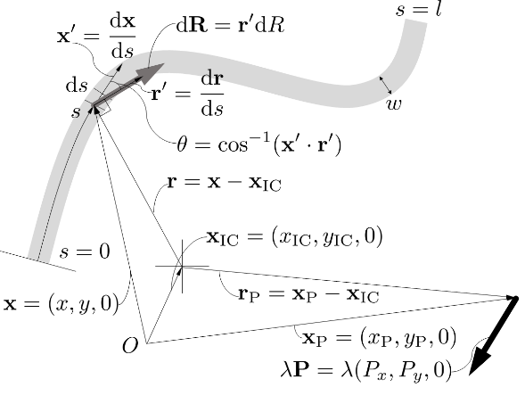

Figure 1 Schematic plot for ICRM

the IC as follows:

|  |  |
| --- | --- |
| $$dR=r'dR$$ | (1) |

where **r**′ is the tangential vector of **r**= **x**-**x**IC, which can be computed as d**r**/d*s,* and

|  |  |
| --- | --- |
| $$dR=0.60F_{EXX}(1.0+0.5\sin^{1.5}{θ})$$ $$×{\left[p\left(1.9-0.9p\right)\right]}^{0.3}w_{e}ds$$ | (2) |

where *we* is the effective weld width, *θ*=cos-1(**x**′·**r**′)is the angle of loading (**r***′*) measured from the weld longitudinal axis (**x**′=d**x**/ds), degrees (see Figure 1), *FEXX* is the weld electrode tensile strength, and *p* is *Δ*/*Δ*sup in which

|  |  |
| --- | --- |
| $$Δ_{sup}=1.087w{\left(θ+6\right)}^{-0.65}≤0.17w$$ | (3) |

and

|  |  |
| --- | --- |
|  | (4) |

where |**r**| is the radius for the element (see Figure 1), and the subscript sup refers to the supremum. Instead of the maximum of the displacement function, the supremum was used in this study, because the infinitesimal element d*s* rather than the finite element *Δs* is used.

3) Check if the load factor of λ satisfies the equilibrium equations. If the equilibrium equations are satisfied within an acceptable tolerance, the analysis is complete. Otherwise, a new trial location of IC should be selected and the procedure repeated. The equilibrium equations are given as follows:

|  |  |
| --- | --- |
| $$λP_{x}-\int_{0}^{l}{{\left(\frac{dR}{ds}\right)}_{x}ds}=0$$ | (5) |
| $$λP_{y}-\int_{0}^{l}{{\left(\frac{dR}{ds}\right)}_{y}ds}=0$$ | (6) |
| $$\left(r_{P}×λP-\int_{0}^{l}{r×\frac{dR}{ds}ds}\right)⋅i_{z}=0$$ | (7) |

where **r**P =**x**P-**x**IC is the distance vector of the applied load, and **i***z* is the unit vector for z direction. Note that, in order to extract the magnitude of the moment, the triple scalar product was used in Eq.(7).

A variety of numerical methods for the ICRM was proposed by various researchers, including Brandt (1982), Iwankiw (1987), and Lue et al. (2017). In the previous researches, Eqs.(5) to (7) were solved by following procedure: 1) calculate **P***n*=*λn***P** defined as the load value by which Eq.(7) is satisfied; 2) substitute **P***n* into the remaining equilibrium equations Eqs.(6) and (7) and compute their residuals; and 3) checks if the computed residuals are within acceptable tolerance. If they are not within the tolerance, update the trial location of IC and repeat the procedure.

2.2. Reformulation of ICRM

The minimum potential principle relates a system of forces in equilibrium to a system of compatible displacements. Stated simply, if a body in equilibrium is given a set of small *compatible* displacement, then the work done by the external loads on these external displacements is equal to the work done by the internal forces on the internal deformation, i.e.,

|  |  |
| --- | --- |
| $$δΠ=δ\left(U+V\right)=0$$ | (8) |

where *δ* is a variational operator, and *U* and *V* are external and internal potential energy, respectively. The virtual work equation can be written as follows:

|  |  |
| --- | --- |
| $$δu_{P}⋅λP=\int_{0}^{l}{δu⋅\frac{dR}{ds}}ds$$ | (9) |

where *δ***u** and *δ***u**P are the virtual displacements for the weld line and external force, respectively.

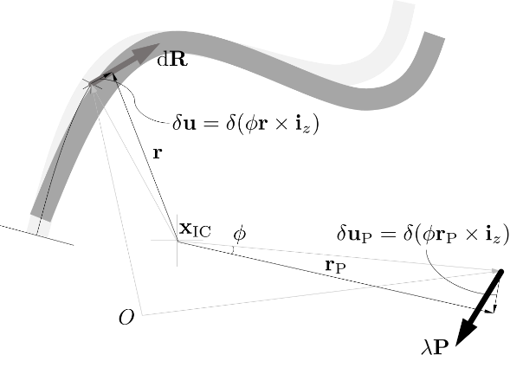

Figure 2 Virtual displacement of given weld line

Using geometrical relationship, the virtual displacement sets *δ***u** and *δ***u**P is determined as follows (see Figure 2):

|  |  |
| --- | --- |
| $$δu=δ(ϕr×i_{z})$$ | (10) |
| $$δu_{P}=δ(ϕr_{P}×i_{z})$$ | (11) |

It should be note that the virtual displacement sets *δ***u** and *δ***u**P depend on not only the angle *ϕ* but also the location of weld element and load point **r** and **r**P, which in turn depends on the assumed location of the IC, **x**IC.

Using calculus of variation, the virtual displacements *δ***u** and *δ***u**P can be expressed as follows:

|  |  |
| --- | --- |
| $$δu=δϕ\left(r×i_{z}\right)-ϕ(δx_{IC}×i_{z})$$ | (12) |
| $$δu_{P}=δϕ\left(r_{P}×i_{z}\right)-ϕ(δx_{IC}×i_{z})$$ | (13) |

where *δϕ* is the virtual rotation angle and *δ***x**IC=(*δx*IC, *δy*IC,0) is the virtual location of the IC. Finally, Eq.(9) can be written into the following form:

|  |  |
| --- | --- |
| $$δy_{IC}\left[λP_{x}-\int_{0}^{l}{{\left(\frac{dR}{ds}\right)}_{x}ds}\right]=0$$ | (14) |
| $$δx_{IC}\left[λP_{y}-\int_{0}^{l}{{\left(\frac{dR}{ds}\right)}_{y}ds}\right]=0$$ | (15) |
| $$δϕ\left(r_{P}×λP-\int_{0}^{l}{r×\frac{dR}{ds}ds}\right)⋅i_{z}=0$$ | (16) |

To investigate the incremental nonlinear behavior of the location of the IC and rotation angle, this study applied the continuation method which can track the path or trajectory of designated parameter. The continuation procedure proposed by Seydel (2009) was applied to calculate the incremental strength of the weld group.

**3. Design example**

In this study, a C-shaped loaded weld group was examined, and only the upper half part of the weld configuration is considered in order to reduce computational burden (see Figure 3). The vertical length *l* is 160 mm (i.e. the vertical length of the upper half part is 80 mm) and the horizontal lengths *kl* are 60 mm each (i.e. *k*= 0.375). The location of C.G. is calculated to be at 47.2 mm from the far left of the weld group, and the eccentric load is applied to the vertical direction (i.e. *Px*=0 and *Py*=1) at 120 mm from the far left of the weld group (i.e. the distance from the C.G. to the nodal load point, *al*, is 120+47.2=167.2 mm and thus *a*= 1.05). The weld size *w* is 10 mm, and E70 electrodes are used. In the analysis, the weld configuration is divided into segments 10 mm long.

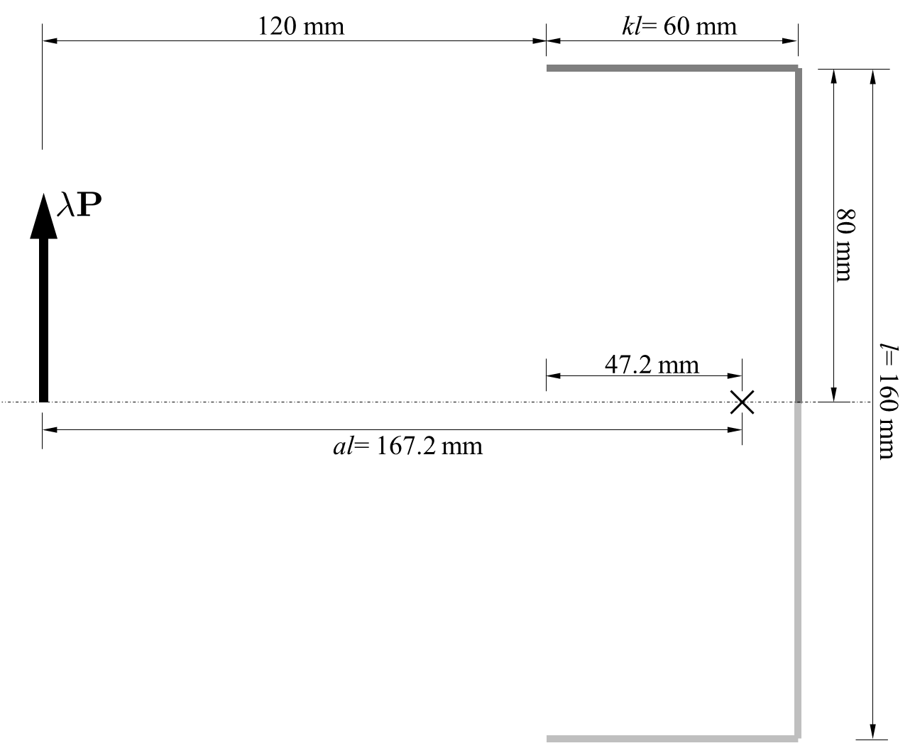

Figure 3 C-shaped loaded weld group examined (k= 0.375 and a= 1.05)

Figure 4 shows the results for the numerical results obtained by the ICRM, where the purple and green arrows, the red arrow, and the asterisk denote the force of each elements, the nominal strength of the weld group and the location of IC, respectively. The nominal strength of the weld group examined was calculated as 237 kN, and the value was only about 1% different from the strength obtained using the AISC table method. Figure 5 shows the trajectory of the location of IC and rotation angle for the examined weld group. It was shown that the continuation method is applicable for the investigation of the incremental nonlinear behavior of the eccentrically loaded weld group.

**3. Conclusions**

In this study, the ICRM is reformulated from minimum potential method, and a continuation method is applied for the design of weld group, which can track the path or trajectory of designated parameters such as location of IC and rotation angle. It is expected that the continuous method applied in this study would be helpful in understanding the incremental nonlinear behavior of the weld group.

**4. References**

AISC (2010). *Steel Construction Manual*, AISC, Chicago, Illinois.

Brandt, G. D. (1982). “A General Solution for Eccentric Loads on Weld Groups” *Engineering Journal*, 19(3), pp. 150-159

Iwankiw, N. R. (1987). “Design for Eccentric and Inclined Loads on Bold and Weld Groups” *Engineering Journal*, 24(4), pp.164-171.

Lue, D. M., Chang, C. C., Liao, C. Y., and Hsu, W. T. (2017). “Enhanced analysis and design of eccentrically loaded weld connections” *Journal of the Chinese Institute of Engineers*, 40(8), pp.708-719.

Seydel, R. (2009). *Practical Bifurcation and Stability Analysis*, Springer.



Figure 4 Calculated strength for C-shaped loaded weld group (k= 0.375 and a= 1.05)



(a) Location of IC



(b) Rotation angle

Figure 5 Trajectory of the IC location and rotation angle for C-shaped loaded weld group (k= 0.375 and a= 1.05)