Name | Sung-Yong KIM | 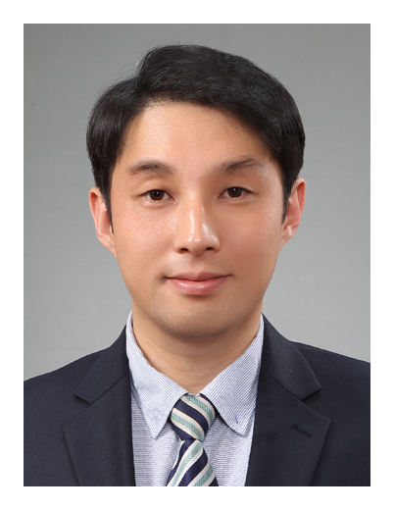
BS / PhD | Seoul National University/ Seoul National University
Position | Assistant Professor
Organization | School Architecture, Changwon National University
Address | 20 Changwondaehak-ro, Uichang-gu, Changwon-si, Gyeongsangnam-do 51140, Republic of Korea
Phone/Fax | +82-55-218-3806
E-mail | sungyong.kim@changwon.ac.kr
Research Interest | (1) Vibration control,  (2) Steel and composite structures
Title of Paper | ARTICIFICIAL NEURAL-NET BASED HYSTERESIS IDENTIFICATION

