How to Access XRP on the Makerspace Laptops:

On the taskbar of each MakerSpace laptop, there is an icon for both the XRP code editor and the pestolink for tele-op of the robots.

Where is the “reset” button on the XRP?

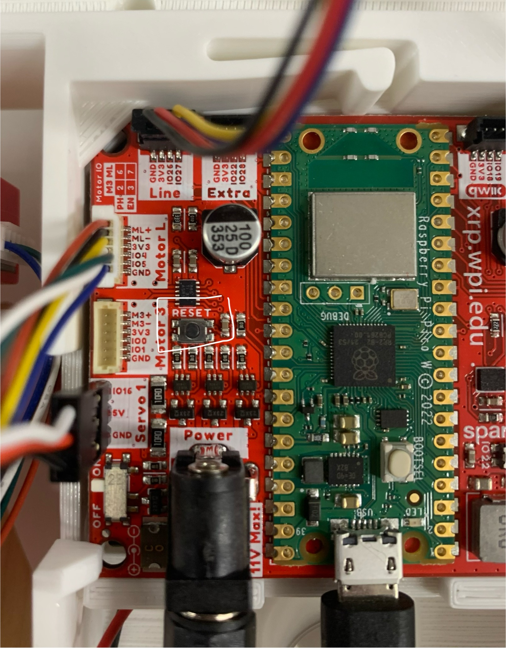

How to start the robot:

* Press connect XRP (shows up as com3 or com4; if it does not show up, something went wrong)
* Click on XRP name
* Connect
  + A lot times it will say cannot connect + redownload
    - DO NOT redownload
    - Press reset button on XRP as long as your xrp is connected
    - If that doesn’t work, physically disconnect and connect robot and reload page
    - Button should become green and say “run”

XRP Programming Hacks:

* Create a program using blocks
* Press “run” to run the program
* Use while loops for long codes that run over long periods of time
* Once you start, if there is a while loop, you can disconnect the xrp from computer (does not need to be connected to run)
* If you want to stop the code, connect back to laptop and click reset on XRP

Challenge Answers:

1. Sumo
2. Solo Challenges
3. Reef