**Implemented Solution**

Below is the implemented solution.

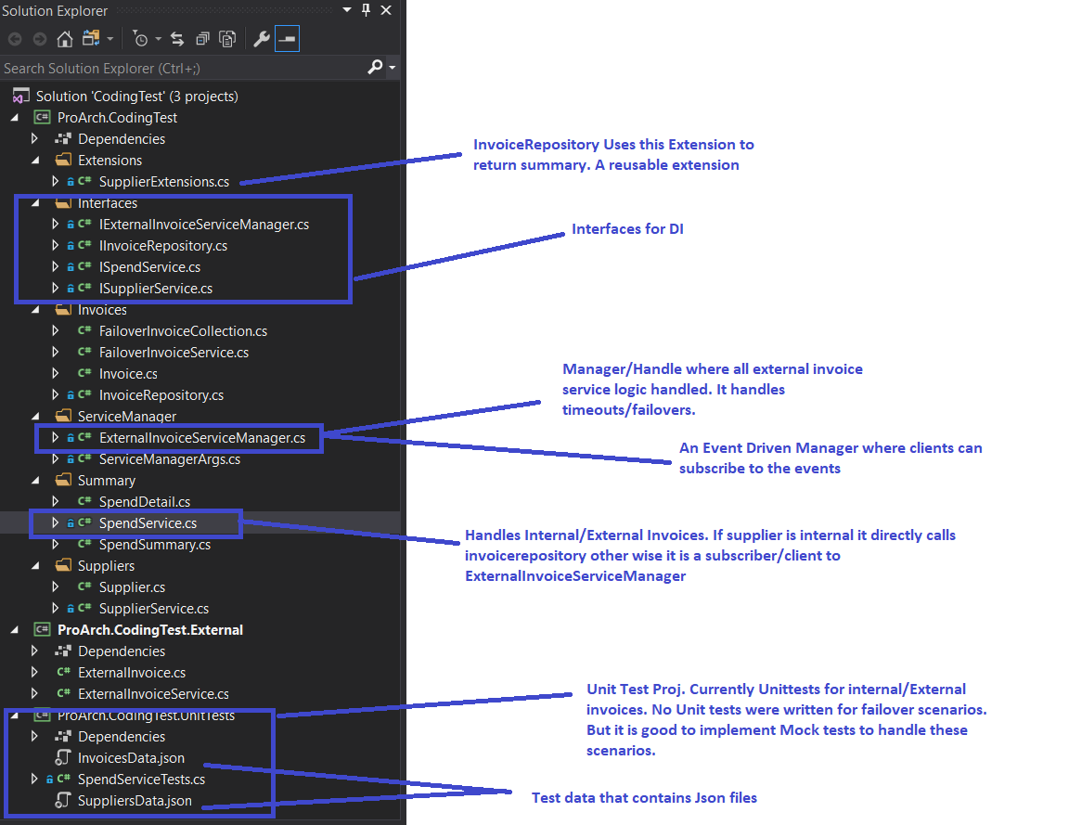

The solution uses the following Design principles

* DI in the below classes and uses DI containers
  + ExternalInvoiceServiceManager
  + InvoiceRepository
  + SpendService
  + SupplierService
* Spend Service works like Repository
* **Pub/Sub pattern**
  + ExternalInvoiceServiceManager
  + SpendService

**What more can be implemented:**

More unit test cases can be implemented to handle fail over scenarios, timeout, db refresh date etc. But to keep the solution simple , positive test cases were written. We can use test frameworks like moq to simulate and test those scenarios .