## Below are the steps to be followed.

# Step -1

Cloned the specified <https://github.com/JamesNK/grpc-dotnet.git>

From the url <https://github.com/JamesNK/grpc-dotnet/tree/jamesnk/updateclientcert>

# Step - 2

Make sure the certificate is valid with below command .

Certificate password is 1111

certutil -dump e:\MyGithub\grpccertauth\Certifier\Client\Certs\client.pfx

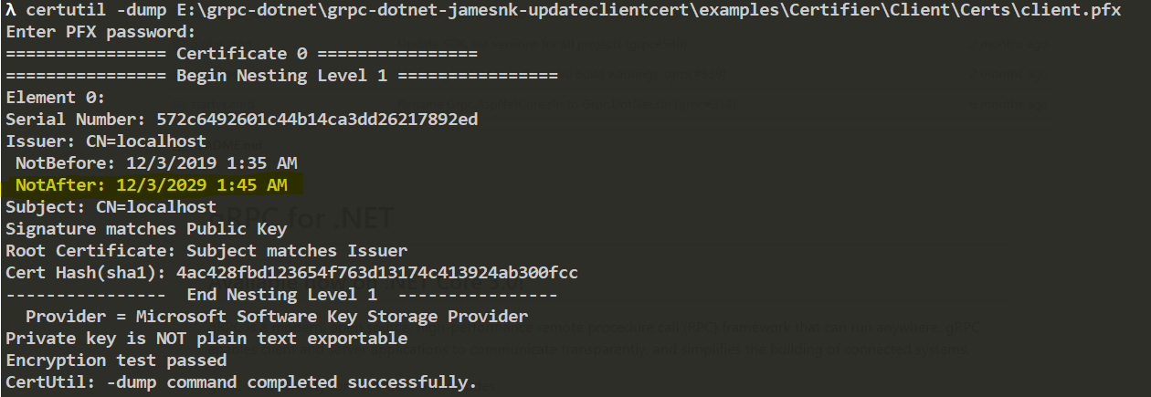

# Step-3

Trust the certificate( in both personal/certificates and trusted root certification authorities)

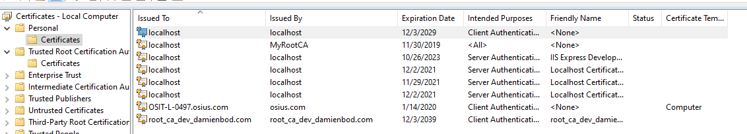

# Start server

E:\MyGithub\grpccertauth\Certifier\Server

dotnet run

# Started client

E:\MyGithub\grpccertauth\Certifier\Client

Dotnet run