P2 Debug Window System User Manual
A Comprehensive Guide to Propeller 2 Visual Debugging and Display Interfaces

Table of Contents
- Introduction
- System Overview
- DEBUG Terminal Windows
- SCOPE Oscilloscope Displays
- PLOT Graphics Windows
- FFT Analysis Displays
- Single-Step Debugger
- Variable Monitors
- Memory Displays
- Dashboard Design Patterns
- System Integration
- Real-World Applications
- Troubleshooting
- Best Practices

Introduction
The Propeller 2 Debug Window System provides a comprehensive suite of visual debugging and display interfaces that transform how you develop, debug, and monitor P2 applications. Unlike traditional microcontrollers that rely on external tools, the P2 integrates powerful display capabilities directly into the silicon through its DEBUG infrastructure.

What You'll Learn
By the end of this manual, you'll master: - Multi-window debugging using coordinated display systems - Real-time monitoring dashboards for complex applications
- Signal analysis using integrated oscilloscope and FFT displays - Memory and variable visualization for performance optimization - Interactive debugging with single-step control and breakpoints - Dashboard design patterns for professional monitoring systems

System Capabilities
The P2 Debug Window System includes:
Window Type | Primary Function | Key Features
DEBUG TERM | Text displays and user interfaces | 300×200 chars, 4 color schemes, real-time output
DEBUG SCOPE | Oscilloscope displays | Real-time waveforms, multi-channel, auto-triggering
DEBUG PLOT | Graphics and plotting | Hub RAM visualization, architectural diagrams
DEBUG FFT | Frequency analysis | Signal processing, spectrum analysis
Debugger Interface | Code debugging | Single-step, breakpoints, multi-COG support
Variable Monitors | Runtime data display | Real-time variable tracking, formatted output
Memory Displays | Memory visualization | Hub/COG memory mapping, usage analysis

When to Use This System
Development Scenarios: - Algorithm Development: Visualize data flow and transformations - Signal Processing: Monitor input/output waveforms and frequency content
- System Monitoring: Create dashboards for multi-COG applications - Educational Demonstrations: Build interactive learning tools - Production Debugging: Diagnose field issues with integrated displays
Professional Applications: - Industrial Control: Real-time process monitoring dashboards - Audio/Video Systems: Signal analysis and quality monitoring - Robotics: Sensor fusion and control system visualization
- IoT Devices: Status displays and diagnostic interfaces - Test Equipment: Custom measurement and analysis tools

System Overview

Architecture Integration
The P2 Debug Window System operates as an integrated part of the Propeller 2 architecture:
┌─────────────────────────────────────────────────────────────┐
│ P2 Debug Window System │
├─────────────────────────────────────────────────────────────┤
│ DEBUG TERM │ DEBUG SCOPE │ DEBUG PLOT │ DEBUG FFT │
│ Text Windows │ Oscilloscope │ Graphics │ Analysis │
├─────────────────────────────────────────────────────────────┤
│ DEBUG Infrastructure & Communication │
├─────────────────────────────────────────────────────────────┤
│ COG 0 │ COG 1 │ COG 2 │ COG 3 │...│
│ (Main) │ (Signal) │ (Monitor) │ (Control) │ │
├─────────────────────────────────────────────────────────────┤
│ Hub Memory & Smart Pin System │
└─────────────────────────────────────────────────────────────┘

Multi-Window Coordination
Simultaneous Operation: Multiple window types can operate concurrently: - Text terminals for status and control - Scope displays for real-time signals
- Plot windows for data visualization - FFT displays for frequency analysis - Debug interfaces for code development
Resource Management: Each window type uses different P2 resources: - COG Independence: Non-blocking operation across COGs - Memory Efficiency: Optimized for real-time performance - Communication: Seamless data sharing between displays

Window Lifecycle
Phase | Description | Actions
Declaration | Define window parameters | Set size, color schemes, display modes
Initialization | Activate window display | Open window, establish communication
Active Operation | Real-time data updates | Send data, update displays, handle user input
Coordination | Multi-window synchronization | Coordinate updates, manage resources
Termination | Clean shutdown | Close displays, release resources

DEBUG Terminal Windows
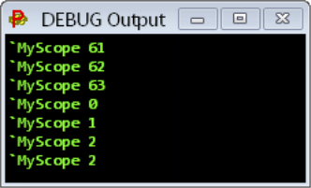
DEBUG Terminal Output
Basic DEBUG terminal showing text output functionality

Overview
DEBUG Terminal windows provide sophisticated text-based displays for user interfaces, status monitoring, and debugging output. These are the foundation of P2's visual debugging system.

Terminal Specifications
Resolution and Sizing:
Parameter | Range | Default | Description
Columns | 1-300 | 40 | Character columns per line
Rows | 1-200 | 20 | Text rows in display
Font Size | 6-200 pts | 12 | Text size for readability
Color Schemes | 4 simultaneous | B&W | Foreground/background combinations

Terminal Declaration and Setup
' Basic terminal creation
DEBUG(`TERM MyStatus SIZE 80 25 TEXTSIZE 14)
' Multi-terminal dashboard
DEBUG(`TERM SystemLog SIZE 60 30 TEXTSIZE 10)
DEBUG(`TERM UserInterface SIZE 40 15 TEXTSIZE 16)
DEBUG(`TERM DataDisplay SIZE 50 20 TEXTSIZE 12)
Configuration Commands:
' Sizing and appearance
DEBUG(`TERM MyTerm SIZE 80 25) ' Set dimensions
DEBUG(`TERM MyTerm TEXTSIZE 14) ' Set font size
DEBUG(`TERM MyTerm COLOR 1 0) ' White text, black background
' Real-time content updates
DEBUG(`TERM MyTerm "System Status: OK")
DEBUG(`TERM MyTerm.dec(sensor_value)) ' Formatted numeric output
DEBUG(`TERM MyTerm.bin(status_bits)) ' Binary representation

Control Character System
Basic Control Characters:
Code | Function | Usage Example | Description
0 | Clear & Home | DEBUG(TERM.char(0))| Clear screen, cursor to home | |1| Home Only |DEBUG(TERM.char(1)) | Move cursor to top-left
2 | Set Column | DEBUG(TERM.char(2,40))| Position cursor horizontally | |3| Set Row |DEBUG(TERM.char(3,15)) | Position cursor vertically
4-7 | Color Select | DEBUG(TERM.char(5))` | Choose color scheme 0-3

SCOPE Oscilloscope Displays
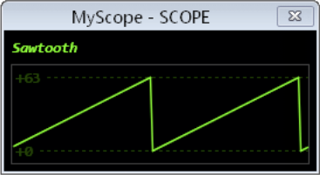
SCOPE Sawtooth Display
SCOPE display showing real-time waveform visualization with sawtooth pattern
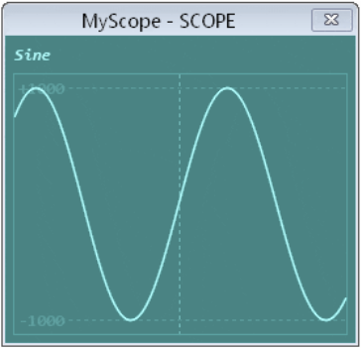
SCOPE Anti-aliasing Display
SCOPE display demonstrating anti-aliasing for smooth waveform rendering

Overview
DEBUG SCOPE displays provide real-time oscilloscope functionality integrated directly into the P2 system. These displays are essential for signal analysis, waveform monitoring, and real-time system debugging.

SCOPE Capabilities
Display Features:
Feature | Specification | Description
Real-time Plotting | Live updates | Continuous waveform display during execution
Multi-channel | Multiple signals | Simultaneous display of different signals
Auto-scaling | Automatic range | Dynamic scaling for optimal viewing
Anti-aliasing | Smooth rendering | High-quality waveform display
Color Coding | Channel identification | Different colors for different signals
Trigger System | Auto-triggering | Stable waveform capture

SCOPE Declaration and Basic Usage
' Single-channel scope display
DEBUG(`SCOPE MySig samples signal)
' Multi-channel X-Y scope
DEBUG(`SCOPE_XY Waveforms samples x_signal y_signal color)
' Auto-scaling scope with triggering
DEBUG(`SCOPE AutoScope AUTO)
DEBUG(`SCOPE AutoScope TRIGGER channel AUTO)

PLOT Graphics Windows
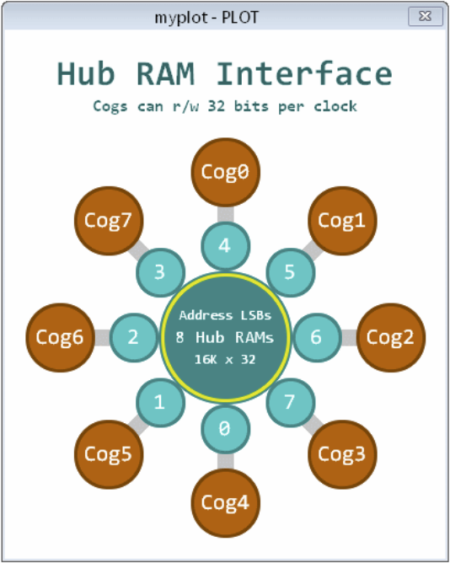
PLOT Hub RAM Display
PLOT display showing Hub RAM memory visualization and system architecture

Overview
DEBUG PLOT windows provide sophisticated graphics and plotting capabilities for visualizing system architecture, memory usage, data relationships, and complex visualizations that go beyond simple waveforms.

PLOT Capabilities
Graphics Features:
Feature | Description | Applications
Memory Mapping | Visual memory layout | Hub/COG memory visualization
Architecture Diagrams | System structure display | Hardware configuration views
Data Relationships | Multi-dimensional plotting | Sensor correlation analysis
Performance Metrics | Resource usage graphics | CPU/memory utilization
Network Topology | Connection mapping | Multi-COG communication

FFT Analysis Displays
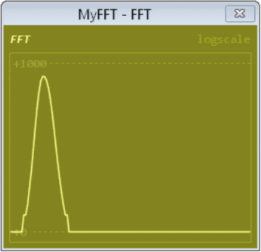
FFT Frequency Analysis
FFT display showing frequency domain analysis of digital signals

Overview
DEBUG FFT displays provide integrated frequency domain analysis capabilities, essential for signal processing applications, audio analysis, vibration monitoring, and digital signal processing validation.

FFT Display Features
Analysis Capabilities:
Feature | Description | Applications
Real-time FFT | Live frequency analysis | Audio processing, vibration analysis
Spectrum Display | Frequency domain visualization | Signal quality assessment
Peak Detection | Automatic frequency identification | Tone detection, fault analysis
Windowing Functions | Signal conditioning | Spectral leakage reduction
Multiple Channels | Simultaneous analysis | Comparative frequency analysis

Single-Step Debugger

Overview
The P2 Single-Step Debugger provides PASM-level debugging capabilities with breakpoint support, variable monitoring, and multi-COG debugging coordination. This is essential for low-level optimization and system debugging.

Debugger Features
Core Capabilities:
Feature | Description | Usage
Single-Step Execution | Step through PASM instructions | Instruction-level debugging
Breakpoint Management | Set/remove breakpoints | Conditional program halting
Variable Monitoring | Real-time variable display | State inspection
Multi-COG Debugging | Independent COG debugging | Parallel process debugging
Clock Adaptation | Dynamic frequency tracking | Debug across clock changes

Variable Monitors

Overview
Variable Monitors provide real-time display of program variables, memory contents, and system state information. These displays are essential for understanding program behavior and optimizing performance.

Monitor Types
Variable Display Formats:
Format | Description | Example Usage
Decimal Display | Numeric values | Sensor readings, counters
Hexadecimal Display | Memory addresses, bit patterns | Pointer values, status registers
Binary Display | Bit-level information | Pin states, flag collections
Formatted Display | Custom formatting | Timestamps, structured data

Memory Displays

Overview
Memory Displays provide visualization of Hub RAM usage, COG memory allocation, and memory access patterns. These displays are crucial for performance optimization and memory management.

Memory Visualization Types
Display Categories:
Type | Purpose | Information Shown
Hub Memory Map | RAM allocation tracking | Used/free regions, fragmentation
COG Memory Status | Per-COG memory usage | Active/inactive COGs, memory utilization
Memory Access Patterns | Performance analysis | Read/write hotspots, access frequency
Stack Usage | Stack overflow prevention | Stack depth, peak usage

Dashboard Design Patterns

Overview
Effective dashboard design combines multiple window types to create comprehensive monitoring and control systems. This section covers proven patterns for organizing complex information displays.

Multi-Window Coordination Patterns
System Monitor Dashboard:
┌─────────────────────────────────────────────────────────────────────┐
│ P2 System Dashboard │
├─────────────────────┬─────────────────────┬─────────────────────────┤
│ Status Terminal │ Performance Plot │ Variable Monitor │
│ │ │ │
│ • System: Online │ [CPU Usage Graph] │ Temperature: 45°C │
│ • COGs: 6/8 Active │ [Memory Usage] │ Pressure: 1013 mBar │
│ • Errors: 0 │ [Network Traffic] │ Flow Rate: 15.2 L/min │
│ • Uptime: 15:42:33 │ │ Battery: 12.6V │
├─────────────────────┼─────────────────────┼─────────────────────────┤
│ SCOPE Display │ FFT Analysis │ Memory Map │
│ │ │ │
│ [Real-time Signal] │ [Frequency Spectrum]│ [Hub Memory Layout] │
│ [Trigger: Auto] │ [Peak: 440Hz] │ [COG Status Grid] │
│ [Scale: 1V/div] │ [Level: -20dB] │ [Free: 234KB] │
└─────────────────────┴─────────────────────┴─────────────────────────┘

System Integration

Overview
System Integration covers how to coordinate multiple debug windows, manage resources efficiently, and create robust multi-window applications that provide comprehensive system visibility.

Resource Management
Window Resource Allocation:
Resource Type | Consideration | Management Strategy
Memory Usage | Each window consumes RAM | Monitor total allocation, prioritize critical displays
Update Frequency | Balance detail vs performance | Stagger updates, variable refresh rates
COG Coordination | Multi-COG display updates | Coordinate timing, avoid conflicts
Communication Bandwidth | Serial/debug channel limits | Batch updates, compress data

Real-World Applications

Overview
This section demonstrates practical applications of the P2 Debug Window System in real-world scenarios, showing how to combine multiple window types for effective monitoring and control systems.

Industrial Process Monitoring
Chemical Plant Dashboard:
CON
' Process parameters
NUM_TANKS = 4
NUM_PUMPS = 6
NUM_SENSORS = 20
VAR
long tank_levels[NUM_TANKS]
long tank_temperatures[NUM_TANKS]
long pump_speeds[NUM_PUMPS]
long sensor_readings[NUM_SENSORS]
long process_alarms
long production_rate
PUB chemical_plant_monitoring()
' Initialize comprehensive plant monitoring system
' Main overview terminal
DEBUG(`TERM PlantOverview SIZE 80 30 TEXTSIZE 12)
' Individual system monitors
DEBUG(`TERM TankStatus SIZE 40 20 TEXTSIZE 10)
DEBUG(`TERM PumpControl SIZE 40 20 TEXTSIZE 10)
DEBUG(`TERM AlarmLog SIZE 60 15 TEXTSIZE 10)
' Real-time process visualization
DEBUG(`PLOT ProcessFlow)
DEBUG(`SCOPE ProcessSignals)
DEBUG(`FFT VibrationAnalysis)

Troubleshooting

Overview
This section covers common issues with the P2 Debug Window System, diagnostic techniques, and solutions for optimal performance and reliability.

Common Display Issues
Window Communication Problems:
Problem | Symptoms | Diagnosis | Solution
No Display Output | Window opens but shows nothing | Check DEBUG statements | Verify correct window name, check syntax
Garbled Text | Corrupted characters in terminal | Serial communication issue | Check baud rate, cable connection
Slow Updates | Delayed or choppy display | Resource overload | Reduce update frequency, optimize code
Window Freezing | Display stops updating | Blocking code in update loop | Add non-blocking delays, check infinite loops

Best Practices

Overview
This section outlines proven strategies for designing effective debug window systems, optimizing performance, and creating maintainable monitoring solutions.

Design Principles
Information Hierarchy:
Priority Level | Information Type | Window Type | Update Rate
Critical | Safety alarms, system faults | Status terminals | Immediate
Important | Process variables, performance | Variable monitors | 1-10Hz
Useful | Trends, diagnostics | SCOPE/PLOT displays | 0.1-1Hz
Reference | Memory usage, statistics | Memory displays | 0.01-0.1Hz

End of Manual
This comprehensive guide covers the complete P2 Debug Window System, providing you with the knowledge and tools needed to create sophisticated monitoring, debugging, and control interfaces for your Propeller 2 applications. The integrated approach to multiple window types enables professional-grade dashboards suitable for industrial, educational, and development applications.

