MichelleBerginQZ3 Explanation and ScreenShots

**QUESTION 1**

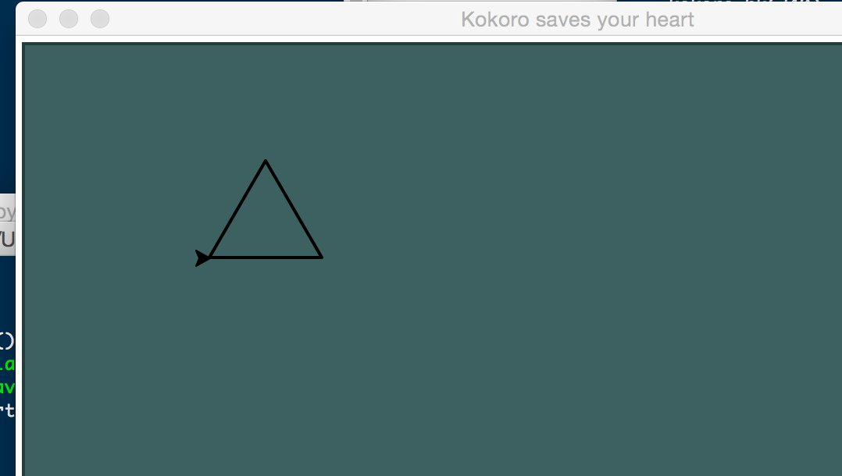

**QUESTION 2**

**QUESTION 3**

**QUESTION 4**

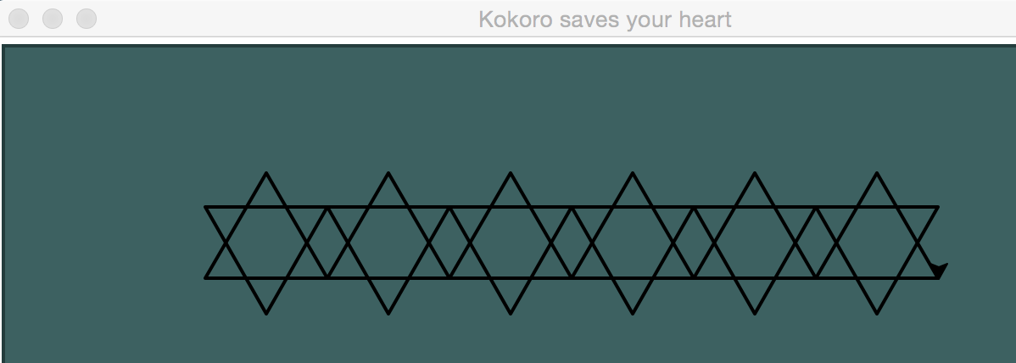

**QUESTION 5/6**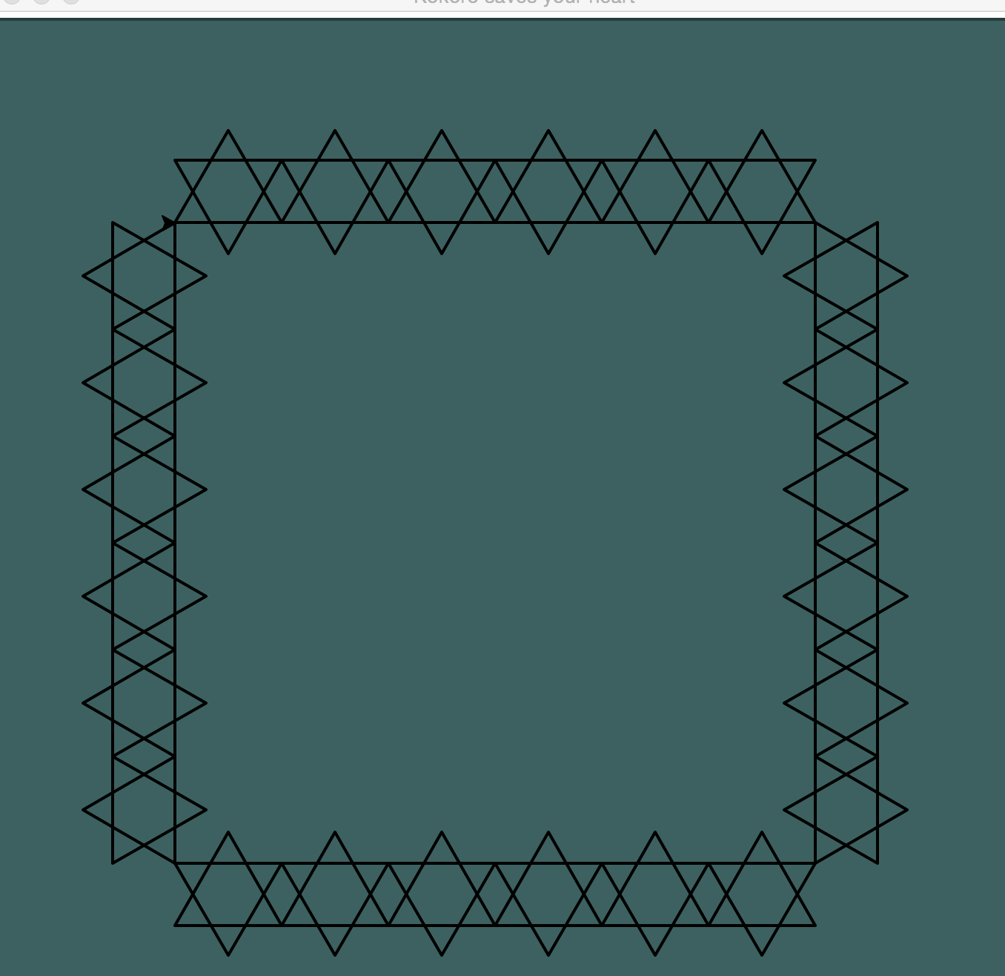

To be honest I didn’t write down what I thought would work. I just went at it with a hacksaw! I played around mostly with cutting my code more than in half! I had too much at first. And as I did that I saw room for a new definition to allow what we had already learned was:

if num % 2 == 0:

kokoro.pencolor('Red')

else:

kokoro.pencolor(‘Black')

Using evens and odds in order to alternate. The problem is, NO MATTER WHERE I PUT IT I would either get all top triangles the same color or each 6 pronged star to be all one color. So I started to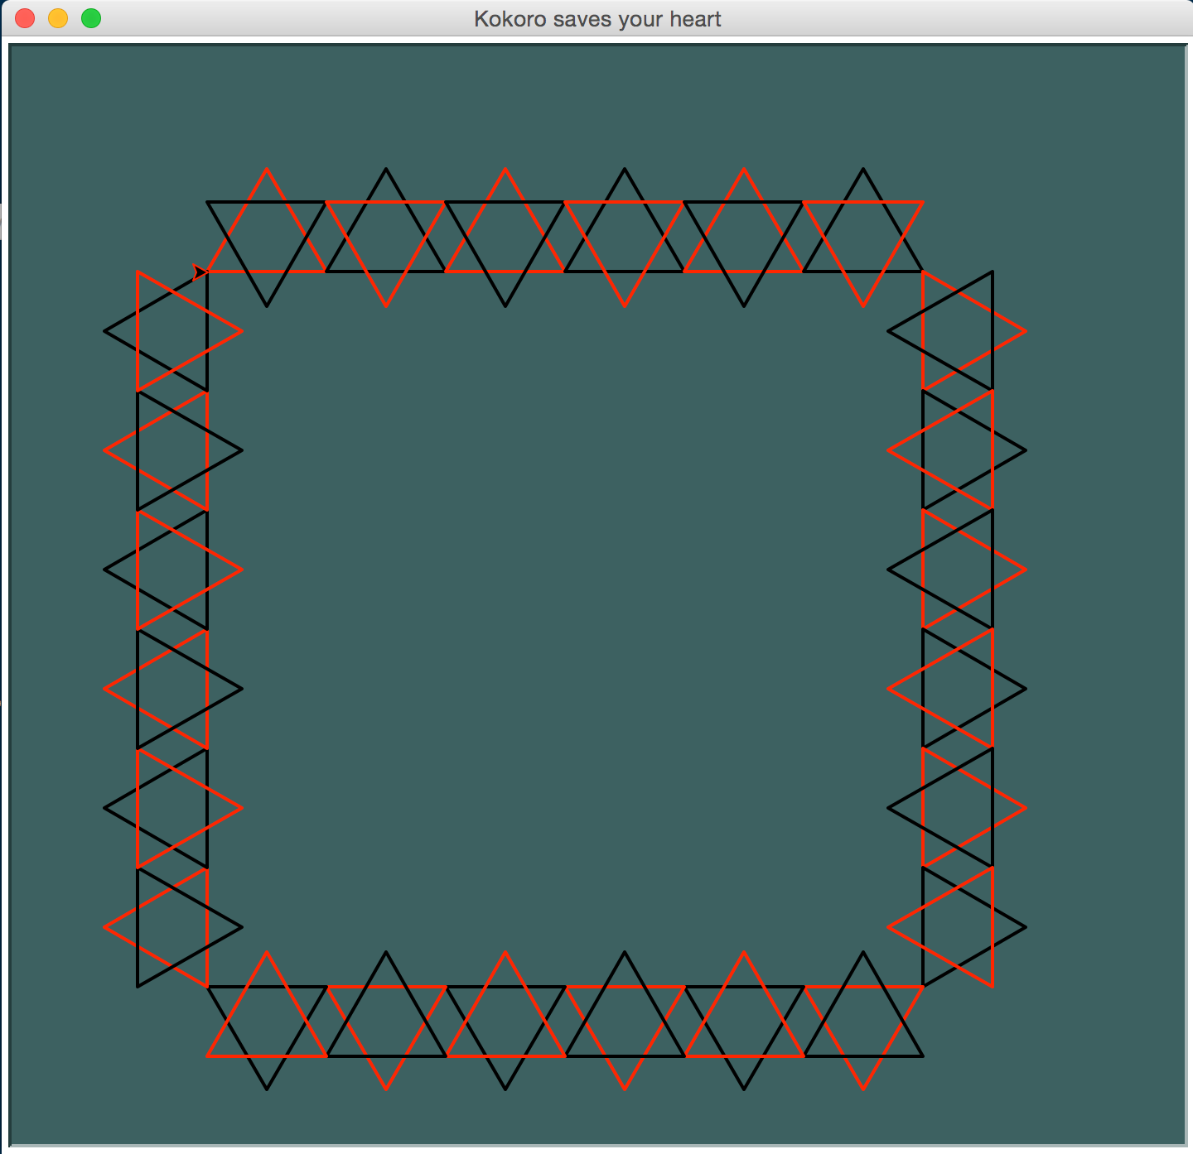 count…. what if… what if I added the range statements together rather than just using one? Ok so:

1 + 1 = 2

1 + 2 = 3

2 + 1 = 3

2 + 2 = 4

I then realized that odd and even bounced back and forth, so I could alternate each triangle based on that algorithm!

YeaY! I iz smert!

Here is a beauty shot: