Exercise 5. Answer Sheet

Student's Name: Tomonori Masubuchi Student's ID: s1240078

Problem 1. (15 points) Consider the graph below.

Draw a shortest path spanning tree with root at vertex s. Show the cost (weight) of paths to each vertex.

Put your answer here.

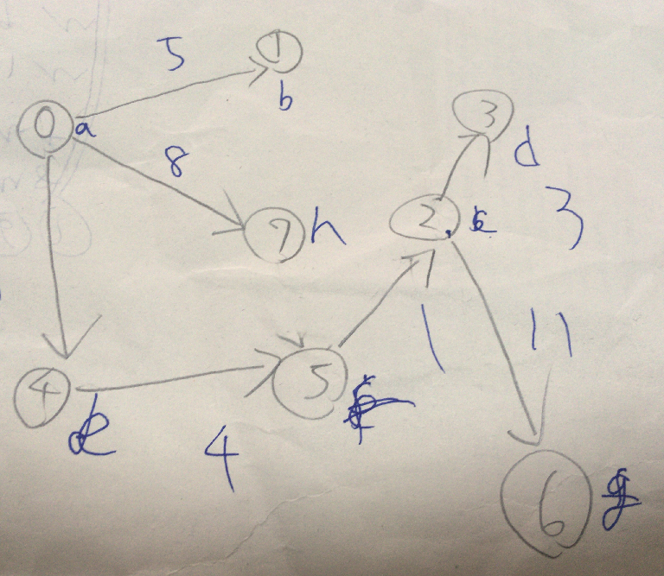

(0~1) : cost 5
(0~2) : cost 14
(0~3) : cost 17
(0~4) : cost 9
(0~5) : cost 13
(0~6) : cost 25
(0~7) : cost 8

Problem 2. (15 points) Dijksta's algorithm cannot handle negative weights. Show an example and explain what happens.

Put your answer here.

Problem 3. (20 points) Extend the pseudocode of the Bellman-Ford algorithm given at the lecture so it can detect negative cycles.

def Bellman-Ford-modified (G,s,w):
Init-SS (G,s)
for i=1 to |G.V|-1
for each edge (u,v) in G.E
RELAX (u,v,w)
Add your code here.

Problem 4. (50 points) Write a program implementing Dijksta's algorithm. Upload your source code. Show your input graph and the obtained shortest path spanning tree in the space below.

Put your answer here.

#include <stdio.h>
#include <stdlib.h>

#define INFTY 99999

void dijkstra(int,int);

int *label;
int **D;
int *d;
int *adj;

int main(){

int i,j,n,start;

printf("Input the number of data:");
scanf("%d",&n);

label = (int *)malloc(n*sizeof(int));
d = (int *)malloc(n*sizeof(int));
adj = (int *)malloc(n*sizeof(int));
D = (int **)malloc(n*sizeof(int *));

for(i = 0;i < n;i ++)
{
D[i] = (int *)malloc(n * sizeof(int));
}

printf("Input the Distance matrix:\n");

for(i = 0;i < n;i ++)
{
for (j = 0;j < n;j ++)
{
scanf("%d", &D[i][j]);
}
}

printf("Input the initial node: ");
scanf("%d", &start);

dijkstra(start,n);

printf("\nresult:\n");

for(i = 0;i < n;i ++)
{
if(i == start)
printf("vertex %c -> root\n",97 + i);

else printf("vertex %c -> %d (visited_order : %d)\n",97 + i,d[i] ,label[i]);
}

for(i = 0;i < n;i ++)
{
free(D[i]);
}

free(label);
free(adj);
free(D);
free(d);

return 0;
}

void dijkstra(int root,int n){

int i;
int cmin,nmin;
int visitedOrder = 0;

for(i = 0;i < n;i ++)
{
label[i] = 0;
d[i] = D[root][i];
}

adj[root] = -1;
label[root] = ++visitedOrder;

while (visitedOrder < n) {

cmin = INFTY;

for(i = 0;i < n;i ++)
{
if(label[i] != 0)continue;

if(d[i] < cmin)
{
cmin = d[i];
nmin = i;
}
}

if(cmin == INFTY) continue;

label[nmin] = ++visitedOrder;

for(i = 0;i < n;i ++)
{
if(label[i] != 0) continue;

if (d[i] > d[nmin]+D[nmin][i])
{
d[i] = d[nmin]+D[nmin][i];
adj[i] = nmin;
}
}
}
}

Input:
Input the number of data: 8
Input the Distance matrix:
99999 5 99999 99999 9 99999 99999 8
99999 99999 12 15 99999 99999 99999 4
99999 99999 99999 3 99999 99999 11 99999
99999 99999 99999 99999 99999 99999 9 99999
99999 99999 99999 99999 99999 4 20 5
99999 99999 1 99999 99999 99999 13 99999
99999 99999 99999 99999 99999 99999 99999 99999
99999 99999 7 99999 99999 6 99999 9999
Input the initial node: 0

Output
vertex a -> root
vertex b -> 5 (visited_order : 2)
vertex c -> 14 (visited_order : 6)
vertex d -> 17 (visited_order : 7)
vertex e -> 9 (visited_order : 4)
vertex f -> 13 (visited_order : 5)
vertex g -> 25 (visited_order : 8)
vertex h -> 8 (visited_order : 3)

