Exercise 6. Answer Sheet

Student's Name: Tomonori Masubuchi Student's ID: s1240078

Problem 1. Given the graph below

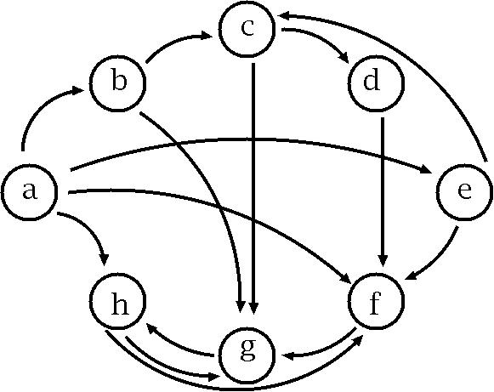

a) (10 points) Fill the following matrix by putting 1 if there is an edge between nodes. Put 0 otherwise.

 | a | b | c | D | E | f | g | H
a | 0 | 1 | 0 | 0 | 1 | 1 | 0 | 1
b | 0 | 0 | 1 | 0 | 0 | 0 | 1 | 0
c | 0 | 0 | 0 | 1 | 0 | 0 | 1 | 0
d | 0 | 0 | 0 | 0 | 0 | 1 | 0 | 0
e | 0 | 0 | 1 | 0 | 0 | 1 | 0 | 0
f | 0 | 0 | 0 | 0 | 0 | 0 | 1 | 0
g | 0 | 0 | 0 | 0 | 0 | 0 | 0 | 1
h | 0 | 0 | 0 | 0 | 0 | 1 | 1 | 0

b) (40 points) Write a program implementing Warshal's algorithm. Upload your code. Use your program to create a transitive closure G* of the graph above and show it in the space below.

Transitive closure defined by adjacency table
 | a | b | c | D | e | f | g | H
a | 0 | 1 | 1 | 1 | 1 | 1 | 1 | 1
b | 0 | 0 | 1 | 1 | 0 | 1 | 1 | 1
c | 0 | 0 | 0 | 1 | 0 | 1 | 1 | 1
d | 0 | 0 | 0 | 0 | 0 | 1 | 1 | 1
e | 0 | 0 | 1 | 1 | 0 | 1 | 1 | 1
f | 0 | 0 | 0 | 0 | 0 | 1 | 1 | 1
g | 0 | 0 | 0 | 0 | 0 | 1 | 1 | 1
h | 0 | 0 | 0 | 0 | 0 | 1 | 1 | 1

#include<stdio.h>

int n;
int func[100][100];

int main(){
int i,j,k;

printf("Please input:");
scanf("%d",&n);

for(i = 0;i < n;i ++)
{
for(j = 0;j < n;j ++)
{
scanf("%d",&func[i][j]);
}
}

for(k = 0;k < n;k ++)
{
for(i = 0;i < n;i ++)
{
for(j = 0;j < n;j ++)
{
if(func[i][j] != 1)func[i][j] = func[i][k] * func[k][j];
}
}
}

printf("\nOutput\n");

for(i = 0;i < n;i ++)
{
for(j = 0;j < n;j ++)
{
printf("%d ",func[i][j]);
}
printf("\n");
}

return 0;

}

Problem 2. (50 points) Consider the following weight adjacency matrix.

 | a | b | c | d | e | f | g | H
a | 0 | 48 | ∞ | 8 | 20 | ∞ | 20 | ∞
b | ∞ | 0 | 24 | ∞ | 9 | ∞ | 76 | 29
c | 97 | ∞ | 0 | ∞ | ∞ | ∞ | 18 | 1
d | ∞ | 52 | 34 | 0 | 29 | ∞ | ∞ | ∞
e | ∞ | ∞ | ∞ | ∞ | 0 | 10 | ∞ | ∞
f | ∞ | 10 | 85 | 43 | ∞ | 0 | 41 | 29
g | ∞ | ∞ | ∞ | 76 | 38 | ∞ | 0 | ∞
h | 28 | 42 | ∞ | 77 | 21 | ∞ | 11 | 0

Write a program implementing Floyd's algorithm. Upload your code. Given the matrix above, calculate all pairs shortest paths using your program and fill the table below:

All pairs shortest path table
 | A | b | c | d | e | f | g | H
a | 0 | 40 | 42 | 8 | 20 | 30 | 20 | 43
b | 53 | 0 | 24 | 61 | 9 | 19 | 36 | 25
c | 29 | 42 | 0 | 37 | 22 | 32 | 12 | 1
d | 63 | 49 | 34 | 0 | 29 | 39 | 46 | 35
e | 67 | 20 | 44 | 53 | 0 | 10 | 50 | 39
f | 57 | 10 | 34 | 43 | 19 | 0 | 40 | 29
g | 105 | 58 | 82 | 76 | 38 | 48 | 0 | 77
h | 28 | 41 | 65 | 36 | 21 | 31 | 11 | 0

#include<stdio.h>
#include<stdlib.h>
#include<string.h>

#define INF 99999

int min(int x, int y){
if(x == 0) return x;
if(x == INF || y < x) return y;
else return x;
}

int n;
int func[100][100];

int main(){

int i,j,k;

char c[100];

printf("Please input: ");
scanf("%d", &n);

for(i = 0;i < n;i ++)
{
for(j = 0;j < n;j ++)
{
scanf("%s", c);

if(strcmp(c,"infinity") == 0)func[i][j] = INF;
else func[i][j] = atoi(c);
}
}

for(k = 0;k < n;k ++)
{
for(i = 0;i < n;i ++)
{
for(j = 0;j < n;j ++)
{
if(func[i][k] != INF && func[k][j] != INF) func[i][j] = min(func[i][j], func[i][k] + func[k][j]);
}
}
}

printf("\nOutput\n");

for(i = 0;i < n;i ++)
{
for(j = 0;j < n;j ++)
{
if(func[i][j] == INF)printf("infinity ");
else printf("%d ",func[i][j]);
}
printf("\n");
}
return 0;
}

