Exercise 9. Answer Sheet

Student's Name: Tomonori Masubuchi Student's ID: s1240078

Problem 1. (40 points) Find an optimal parenthesization of a matrix-chain product whose sequence of dimensions is <5, 10, 3, 12, 5, 50, 6>. Show your work (costs matrix m, number of multiplications).
Put your answer here.
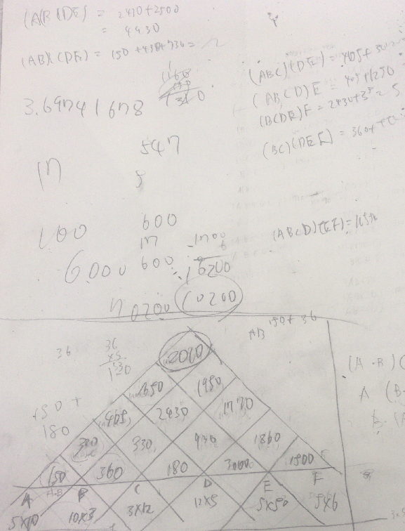

Cost is 2010

((AB)((CD)(EF)))
Problem 2. (60 points) Write a program implementing the algorithms Matrix-Chain-Order and Print-Optimal-Parens given in the lecture. Upload your code. Using your program, find the optimal parenthesization for the following matrix-chain products and show your m and s matrices.

a) (20 points) p = [30,35,15,5,10,20,25]

Put your answer here.
Please enter the number of matrix chian
6
Please enter the order of chain matrix
35 15 5 10 20 25
30 35 15 5 10 20

//Cost of Matrix//
0 2625 4375 7125 10500 15125
0 0 750 2500 5375 9500
0 0 0 1000 3500 7250
0 0 0 0 5000 12500
0 0 0 0 0 15000
0 0 0 0 0 0

//Sequence of Matrix//
0 1 2 2 2 2
0 0 2 2 2 2
0 0 0 3 4 5
0 0 0 0 4 5
0 0 0 0 0 5
0 0 0 0 0 0

((AB)(((CD)E)F))

Cost of Matrix chain multiplication is 15125

b) (20 points) p = [10,20,10,15,20,10]

Put your answer here.
Please enter the number of matrix chian
5
Please enter the order of chain matrix
20 10 15 20 10
10 20 10 15 20

//Cost of Matrix//
0 3000 7000 6500 7500
0 0 3000 4500 5500
0 0 0 3000 4500
0 0 0 0 2000
0 0 0 0 0

//Sequence of Matrix//
0 1 1 1 1
0 0 2 2 4
0 0 0 3 4
0 0 0 0 4
0 0 0 0 0

(A((B(CD))E))

Cost of Matrix chain multiplication is 7500

c) (20 points) p = [100,10,100,1,1000,100]

Put your answer here.
Please enter the number of matrix chian
5
Please enter the order of chain matrix
10 100 1 1000 100
100 10 100 1 1000

//Cost of Matrix//
0 1000 11000 102000 112000
0 0 100000 110000 120000
0 0 0 100000 110000
0 0 0 0 10000000
0 0 0 0 0

//Sequence of Matrix//
0 1 2 2 2
0 0 2 2 2
0 0 0 3 4
0 0 0 0 4
0 0 0 0 0

((AB)((CD)E))

Cost of Matrix chain multiplication is 112000

