Game Design Document

Fill up the Following document

1. Write the title of your project.

Run for Life

1. What is the goal of the game?

The adventurer needs to run away from the dragon to save his life

1. Write a brief story of your game?

The adventurer was throwing a stone at a mango on the tree in the

forest so that he could eat the mango to fullfill his hunger, but his

shot missed the mango and fell down behind a big bush. There was a scream from behind the bush and a big dragon arose and said that he would kill him. The adventurer was scared and asked why was he going to kill him ?. Th dragon roared and said that he had just killed his son. The adventurer asked him how cause he had only thrown a stone. The dragon replied by saying that the stone that he threw had caused his egg to break and so his son died and he shall kill him for that . The adventurer said sorry to him and started running and we shall lead him away from the dragon.

1. Which are the playing characters of this game?

* Playing characters are the ones which respond to the user based on the input from the user
* Cars, monkeys, dinos, wizards etc, are the playing characters in the game.

|  |  |  |
| --- | --- | --- |
| Number | Character Name | What can this character do? |
| 1 | Adventurer | run , jump , turn |
| 2 | Dragon | run |
| 3 |  |  |
| 4 |  |  |
| 5 |  |  |
| 6 |  |  |
| 7 |  |  |
| 8 |  |  |

1. Which are the Non Playing Characters of this game?

* Non Playing characters are the ones which don't have an action or a behaviour when the user interacts with the game.
* Hurdles, stones, bananas, coins, etc are non playing characters in the game.

|  |  |  |
| --- | --- | --- |
| Number | Character Name | What can this character do? |
| 1 | Coins | Purchase costumes and powerups |
| 2 | Hurdles | Block path of the adventurer |
| 3 | Power ups | Help the adventurer in running away from the dragon |
| 4 |  |  |
| 5 |  |  |
| 6 |  |  |
| 7 |  |  |
| 8 |  |  |

Draw your imagination of this game. What does this game look like?

* Draw the game either on your computer or on paper,
* Add images of scenes of the game to show each of the playing and non-playing characters at least once.

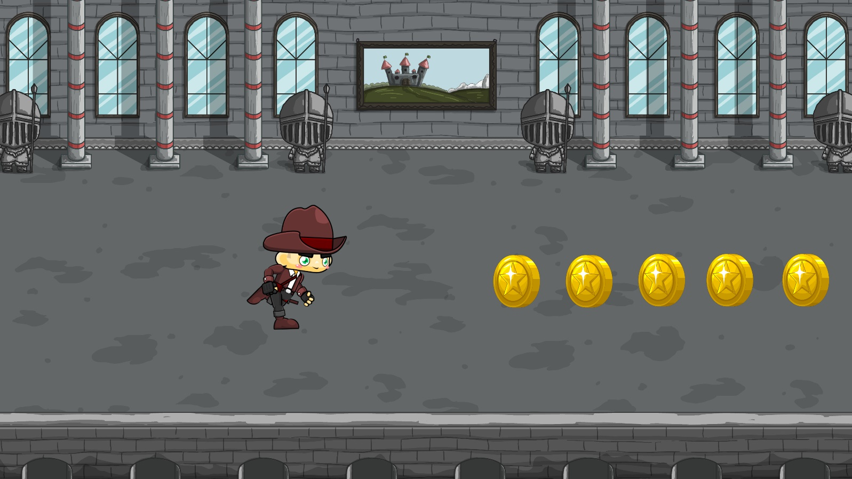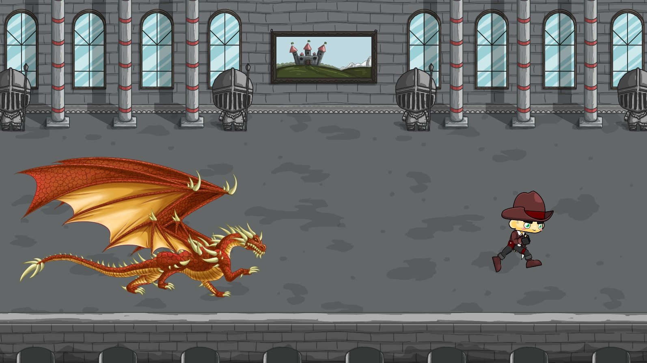

How do you plan to make your game engaging

I will include powerups and coins so that the player plays the game to collect coins and then buy powerups to improve their gameplay