

IronVision AI
Human-approved AI for the NIST Risk Management Framework
Whitepaper · formerly AegisRMF

Version 1.0 · October 2026
Derived from the code base, migrations, API specification and project reports. Labels: MOCKED · REQUIRES HUMAN VERIFICATION · SME REVIEW REQUIRED. Demonstration content is synthetic. IronVision AI is not FedRAMP-authorized and holds no ATO.

Contents
1
(Right-click → Update field to refresh page numbers.)

1 Executive summary
IronVision AI (formerly AegisRMF) is a web application for the NIST Risk Management Framework (RMF). It covers all seven steps of NIST SP 800-37 Rev. 2 for a portfolio of systems, from preparation and categorization through continuous monitoring. It brings together the records that are usually spread across spreadsheets, SharePoint folders, scanner exports and eMASS: systems, roles, categorization, baselines and overlays, control implementations, evidence, findings, POA&Ms, assessments, authorization decisions and the audit trail.
The product rests on four commitments:
- Human-approved AI. AI drafts, ranks and explains. It never decides. Every AI output is schema-validated, quotes and references are checked against the source, and a human must approve before anything changes a compliance record. With no AI provider configured, every feature still works with deterministic analysis.
- Evidence integrity. Every artifact is stored content-addressed by SHA-256, with provenance, freshness, version history and a hash-chained, append-only audit trail.
- eMASS-faithful workbooks. Test Result and Hardware/Software workbooks are imported and written back into the user's own eMASS templates. Only permitted cells change, macros are never executed, and every export comes with a validation report.
- Portability. Standard components only (React/TypeScript, FastAPI, PostgreSQL, S3-compatible storage, OIDC), deployable with Docker Compose. AI providers and storage back-ends are chosen through environment values, with no code change.
This paper describes what the software does today. It is derived from the code base, database migrations, API specification and project reports. Capabilities that are simulated are labelled MOCKED. Results that could not be verified in the development environment are labelled REQUIRES HUMAN VERIFICATION. Interpretations of authoritative documents that need a subject-matter expert are labelled SME REVIEW REQUIRED.
NOTE
IronVision AI is not FedRAMP-authorized, holds no ATO and has not been assessed for IL4–IL6 or CUI. The demonstration environment contains synthetic data only. Nothing in this document claims FIPS 140-3 validation or CAC/PIV conformance.

1.1 Problem statement
Getting and keeping an Authority to Operate (ATO) is labour-intensive. The RMF itself is sound; the burden comes from the tooling around it:
- ISSOs keep control narratives, evidence folders and STIG/ACAS results consistent by hand. They re-type the same facts into the SSP, the Test Result workbook, the POA&M and the hardware/software list.
- Security Control Assessors (SCAs) must judge evidence that is stale, unattributed or impossible to trace back to a specific file, scan or policy paragraph.
- Authorizing Officials (AOs) sign risk decisions based on packages whose provenance is hard to check, with little visibility into what changed since the last review.
- ISSMs and leadership lack a live, cross-system view of authorization expirations, overdue POA&Ms, CAT I findings and stale evidence.
- National Security Systems add CNSSI 1253 categorization (separate C/I/A impact levels), NSS baselines, overlays and parameter values. Teams usually apply these from PDF tables by hand.
Generic GRC tools either ignore these DoD/IC specifics or bolt on unverifiable AI. IronVision AI models the RMF tasks directly, keeps every artifact traceable, and uses AI only where its output can be checked.

2 Core value and differentiators
Differentiator | What it means in practice | Where it is enforced
Human-approved AI | AI produces drafts, suggestions, rankings and explanations. Approval gates are locked on and cannot be disabled. | AIService (schema + quote validation), review engine, Admin AI settings ('human approval: always on (locked)')
Grounded output | Policy quotes must be exact substrings of the uploaded text. Evidence references must point to real records. Fabricated items are dropped and counted. | policy_profile.verify_quote, TR analysis and inventory validators
Deterministic fallback | With no AI provider, or when AI output fails validation, the deterministic result stands and is labelled. | Every AI call site; the AI status panel shows 'Deterministic analysis (no AI)'
Evidence integrity | SHA-256 content addressing, integrity re-verification, version history, freshness windows, retention with legal hold. | Storage service, evidence_versions, retention job, Evidence Ledger
Tamper-evident audit | Every state change writes a hash-chained audit_events row. A database trigger makes the table append-only. | audit service, migration 0001 trigger, chain verification in the Audit Log
Separation of duties | No self-approval, SCA independence, AO-only decisions, Platform Admin without decision rights. | rbac.py assertion, sod.py, review engine
eMASS-faithful workbooks | Import and write back the user's own TR and HW/SW templates. Only permitted ranges change; the VBA project and signature parts stay byte-identical. | services/tr, services/inventory/hwsw, validation reports
CNSSI 1253 depth | Per-objective C/I/A, Appendix D baselines with page citations, official overlays, parameter value adoption with undo and conflict detection. | cnssi1253.py, cnssi_params.py, overlays.py
Portability | Docker Compose, PostgreSQL, any S3 API, OIDC, pluggable AI. The env file is parsed as data and validated by check_env. | deploy/, scripts/check_env.py, docs/PORTABILITY.md

3 Personas, roles and separation of duties
Authorization is role-based and scoped to an organization or to a single system. Roles come only from IronVision AI's own RBAC, never from identity-provider claims. The permission matrix is defined in code (backend/app/security/rbac.py) and shown read-only on the Admin page and in 'Help: who can do what'.
Role | Typical person | Key permissions (abridged)
System Owner | Mission/system owner | system.write, evidence.submit, poam.manage, system.register, ingest.upload, implementation.write
ISSO | Information System Security Officer | System Owner rights plus finding.map, source.manage, evidence.verify, audit.read, emass.queue
ISSM | Information System Security Manager | portfolio.read, system.roles.manage, content.apply, finding.map, emass.queue, admin.health.read
SCA | Security Control Assessor | assessment.perform (the only role that sets assessment status / TR compliance status), evidence.verify
AO | Authorizing Official | authorization.decide, risk.accept, portfolio.read
DevSecOps | Engineer / pipeline owner | evidence.submit, ingest.upload, source.manage
Leadership Viewer | Executive | portfolio.read (read-only)
Privacy Official | Senior agency privacy official | privacy.review (approve or return PTAs and privacy determinations)
Platform Admin | Tool administrator | Users, content loading, AI test, jobs, eMASS connector settings. No AO, SCA or risk-acceptance rights (asserted at start-up).

3.1 Separation of duties
- A requester can never approve their own request (reviews engine).
- Only the SCA sets an assessment result. The SCA must be independent of the implementer.
- Only the AO issues ATO, ATO with conditions, IATT or DATO decisions and accepts risk. The ISSO cannot accept risk.
- Test Results: a row edited or prepared by one person must be approved by a different real user (shared helper services/sod.py). The same applies to inventory changes (accept → approve).
- Every denial is audited as authz.denied. Every mutating API route declares a permission dependency, and an automated test fails if any route lacks one.

3.2 Real organizations vs. sandboxes
Self-service sandboxes (Explore Demo or self sign-up) can enable persona mode. One person can then act as ISSO, SCA, AO and the other roles through the 'Acting as' switcher in the header. Actions run as synthetic persona identities, so the role rules stay enforced. Every audit event also records the real operator.
- In a real organization, approval must come from a different real user. Switching persona does not count, and the UI shows the action as locked with the reason.
- In a sandbox, a different persona of the same real user may approve. The event is labelled 'Sandbox: same person' in the audit log, on the row and in export history.
- Persona approvals are labelled 'simulated signature – not CAC/PIV · sandbox persona'.
- Persona mode is refused (403) on non-sandbox tenants. Client-supplied flags such as is_sandbox or X-Sandbox are ignored.
NOTE
One human holding all personas is not acceptable separation of duties for production. Production tenants keep strict real-identity separation of duties.

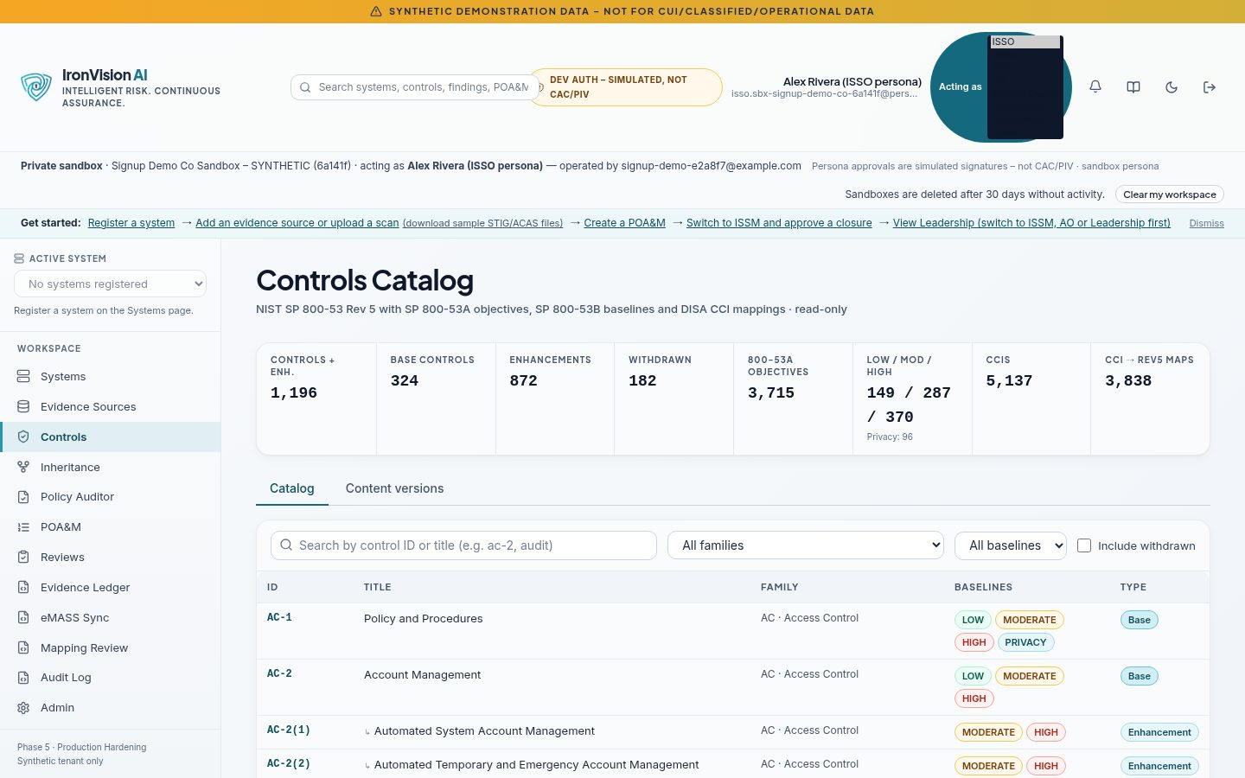
Figure: Sandbox persona switcher ('Acting as') in the header

4 RMF lifecycle coverage (NIST SP 800-37 Rev. 2)
The RMF overview ('Getting started') and the per-system stepper compute a status for each of the seven steps from live data. A status is never typed in by hand. Each step reports one of not started, needs attention or complete, with the criteria behind it, a progress counter and the single next action with a deep link.
Step | What IronVision AI does | 'Complete' when
1 Prepare | Key roles (AO, ISSM, ISSO, System Owner, SCA, Privacy Official …) assigned per system, with role history; system boundary and description. | All required key roles are filled
2 Categorize | Information types from the NIST SP 800-60 Vol. 2 Rev. 1 catalog (168 types); FIPS 199 high-water mark or CNSSI 1253 per-objective C/I/A; NSS determination (Yes/No/Unsure); PTA; AO approval with revision history and re-approval on change. | Categorization approved and no required field missing
3 Select | SP 800-53B baseline (FIPS) or CNSSI 1253 Appendix D trigraph union (NSS); overlays; tailoring in/out with justification; organization-defined parameters (ODPs); CNSSI parameter adoption; Privacy Overlay prompt. | Baseline applied, no unresolved reconciliation or tailoring issues
4 Implement | Control Workbench: implementation status, statements (with optional AI draft), inheritance, evidence, policy mappings, CCIs. | Every assigned control has an implementation status
5 Assess | SCA assessments per control, eMASS Test Results workbook, STIG/ACAS findings, Mapping Review. | Every assigned control is assessed
6 Authorize | Authorization package, ISSM endorsement, AO decision (ATO / ATO w/ conditions / IATT / DATO), POA&Ms, risk acceptance, eMASS sync. | A current authorization decision exists
7 Monitor | Rule-based monitoring: CISA KEV, CAT I, overdue POA&Ms, stale evidence; scheduled jobs; evidence freshness; Evidence Ledger. | Monitoring configured and nothing needs attention

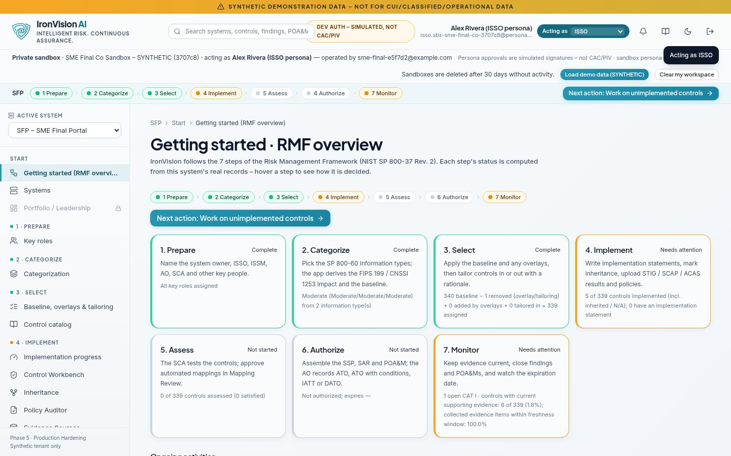
Figure: RMF overview with live step statuses and the next action

5 Screen-by-screen guide
Each entry describes one page in the application: its purpose, who uses it, the key actions, what it produces and the guardrails that apply. Routes are given for orientation. Navigation follows the RMF steps (Start, 1 Prepare … 7 Monitor, Tools).

5.1 Access

Login, demo and sign-up (/login)
Aspect | Detail
Purpose | Sign in with the configured provider (local password in development and demo, OIDC/Keycloak in deployed environments), open the shared synthetic demo, or create a private sandbox.
Used by | Everyone
Key actions | Sign in; 'Explore demo' (one-click, rate-limited, audited); 'Create account' (when sign-up is enabled); open the public whitepaper.
Outputs | A server-side session (idle timeout 30 min, absolute 12 h, rotating refresh tokens).
Guardrails | Lockout after 5 failures for 15 minutes. Sign-up bot checks (trap field and minimum time-to-submit), 12+ character passwords. Sign-up is off in production. New sandboxes start empty.

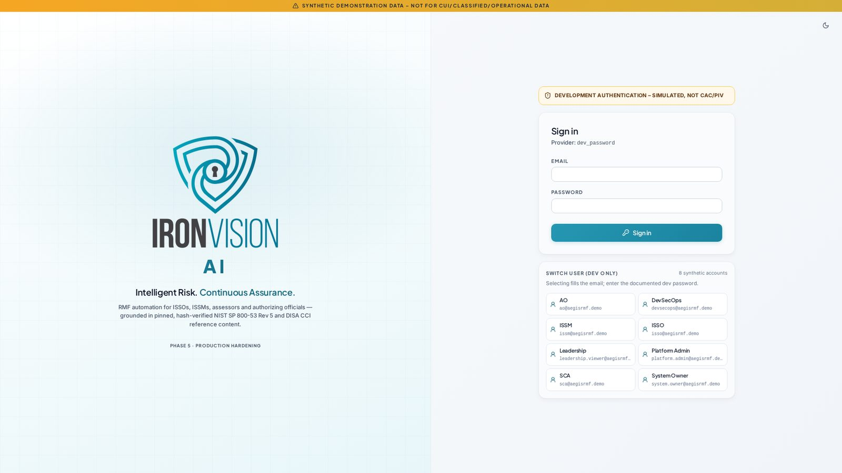
Figure: Login page

5.2 Start

Getting started – RMF overview (/rmf-workflow)
Aspect | Detail
Purpose | Live seven-step overview for the active system, with criteria and the next action.
Used by | All roles
Key actions | Follow the next-action link; open any step.
Outputs | Step statuses, progress counters.
Guardrails | Statuses are computed, never edited.

Systems (/systems, /systems/new, /systems/:id)
Aspect | Detail
Purpose | Register systems, maintain boundary, description, operating environment, DoD Cloud SRG impact level, assets and system-scoped role assignments.
Used by | ISSO, ISSM, System Owner
Key actions | Register (role keys validated server-side); edit; assign and revoke roles (audited); archive and restore (audited).
Outputs | System record, role history.
Guardrails | Impact-level rules: IL picker only for cloud deployment models; IL6 only for NSS + classified = Yes (422 otherwise). Archived systems are hidden but restorable.

Portfolio / Leadership (/portfolio)
Aspect | Detail
Purpose | Cross-system posture: ATO expirations, open POA&Ms, CAT I, KEV exposure, evidence freshness, trends, 'waiting on you'.
Used by | ISSM, AO, Leadership Viewer
Key actions | Drill into a system or POA&M.
Outputs | Portfolio cards, operational priority scores with a breakdown that sums.
Guardrails | Requires portfolio.read.

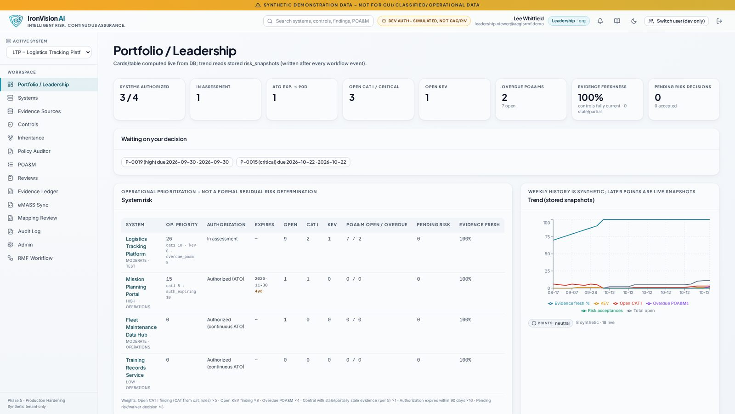
Figure: Portfolio / Leadership dashboard

5.3 Step 1 – Prepare

Key roles (/rmf/prepare)
Aspect | Detail
Purpose | Assign the RMF key roles for the system and record the people who hold them.
Used by | ISSM, ISSO
Key actions | Assign or replace a role holder; view history.
Outputs | Role assignments used by the review engine.
Guardrails | Role changes need system.roles.manage and are audited.

5.4 Step 2 – Categorize

Categorization (/rmf/categorize)
Aspect | Detail
Purpose | Select information types and compute the security category. Record the NSS determination, framework (FIPS 199 or CNSSI 1253), PII presence and Privacy Threshold Analysis.
Used by | ISSO (prepares), AO (approves), Privacy Official (PTA)
Key actions | Pick SP 800-60 information types with provisional impacts and adjust them with justification; answer 'Is this a National Security System?' (Yes/No/Unsure); fill in the PTA questionnaire; submit for approval.
Outputs | FIPS 199: per-objective high-water mark and overall category. CNSSI 1253: separate C/I/A trigraph (e.g. M-H-L) and no overall value. A versioned categorization revision.
Guardrails | Approval needs authorization.decide. A change to an approved categorization creates a pending re-approval and the approved values stay in force. PTA outcomes are recommendations only; a single 'No' never concludes 'no PIA required'. Only a Privacy Official approves a PTA.

SME REVIEW REQUIRED
The default PTA questions are a generic example set ('validate against your agency's privacy requirements'). Agencies must replace or confirm them.

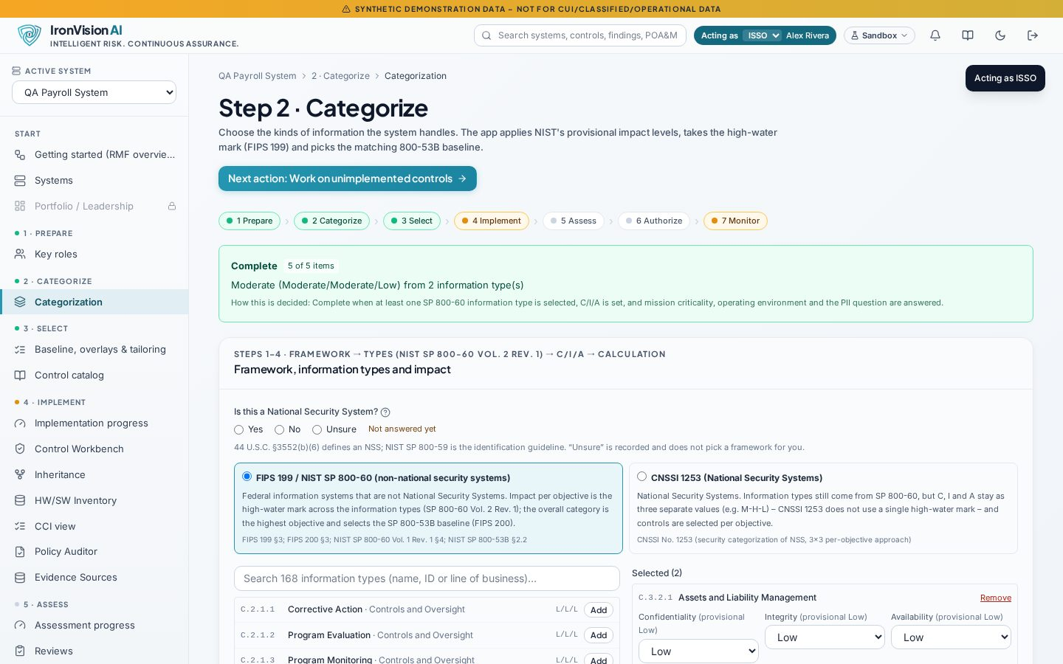
Figure: Categorize: NSS determination and framework selection
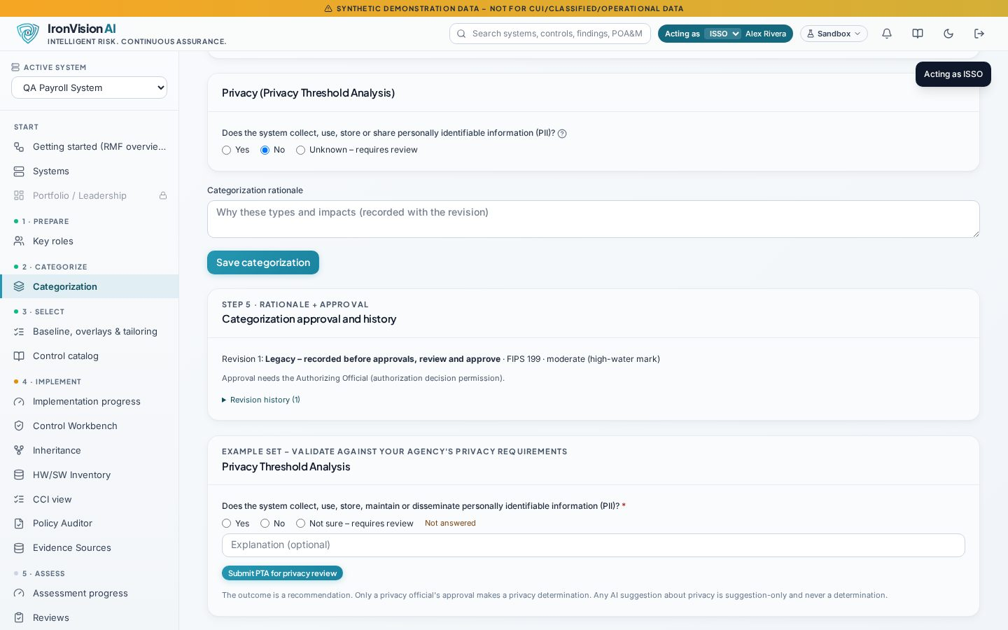
Figure: Privacy Threshold Analysis questionnaire (example question set)

5.5 Step 3 – Select

Baseline, overlays and tailoring (/rmf/select)
Aspect | Detail
Purpose | Apply and reconcile the control baseline, overlays, tailoring decisions and organization-defined parameters.
Used by | ISSO, ISSM
Key actions | Apply the SP 800-53B baseline or the CNSSI 1253 trigraph baseline; accept or decline a baseline proposal after re-categorization; apply overlays (official CNSSI overlays for NSS, agency overlays as metadata); tailor controls in or out with justification; compare and adopt CNSSI parameter values; respond to the Privacy Overlay prompt.
Outputs | Control assignments with selection provenance (for example 'Selected by CNSSI 1253 Table D-3 (C=M), p. D-22 (PDF p. 43)'), tailoring record, ODP values with source.
Guardrails | Proposals apply only on Accept. Tailored-out controls stay out, and controls that already have statements, evidence or assessment work are kept as tailored in, never dropped. Overlays: CNSSI overlays only on NSS; the Classified overlay requires an explicit 'classified = Yes'; restricted overlays show 'Unavailable – pending validation'. Parameter adoption returns 409 with the conflicts before it overwrites a differing value, and can be undone.

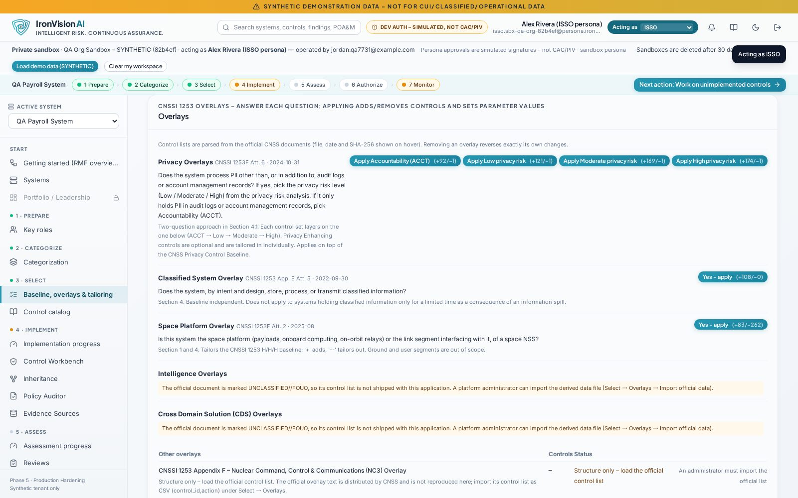
Figure: Select: official CNSSI 1253 overlay groups with applicability
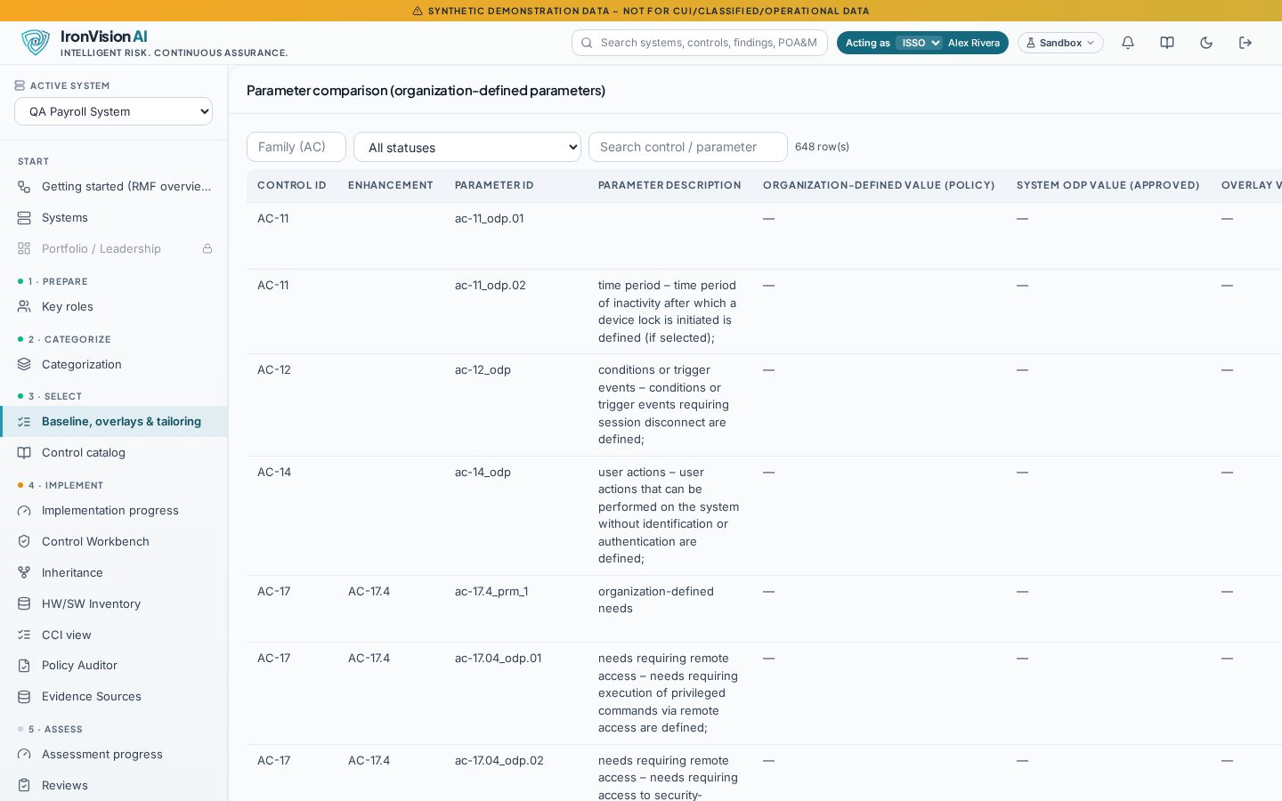
Figure: Select: parameter comparison (catalog vs. CNSSI 1253 vs. system values)

Control catalog (/catalog)
Aspect | Detail
Purpose | Browse the pinned NIST SP 800-53 Rev. 5 catalog with assessment objectives, baselines and content versions.
Used by | All roles
Key actions | Search; filter by family or baseline; open control detail.
Outputs | None (read-only).
Guardrails | Content is SHA-256 verified at load.

5.6 Step 4 – Implement

Implementation progress (/rmf/implement)
Aspect | Detail
Purpose | Progress of implementation statuses and statements across the system's controls.
Used by | ISSO, System Owner
Key actions | Filter by status or family; open the workbench.
Outputs | Counts consistent with the stepper.
Guardrails | Read-only summary.

Control Workbench (/controls, /systems/:id/controls/:controlId)
Aspect | Detail
Purpose | The ISSO's main workspace: one control at a time with status, implementation statement, parameters, inheritance, evidence, mapped policies, CCIs, findings and assessment.
Used by | ISSO, System Owner, SCA (assessment section)
Key actions | Save implementation status; write or AI-draft a statement (grounded in evidence, policies and POA&Ms); submit it for review; attach evidence; view policy mappings and coverage.
Outputs | Versioned implementation statements, review requests.
Guardrails | AI drafts are labelled, carry validated citations and need human approval. Only the SCA sets the assessment status.

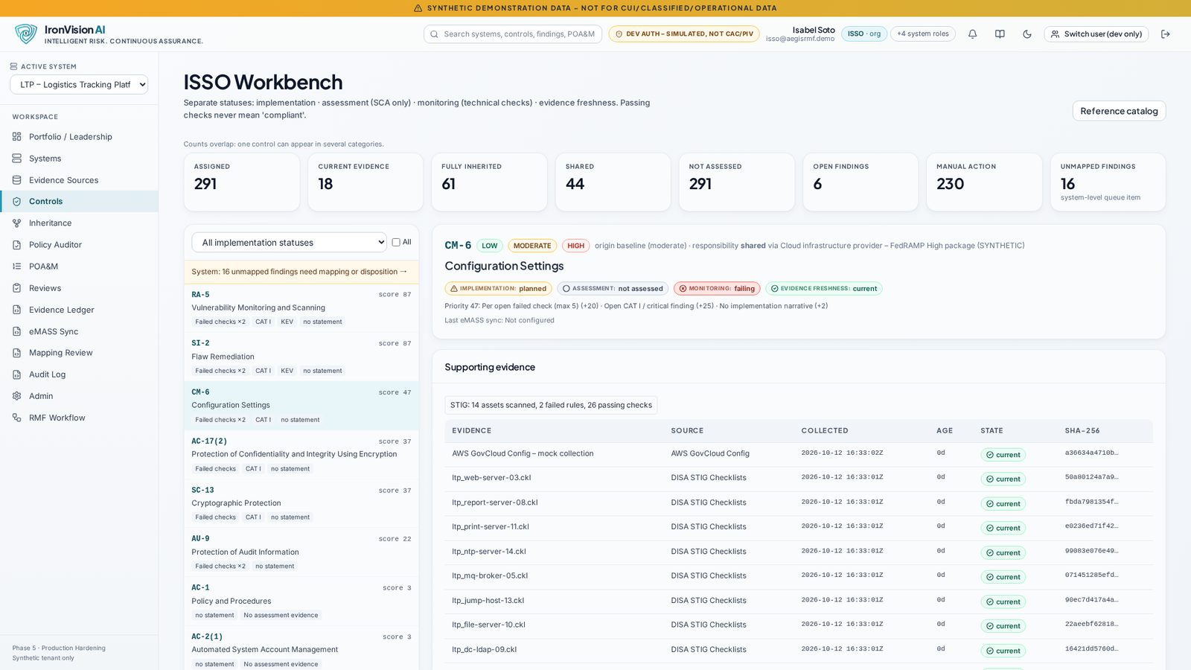
Figure: Control Workbench (CM-6)

Inheritance (/inheritance)
Aspect | Detail
Purpose | Common and hybrid control inheritance from providers (data centres, cloud platforms, enclaves).
Used by | ISSO, ISSM
Key actions | Add or edit providers with package, authorization type and expiry; import a customer responsibility matrix (CRM); bulk inheritance; owner attestations.
Outputs | Inherited, shared and system-owned responsibility per control.
Guardrails | Expired or expiring provider authorizations are flagged with the number of dependent controls.

HW/SW Inventory (/inventory)
Aspect | Detail
Purpose | The eMASS hardware/software list together with scan-observed hosts.
Used by | ISSO, ISSM
Key actions | Import the HW/SW .xlsm; review correlations between scan hosts and assets; resolve consistency issues; export to the same template.
Outputs | Inventory records, discrepancy decisions, validated export.
Guardrails | See section 6 (AI) and section 9 (workbooks).

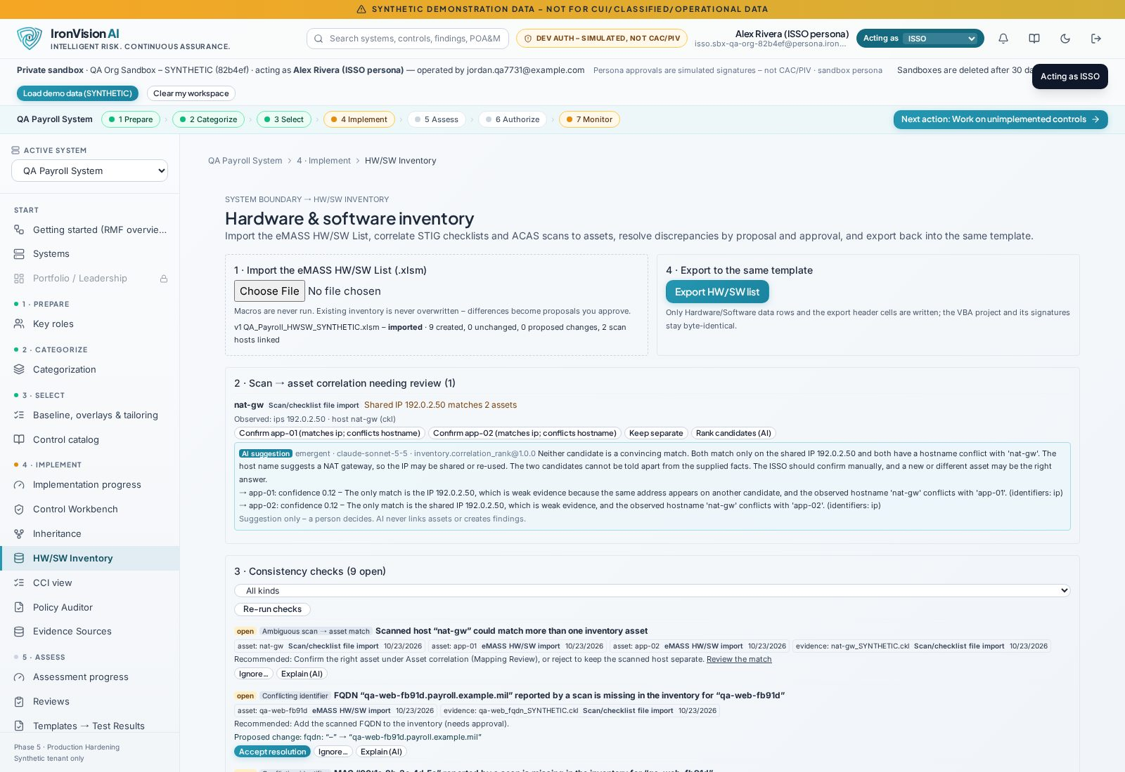
Figure: HW/SW Inventory overview

CCI view (/ccis)
Aspect | Detail
Purpose | DISA CCIs of the system's controls with their policy coverage.
Used by | ISSO, SCA
Key actions | Filter by control, family or coverage status; open the source policy passage.
Outputs | Coverage per CCI.
Guardrails | Coverage comes from policy text only; 'covered elsewhere' links never turn MISSING into MET.

Policy Auditor (/policy-auditor, /policy-auditor/:id)
Aspect | Detail
Purpose | Upload policies and procedures (PDF/DOCX/TXT). They are parsed into sections and pages, mapped to controls and evaluated against assessment objectives and CCIs.
Used by | ISSO, ISSM
Key actions | Upload; reanalyze; review proposed mappings; confirm, dismiss (with justification) or link findings; export CSV.
Outputs | Policy-to-control mappings with confidence and source (section/page), per-requirement coverage (met / partial / missing) with quotes.
Guardrails | Findings stay proposed until a human confirms them. AI may raise a requirement only with an exact quote.

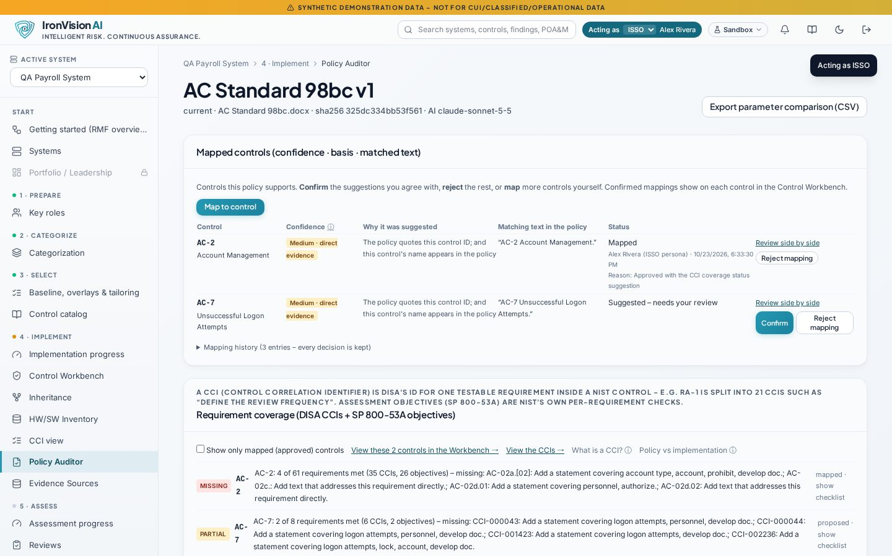
Figure: Policy mappings with confidence and source attribution

Evidence Sources (/evidence-sources, /ingest-runs/:id)
Aspect | Detail
Purpose | Upload STIG checklists (.ckl/.cklb), ACAS/Nessus (.nessus/CSV), SCAP/XCCDF and other evidence, and manage connectors.
Used by | ISSO, DevSecOps
Key actions | Upload; follow an ingest run (processing → analysed / failed with reason); retry failed runs.
Outputs | Evidence records, canonical deduplicated findings, CCI→800-53 mappings, asset correlation.
Guardrails | Upload allowlists, magic-byte checks, size limits, safe XML parsing and archive checks.

MOCKED
Live connectors (scanner, cloud configuration and ticketing APIs) are MOCKED in this release. The MockAdapter contacts no external system, and its records are labelled 'MOCKED source · <collector>'. File import is the real ingestion path.

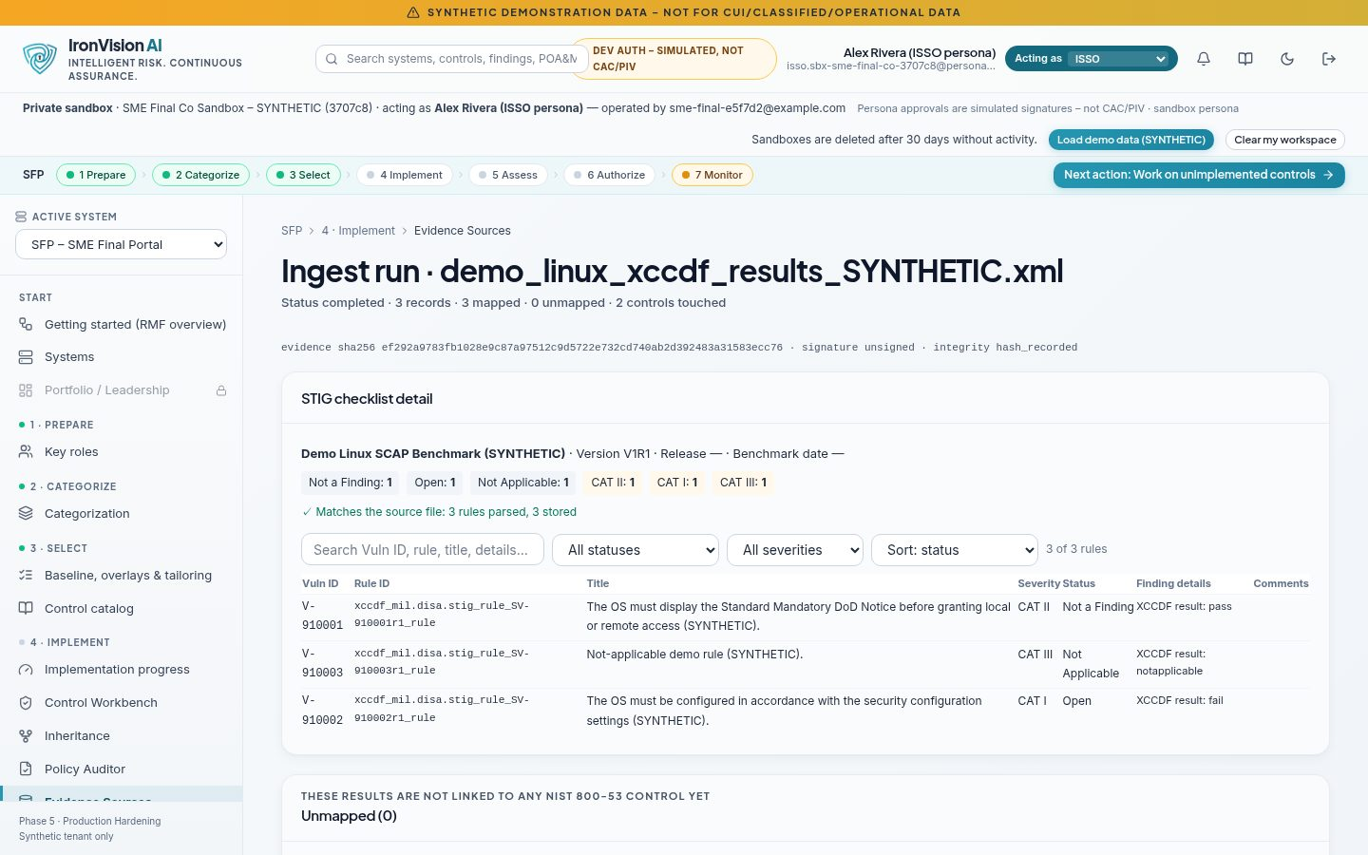
Figure: STIG ingest run detail

5.7 Step 5 – Assess

Assessment progress (/rmf/assess)
Aspect | Detail
Purpose | Assessment coverage across the system's controls.
Used by | SCA, ISSM
Key actions | Filter; open controls to assess.
Outputs | Counts consistent with the stepper.
Guardrails | Read-only summary.

Reviews (/reviews, /reviews/:id)
Aspect | Detail
Purpose | Every review request type (implementation statements, dispositions, closures, risk acceptances, extensions, categorization, authorization package) runs under versioned decision rules.
Used by | Requesters and the roles named in each decision rule
Key actions | Endorse, approve, return or deny, with comments.
Outputs | Decisions and their effects (applied only on approval).
Guardrails | Self-approval blocked; decision rules versioned and audited.

Templates → Test Results (/test-results)
Aspect | Detail
Purpose | Import the eMASS Test Result template (blank or pre-populated), generate rows from assessments, scans, policy coverage and evidence, run AI evidence analysis, have the SCA approve rows, and export.
Used by | ISSO (prepares), SCA (approves)
Key actions | Import; resolve header and AP/CCI matching; review auto-suggested rows; run evidence analysis; 'Use this text'; SCA approval (single or bulk) with actual tester and test date; export with a validation report.
Outputs | Exported workbook, validation report, export history.
Guardrails | Only the SCA sets or approves Compliance Status. Approval requires 'Tested by' and a 'Date tested' not in the future. AI never sets Compliance Status, Tested By or Date Tested.

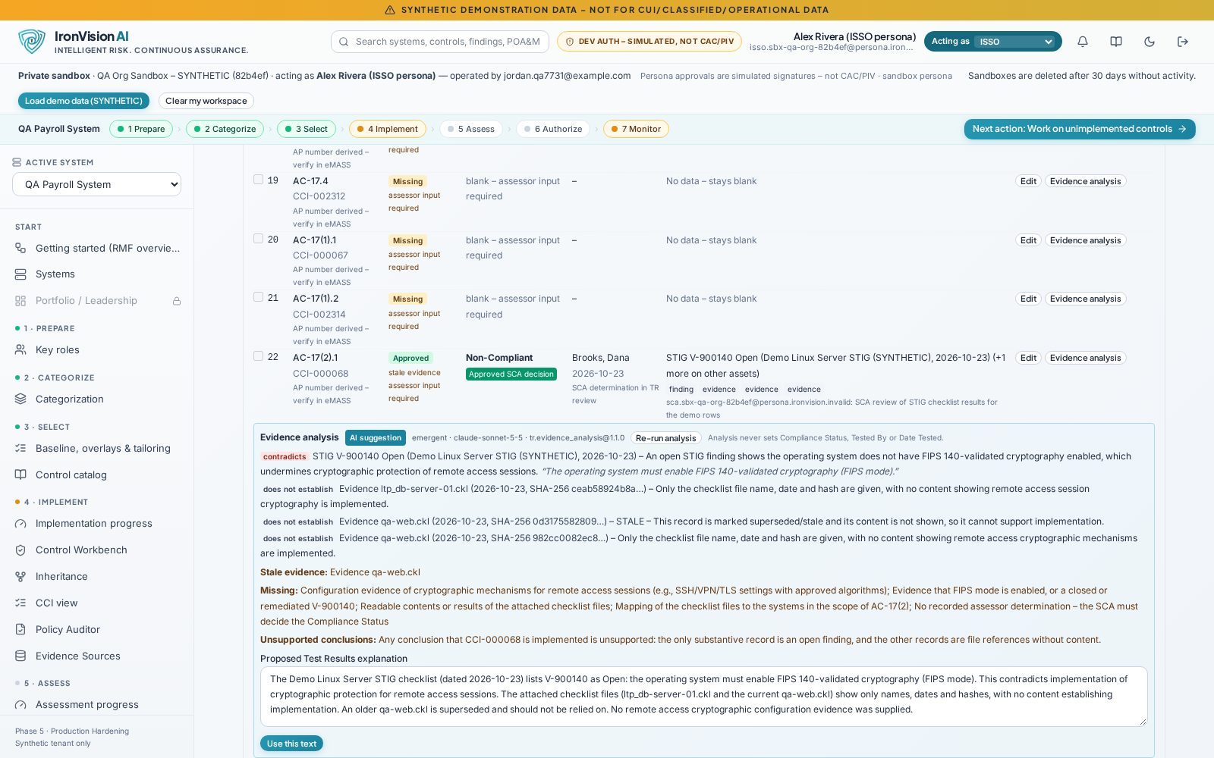
Figure: Test Results: AI evidence analysis on a row (suggestion only)

Mapping Review (/mapping-review)
Aspect | Detail
Purpose | One queue for status suggestions, policy proposals, unmapped findings and asset correlations, with a side-by-side view of the source passage and the control requirement.
Used by | ISSO, ISSM
Key actions | Accept or reject proposals; map unmapped rules (with optional AI suggestion); disposition with justification.
Outputs | Human-approved mappings.
Guardrails | AI suggestions are proposals; dispositions create reviews.

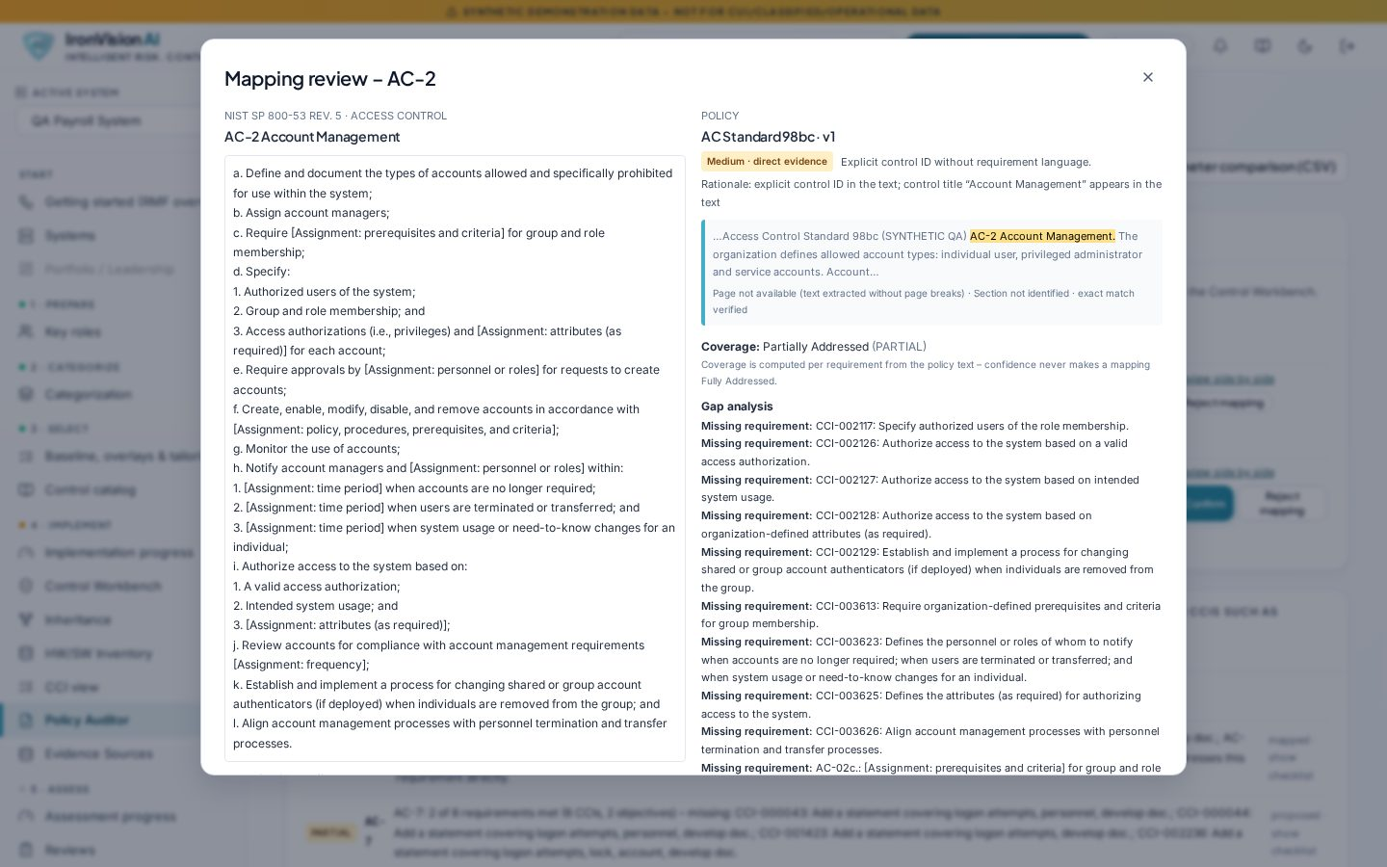
Figure: Mapping Review: side-by-side source passage and control requirement

5.8 Step 6 – Authorize

Authorization package (/rmf/authorize, /systems/:id/authorization)
Aspect | Detail
Purpose | Assemble the package, request ISSM endorsement and AO decision.
Used by | ISSO, ISSM, AO
Key actions | Submit; endorse; decide ATO / ATO with conditions / IATT / DATO with expiry and conditions.
Outputs | Authorization decision record; authorization type and expiry drive the Portfolio view.
Guardrails | Only the AO decides; denials are audited.

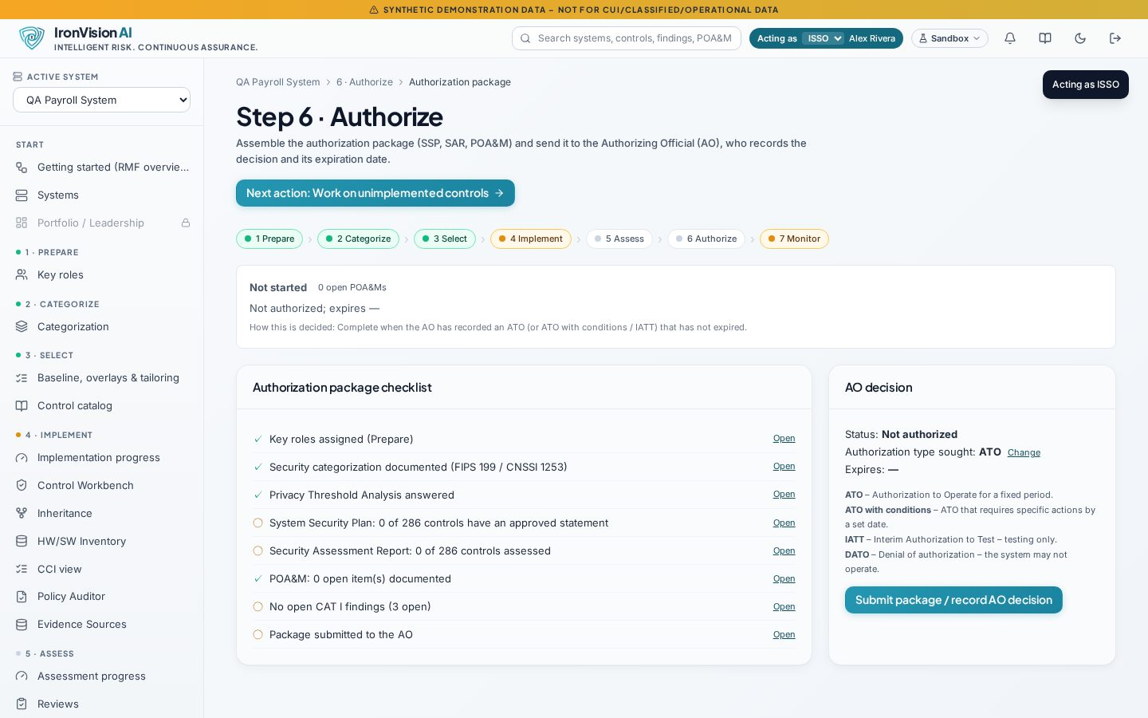
Figure: Authorize: authorization type and decision

POA&M (/poams, /poams/:id)
Aspect | Detail
Purpose | Plan of Action and Milestones with weaknesses, milestones, risk, linked findings and history.
Used by | ISSO, ISSM, AO (risk acceptance)
Key actions | Create from findings (match/link rules); add milestones; request closure, risk acceptance or extension.
Outputs | POA&M records; OSCAL POA&M export.
Guardrails | Remediation detection marks items closure-eligible but never closes them automatically. Status cannot change while a closure or risk review is pending. Later due dates need an extension request.

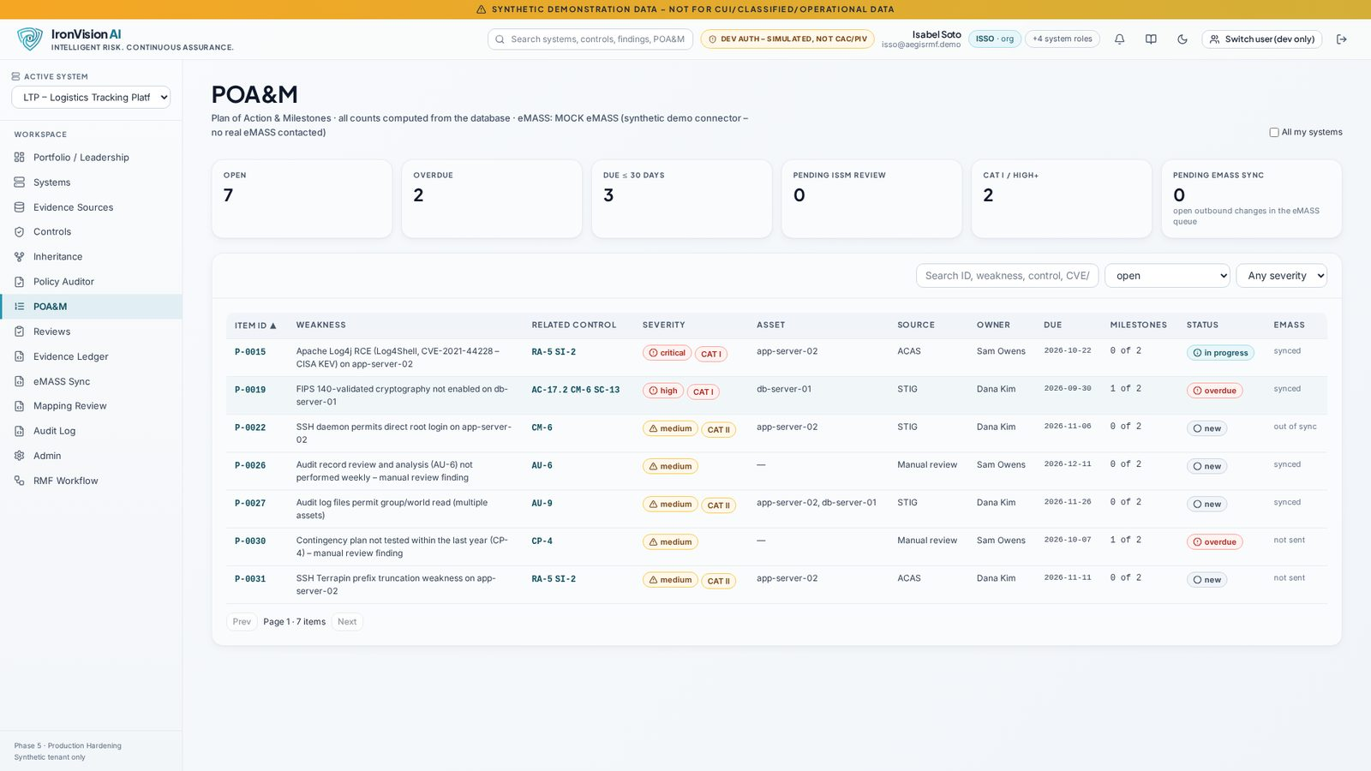
Figure: POA&M list

eMASS Sync (/emass)
Aspect | Detail
Purpose | Connector setup, approval-gated outbound queue, compare/import, retry with back-off, conflict resolution and failure simulation.
Used by | ISSO, ISSM (queue), Platform Admin (connector)
Key actions | Queue changes; approve; resolve conflicts ('keep local' needs a fresh ISSM approval).
Outputs | Sync history.
Guardrails | Truthful setup panel showing which capabilities are real.

MOCKED
The default eMASS adapter is MOCKED ('MOCK eMASS – synthetic demo connector, no real eMASS contacted'). The authorized read/write REST adapters are stubs that require credentials and have not been run against eMASS.

5.9 Step 7 – Monitor

Continuous monitoring (/rmf/monitor)
Aspect | Detail
Purpose | Rule-based monitoring status: CISA KEV matches, CAT I findings, overdue POA&Ms, stale evidence, scheduled job health.
Used by | ISSO, ISSM
Key actions | Open the items that need attention.
Outputs | Monitoring status feeding step 7.
Guardrails | KEV is versioned content (pinned CISA snapshot) re-evaluated daily; EPSS is not loaded (labelled).

Evidence Ledger (/evidence-ledger)
Aspect | Detail
Purpose | Tamper-evident list of all evidence with SHA-256, provenance, freshness, integrity status and versions.
Used by | ISSO, SCA, ISSM
Key actions | Verify integrity; view, replace (new version) or remove (with reason) evidence; see dependents flagged for re-review.
Outputs | Integrity checks, version history.
Guardrails | Removal and replacement keep history and flag dependent controls.

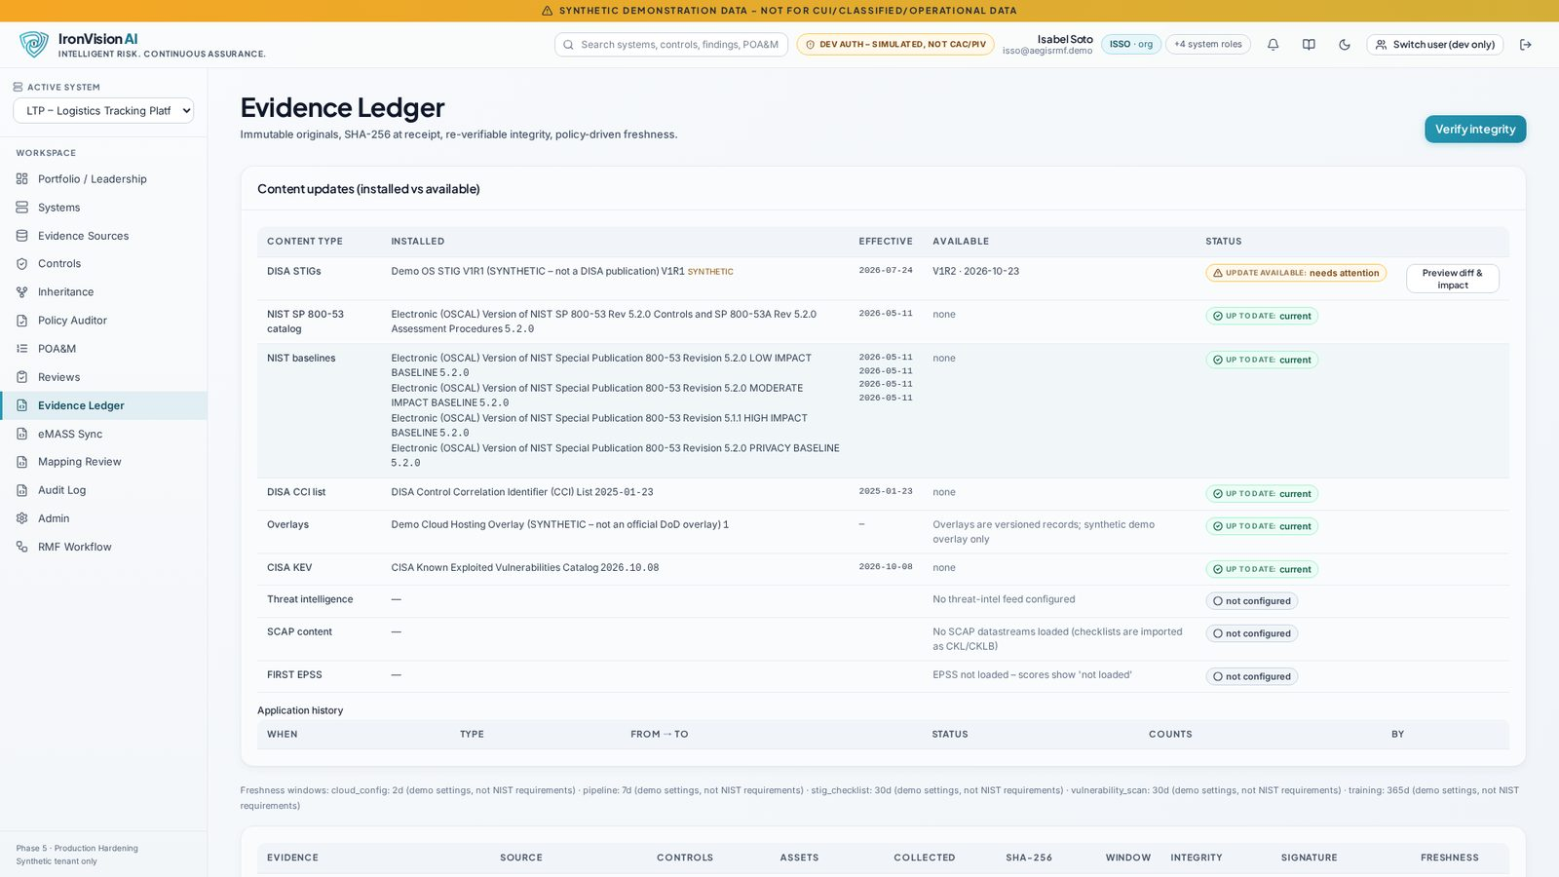
Figure: Evidence Ledger

5.10 Tools and administration

Traceability matrix (/traceability)
Aspect | Detail
Purpose | Control → implementation → evidence → finding → POA&M → assessment chain.
Used by | SCA, ISSM, AO
Key actions | Filter; follow links.
Outputs | Traceability view.
Guardrails | Read-only.

Help: who can do what (/help)
Aspect | Detail
Purpose | Plain-language permission matrix and role descriptions.
Used by | All
Key actions | Read.
Outputs | —
Guardrails | —

Audit Log (/audit-log)
Aspect | Detail
Purpose | The hash-chained audit trail with filters, pagination, chain verification and CSV/JSON export.
Used by | ISSO, ISSM, SCA, AO, Privacy Official, Platform Admin (audit.read)
Key actions | Filter by action, outcome, actor; verify chain; export.
Outputs | Exports.
Guardrails | Append-only; the retention job refuses to purge audit events.

Admin (/admin)
Aspect | Detail
Purpose | Platform health (database, storage, worker heartbeat, AI), AI status and 'Test AI connection', RBAC enforcement demo, worker jobs and schedules, users and roles, security status, AI administration (model override, use cases), decision rules, content updates, demo tools.
Used by | Platform Admin (most panels), all roles (health and AI status)
Key actions | Run health checks; test the AI connection; enqueue content loads; invite users (dev); edit decision rules; edit the banner.
Outputs | Health, audit entries.
Guardrails | Panels are permission-gated with an explicit 'Your roles do not grant …' message. No secrets are shown.

Docs Center (/docs-center)
Aspect | Detail
Purpose | In-app handover documentation (deployment, security, operations).
Used by | Admins, operators
Key actions | Read.
Outputs | —
Guardrails | —

Notifications (/settings/notifications) and global search
Aspect | Detail
Purpose | Per-user notification preferences; RBAC-filtered search across systems, controls, findings and POA&Ms.
Used by | All
Key actions | Set preferences; search.
Outputs | —
Guardrails | The email adapter is disabled by default.

Sandbox controls (header)
Aspect | Detail
Purpose | Sandbox badge, 'Acting as' persona switcher, demo reset (demo tools).
Used by | Sandbox users
Key actions | Switch persona; reset the demo workspace.
Outputs | —
Guardrails | Only on sandbox tenants; persona actions are labelled.

6 AI components
All AI calls go through one service (backend/app/services/ai/service.py). Every prompt is versioned (id@version) and declares a strict output schema (Pydantic). Each call is logged to the ai_interactions table: provider, model, prompt id and version, input SHA-256, token usage, latency, validation status and correlation id. Output that fails schema validation gets exactly one repair retry. A reply cut off at the output-token limit (finish_reason 'length') is detected and retried as a smaller batch. If it still fails, the deterministic result stands.

6.1 Inventory of AI features
Feature (prompt) | Inputs | Output | Grounding / validation | Fallback
Policy audit (policy.audit@1.0.0) | Policy text, mapped control, ODP / observed values | Proposed findings (gaps, value mismatches) | Schema; findings stay proposed until a human confirms | Deterministic parser findings
Policy coverage refine (policy.coverage_refine@1.0.0) | Assessment objectives / CCIs of one control (batches of 8), deterministic result, policy text | met / partial / missing + exact quote + rationale per requirement | Quote must be an exact contiguous substring of the policy; otherwise the AI result is discarded and noted; disagreement lowers confidence and needs review | Per-batch deterministic coverage
Mapping suggestion (mapping.suggest@1.0.0) | Finding title, source, rule/plugin, CVEs, CCIs | Up to 3 controls with rationale and confidence | Control IDs validated against the catalog; proposal only | Manual mapping
Implementation statement draft (control.implementation_statement@1.0.0) | Control, system context, evidence, policies, open POA&Ms | Sectioned draft with citations | Citations validated against real records; draft versioning; review request required | Manual writing
TR evidence analysis (tr.evidence_analysis@1.1.0) | TR row (CCI / AP), linked evidence, STIG/ACAS results, policy coverage, POA&Ms | Per-source verdict, reason, quote and suggested Test Results text | References must exist; quotes verified; fields compliance_status / tested_by / date_tested are rejected by the schema | Deterministic analysis label
Inventory correlation ranking (inventory.correlation_rank@1.0.0) | Scan host facts and candidate assets | Ranked candidates with confidence and identifiers | Fabricated candidates and unsupported identifiers dropped; creates no asset or finding | Deterministic correlation engine
Discrepancy explanation (inventory.discrepancy_explain@1.0.0) | An inventory discrepancy and its records | Plain-language explanation and ranking | References validated; suggestion only | Rule text
Connection test (ai.health_check@1.0.0) | A random nonce | Status, echoed nonce, one-sentence summary | Nonce must match | —

AI IS NEVER ALLOWED TO
Set or approve a Compliance Status, assessment result, authorization decision or risk acceptance; fill in 'Tested by' or 'Date tested'; close a POA&M; approve its own suggestion; make a privacy determination; create assets or findings; change inventory records; or bypass the human approval gate, which is locked on.

6.2 Provider architecture
The provider is chosen with environment values only: AI_PROVIDER, AI_MODEL, an optional per-use-case AI_MODEL_DRAFTING / _POLICY / _MAPPING / _SUMMARY, AI_TIMEOUT_SECONDS and AI_MAX_OUTPUT_TOKENS (default 8000). Switching providers takes an env change and a restart of the backend and worker. A platform admin can override the model in the Admin page; this is audited.
AI_PROVIDER | Transport | Notes
openrouter (recommended) | OpenAI Chat Completions over HTTPS, base https://openrouter.ai/api/v1 | One key (OPENAI_COMPAT_API_KEY); any model slug passed verbatim; structured output negotiated json_schema → json_object → prompt; 429/502/503 retried honouring Retry-After; clear 401/402/404 messages
anthropic | Anthropic Messages API | ANTHROPIC_API_KEY; direct adapter (not exercised against the live API in development)
openai_compatible | Any OpenAI-compatible endpoint (vLLM, Ollama, LM Studio, gateways) | Keeps data inside your boundary when self-hosted
emergent | Emergent universal key | Development preview only; refused in staging and production
none / empty | — | All features run in deterministic mode

6.3 Status, health and usage
- GET /api/v1/ai/status (every signed-in role): provider / model, configured yes/no, analysis mode ('AI-assisted (provider / model)' or 'Deterministic analysis (no AI)'), endpoint, whether a key is configured (never the key), last successful call, 24-hour call and token usage. Only admins see the last error.
- POST /api/v1/ai/health (platform admin, 'Test AI connection'): one tiny call returning provider, model and latency. Success and failure are both audited.
- GET /api/v1/health: platform health including the AI component.
- The API key is sent only as a bearer header. It is never logged, returned or shown.
NOTE
With OpenRouter, prompts go to OpenRouter and on to the provider of the selected model. Choose models and routing settings (data retention, no training) that fit your data policy, or use a self-hosted openai_compatible endpoint for data that must stay inside your boundary. Development and staging use synthetic data only.

7 Reference content
Reference content is pinned, versioned and SHA-256-verified at load. Updates are previewed (diff and impact) and applied only by a role with content.apply. History is never rewritten: observations and assessments keep the content version they were made against.
Content | Version / source | Loaded
NIST SP 800-53 Rev. 5 controls | OSCAL catalog (5.1.x) | 1,196 controls: 324 base, 872 enhancements, 182 withdrawn
NIST SP 800-53A assessment objectives | OSCAL | 3,715 objectives
NIST SP 800-53B baselines | OSCAL profiles | Low 149 · Moderate 287 · High 370 · Privacy 96
DISA CCI list | Pinned DISA CCI XML | 5,137 CCIs; 3,838 CCI → Rev. 5 mappings, all resolved
NIST SP 800-60 Vol. 2 Rev. 1 | Appendices C and D | 168 information types (C: 76, D: 92) with provisional C/I/A
CNSSI 1253 Appendix D | 29 July 2022, corrected copy 6 Oct 2022 (161 pp.) | 1,189 rows (Tables D-1 … D-20), 182 withdrawn, page-cited
CNSSI 1253 parameter values | Appendix D 'Parameter Value' column | 162 controls with values; 204 mapped to single ODPs; 27 kept at control level
CNSSI 1253 overlays | Official attachments (e.g. Classified, Privacy, Space) | 13 overlay records; restricted overlays shown as unavailable
CISA KEV | Pinned snapshot | Re-evaluated daily against findings
STIG content | Versioned releases (demo data synthetic) | Diff and impact preview before apply
OSCAL schemas | OSCAL 1.2.2 | SSP, POA&M, Assessment Plan, Assessment Results

7.1 CNSSI 1253 baseline numbers (selected = 'X' or '+')
Impact level | Confidentiality | Integrity | Availability
Low | 273 | 310 | 147
Moderate | 319 | 380 | 202
High | 397 | 474 | 283

The privacy control baseline has 93 rows. Example unions: L-L-L = 394 (357 security plus privacy), M-M-M = 492, M-H-L = 559, H-H-H = 607. Thirty rows were checked by hand against rendered PDF pages and are pinned in the test suite. Compared with SP 800-53B: all 149 Low controls are selected at L-L-L; 286 of 287 Moderate at M-M-M (IA-12(5) is '--'); 369 of 370 High at H-H-H.
SME REVIEW REQUIRED
Union interpretation: the NSS baseline is computed as (C column at the C level) ∪ (I at the I level) ∪ (A at the A level) ∪ the privacy control baseline, with no high-water mark. CNSSI 1253 §3.2.1 does not use the word 'union'. Seven Rev. 5 controls that are not in the 2022 tables (IA-13 and its enhancements, SA-15(13), SA-24, SI-2(7)) are not selected and are listed for SME review.

SME REVIEW REQUIRED
Privacy Overlay / ACCT layering: whether ACCT layers under Low/Moderate/High exactly as the variant switcher assumes (CNSSI 1253F Att. 6 Table 2). ACCT covers 23 of the 27 privacy controls left to the overlay; SA-4, SC-7(24), SI-12(2) and SI-19 are shown as 'not covered – SME review'.

SME REVIEW REQUIRED
Privacy Threshold Analysis defaults: the shipped questionnaire is a generic example and must be validated by the agency's privacy office.

8 Evidence and data integrity
- Content addressing. Every uploaded file is stored under its SHA-256. File names are never used as storage paths. Duplicate uploads are detected by hash.
- Provenance. Each evidence item records its source (upload, connector, generated export), uploader, ingest run, linked controls and scan status ('not_scanned' when no ClamAV scanner is configured).
- Integrity verification. A worker job re-reads each object, recomputes SHA-256 and records an integrity check. The Evidence Ledger shows the current integrity status and the last verification time.
- Freshness. Freshness policies define a window per evidence type. Controls are rolled up as current, partially stale or expired per asset ('N of M assets'). Stale evidence feeds Continuous Monitoring.
- Versioning. Replacing evidence creates a new version with a reason. The previous version is kept, and dependent controls and TR rows are flagged for re-review. Removal requires a reason and is audited.
- Retention and legal hold. Retention rules per resource type purge only after their window; items under legal hold are never purged. Every purge supports a dry run and is audited. The audit log itself is never purged.
- Generated artifacts. OSCAL exports and workbook exports are stored as hashed evidence with their validation reports.
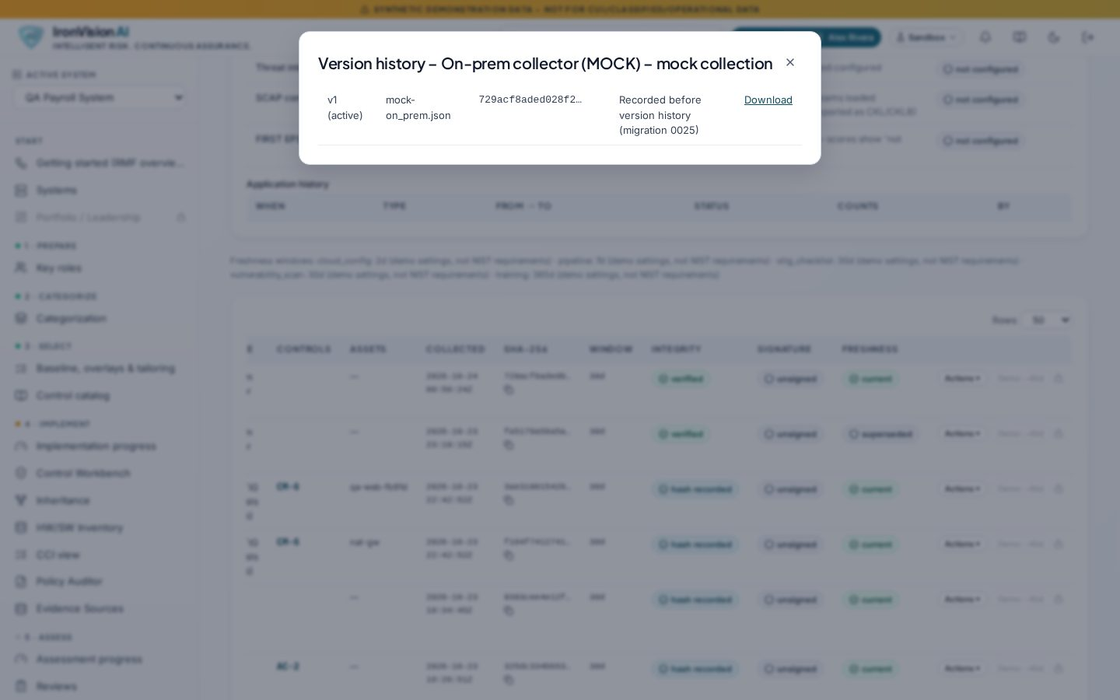
Figure: Evidence version history

9 eMASS workbooks

9.1 Test Result (TR) workbook
- Import: the real eMASS Test Result template. Header roles are detected (control acronym, AP acronym, CCI, CCI definition, implementation guidance, assessment procedures, Compliance Status, Date Tested, Tested By, Test Results). AP/CCI rows are matched to the system's controls, with manual resolution, and the mapping is saved as a reusable template definition.
- Generation: rows are proposed from SCA assessments, STIG/ACAS results, policy coverage, evidence freshness and POA&Ms, with missing, conflict and stale flags.
- Approval: only the SCA approves. Each approval records the actual tester and test date (not the approver or today's date). Rows approved under an older rule were marked 'needs confirmation'.
- Two export modes, detected automatically. Pre-populated mode (rows came from eMASS) writes only columns M–P (Compliance Status, Date Tested, Tested By, Test Results) of SCA-approved rows. Blank-template mode also writes the identifiers A/F/G/H, but only on rows added from the system, because eMASS needs them to identify each added row.
- Validation report: every cell outside the permitted ranges is compared (value, formula, style) and every other package part byte-for-byte. The report lists the mode, the permitted ranges with a reason for each, and the changed cells.
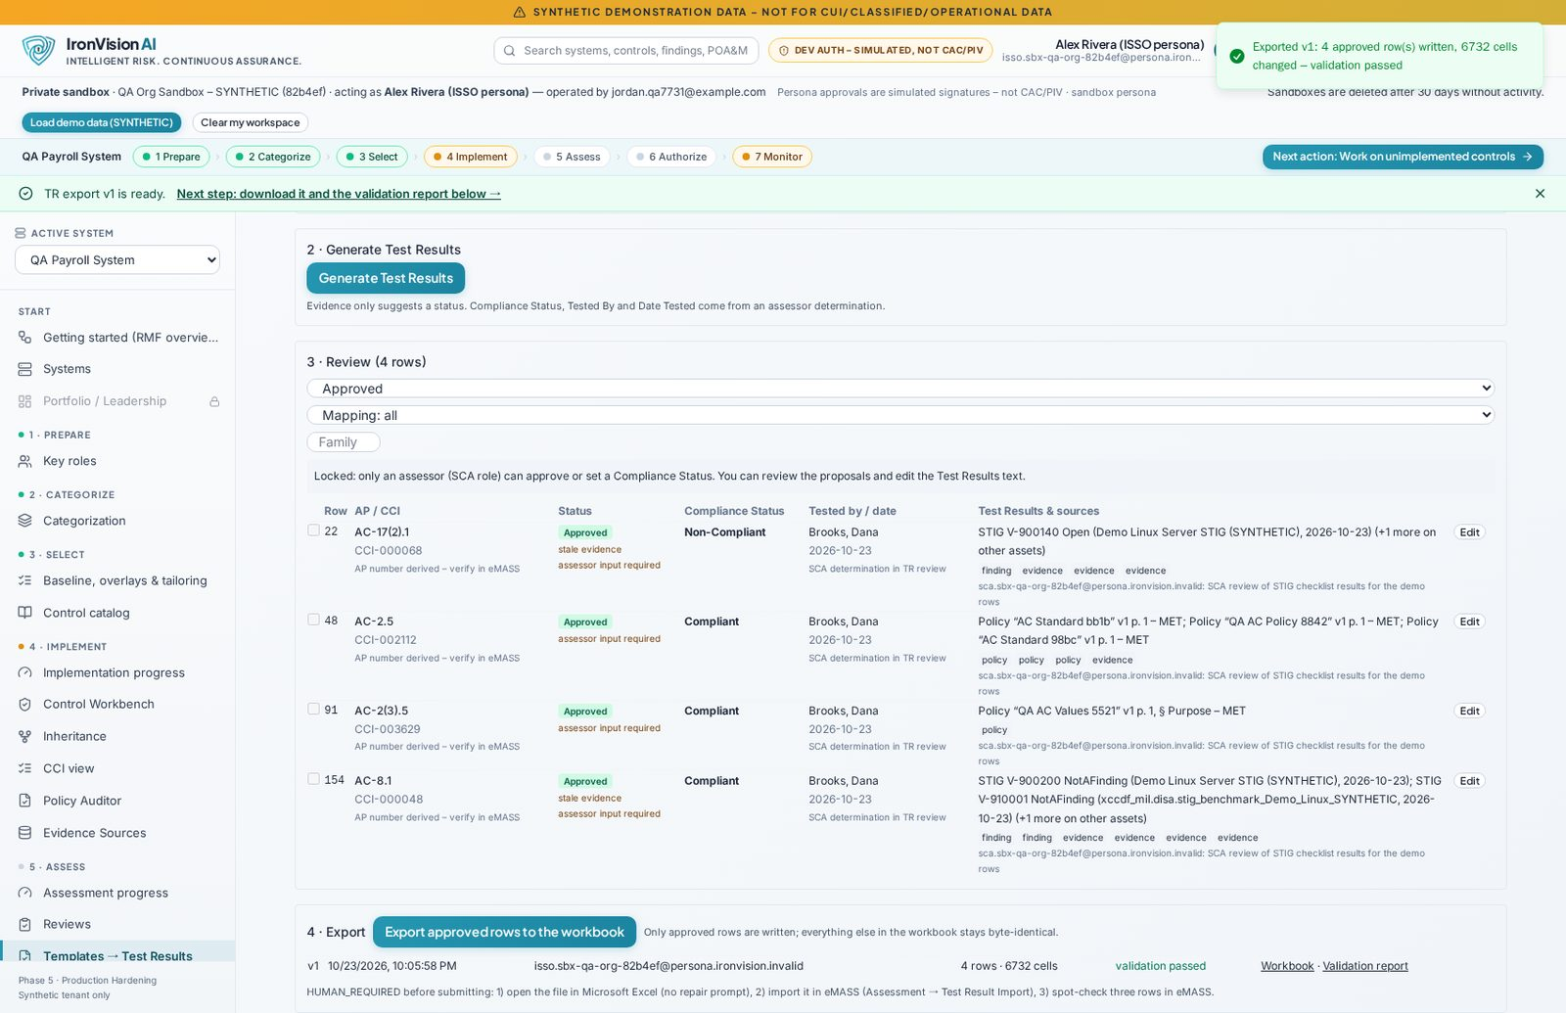
Figure: Test Results export history with validation status

9.2 Hardware/Software (HW/SW) list
- Import of the eMASS HW/SW .xlsm. Headers are detected and vocabularies come from the template's '(U) Lists' tables. Existing records are never overwritten without proposal → accept → approve.
- Macros are never executed. The workbook is processed as an OOXML package. On export, vbaProject.bin and the three signature parts stay byte-identical to the template, and only permitted cells are written.
- Every export comes with a validation report.
REQUIRES HUMAN VERIFICATION
Open both exported workbooks in Microsoft Excel (macros disabled) and confirm there is no repair prompt and that the dropdowns still work. Import the TR export (Assessment → Test Result Import) and the HW/SW export into eMASS, and spot-check rows. eMASS import compatibility has not been verified in the development environment.

10 Technical architecture
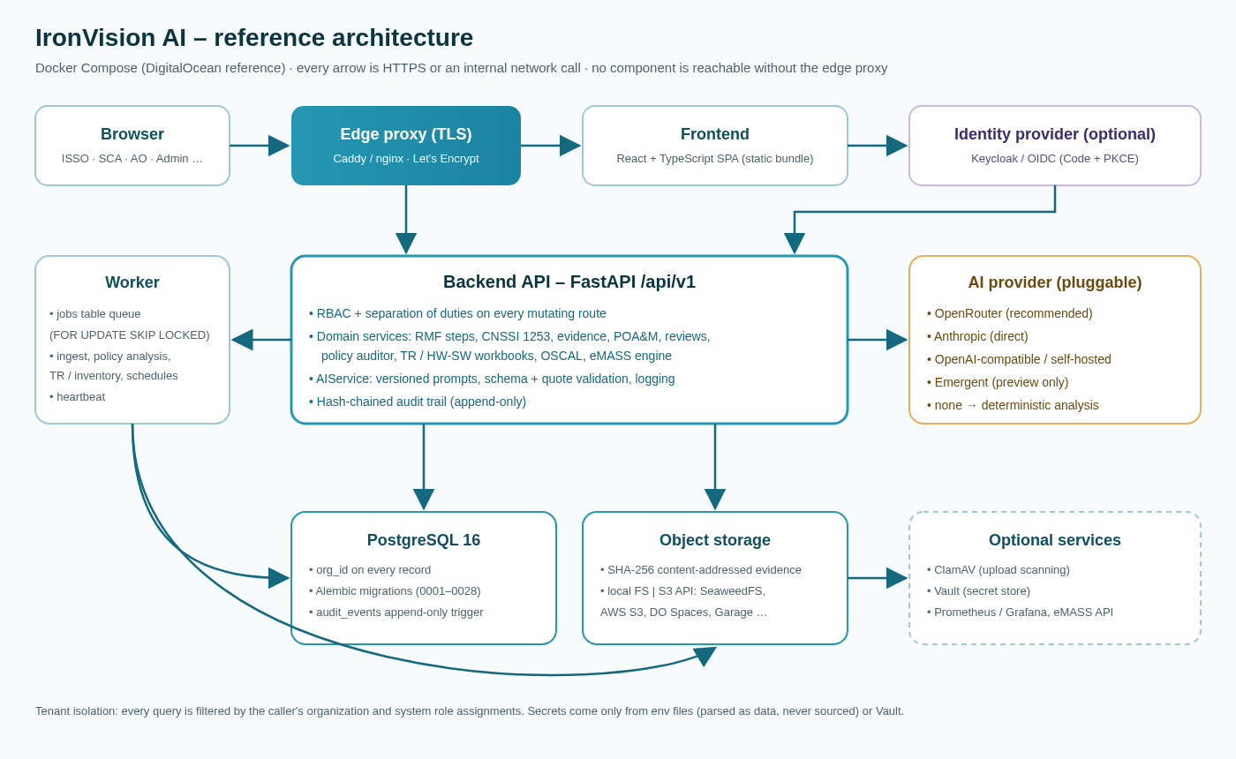
Figure: Reference architecture
Layer | Technology | Responsibility
Frontend | React + TypeScript, Tailwind design tokens, shadcn/ui | Page per RMF module; permission-aware UI; no secrets in the bundle
API | FastAPI (Python 3.11), Pydantic, SQLAlchemy 2 | REST under /api/v1; OpenAPI at /api/openapi.json; RBAC dependencies on every mutating route
Worker | Separate Python process | jobs table queue (SELECT … FOR UPDATE SKIP LOCKED), DB-stored schedules with locking and stale-job recovery, heartbeat
Database | PostgreSQL 16, Alembic | 29 migration files (0001 … 0028); additive, reversible; org_id on every record; append-only audit trigger
Object storage | Storage abstraction: local FS or any S3 API | SeaweedFS (Compose profile), AWS S3, DigitalOcean Spaces, Garage; selected via env
Identity | dev_password (dev/demo), OIDC (Keycloak profile), mTLS header stub | Authorization Code + PKCE, server-side sessions
Optional | ClamAV, HashiCorp Vault, Prometheus / Grafana | Compose profiles

10.1 API design
- JSON over HTTPS, bearer-token authentication, base path /api/v1. Interactive docs at /api/docs.
- Error semantics: 401 unauthenticated or expired session · 403 RBAC denial (audited) · 404 not found or other tenant · 409 state conflict · 413/415/422 upload or validation · 429 rate limited with Retry-After.
- Long-running work (ingest, policy analysis, TR generation and analysis, inventory checks) returns 202 with a job id.
- Appendix A summarises the endpoint groups from the live OpenAPI specification.

10.2 Multi-tenancy
Every record carries org_id. Queries are scoped to the caller's organization and to their system role assignments. Objects addressed by id (workbooks, rows, evidence, discrepancies) resolve their owning system, and requests across tenants return 404. Automated tests check that a user of tenant B gets 403/404 or empty results for tenant A's systems, POA&Ms, findings, search, audit, TR and inventory objects. Each sandbox is its own tenant and is purged after a configurable inactivity period.

11 Security and compliance posture
Area | Implementation
Authentication | AUTH_PROVIDERS: dev_password (simulated, dev only, disabled in production compose), oidc (Code + PKCE S256, state + nonce, JWKS signature, iss/aud/exp checks), mtls_header (trusted-proxy stub for CAC/PIV front-ends)
Sessions | Server-side sessions; idle 30 min, absolute 12 h; rotating hashed refresh tokens; logout revokes; lockout 5 failures / 15 min
Authorization | RBAC scoped to org/system; every mutating route declares a permission dependency (enforced by test); denials audited
Separation of duties | Self-approval blocked; SCA independence; AO-only decisions; Platform Admin has no decision rights; real-user SoD in production
Audit | Hash-chained, append-only audit_events (DB trigger); chain verification; CSV/JSON export; never purged
Web hardening | Strict CSP, nosniff, X-Frame-Options DENY, no-referrer, HSTS; exact-origin CORS allowlist ('*' refused); per-IP rate limits
Uploads | Extension allowlist per kind, magic bytes, size limit, defusedxml, zip-bomb/path-traversal checks, optional ClamAV
Secrets | Env files are parsed as data (never sourced) and validated by check_env; Fernet secret store or Vault KV v2; keys never logged or returned
Production safety | check_env refuses insecure production settings (e.g. AI_PROVIDER=emergent, wildcard CORS, demo login without explicit opt-in)
Supply chain | pip-audit clean on production requirements; Bandit high/medium 0; remaining yarn-audit highs are build-time only (react-scripts)

REQUIRES HUMAN VERIFICATION
OIDC has been tested against a mocked IdP and a dev Keycloak realm. Vault was tested with a mocked client only and ClamAV was not run against a live clamd. FIPS 140-3 operation needs a FIPS-validated OpenSSL provider and host FIPS mode, which have not been set up or validated.

12 Deployment and portability
- Docker Compose is the reference deployment: edge proxy, frontend, backend, worker, PostgreSQL, object storage, optional Keycloak, ClamAV, Vault and monitoring profiles.
- DigitalOcean reference (docs/DIGITALOCEAN_DEPLOYMENT.md): measured sizing, Ubuntu 24.04 set-up, block-storage volumes, TLS with automatic certificates, a one-command deploy script with fail-fast preflight checks, environment templates, lifecycle procedures, and migration paths to Managed PostgreSQL and other storage profiles with no code change.
- Demo deploy with recovery deferred (deploy.sh --demo-without-recovery): read-only preflight, rollback snapshot of the env and image tags, demo settings, backup verification, migration, demo smoke test. Any failure restores the previous env and images.
- Data recovery tooling (recover.sh): read-only rehearsal on isolated replicas, a plan with a hash that must match at apply time, read-only evidence integrity checks, cutover and rollback.
- Portability register (docs/PORTABILITY.md): the only preview-platform dependencies are the Emergent AI adapter (refused outside preview) and pod bootstrap scripts, neither of which is used by Docker deployments.
REQUIRES HUMAN VERIFICATION
The recovery toolkit was built and verified on isolated replicas in the build environment only. It has not been run on the customer Droplet. Docker builds and 'compose up --wait' health checks were validated statically (YAML and shellcheck) in development; the first real run is on the target host.

13 Use cases and walkthroughs

13.1 New system to ATO (FIPS 199)
- ISSO registers the system and its assets; the ISSM assigns key roles (Prepare).
- ISSO selects SP 800-60 information types; FIPS 199 computes the high-water mark; the AO approves (Categorize).
- ISSO applies the SP 800-53B Moderate baseline, tailors with justification and sets ODPs (Select).
- ISSO writes implementation statements (optionally AI-drafted and reviewed), uploads STIG/ACAS results and policies (Implement).
- SCA assesses controls, approves TR rows with tester and date, and exports the TR workbook (Assess).
- ISSM endorses the package; the AO grants ATO with an expiry; POA&Ms track residual risk (Authorize).
- Monitoring flags KEV, CAT I, overdue POA&Ms and stale evidence (Monitor).

13.2 National Security System (CNSSI 1253)
- Categorize answers 'Is this an NSS?' = Yes, which preselects CNSSI 1253; C/I/A are kept separate (e.g. M-H-L).
- Select loads the Appendix D trigraph union with page citations; a re-categorization produces an 'N added / M removed' proposal that applies only on Accept.
- Official overlays are offered with applicability; the Classified overlay requires an explicit 'classified = Yes'.
- The parameter comparison shows catalog, CNSSI and system values. Adopting a CNSSI value is audited, can be undone and warns about conflicts.
- When PII is present (Yes or Unknown), the Privacy Overlay prompt shows the 27 privacy controls left to the overlay.

13.3 Continuous monitoring
Scheduled jobs re-evaluate KEV, freshness and deadlines. The Monitor step and the Portfolio surface what needs attention. New scans deduplicate into canonical findings; remediation marks POA&Ms closure-eligible for a human to close.

13.4 eMASS round trip
Export the TR template from eMASS, import it, let IronVision AI propose results, have the SCA approve, export, review the validation report, and import into eMASS. The same applies to the HW/SW list. Final eMASS acceptance requires human verification.

13.5 Policy gap analysis
Upload an organization's policies. The Policy Auditor maps sections and pages to controls, evaluates each assessment objective and CCI, and optionally refines the results with AI using verified quotes. Gaps become proposed findings that a human confirms or dismisses; the CCI view shows coverage.

13.6 Inventory reconciliation
Import the HW/SW list and scans. The correlation engine links hosts deterministically, sends ambiguous matches (shared IPs, conflicts) to review with optional AI ranking, and lists discrepancies (missing from inventory, no scan, conflicting identifiers, duplicates, stale scans). Each change needs accept and then approval by a different real user.

13.7 Demo and sales sandbox
'Explore demo' opens a shared synthetic workspace that resets nightly. 'Create account' provisions an empty private sandbox with personas, so one person can walk through ISSO → SCA → AO hand-offs, labelled 'Sandbox: same person'.

14 Limitations, known gaps and roadmap
Area | Status today | Roadmap
Live evidence connectors | MOCKED (MockAdapter, labelled) | Real scanner, cloud and ticketing connectors
eMASS REST sync | MOCKED default adapter; REST adapters are stubs | Authorized read/write against eMASS
eMASS / Excel acceptance of exported workbooks | REQUIRES HUMAN VERIFICATION | Confirm in Excel and eMASS
Droplet deployment and data recovery | Built and rehearsed on replicas; not run on the customer Droplet | Operator-run cutover
CNSSI union, PTA defaults, ACCT layering | SME REVIEW REQUIRED | Agency SME sign-off
Agency-specific information types, SP 800-60 descriptions | Not implemented | Load descriptions; agency type editor
Agency overlay control changes | Metadata only | Apply agency overlay deltas
EPSS, email notifications, OSCAL component definitions | Not implemented / disabled | Backlog
Software ↔ asset assignment UI, asset merge | Future | Inventory phase 2
Multi-replica rate limiting / OIDC state | Per-process in memory | Shared store (Redis or proxy)
Frontend build tooling | Create React App (build-time audit findings) | Migrate to Vite
FIPS 140-3, CAC/PIV, FedRAMP, ATO of the tool itself | Not claimed | Customer-specific

15 Glossary
Term | Meaning
ACAS | Assured Compliance Assessment Solution (Tenable-based DoD vulnerability scanning)
ACCT | Accountability control set of the CNSS Privacy Overlay (CNSSI 1253F Att. 6)
AO / AODR | Authorizing Official / AO Designated Representative
AP | Assessment Procedure (eMASS)
ATO / IATT / DATO | Authority to Operate / Interim Authority to Test / Denial of Authority to Operate
CAT I/II/III | STIG severity categories
CCI | Control Correlation Identifier (DISA)
CKL / CKLB | STIG Viewer checklist formats
CNSSI 1253 | Committee on National Security Systems Instruction 1253: categorization and control selection for NSS
CRM | Customer Responsibility Matrix
eMASS | Enterprise Mission Assurance Support Service
FIPS 199 / 200 | Federal standards for security categorization / minimum security requirements
HW/SW | Hardware/Software list
IL2–IL6 | DoD Cloud Computing SRG information impact levels
ISSM / ISSO | Information System Security Manager / Officer
KEV | CISA Known Exploited Vulnerabilities catalog
NSS | National Security System (44 U.S.C. §3552(b)(6))
ODP | Organization-Defined Parameter
OIDC / PKCE | OpenID Connect / Proof Key for Code Exchange
OSCAL | Open Security Controls Assessment Language (NIST)
PII / PIA / PTA | Personally Identifiable Information / Privacy Impact Assessment / Privacy Threshold Analysis
POA&M | Plan of Action and Milestones
RBAC / SoD | Role-Based Access Control / Separation of Duties
RMF | Risk Management Framework (NIST SP 800-37 Rev. 2)
SCA | Security Control Assessor
SCAP / XCCDF | Security Content Automation Protocol / Extensible Configuration Checklist Description Format
SSP | System Security Plan
STIG | Security Technical Implementation Guide (DISA)
TR | Test Result (eMASS workbook)

A API endpoint summary (appendix)
Generated from the live OpenAPI specification (/api/openapi.json): 236 paths, 257 operations, grouped by the first path segment under /api/v1. Every mutating operation requires a permission (see section 11); only sign-in, demo login, refresh, logout, sign-up, health and the public whitepaper downloads are unauthenticated.
Group | Ops | Examples
admin | 10 | GET /admin/ai-settings; GET /admin/identity-mappings; GET /admin/security; GET /admin/users …
agency-overlays | 2 | GET /agency-overlays; POST /agency-overlays
ai | 2 | GET /ai/status; POST /ai/health
attestations | 5 | GET /attestations/{att_id}/history; POST /attestations/{att_id}/attest; POST /attestations/{att_id}/evidence; POST /attestations/{att_id}/remind …
audit-events | 2 | GET /audit-events; GET /audit-events/verify
audit-log | 1 | GET /audit-log
auth | 13 | GET /auth/me; GET /auth/oidc/callback; GET /auth/oidc/login; GET /auth/oidc/register …
authorization-decisions | 1 | POST /authorization-decisions/test
banner | 1 | GET /banner
content | 3 | GET /content/counts; GET /content/stats; GET /content/versions
content-updates | 4 | GET /content-updates; GET /content-updates/{update_id}; POST /content-updates/register; POST /content-updates/{update_id}/apply
content-versions | 2 | GET /content-versions/{version_id}/rules; POST /content-versions/{version_id}/preview
controls | 3 | GET /controls; GET /controls/families; GET /controls/{control_id}
crm | 1 | GET /crm/sample.csv
dashboard | 1 | GET /dashboard/leadership
decision-rules | 2 | GET /decision-rules; PUT /decision-rules/{request_type}
demo | 2 | POST /demo/attestations/{att_id}/expire; POST /demo/evidence/{evidence_id}/collected-at
docs-center | 4 | GET /docs-center; GET /docs-center/archive.zip; GET /docs-center/{slug}; GET /docs-center/{slug}/download
emass | 7 | GET /emass/status; POST /emass/changes/{change_id}/request-approval; POST /emass/changes/{change_id}/resolve; POST /emass/changes/{change_id}/submit …
evidence | 5 | GET /evidence/{evidence_id}; GET /evidence/{evidence_id}/download; POST /evidence/{evidence_id}/legal-hold; POST /evidence/{evidence_id}/remove …
findings | 8 | GET /findings/{finding_id}; GET /findings/{finding_id}/mappings; GET /findings/{finding_id}/poam-match; GET /findings/{finding_id}/score …
freshness-policies | 1 | GET /freshness-policies
health | 2 | GET /health; GET /health/live
ingest-runs | 3 | GET /ingest-runs/{run_id}; GET /ingest-runs/{run_id}/stig; POST /ingest-runs/{run_id}/retry
inventory | 4 | GET /inventory/exports/{eid}/download; GET /inventory/exports/{eid}/validation-report; POST /inventory/correlations/{cid}; POST /inventory/discrepancies/{did}
jobs | 2 | GET /jobs; GET /jobs/{job_id}
mapping-review | 3 | GET /mapping-review; POST /mapping-review/decide; POST /mapping-review/rule-action
mappings | 1 | POST /mappings/{map_id}/review
notification-prefs | 2 | GET /notification-prefs; PUT /notification-prefs
notifications | 2 | GET /notifications; POST /notifications/{notification_id}/ack
oscal-exports | 1 | GET /oscal-exports/{evidence_id}/download
overlays | 2 | POST /overlays/import-reference; POST /overlays/{overlay_key}/import
poam-match-rules | 1 | GET /poam-match-rules
poam-milestones | 1 | PATCH /poam-milestones/{milestone_id}
poams | 10 | GET /poams; GET /poams/{poam_id}; PATCH /poams/{poam_id}; POST /poams …
policies | 11 | GET /policies; GET /policies/{policy_id}; GET /policies/{policy_id}/mappings/{control_id}/review; GET /policies/{policy_id}/parameters.csv …
policy-findings | 1 | POST /policy-findings/{pf_id}/{action}
priority-weights | 1 | GET /priority-weights
providers | 5 | PATCH /providers/{provider_id}; POST /providers; POST /providers/{provider_id}/crm/apply; POST /providers/{provider_id}/crm/preview …
pta | 2 | GET /pta/question-sets; POST /pta/question-sets
public | 1 | GET /public/whitepaper.{ext}
rbac | 1 | GET /rbac/matrix
ready | 1 | GET /ready
reference | 6 | GET /reference/frameworks; GET /reference/info-types; GET /reference/registration; GET /reference/rmf …
reviews | 3 | GET /reviews; GET /reviews/{request_id}; POST /reviews/{request_id}/decisions
risk | 2 | GET /risk/weights; PUT /risk/weights
sandbox | 6 | GET /sandbox/samples.zip; GET /sandbox/status; POST /sandbox/act-as; POST /sandbox/demo-data …
scheduled-jobs | 3 | GET /scheduled-jobs; POST /scheduled-jobs/{job_id}/run; PUT /scheduled-jobs/{job_id}
search | 1 | GET /search
source-types | 1 | GET /source-types
sources | 3 | PATCH /sources/{source_id}; POST /sources/{source_id}/run; POST /sources/{source_id}/test
systems | 81 | DELETE /systems/{system_id}/assets/{asset_id}; DELETE /systems/{system_id}/roles/{assignment_id}; GET /systems; GET /systems/{system_id} …
tr | 14 | GET /tr/exports/{eid}/download; GET /tr/exports/{eid}/validation-report; GET /tr/lookup; GET /tr/workbooks/{wid} …

