**Report 1**

**Part 1: Course exercises**

1.1:描述性分析

1.2:anacxonda

1.3:实时

1.4：Markdown类型

1.5：Numpy

2.1: T

2.2: T

2.3: T

2.4： T

2.5： F

3.1: B

3.2: B

3.3: A

3.4： C

3.5： B

4.1: 数据分析是通过系统化地收集、整理、处理和解释数据，从中提取有价值的信息、洞察和结论的过程。它旨在帮助人们理解数据背后的模式、趋势和关系，从而支持决策、解决问题或优化流程。

4.2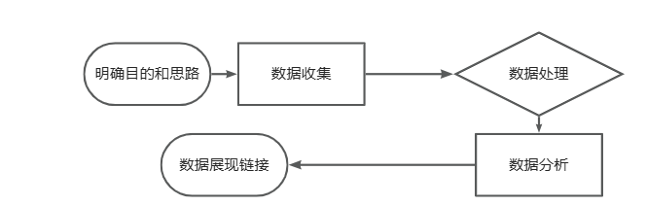

**Part 2:**

**Please watch the video again and summarize what you learn from the video, and discuss what is data analysis in your opinion.**

In my opinion,the data analysis like investigate what had happened.Then we can summarize the rules and forecast what happens the next by the investiagate.in the end,use all the above information to make decisions for somethings.

**Part 3:**

**Research on the internet to investigate commonly used data analysis tools, software, packages, etc. Select at least 3 data analysis tools of your choice and summary their advantages and disadvantages in a table.**

Example:

|  |  |  |  |  |
| --- | --- | --- | --- | --- |
| No. | Tool | Pros | Cons | Comments |
| 1. | siseense | 1. Visualize 2. Pull data from multiple sources 3. ODM the work flow is faster | 1. Expensive |  |
| 2. | Zoho | 1. Connect and blend data from anywhere 2. Prepare and manage data for analysis 3. Share insights as stories |  |  |
| 3. | Qlik | 1. self-service 2. cloud loading 3. supports many types of chart | Can’t use ai  Can’t use by team |  |
| 4. | … |  |  |  |