**Report 6**

**Part 1: Course exercises**

1.1: 直方图

1.2: 中位数

1.3: pyplot

1.4: 六边形

1.5: pyecharts

2.1:T

2.2:F

2.3:T

2.4:F

2.5:F

3.1:D

3.2:D

3.3:C

3.4:B

3.5:B

4.1:

图表常用的辅助元素包括坐标轴、标题、图例、网格、参考线、参考区域、注释文本，其中坐标轴是用于界定图表绘图区的一组直线，用作度量的参照框架；标题是图表的说明性文本，用于描述图表的大致内容；图例是集中在图表一角或一侧的方框，主要作用是标识为图表中的数据系列或分类指定的图案或颜色；网格是从坐标轴的刻度线开始、贯穿绘图区域的若干条线，作为估算图形所示值的标准；参考线是标记坐标轴上特殊值的一条直线；参考区域是标记坐标轴上特殊范围的一块区域；注释文本表示对图形的一些注释和说明。

4.2:

**直方图**，由一系列高度不等的矩形条或线段组成，用于反映数据的分布和波动情况；**折线图**是用直线段将各数据点连接起来而组成的图形，以线条的方式显示数据的变化趋势；**柱形图**是由一系列宽度相等的纵向矩形条组成的图表，它使用矩形条的高度表示数据的多少，以此反映不同分类数据之间的差异；**饼图**是一种用于了解数据中各分类占比情况的图表，它使用圆表示数据的总量，组成圆的扇面表示数据各项占总量的比例大小；**散点图**是由若干组数据点组成的图表，主要用于判断两变量之间是否存在某种关联，或者总结数据点的分布模式；**箱形图**是利用数据中的5个统计量——最小值、第一四分位数、中位数、第三四分位数和最大值­——描述数据的一种图表，主要用于反映一组或多组数据的对称性、分布程度等信息。

5:

**Part 2:**

**Find at least 5 examples of using introduced data visualization methods from website, mobile application, media sources, etc. and summarize them in the report.**

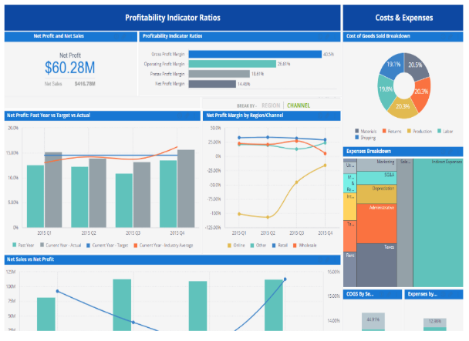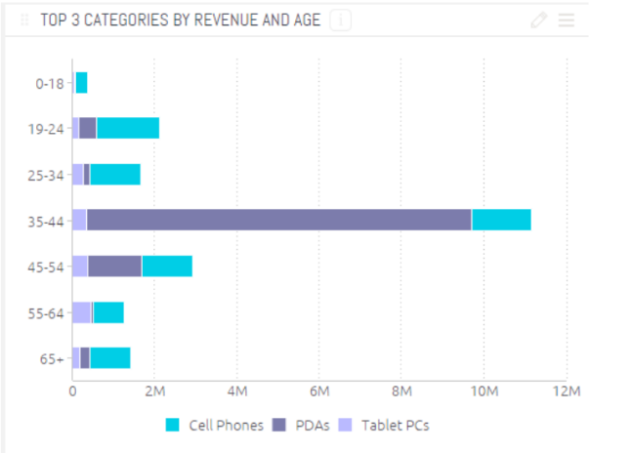

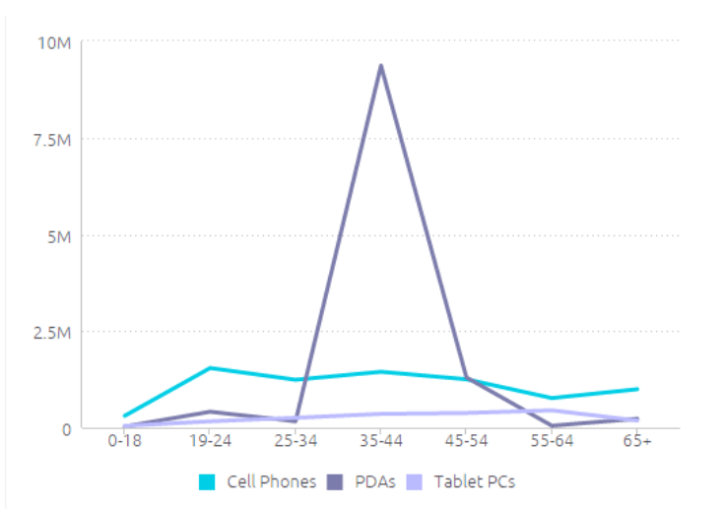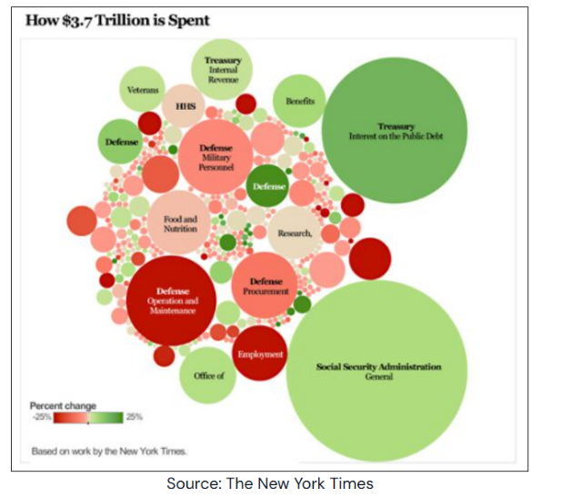

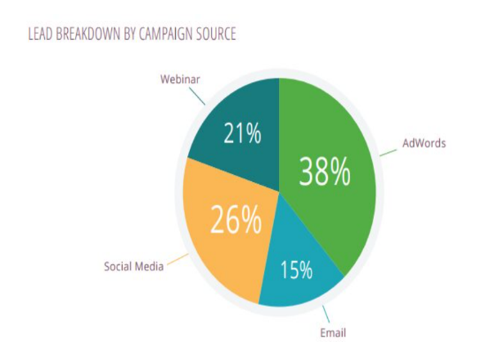 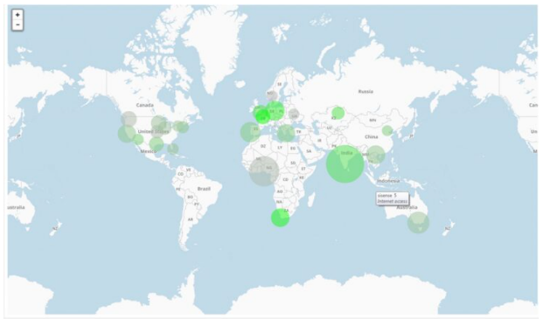

2、Indicators show one KPI, clearly

3、Line charts display trends

4、Bubble charts: understand multiple variables

5、Pie charts clearly show proportions

6、Area/scatter maps show geographic data

**Part 3:**

**Watch the video“The art of data visualization”on Moodle and there are 4 speakers presenting what is data visualization in their own opinions in this video. Please watch the entire video and summarize the most important ideas you learn from this video in the report. 200 words minimum.**

Edward Tufte

I think, in general, audiences are a lot smarter than a lot of people think. So it’s not just "know your audience"—it’s respect your audience and really know your content. That is what you should be knowing and reasoning about. Look after truth and goodness, and beauty will look after herself. You want to see to learn something, not to confirm something. We usually see to confirm things. It is very economizing for the brain. How can we see not to confirm, but to see to learn.

Julie Steele

And so, if you want to change someone’s mind, if you want to change someone’s behavior, sometimes presenting the information in a visual format is the fastest way to get them to engage with the information.

Josh Smith

Truth is one of those ambiguous things that you can’t really define, and it probably changes and evolves the more understanding you have. Data itself is a result of research. So I would say that data is just a clue to the end truth. I think a successful infographic tells a story. It communicates, hopefully, accurate and sometimes complicated data in a way that many people can understand.

Jer Thorp

My deepest interest lies in the boundary between data and culture. Data are measurements of something. In very many cases, the "somethings" we’re talking about are human systems. We’re dealing with data systems that are larger than anything that humans have ever built or experienced before. And in these really large systems, things happen within them that are emerging.