**Report 7**

**Part 1: Course exercises**

1.1: 时间序列

1.2: 时间戳

1.3: 基础频率

1.4: 重采样

1.5: Period

2.1: T

2.2: T

2.3: F

2.4: T

2.5: F

3.1: A

3.2: D

3.3: D

3.4 B

3.5: C

4.1: 时间戳表示带时区的特定的日期时间；时间差表示绝对的持续时间；时期是由时间点及其相关频率定义的时间跨度。

4.2: 如果是将高频率数据聚合到低频率，比如将每日采集的频率变成每月采集，则称为降采样；如果将低频率数据转换到高频率数据，比如将每月采集的频率变成每日采集，则称为升采样。

5:

（1）、运行产生ValueError异常，主要是因为date_range()函数中必须传入start、end、periods、freq中至少三个参数，而代码中只传入了start和freq参数。

（2）、运行结果为5

（3）、运行出现异常，因为日期字符串的格式不能够被正确解析。

**Part 2:**

**Re-implement the codes from the stock prediction and analysis Demo in the text book page 223-228, summarize the results and screenshot the codes in the report.**

**Part 3:**

**从Moodle下载‘Report7-AirPassengers.csv’文件并完成以下操作.**

1. 读取并显示数据；

import numpy as np  
import pandas as pd  
from datetime import datetime  
df = pd.read_csv('./Report7-AirPassengers.csv')  
df.index = pd.to_datetime(df.index)  
ts = df  
print(ts.head())  
print(ts.head().index) 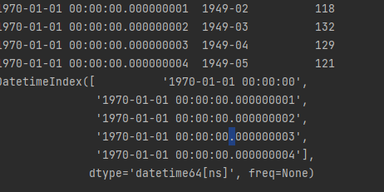

1. 查看1955年数据；

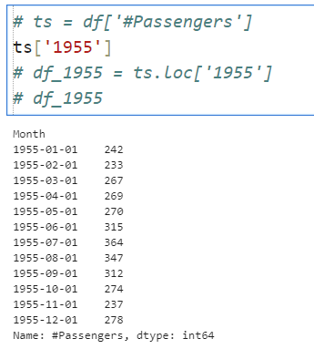

1. 对1950年1月到8月数据进行切片；

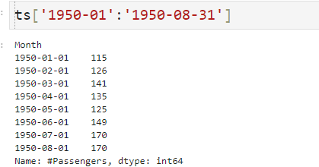

1. 利用观察法进行数据平稳性检测；

test_stationary.py

from statsmodels.tsa.stattools import adfuller  
import pandas as pd  
import matplotlib.pyplot as plt  
import numpy as np  
from statsmodels.graphics.tsaplots import plot_acf, plot_pacf  
  
# 移动平均图  
def draw_trend(timeSeries, size):  
 f = plt.figure(facecolor='white')  
 # 对size个数据进行移动平均  
 rol_mean = timeSeries.rolling(window=size).mean()  
 # 对size个数据进行加权移动平均  
 rol_weighted_mean = pd.ewma(timeSeries, span=size)  
  
 timeSeries.plot(color='blue', label='Original')  
 rolmean.plot(color='red', label='Rolling Mean')  
 rol_weighted_mean.plot(color='black', label='Weighted Rolling Mean')  
 plt.legend(loc='best')  
 plt.title('Rolling Mean')  
 plt.show()  
  
def draw_ts(timeSeries):  
 f = plt.figure(facecolor='white')  
 timeSeries.plot(color='blue')  
 plt.show()  
def testStationarity(ts):  
 dftest = adfuller(ts)  
 # 对上述函数求得的值进行语义描述  
 dfoutput = pd.Series(dftest[0:4], index=['Test Statistic','p-value','#Lags Used','Number of Observations Used'])  
 for key,value in dftest[4].items():  
 dfoutput['Critical Value (%s)'%key] = value  
 return dfoutput  
  
# 自相关和偏相关图，默认阶数为31阶  
def draw_acf_pacf(ts, lags=31):  
 f = plt.figure(facecolor='white')  
 ax1 = f.add_subplot(211)  
 plot_acf(ts, lags=31, ax=ax1)  
 ax2 = f.add_subplot(212)  
 plot_pacf(ts, lags=31, ax=ax2)  
 plt.show()

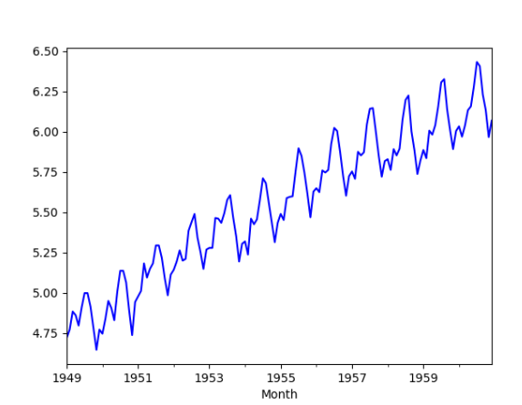

1. 利用单位根检验方法对数据进行平稳性检测；

代码同上

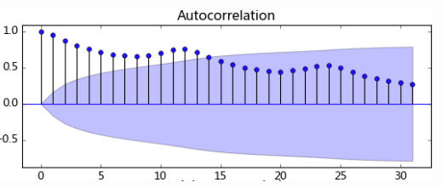

1. 对数据进行基于对数变换的平稳性处理；

main.py

import test_stationarity  
import numpy as np  
import pandas as pd  
  
df = pd.read_csv(r'D:\schoolzwu\AI\machine-study\data_analyse\3-30\Report7-AirPassengers.csv', encoding='utf-8', index_col='Month')  
df.index = pd.to_datetime(df.index)  
ts = df['#Passengers'] # 生成pd.Series对象  
  
ts_log = np.log(ts)  
test_stationarity.draw_ts(ts_log)

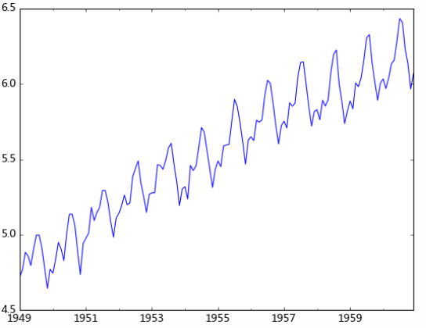

1. 对数据进行基于平滑法的平稳性处理；

test_stationarity.draw_trend(ts_log, 12)

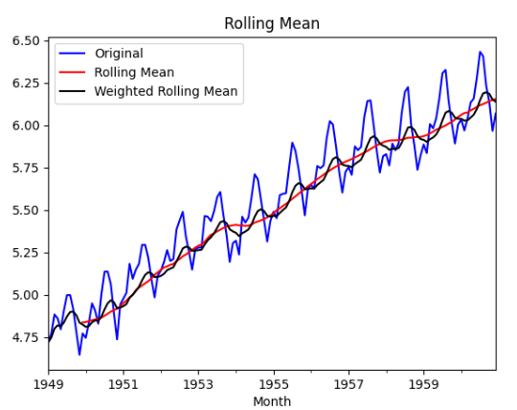

1. 对数据进行基于差分的平稳性处理；

diff_12 = ts_log.diff(12)

diff_12.dropna(*inplace*=True)

diff_12_1 = diff_12.diff(1)

diff_12_1.dropna(*inplace*=True)

test_stationarity.draw_ts(diff_12)

print(test_stationarity.testStationarity(diff_12_1))

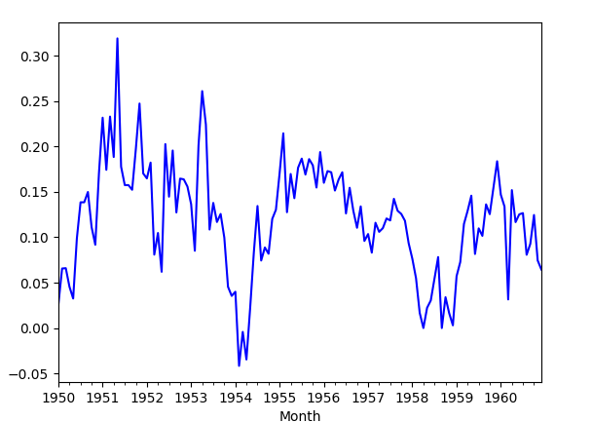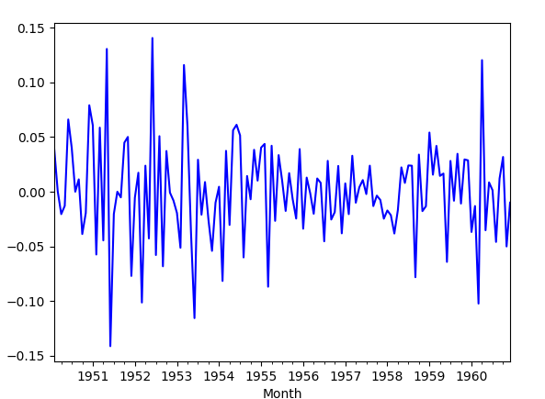

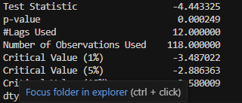

1. 对数据进行基于分解的平稳性处理；

*import* test_stationarity

*import* numpy *as* np

*import* pandas *as* pd

*from* statsmodels.tsa.arima_model *import* ARMA

df = pd.read_csv(r'D:\schoolzwu\AI\machine-study\data_analyse\3-30\Report7-AirPassengers.csv', *encoding*='utf-8', *index_col*='Month')

df.index = pd.to_datetime(df.index)

ts = df['#Passengers']  *# 生成pd.Series对象*

ts_log = np.log(ts)

*# 差分*

*# diff_12 = ts_log.diff(12)*

*# diff_12.dropna(inplace=True)*

*# diff_12_1 = diff_12.diff(1)*

*# diff_12_1.dropna(inplace=True)*

*# test_stationarity.draw_ts(diff_12)*

*# print(test_stationarity.testStationarity(diff_12_1))*

*# 分解*

*from* statsmodels.tsa.seasonal *import* seasonal_decompose

decomposition = seasonal_decompose(ts_log, *model*="additive")

trend = decomposition.trend

seasonal = decomposition.seasonal

residual = decomposition.resid

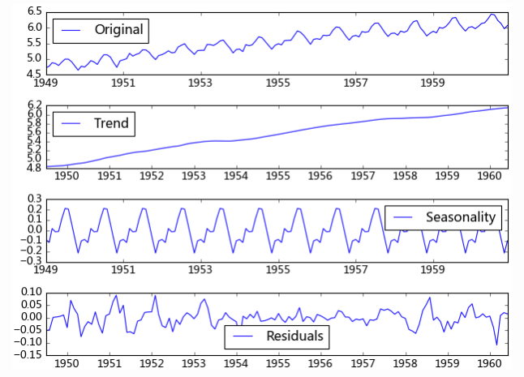

1. 对数据进行基于1阶差分的模型识别；

rol_mean = ts_log.rolling(*window*=12).mean()

rol_mean.dropna(*inplace*=True)

ts_diff_1 = rol_mean.diff(1)

ts_diff_1.dropna(*inplace*=True)

print(test_stationarity.testStationarity(ts_diff_1))

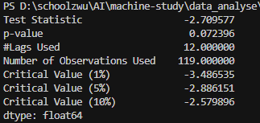

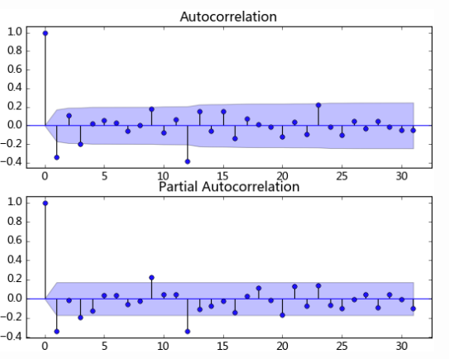

1. 对数据进行逆变换还原后进行基于均方根误差的样本拟合；

ts = ts[log_recover.index]  *# 过滤没有预测的记录*

plt.figure(*facecolor*='white')

log_recover.plot(*color*='blue', *label*='Predict')

ts.plot(*color*='red', *label*='Original')

plt.legend(*loc*='best')

plt.title('RMSE: %.4f'% np.sqrt(sum((log_recover-ts)**2)/ts.size))

plt.show()

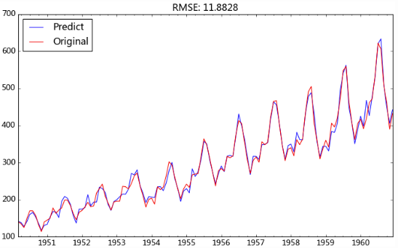

1. 分离差分，完善ARIMA模型；

model = ARIMA(ts_diff_2, *order*=(1, 1, 0))

*# order=(p,d,q) 其中 p=1 是 AR 阶数，d=1 是差分阶数，q=1 是 MA 阶数*

result_arma = model.fit()

predict_ts = result_arma.predict()

*# 一阶差分还原*

diff_shift_ts = ts_diff_1.shift(1)

diff_recover_1 = predict_ts.add(diff_shift_ts)

*# 再次一阶差分还原*

rol_shift_ts = rol_mean.shift(1)

diff_recover = diff_recover_1.add(rol_shift_ts)

*# 移动平均还原*

rol_sum = ts_log.rolling(*window*=11).sum()

rol_recover = diff_recover*12 - rol_sum.shift(1)

*# 对数还原*

log_recover = np.exp(rol_recover)

log_recover.dropna(*inplace*=True)

ts = ts[log_recover.index]  *# 过滤没有预测的记录*

plt.figure(*facecolor*='white')

log_recover.plot(*color*='blue', *label*='Predict')

ts.plot(*color*='red', *label*='Original')

plt.legend(*loc*='best')

plt.title('RMSE: %.4f'% np.sqrt(sum((log_recover-ts)**2)/ts.size))

plt.show()

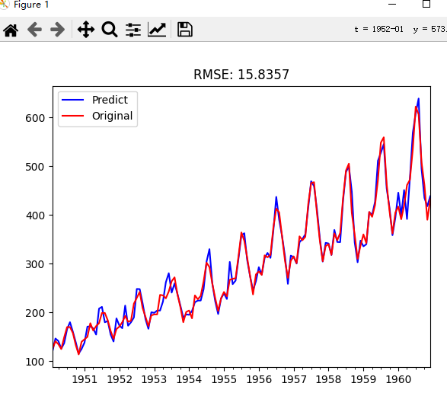

1. 以周为单位对数据进行滚动预测；

*from* dateutil.relativedelta *import* relativedelta

def **_add_new_data**(*ts*, *dat*, *type*='day'):

*if* *type* == 'day':

        new_index = *ts*.index[-1] + relativedelta(*days*=1)

*elif* *type* == 'month':

        new_index = *ts*.index[-1] + relativedelta(*months*=1)

*ts*[new_index] = *dat*

def **add_today_data**(*model*, *ts*,  *data*, *d*, *type*='day'):

    _add_new_data(*ts*, *data*, *type*)  *# 为原始序列添加数据*

*# 为滞后序列添加新值*

    d_ts = diff_ts(*ts*, *d*)

*model*.add_today_data(d_ts[-1], *type*)

def **forecast_next_day_data**(*model*, *type*='day'):

*if* *model* == None:

*raise* ValueError('No model fit before')

    fc = *model*.forecast_next_day_value(*type*)

*return* predict_diff_recover(fc, [12, 1])

ts_train = ts_log[:'1956-12']

ts_test = ts_log['1957-1':]

diffed_ts = diff_ts(ts_train, [12, 1])

forecast_list = []

*for* i, dta *in* enumerate(ts_test):

*if* i%7 == 0:

        model = arima_model(diffed_ts)

        model.certain_model(1, 1)

    forecast_data = forecast_next_day_data(model, *type*='month')

    forecast_list.append(forecast_data)

    add_today_data(model, ts_train, dta, [12, 1], *type*='month')

predict_ts = pd.Series(*data*=forecast_list, *index*=ts['1957-1':].index)

log_recover = np.exp(predict_ts)

original_ts = ts['1957-1':]

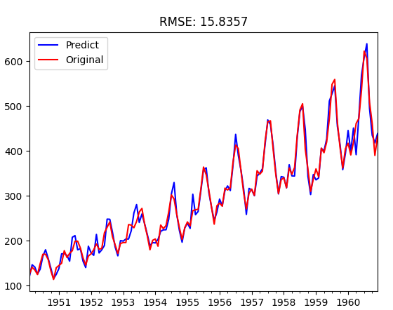

Ref：<https://www.cnblogs.com/foley/p/5582358.html>（任务实现请参考该网址）