CG Team Project

2017314789 MinKyuLee
2015312017 HoHyeongKang
2015312406 Doyoung Yu
1. Modeling : All the models used in the game were made by ourselves.
Cylinder / Sphere : Basic unit geometry of modeling. Various applications through model matrix changes
Skymap : Aside from the main field of game, extra background features were implemented as a Sky-Ball in order to enhance user experience.
2. Texture : All the texture used in the game were made by ourselves and mapped to our models.
3. Dynamic Camera : The camera can be moved dynamically in-game.
W A S D keys : Move the camera forwards, leftwards, backwards, and rightwards, respectively, in the xz- plane.
LEFT and RIGHT keys : Rotate the camera about the Y-axis.
Toggle camera view : By pressing C key, the user will be able to toggle between two camera modes.
Player : Object of player is always positioned slightly in front of eye.
Images below are the two camera modes.

4. Physics : We implemented the physical engine ourselves.
Collision : Simple collision functions are implemented and will be called every time for each collision between user (Professor), enemies (Undergraduates) and the bullet( A+ ball).
Mass : Value of mass is same to volume of object. speed of the object is inversely proportional to mass of the object, and collision speed is proportional to mass of bumped object and inversely proportional to mass of the object.
5. NPC – AI : We implemented interactive NPC
Move : The NPC moves to the center while avoiding the player.
- Let position of NPC as A, origin (center of main stage) as O and position of player as B. Then there are two vector perpendicular to AB at A, vector h and vector -h (value of y is 0). NPC chooses vector which is direct to origin between two vectors. It means ai chooses vector which h.dot(AO) >= 0 or -h.dot(AO) >= 0. Then NPC avoids player and moves to origin. This is because going to origin is almost unconditionally advantageous.
Rotate : NPC looks in the direction of progress.

6. . screen design
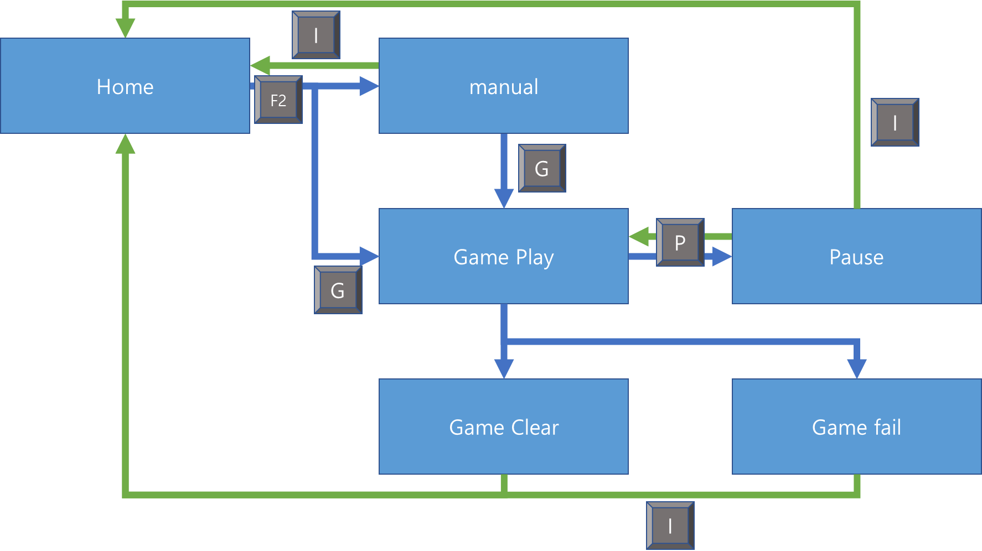
Every screens are linked smoothly and sequentially.
7. Full screen / window toggle
Can toggle screen mode by press F10.
8. Pause/Reset the Game
Can Pause the game when you play the game by press P
Can reset the game in this way. (Pause->Home->Game play)
When you clear or fail, the game automatically reset.
The in-game update is done only when game screen. When pause, time is saved, then restore it and set time as saved time when resume.
When game is initialized, all of elements of some vector(array) should be poped for preventing leak of memory.
8. Change Difficulty
Can change difficulty in the Home screen by changing the number of enemies.
9. Sound
BGM of Home screen and Game Play screen are made by ourselves.
Sound effects are downloaded form freesound.com.
10.Play Environment
Play on ubuntu and windows

