Contents

User Guide 3

Introduction 3

Installation and Using the Application 3

Prerequisites: 3

Spring Boot Jar 5

Configuration 5

Language and Locale 8

Login/Logout 8

Add New Users (administrators only) 9

User Details / Change Password 10

Properties 12

Filter 12

Sorting 12

Add New 13

Edit 14

Delete 15

Rooms 15

Filter 16

Sorting 16

Add New 17

Edit 18

Delete 19

Categories 19

Filter 20

Sorting 20

Add New 21

Edit 22

Delete 23

Inventory 24

Filter 25

Sorting 25

Pagination 26

Add New 26

Edit 32

Delete 33

Attachments 34

Add New 35

Preview 37

Download 39

Delete 40

Reports 41

Estimated Value Report 41

Inventory Report 43

Tracking and Recovery 45

Known Issues 45

# User Guide

## Introduction

This guide will include how to install, setup, log into, create a new user, and use all of the functions of the application. The guide will include instructions for setup on a single server. However, MongoDB and MariaDB offer the ability to distribute work across servers. Additionally, the application can be run on multiple machines at the same time. These machines can then be load balanced.

The standard installation noted in this guide will include a single instance of MariaDB, a single instance of MongoDB, the runnable spring boot jar which includes an embedded tomcat server instance, and an instance of Nginx to proxy the spring boot application to the standard https port and provide a secure TLS connection with an appropriate certificate.

The application has been tested on Windows 10 and CentOS 7 but should run on any system that can run the full openjdk 11.

## Installation and Using the Application

### Prerequisites:

The following applications must be installed on the server prior to the installation of the application.

* OpenJDK 11 - <https://openjdk.java.net>
  + This can either be installed from prebuilt images using instructions at <https://openjdk.java.net/install/> or installed from a site that maintains installers such as <https://adoptopenjdk.net/installation.html>.
* MongoDB v4.2.8 - <https://www.mongodb.com/>
  + Follow standard download and installation instructions on the website and be sure to record the port and credentials for later use.
* MariaDB v10.5.4 - <https://mariadb.org/>
  + Follow standard download and installation instructions on the website and be sure to record the port and credentials for later use.
* Times New Roman Font
  + If installing on a Linux system, the Times New Roman font used by Jasper Reports may not be available by default. These can be installed in various ways depending on the operating system used. For Centos 7, the package msttcorefonts can be downloaded from various sources such as <http://mscorefonts2.sourceforge.net/>.
* Nginx (optional) - <https://nginx.org>
  + The spring boot application can be configured to directly use an existing TLS certificate and the standard port 443 if desired. Or a proxy web server can be used to redirect the spring boot application running on any other port to the standard port and add TLS security.
  + Follow standard download and installation instructions. Configure Nginx for your server’s TLS certificate and configure a location on the server that proxies the spring boot application. An example is below. Note that the port can be changed in the application.yml file, but is 8778 by default.

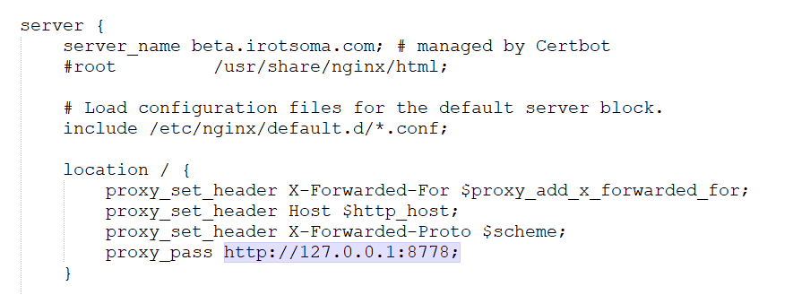

### Spring Boot Jar

The installation package contains a jar file and a config folder. These files ideally should be placed in the same directory. Spring Boot can be configured to use other folders if needed, but this is out of the scope of this guide.

The jar file is directly executable and should be given appropriate permissions to be executable and can either be run directly from the command line or with the command “java -jar <jar filename>”.

### Configuration

Spring Boot offers a wide variety of settings that can be changed in the application.yml file contained in the config folder. This section will show the most common settings for this application, but any applicable Spring Boot settings can be used to customize the installation. Note that as this is YAML, the indentations make a difference in the hierarchy and must be maintained. This can be converted to a flat properties file if desired as long as it is named application.properties.

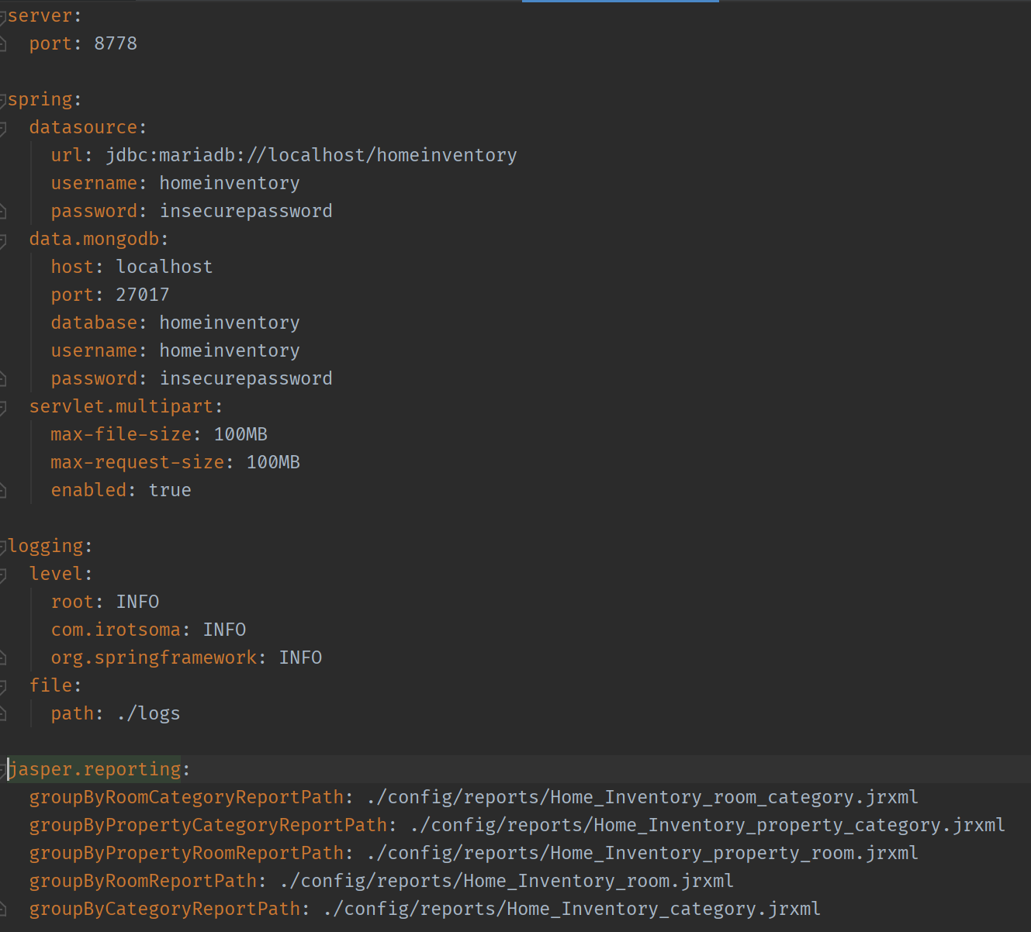

* server:
  + port: set the port that Spring Boot application will run on. If using a proxy server like nginx, this is the port you will configure to proxy.
* spring:
  + datasource: these options apply to the relational database
    - url: a jdbc URL for the appropriate database. The current system only supports mariadb so the prefix should always be jdbc:mariadb: followed by the hostname (port if nonstandard) and database name. Spring Boot also offers separate configuration properties rather than using a URL. See Spring Boot documentation for details.
    - username: Database username that has access to the database. Permissions required to create tables, modify tables, create indexes, and all dml functions.
    - Password: password for above username
  + data.mongodb: These options apply to the MongoDB instance used for attachment storage.
    - host: hostname of the server running the MongoDB instance or localhost if local
    - port: MongoDB port, default is 27017
    - database: the database/collection name to use
    - username: username that has access to database/collection specified above
    - password: password for the above user
  + servlet.multipart: by default, Spring Boot limits file uploads to 3MB. If you wish to allow larger attachments, set these:
    - max-file-size: maximum file size
    - max-request-size: maximum size of entire request
  + logging: (optional) these options can be configured to allow various logging levels for various components for help in troubleshooting issues. Set to DEBUG or TRACE and submit the logs when submitting a support request.
  + jasper.reporting: these options set the location and filename of the detailed inventory reports with different groupings. By default, all files are stored in the reports folder under the config folder as shown in the screenshot above.

## Language and Locale

The application supports multiple language and locale settings. By default, these are selected based on the settings of your browser. However, if needed, they can manually be selected in the top right of the navbar. These settings will adjust the language of the user interface as well as the format of currency and numbers.



Currently supported languages are:

* US English
* Chinese (Simplified)

Note that while only a subset of languages is supported, currency and number support is included by default for most locals and can be activated for the session by adding the locale to the url. For example: <https://beta.irotsoma.com/?locale=fr_FR> will activate French standard formatting which will use the Euro symbol for currency. The comma symbol for decimal separator, and a space for the grouping separator on numbers.

## Login/Logout

1. Click the login link or select login from the Users menu.

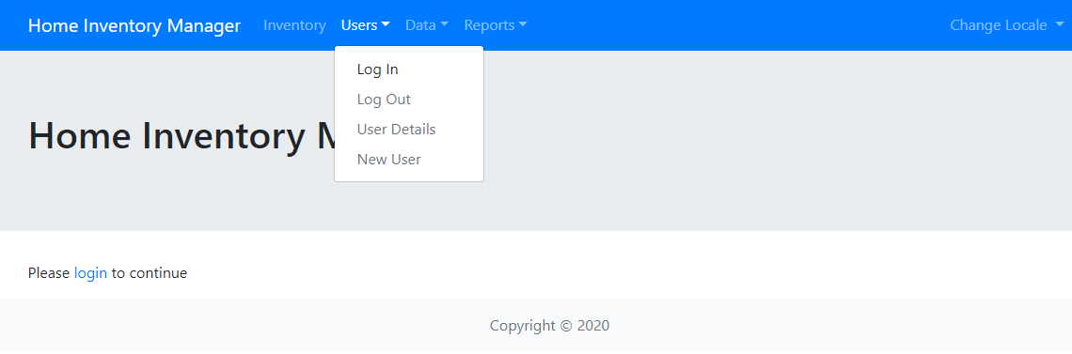

1. Enter your username and password. Selecting, “Remember me on this computer.”, will remember the user for up to 24 hrs or until the user manually selects “Log Out” from the User Menu

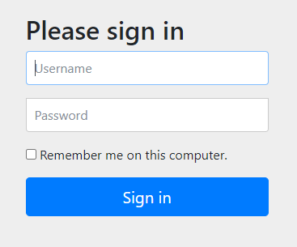

1. To log out, select Log Out from the Users menu. This will return the user to the sign-in page and log the user out of the system.

## Add New Users (administrators only)

Administrator users can add new users to the system. For all other users, this option will be disabled.

1. Select “New User” from the Users menu.

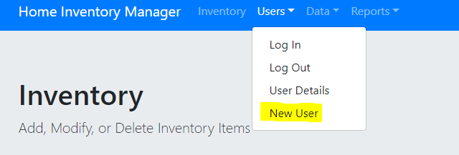

1. Enter a username (must be unique across the system)
2. Enter a password for the user. By default, the password must follow these rules
   1. Length 8-30 Chars
   2. 1 Uppercase
   3. 1 Lowercase
   4. 1 Numeric
   5. 1 Special
   6. No Whitespaces
3. Reenter the password to confirm
4. Select one or more roles for the user. Note: select both options if the user needs to use the system and can create users. This is the default functionality of the initial admin user after installation.
   1. ROLE_USER allows for normal use of the system including adding inventory items, updating all data, viewing all reports. It does not allow creating new users.
   2. ROLE_ADMIN allows for creating new users.

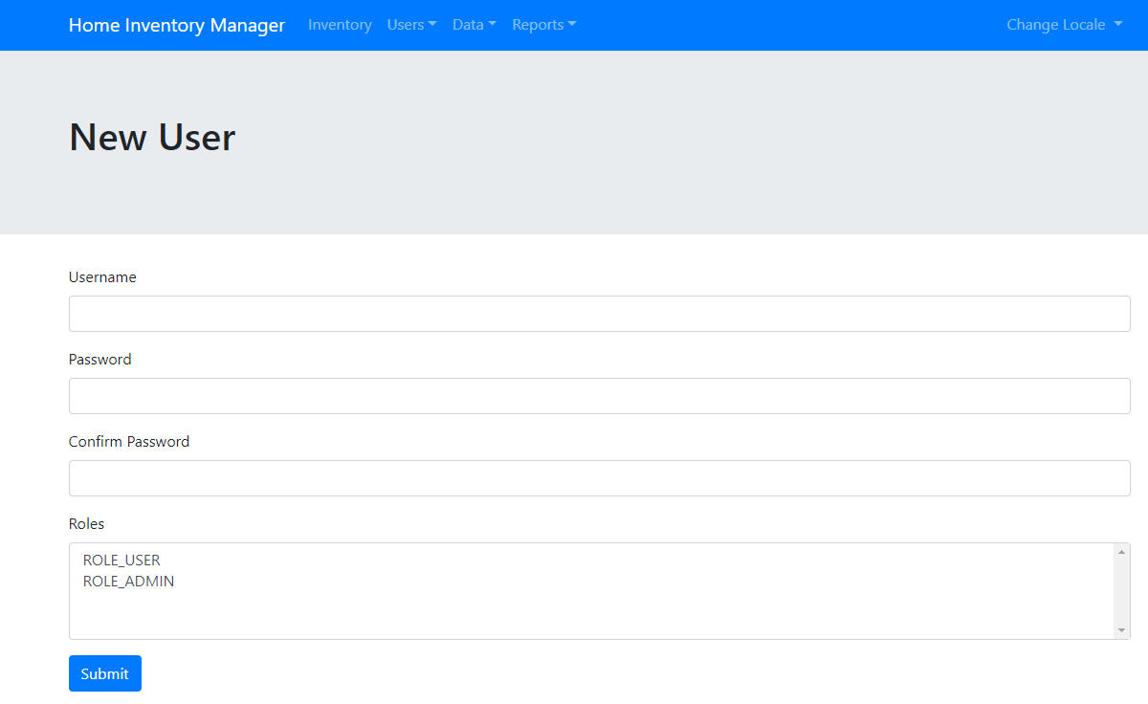

## User Details / Change Password

The user details screen can be used to view settings of the user as well as change the currently logged in user’s password. To change the password:

1. Select “User Details” from the Users menu.
2. Select the “Change Password” link.

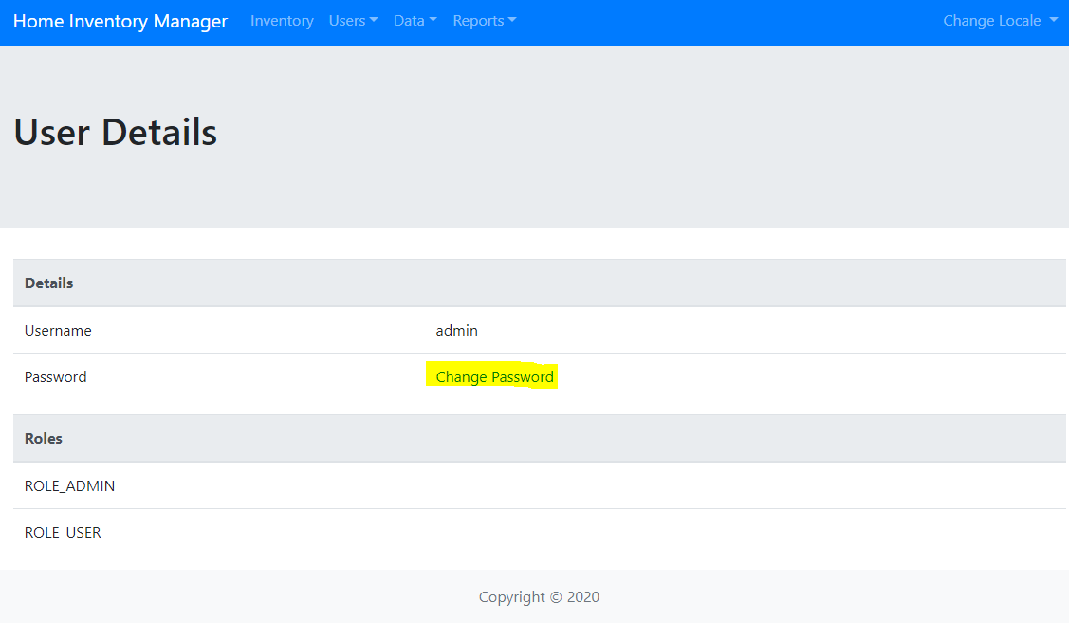

1. In the popup enter the new password and reenter it to confirm then press submit.

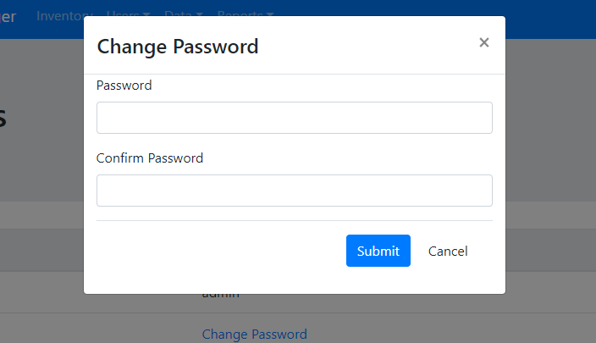

## Properties

The system can be set up to allow the user to enter one or more real-estate properties/homes. It is suggested that the user enter all properties/homes that they wish to track as the first task when initially logging into the system.

1. Select “Property List” from the Data menu to view a list of properties, add new properties, or edit existing properties.

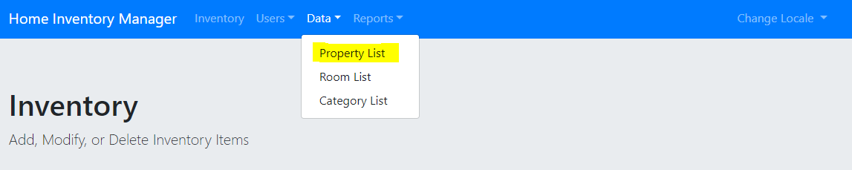

### Filter

1. To filter the list of properties, type in the search field. Both names and addresses can be filtered on. Note, the address column only includes street address and city and only these can be filtered on.

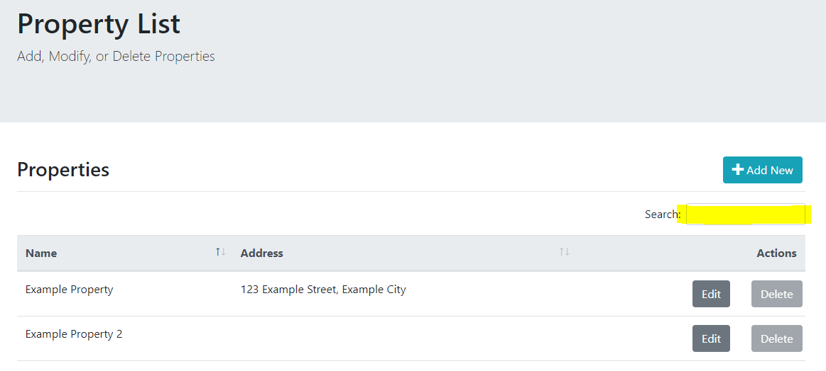

### Sorting

1. Properties can be sorted on either Name or Address by clicking on the header. Note addresses are sorted on the full string of street address and city.

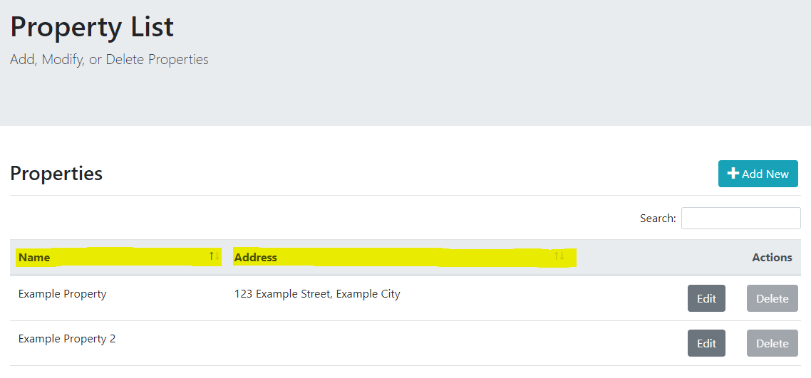

### Add New

1. To add a new property, select the “Add New” button.

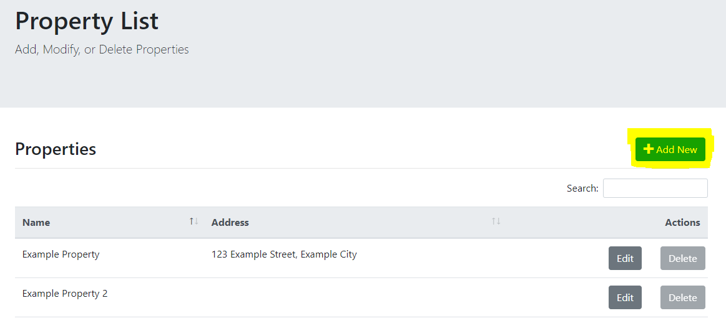

1. In the Edit Property screen, add a name and optionally fill out the address fields. Note: Names must be unique. An error will occur if another record already exists with the same name.

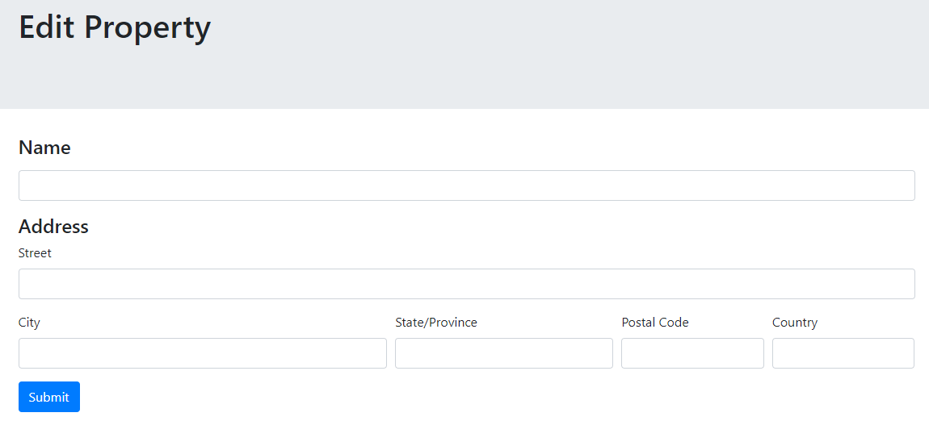

1. Press submit to create the record.

### Edit

1. Select the Edit button on the row to edit the record.

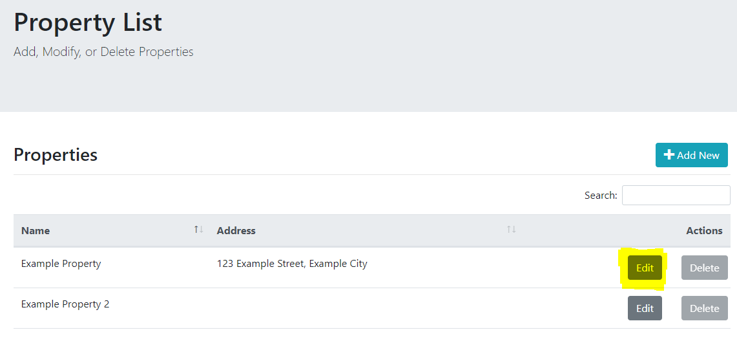

1. Edit the fields that need to be changed and press submit to update the record. Note: Names must be unique. An error will occur if another record already exists with the same name.

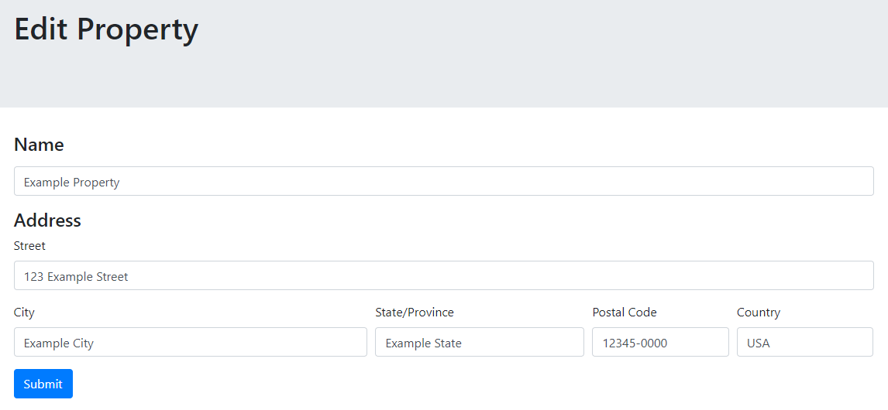

### Delete

1. To delete an existing property, press the delete button on the appropriate row. Press OK on the popup to confirm.

Note: if a record is being used in an inventory item, the button will be disabled. First, delete the inventory items using the record.

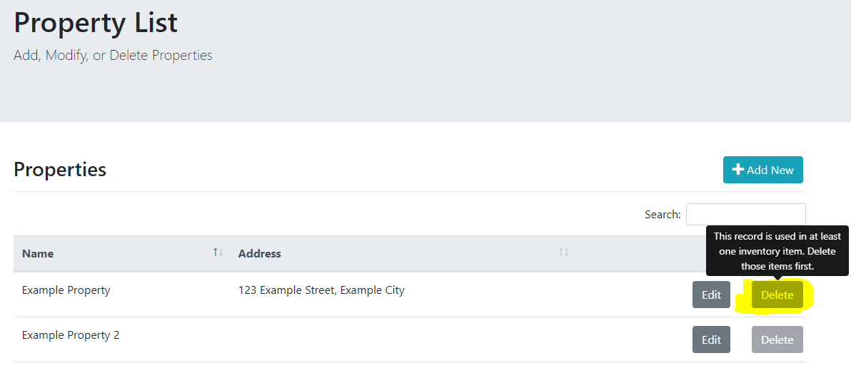

## Rooms

The system can be set up to allow the user to enter one or more rooms to allow for grouping of inventory items.

1. Select “Room List” from the Data menu to view a list of rooms, add new rooms, or edit existing rooms.

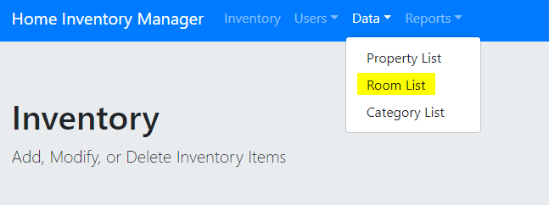

### Filter

1. To filter the list of rooms, type in the search field.

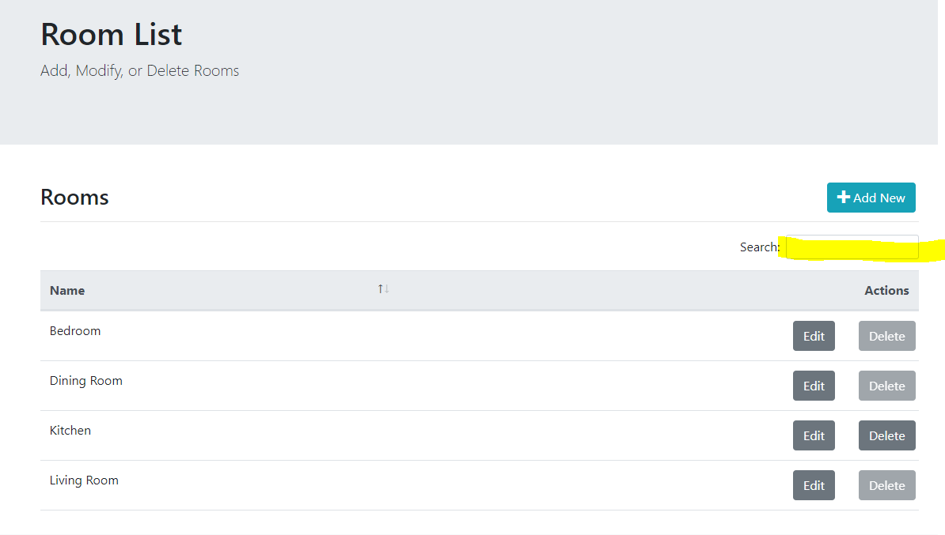

### Sorting

1. Rooms can be sorted on Name by clicking on the header.

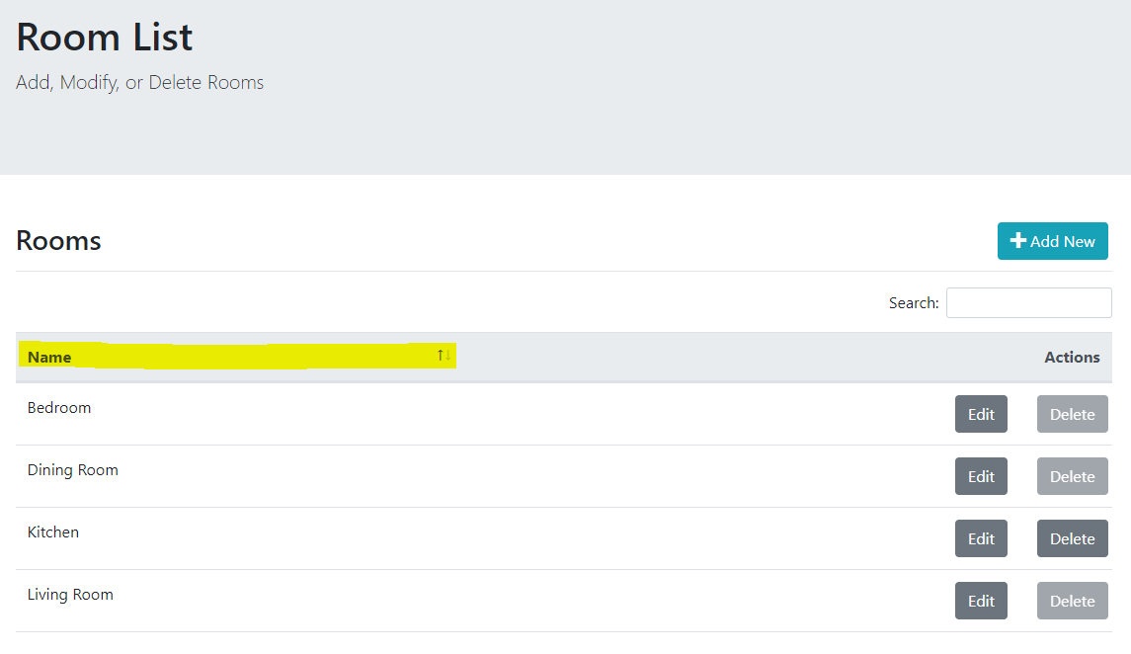

### Add New

1. To add a new room, select the “Add New” button.

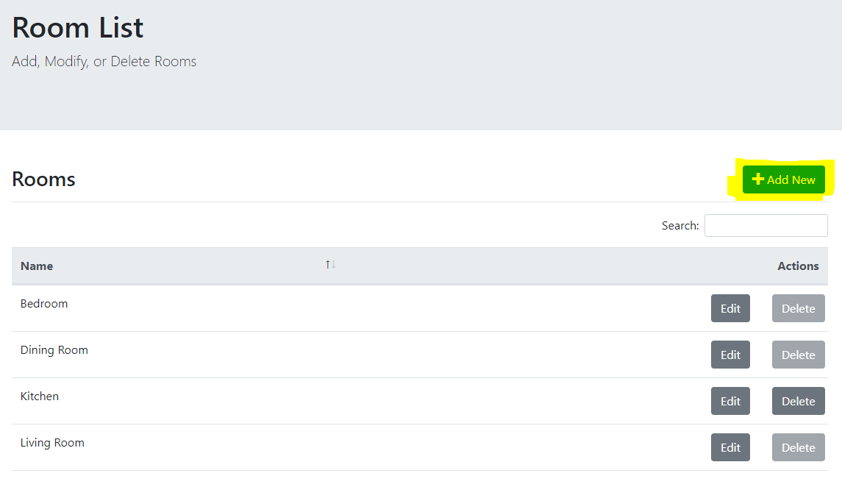

1. In the Edit Room screen, add a name, and click Submit to create the record. Note: Names must be unique. An error will occur if another record already exists with the same name.

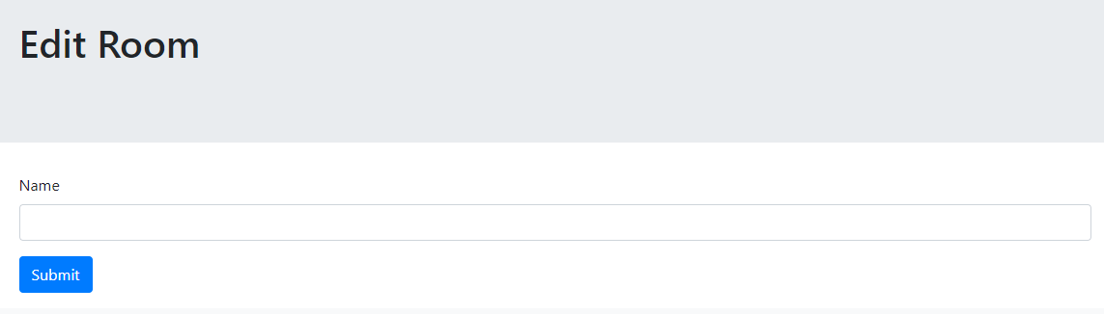

### Edit

1. Select the Edit button on the row to edit the record.

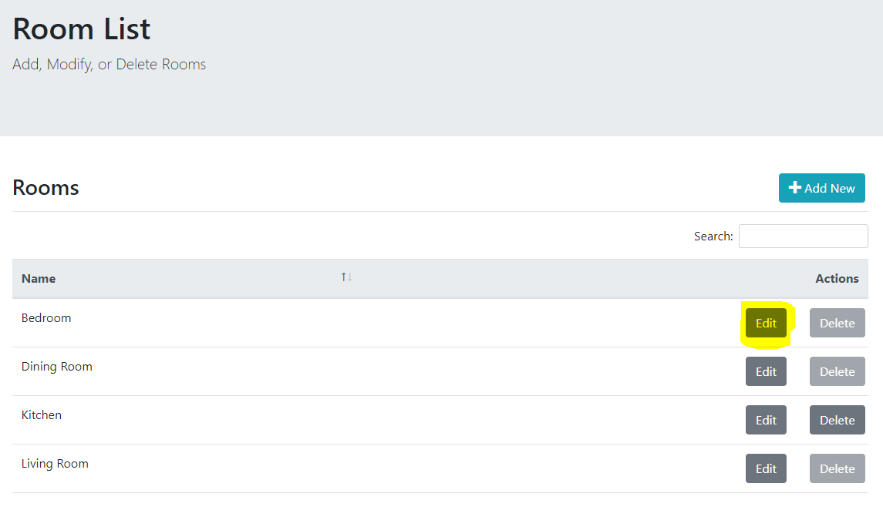

1. Edit the name and press submit to update the record. Note: Names must be unique. An error will occur if another record already exists with the same name.

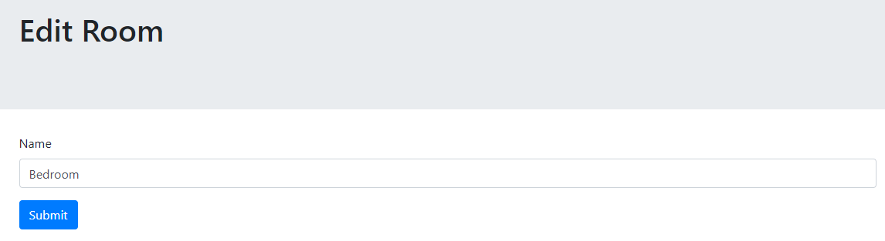

### Delete

1. To delete an existing room, press the delete button on the appropriate row. Press OK on the popup to confirm.

Note: if a record is being used in an inventory item, the button will be disabled. First, delete the inventory items using the record.

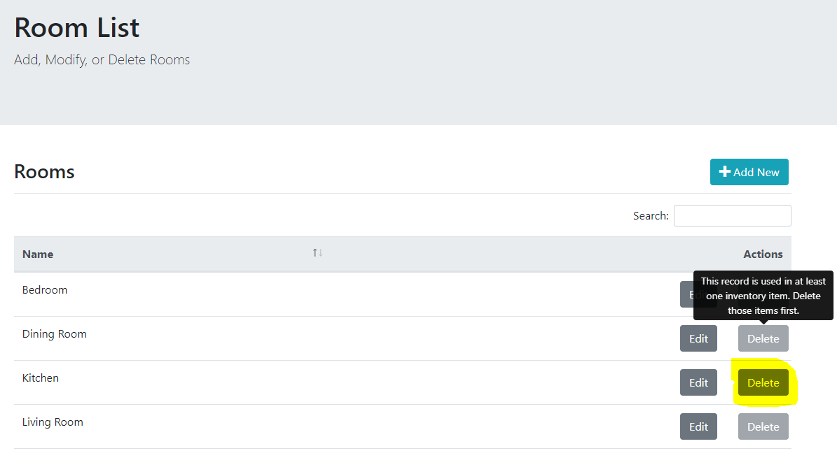

## Categories

The system can be set up to allow the user to enter one or more item categories to allow for grouping of inventory items.

1. Select “Category List” from the Data menu to view a list of categories, add new categories, or edit existing categories.

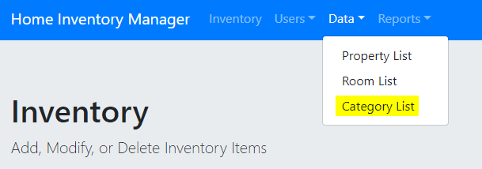

### Filter

1. To filter the list of categories, type in the search field.

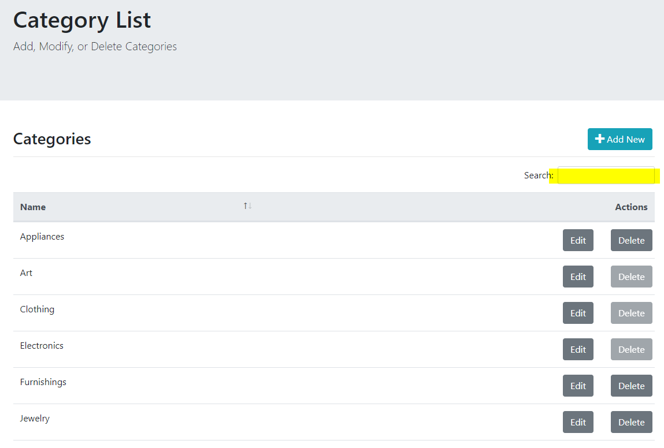

### Sorting

1. Categories can be sorted on Name by clicking on the header.

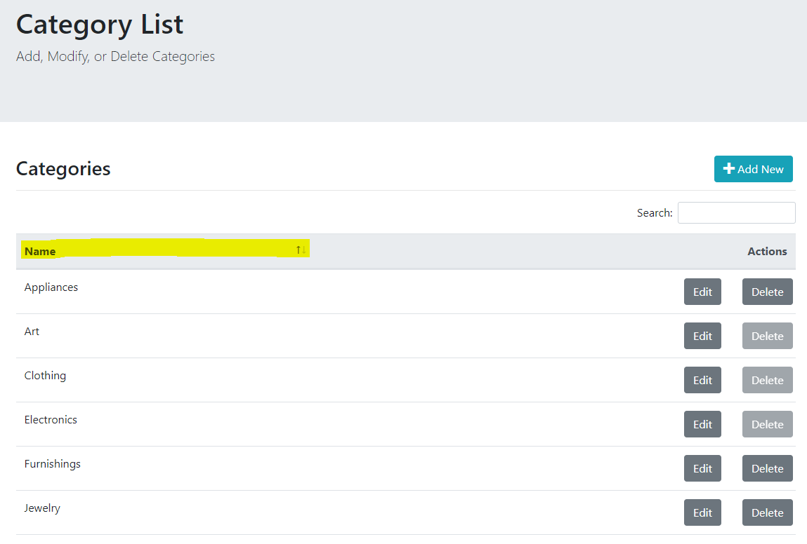

### Add New

1. To add a new category, select the “Add New” button.

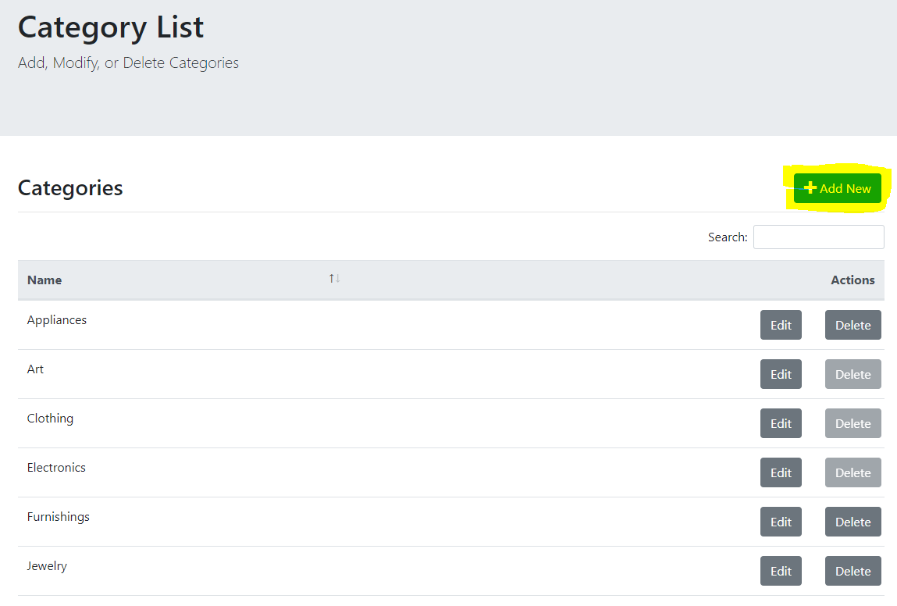

1. In the Edit Category screen, add a name, and click Submit to create the record. Note: Names must be unique. An error will occur if another record already exists with the same name.

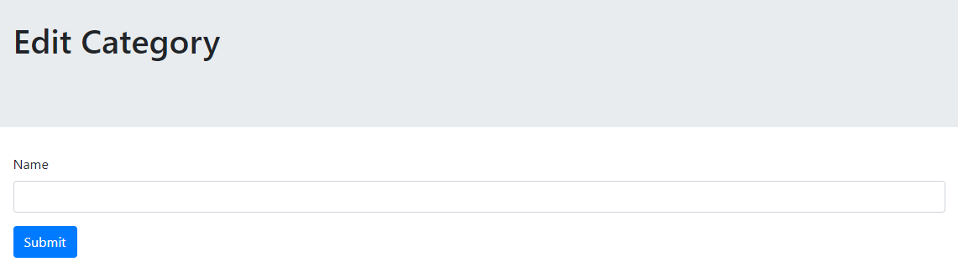

### Edit

1. Select the Edit button on the row to edit the record.

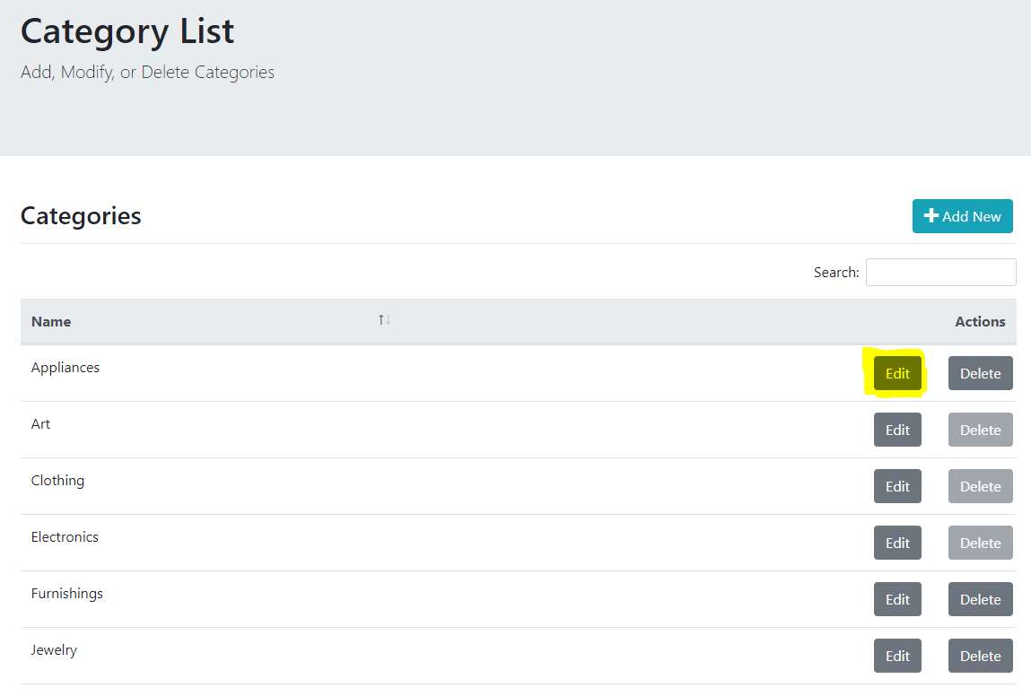

1. Edit the name and press submit to update the record. Note: Names must be unique. An error will occur if another record already exists with the same name.

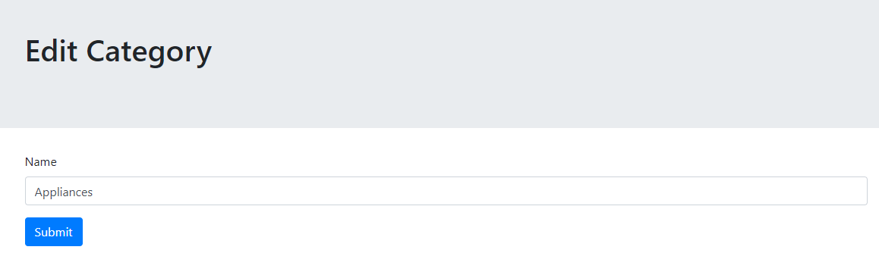

### Delete

1. To delete an existing category, press the delete button on the appropriate row. Press OK on the popup to confirm.

Note: if a record is being used in an inventory item, the button will be disabled. First, delete the inventory items using the record.

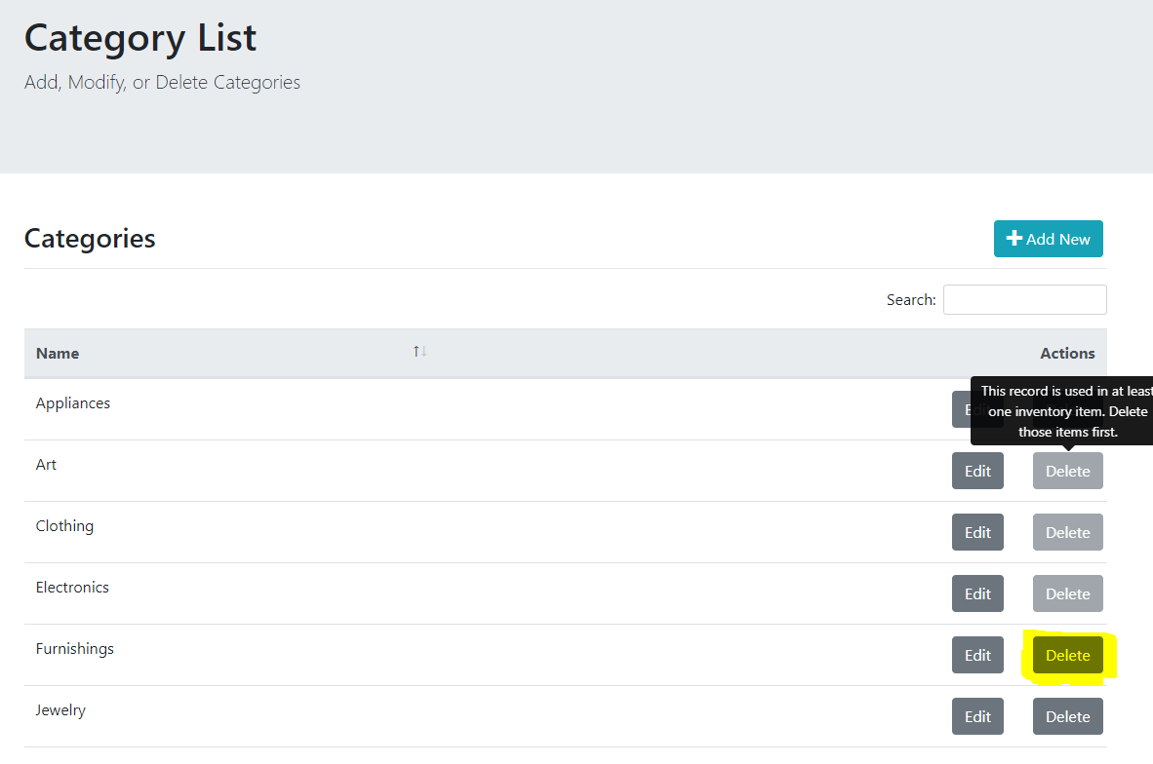

## Inventory

The primary function, once the setup of the data is complete, is to enter and maintain items in the inventory. This function is done on the home page when logged in. It can be reached by selecting either the name of the application or Inventory in the navigation bar.

1. Select “Inventory” from the Data menu to view a list of inventory items, add new items, or edit existing items.

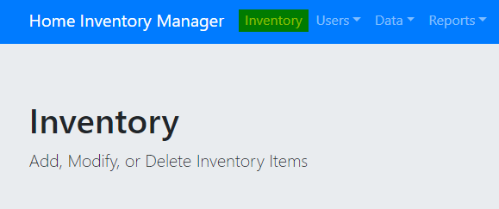

### Filter

1. To filter the list of items, type in the search field. The items are filtered on Name, Category, Room, and Property names.

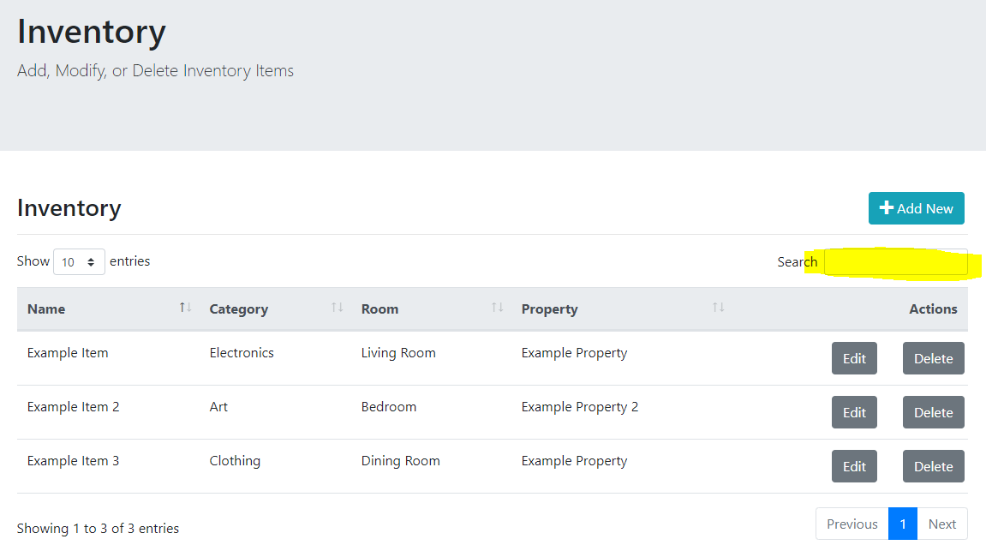

### Sorting

1. Items can be sorted on Name, Category, Room, or Property name by clicking on the appropriate header.

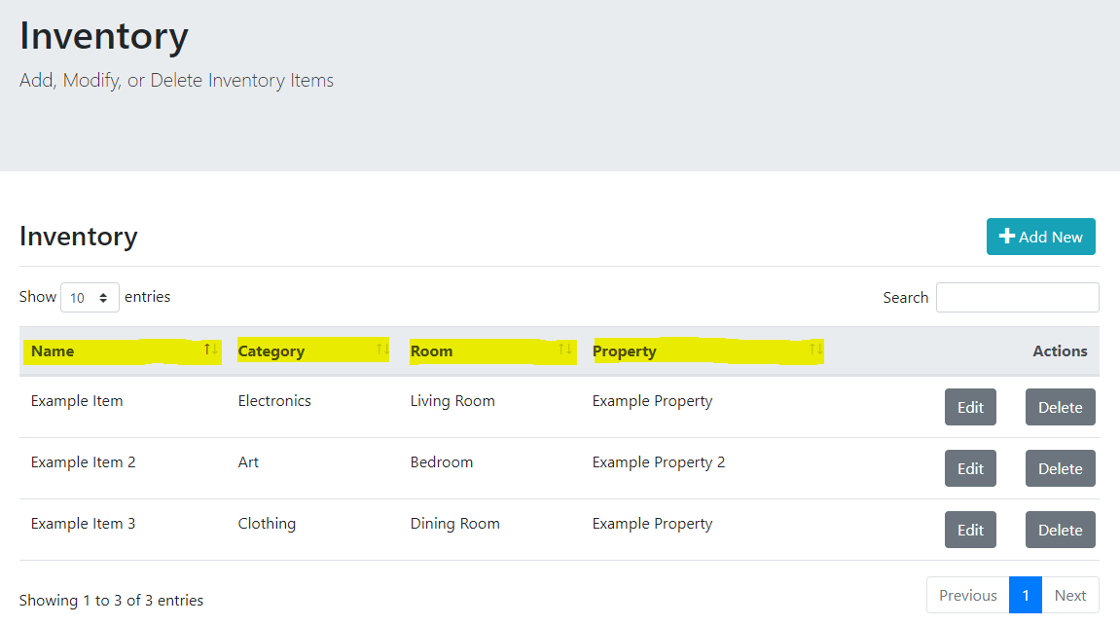

### Pagination

The inventory items will be limited by the number of entries selected in the dropdown at the top left of the table. Buttons for navigating pages are included at the bottom left of the table. The current items being viewed as well as the total number of items are shown at the bottom left.

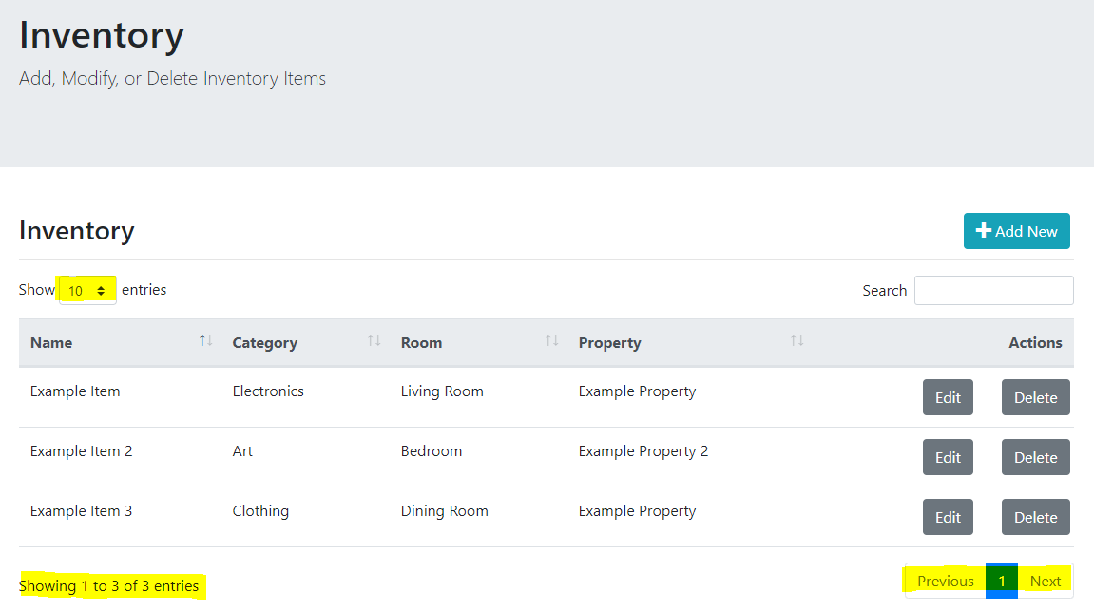

### Add New

Note: attachments cannot be added through the Add New screen. The item must be saved first, and the user must then edit the item as shown in the Edit section below.

1. To add a new item to the list, select the “Add New” button.

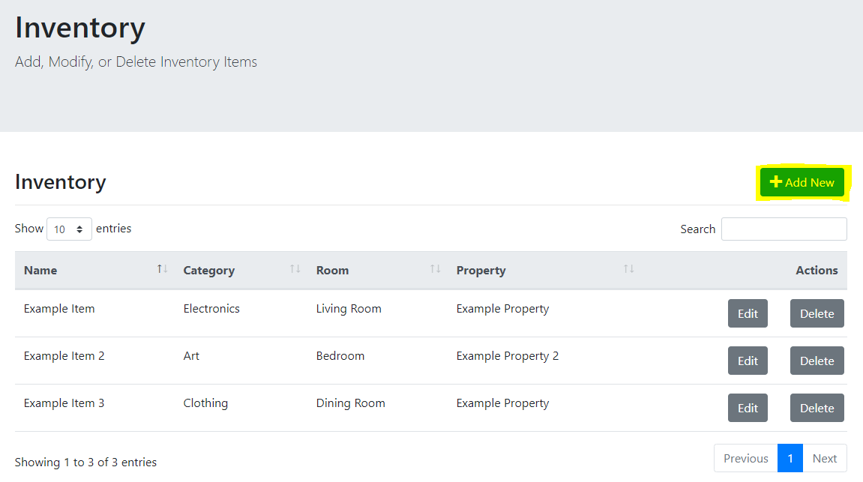

1. In the Edit Inventory Item screen, add a name for the item. Note: Names must be unique. An error will occur if another record already exists with the same name.

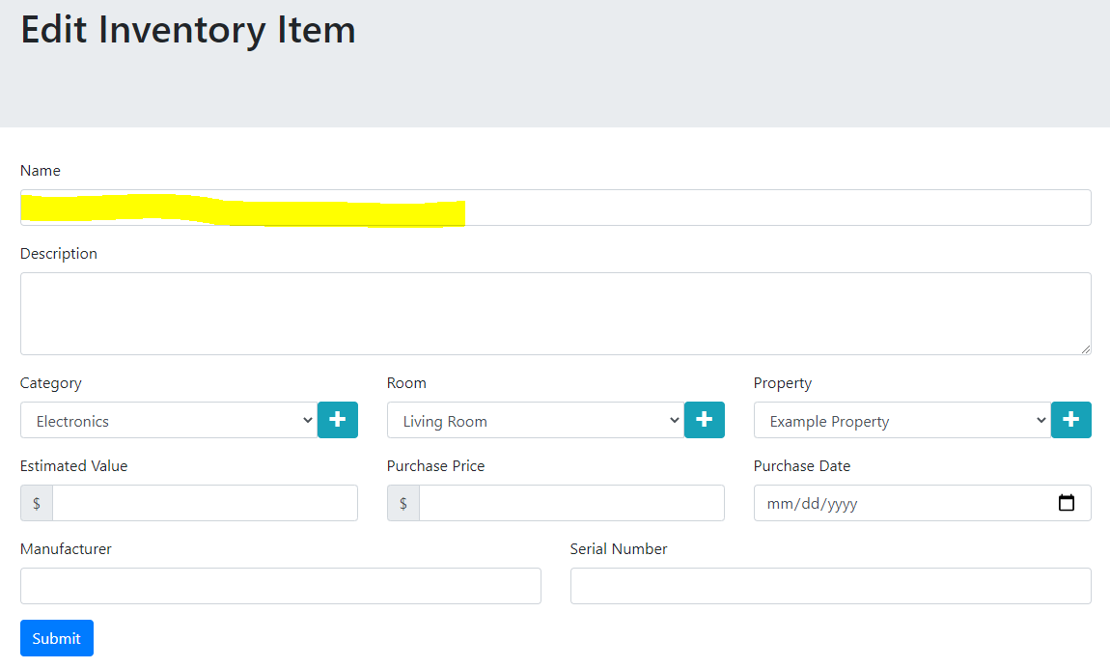

1. Optionally enter a Description for the item.

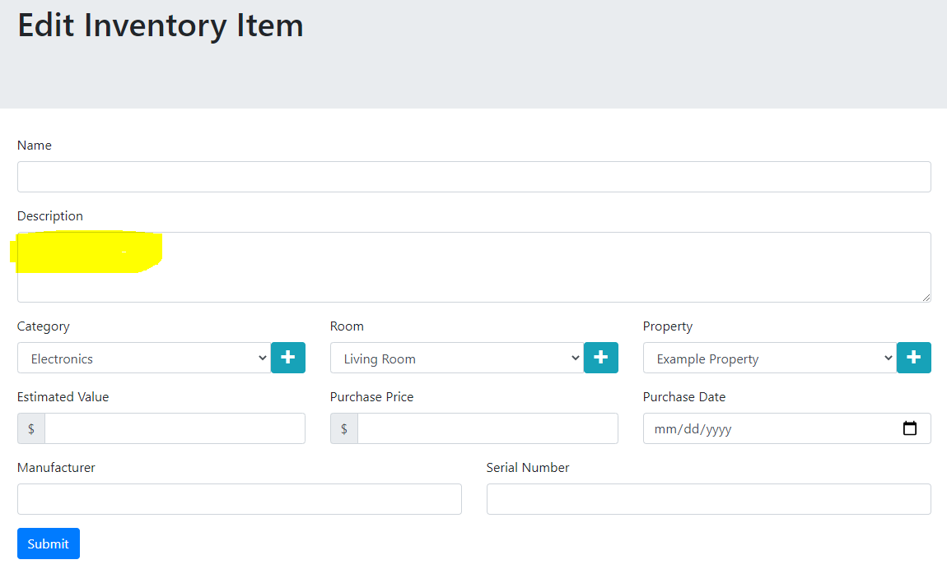

1. Select a category for the item or press the plus sign button to add a new one without losing your place. A popup will be shown allowing you to add the new category when pressing the plus button and the category will show up in the list.

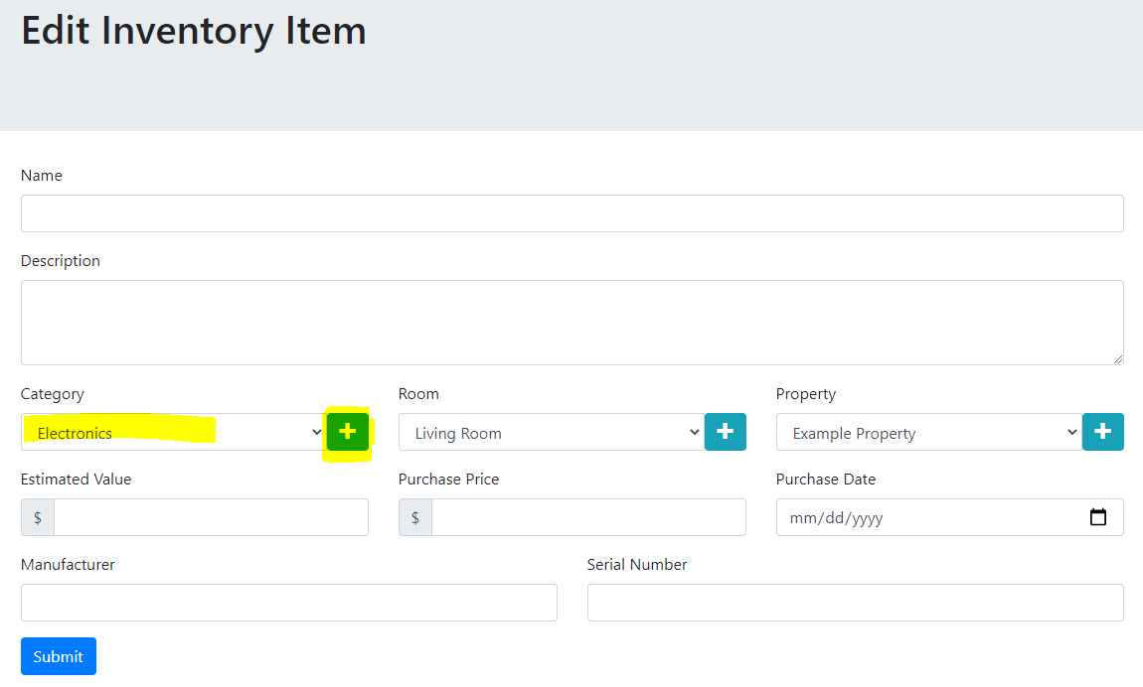

1. Select a room for the item or press the plus sign button to add a new one without losing your place. A popup will be shown allowing you to add the new room when pressing the plus button and the room will show up in the list.

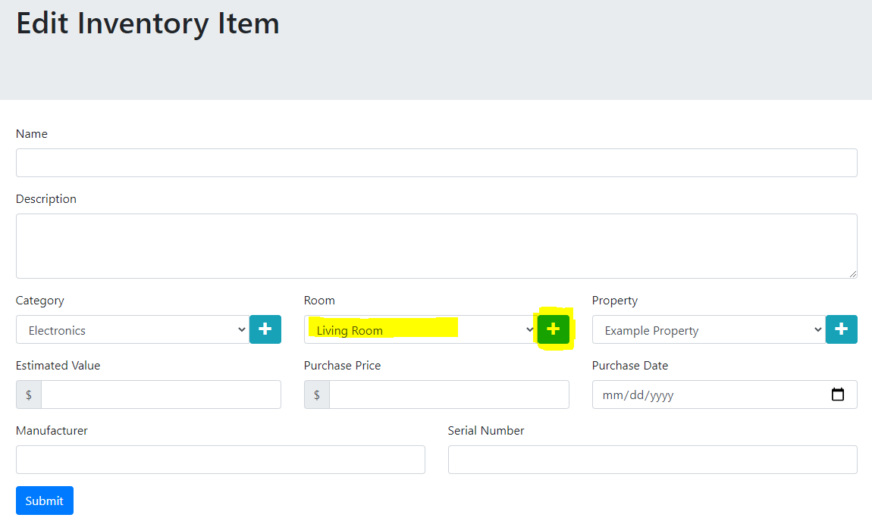

1. Select a property for the item or press the plus sign button to add a new one without losing your place. A popup will be shown allowing you to add the new property when pressing the plus button and the property will show up in the list.

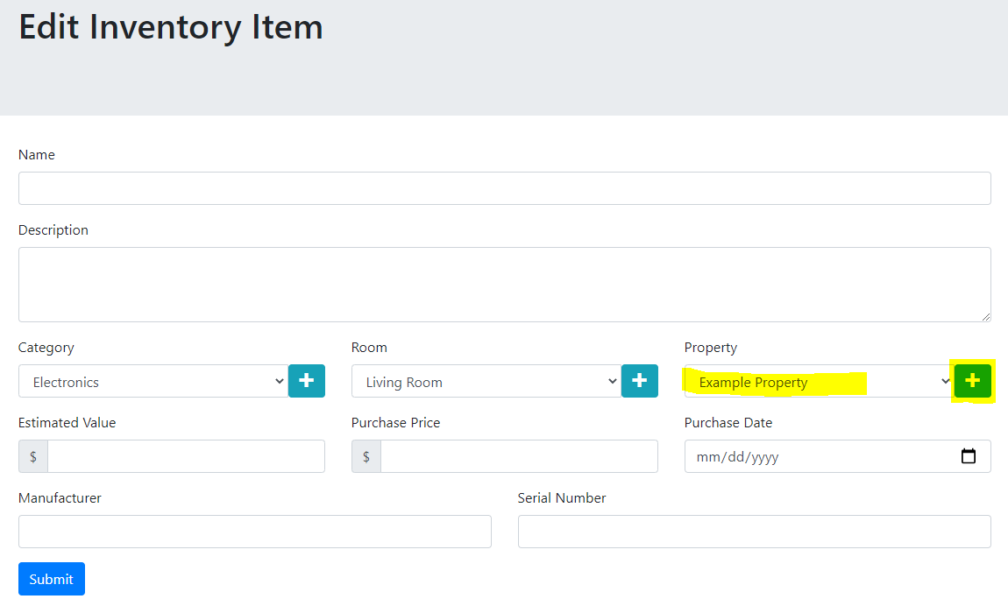

1. Enter the estimated value of the item, the purchase price, or both. Note that entering one is required but entering both are recommended to take advantage of the estimated value report. Estimated Value is the current value estimate of the item after appreciation or depreciation is considered. Purchase Price is the price paid for the item.

Note that no conversion is done when changing locales and the amounts are not meant to be used across regions. The user should enter the appropriate currency for their region.

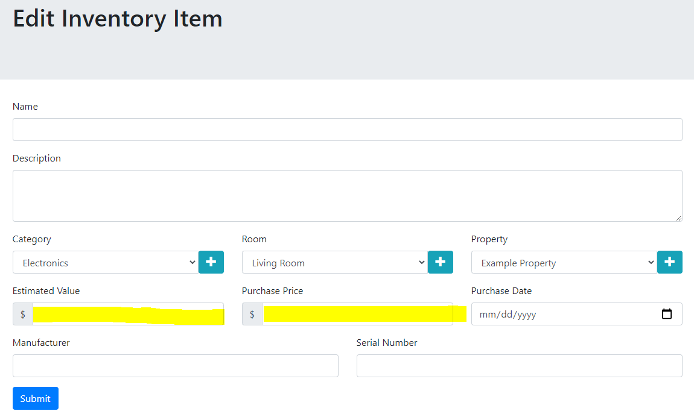

1. Optionally enter the purchase date. This will help with estimating appreciation/depreciation in a future version of the software, so it is recommended.

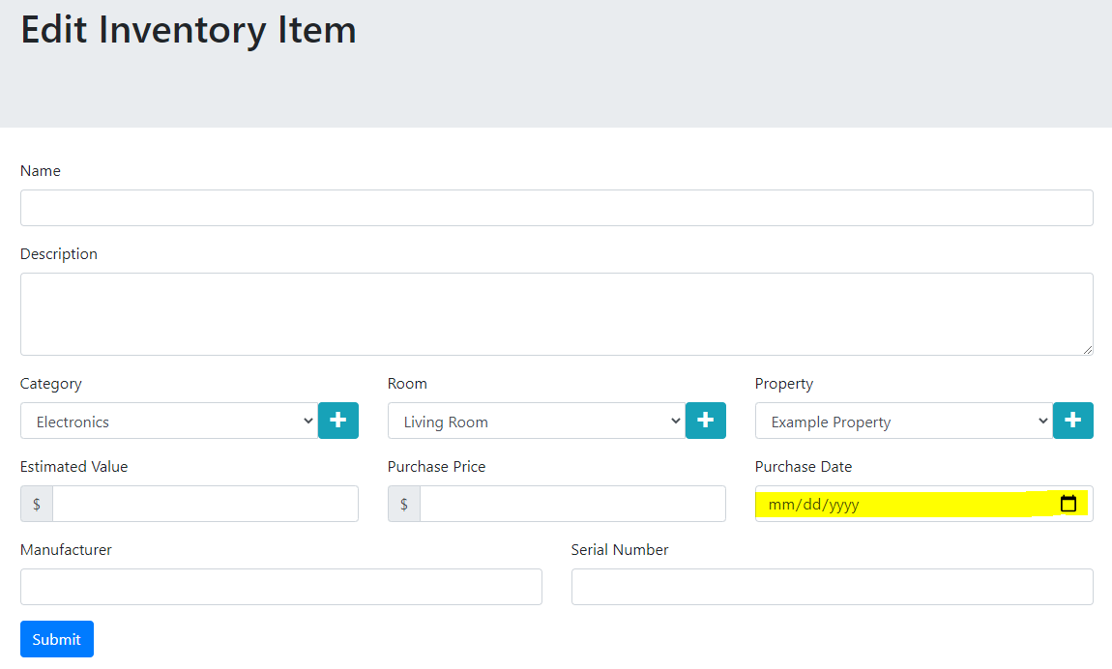

1. Optionally enter the manufacturer and serial number. These items will be helpful in the case of a loss and are recommended if available.

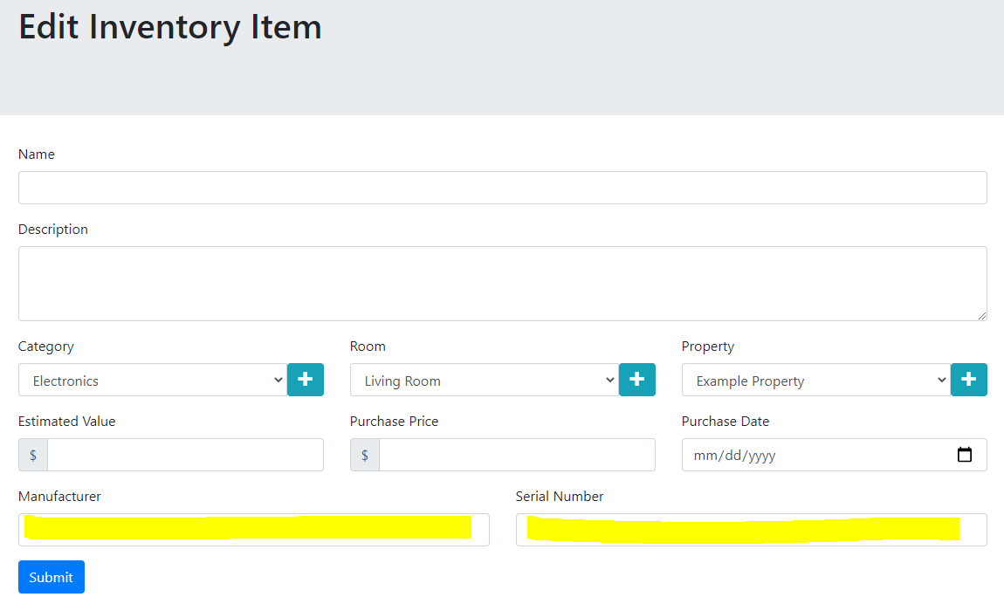

1. Press submit to verify and add the record.

### Edit

1. Select the Edit button on the row to edit the record.

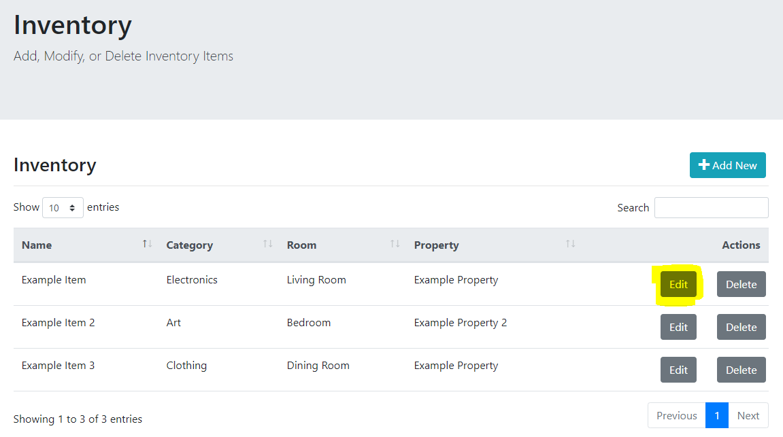

1. Edit the fields that need to be modified and press submit to validate and save the record. Please see the Add New section above for details on all fields other than attachments. Please see the following sections for details on attachments.

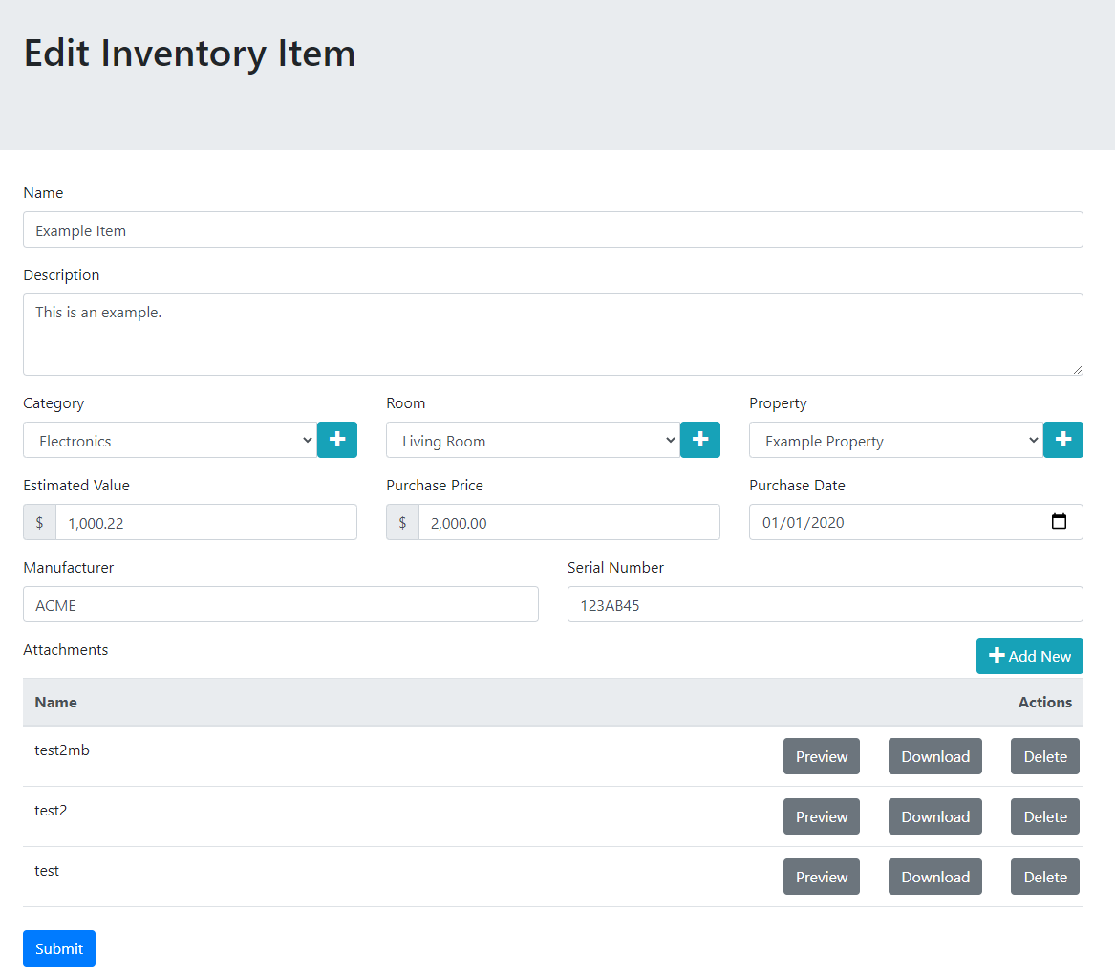

### Delete

1. To delete an existing item, press the delete button on the appropriate row. Press OK on the popup to confirm.

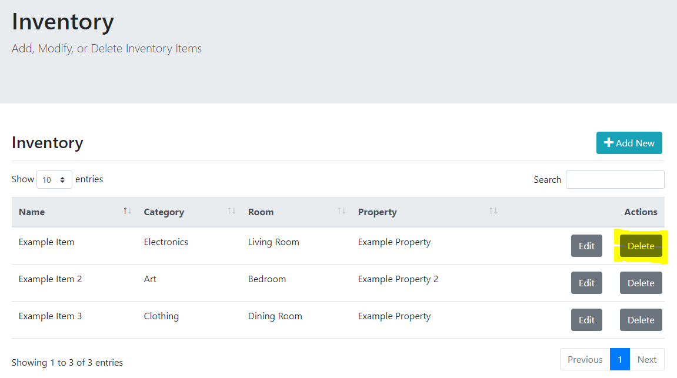

## Attachments

The list of current attachments on an item can be viewed in the Edit Inventory Items screen by pressing the Edit button on the inventory list screen.

Note: It is not required to press submit to save changes to attachments. Changes are permanently saved immediately when adding or deleting attachments.



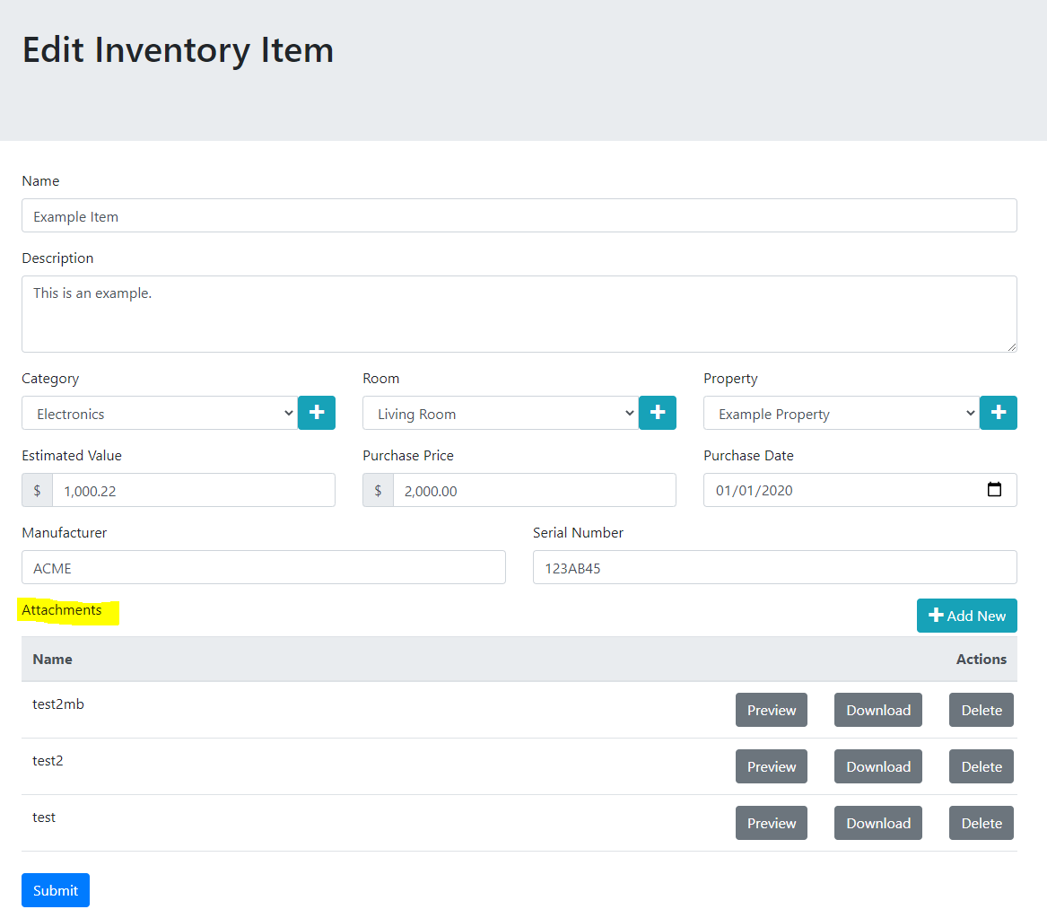

### Add New

1. To add a new attachment to an existing inventory item, press the “Add New” button.

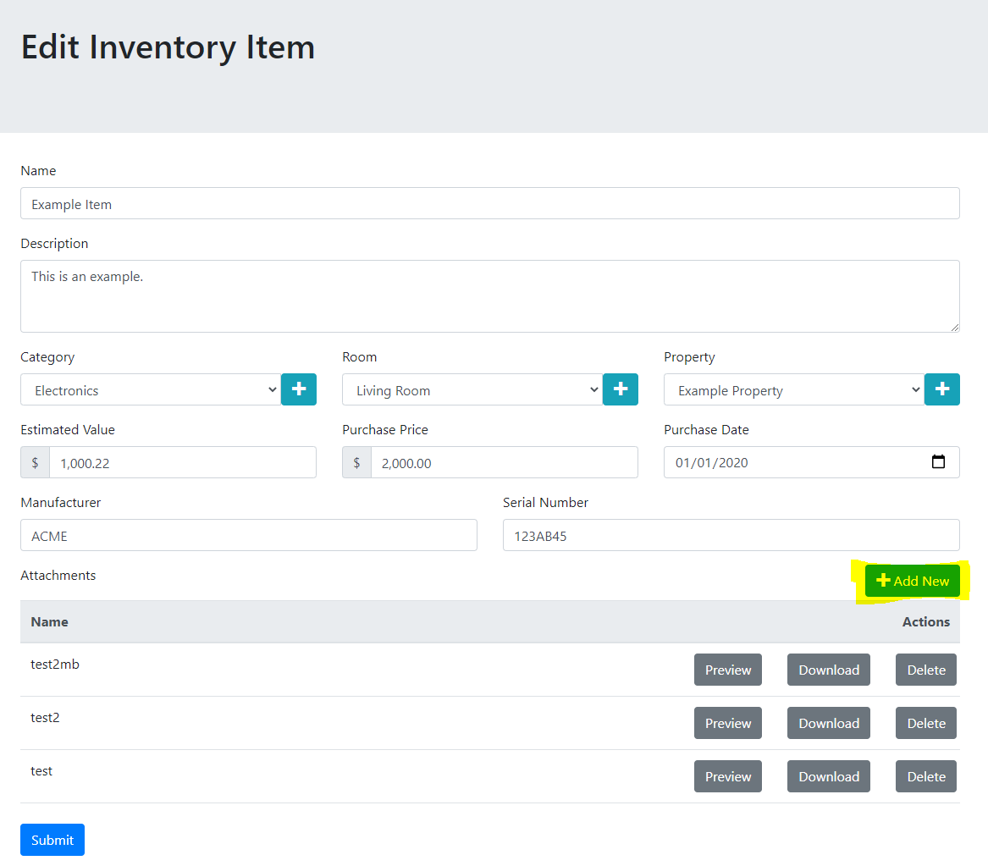

1. A popup will be shown allowing for entering a name and selecting a file. Note the information icon next to the File label will show the max file size when hovered over. The new item will show in the list once the upload is complete.

Note: Depending on your internet speed and the size of the file, this may take some time. Please be patient while the file uploads. The popup will disappear once the upload is complete.

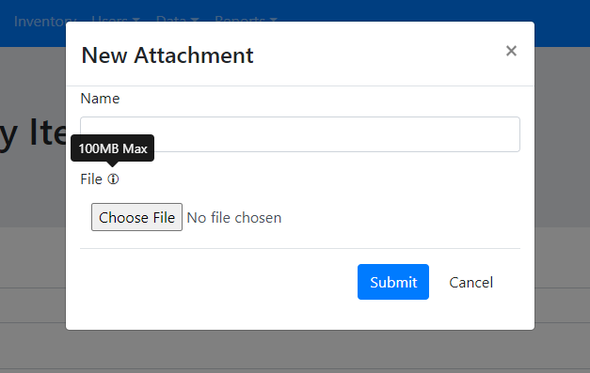

### Preview

If the item is of a type that can be previewed in the browser, the Preview button will be enabled. Currently, this includes images in the PNG, JPEG, or GIF format. To preview an image:

1. Press the Preview button on the appropriate row.

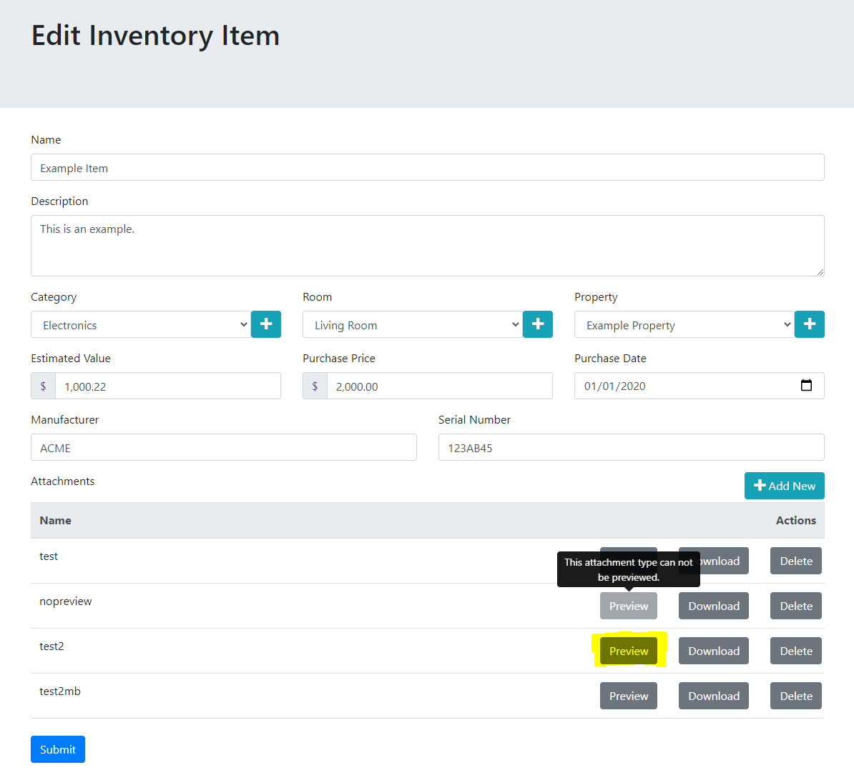

1. A popup will appear with the item selected as a small image.

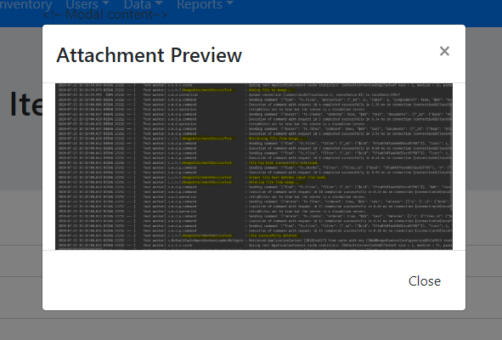

### Download

1. To download an attachment, press the download button on the appropriate row. The item will be sent to your browser for download. See your browser’s user guide for information on how to access downloaded files.

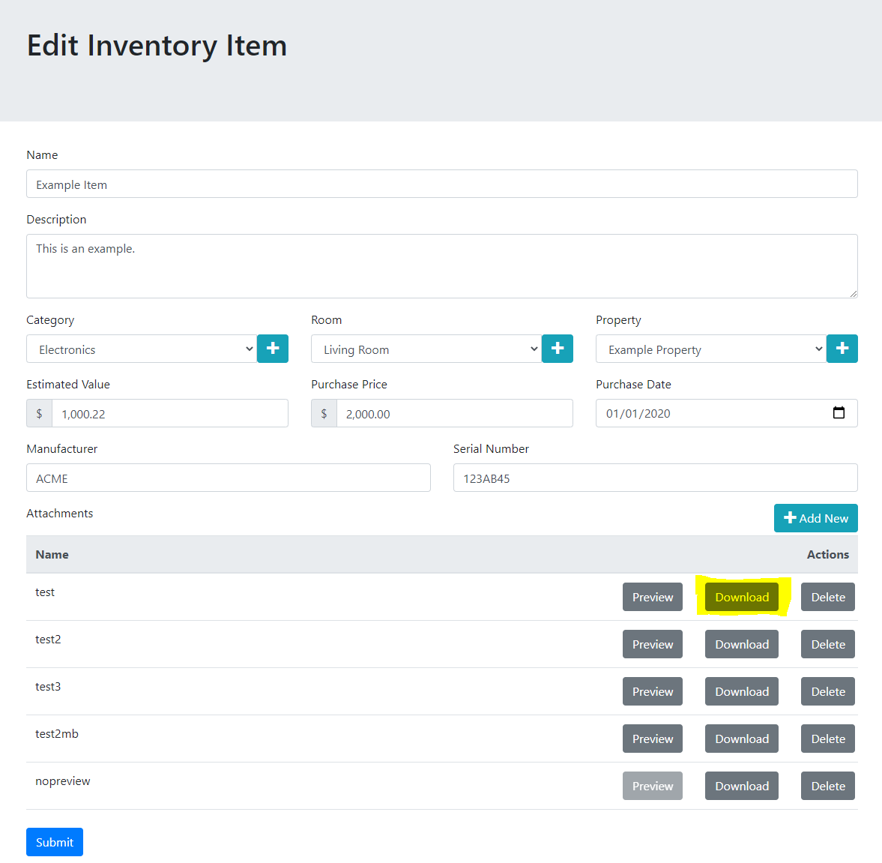

### Delete

1. To delete an attachment, press the delete button on the item and press OK on the confirmation popup.

Note: files are deleted permanently from the database and cannot be recovered.

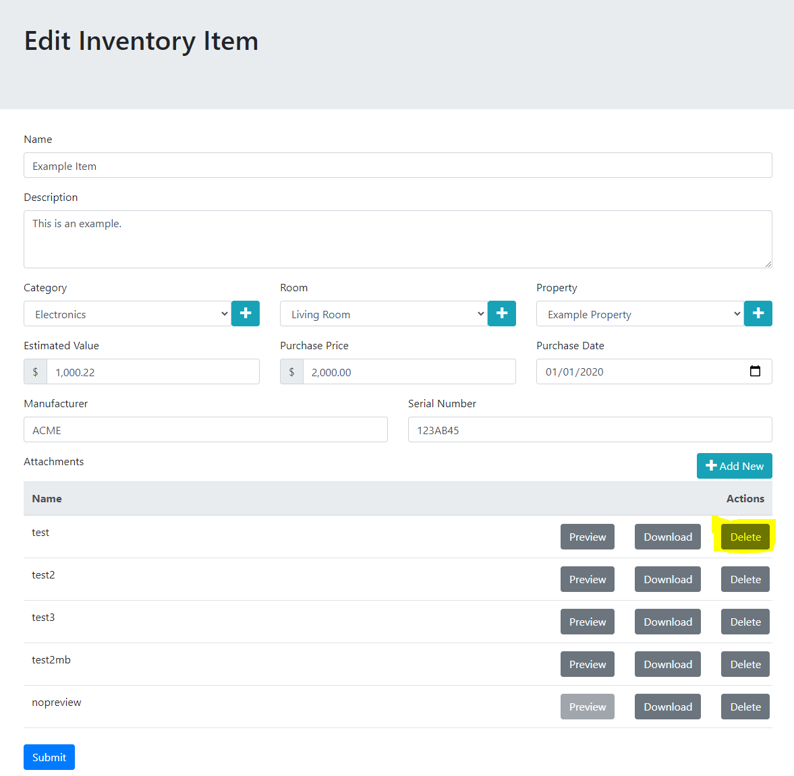

## Reports

### Estimated Value Report

The estimated value report is used to help the customer and the agent talk about how much coverage the customer should have on their personal items. This report is not meant to record the actual value and is not used in the claims process to value items for a claim payout. It is not meant to be an exact indicator of how much coverage you should have. In many cases, the coverage requirements will be higher than these numbers.

Note that this report will only be useful if as estimated value and purchase prices are entered on all items in the inventory.

The Estimated Value amount is calculated by taking the estimated value of each of the items and totaling them. If the estimated value field is not populated, the purchase price field will be used instead but may lower the accuracy of this estimate.

The Estimated Replacement Value is calculated by taking the greater of the value and purchase price of each item and totaling them. If either field is not populated for any items, this may lower the accuracy of this estimate.

Together these values can be used by an agent to help the customer better estimate the coverage amount the customer should purchase.

The report is accessed by:

1. Selecting the Estimated Value Report from the Reports menu.

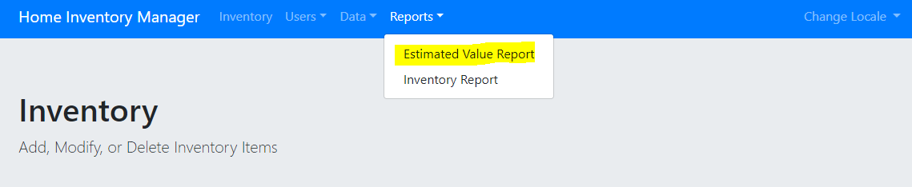

1. Values are displayed as amounts in the currency appropriate to the locale (for US English it is American Dollars). Note that no conversion is done when changing locales and the amounts are not meant to be used across regions. The user should enter the appropriate currency for their region.

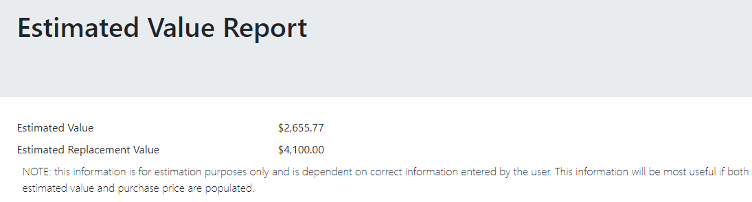

### Inventory Report

The inventory report is a comprehensive list of all items in the user’s inventory. This report is meant to be used in the case of a loss, to better help with the claims process. It is not a list of items that will necessarily be replaced or the amount that will be paid on a claim. It is meant only as a supplement to list items that the claim adjudicators should consider and for the customer to track items.

1. To access the Inventory Report, select “Inventory Report” from the Reports menu.

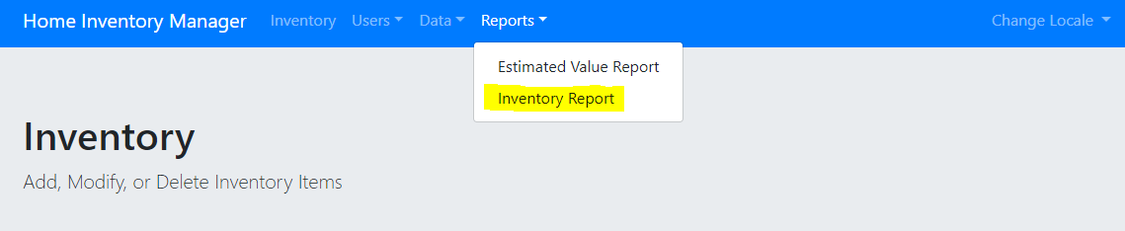

1. Select the grouping you would prefer on from the dropdown and press submit.

The groupings allow the user to better sort items that may or may not have been affected by a claim event. For example, if only one room was damaged, the By Room report will be helpful in determining which items are usually stored in that room and may have been affected. The By Property and Room or By Property and Category reports may be useful if more than one property is being tracked in the application.

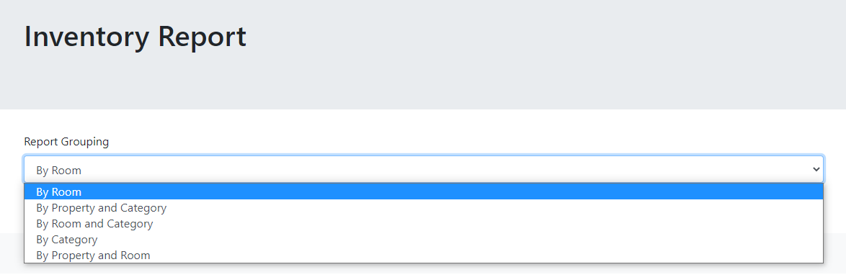

1. The report may take some time to retrieve, especially the first time it is retrieved. In this case, the Submit button will change to “Loading”. Please be patient while this process finishes. It may take some time if the inventory contains many items.

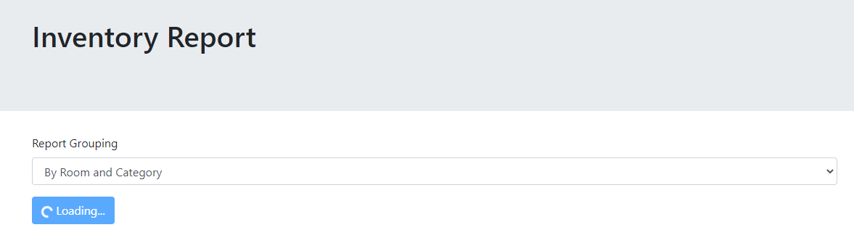

1. If the web browser can view PDF files, the report will be shown in the browser. If the web browser does not support viewing PDF files, it will be downloaded. See your browser’s user guide for information on how to access downloaded files.

This screenshot shows the By Room report.

Note: Reports are currently shown with the dates in US English and with price and value columns formatted as US Dollars. This does not mean the value was converted to dollars, this is a current limitation to the system and will be enhanced in a future version.

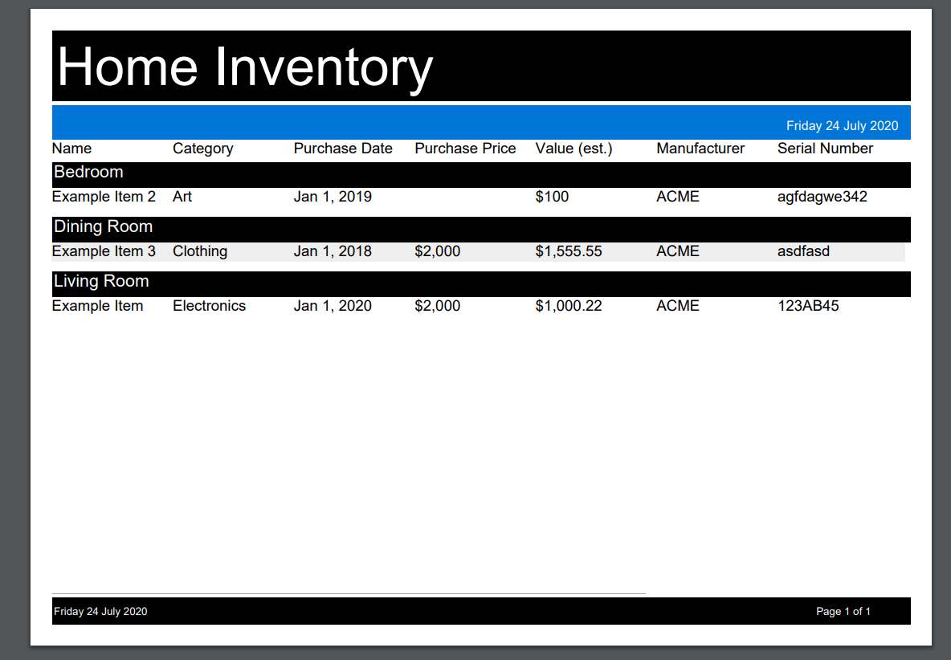

## Tracking and Recovery

In general changes to items in the database are tracked and items are “soft deleted”. The exception is attachments which are permanently deleted and only the time and date of the deletion is recorded.

In most cases, deleted database entries can be recovered if necessary, but there is no guarantee that data can be recovered. If an item was deleted accidentally, please contact support. If you wish to have an item recovered, do not create a duplicate item in the system. It is ok to recreate an item if it was deleted if you do not request recovery from support. Note that attachments cannot be recovered.

## Known Issues

* The Inventory Reports are not translated or formatted based on locale. These will be enhanced in a future version.
* The Inventory Report uses a font that does not support UTF characters and thus does not support Chinese. These will be enhanced in a future version.
* The login screen is not translated. This is a limitation of the Spring Security component and will be replaced in a future version.
* The Purchase Date field is not appropriately formatted for locale.